|  |  |
| --- | --- |
|  | **MINISTRY OF EDUCATION AND TRAINING** |

|  |
| --- |
| **FPT UNIVERSITY** |
| Capstone Project Document |
| **[Container Round use Marketplace]** |
|  |
| |  |  | | --- | --- | | **CRuM Team** | | | **Group Members** | Nguyen Van An - SE05589  Nguyen Van Quyen - SE04772  Nguyen Duc Duong - SE05132  Khong Quang Minh - SE05575  Dao Luong Duy - SE06128 | | **Supervisor** | Nghiem Thi Lan Phuong | | **Ext Supervisor** | N/A | | **Capstone Project code** | CRuM | |
|  |

|  |
| --- |
| - Hanoi, Jun/2020 - |

Contents

**1. Introduction** 6

**1.1** **Purpose** 6

**1.2** **Project Information** 6

**1.3** **Project Team** 6

**1.4** **Background** 6

1.4.1 Difficulties 8

**1.5** **The current system** 9

1.5.1 Vận tải Hà Nội 9

1.5.2 Logivan 10

1.5.3 Competitor Analysis 11

**1.6** **Proposed Solution** 12

1.6.1 Solution Description 12

1.6.2 System Actor 12

1.6.3 System function 12

1.6.4 Out of scope 12

**2. Software Project Management Plan** 13

**2.1. Problem Definition** 13

2.1.1. Name of this Capstone Project 13

2.1.2. Problem Abstract 13

2.1.3. Project Overview 13

**2.2. Project organization** 14

2.2.1. Software Process Model 14

2.2.2. Roles and Responsibilities 14

2.2.3. Tools and Techniques 15

**2.3. Project management plan** 16

2.3.1. Tasks: 16

2.3.2. All Meeting Minutes 16

**2.4. Coding Convention** 22

2.4.1 Coding convention 22

2.4.2 Document convention 22

**2.5. Other material** 22

2.5.1 Risk Management Plan 22

2.5.2 Risk Register 23

2.5.3 Probability - Impact matrix 25

**3. Software Requirements Specifications (SRS)** 26

**3.1. User Requirement Specification** 26

**3.2. System Requirement Specification (Specific Requirements)** 27

3.2.1. External Interface Requirements 27

3.2.2. System Features 27

3.2.3. Software System Attributes 128

**3.3. Entity Relationship Diagram or Data Structures** 130

**3.4. Other material** 130

3.4.1. Business rule repository 130

**4. Software Design Description** 132

**4.1. Design Overview** 132

**4.2. System Architectural Design** 132

4.2.1 Architecture Pattern 132

4.2.2 Technology Stack 133

4.2.3 Component 134

4.2.4 Backend Modules 135

4.2.5 Front-end sites 136

4.2.5 Deployment View 137

**4.3. Detailed Description of Components** 138

4.3.1*.* Component 138

**4.5. Sequence Diagram** 155

4.5.1 Login 155

4.5.2 Register 156

4.5.3 Get a list of Outbound (Lấy danh sách quản lý hàng xuất) 157

4.5.4 Declare outbound (Khai báo hàng xuất) 157

4.5.5 Delete outbound (Xóa hàng xuất) 158

4.5.6 Create Bid (Tạo hồ sơ dự thầu) 158

4.5.7 Forwarder edit Bid (Chỉnh sửa hồ sơ dự thầu) 160

4.5.8 View list of Bid (Xem danh sách hồ sơ dự thầu) 160

4.5.9 Create Bidding Document (Tạo Hồ sơ mời thầu) 161

4.5.10 Edit Bidding Document (Hồ sơ mời thầu) 162

4.5.11 Cancel Bidding Document (Hủy thầu) 162

4.5.12 Receive Bidding Document (Nhận HSMT) 163

4.5.13 Merchant views created Bidding Document (Xem HSMT đã tạo) 163

4.5.14 Bidding Document detail (Chi tiết HSMT) 164

4.5.15 Create Combined (Tạo hàng ghép) 165

4.5.16 Combined Management Page (Trang quản lý hàng ghép) 167

4.5.17 Information page of successful Bid (Trang thông tin hồ sơ trúng thầu) 167

4.5.18 Create report (Tạo báo cáo) 168

4.5.19 Forwarder views Report (Forwarder xem Report) 168

4.5.20 Forwarder views Report (Forwarder xem báo cáo) 169

4.5.21 Moderator views Report (Moderator xem báo cáo) 169

4.5.22 Moderator agrees/ reject Report (Moderator đồng ý/ từ chối báo cáo) 170

4.5.23 Create Feedback (Tạo feedback) 171

4.5.24 View Feedback (Xem feedback) 171

4.5.25 View Container Type List (Xem danh sách Container Type) 172

4.5.26 Declare Container Type (Khai báo Container Type) 172

4.5.27 Update Container Type (Cập nhật Container Type) 173

4.5.28 Delete Container Type (Xóa Container Type) 173

4.5.29 View list Port (Xem danh sách bến cảng) 174

4.5.30 Declare Port (Khai báo bến cảng) 175

4.5.31 Update Port (Cập nhật bến cảng) 175

4.5.32 Delete Port (Xóa bến cảng) 176

4.5.33 View list Shipping Line (Xem danh sách hãng tàu) 177

4.5.34 Declare Shipping Line (Khai báo hãng tàu) 177

4.5.35 Update Shipping Line (Cập nhật hãng tàu) 178

4.5.36 Delete Shipping Line (Xóa hãng tàu) 178

4.5.37 View Inbound list (Xem danh sách hàng nhập) 179

4.5.38 Declare Inbound (Khai báo hàng nhập) 180

4.5.39 Edit Inbound (Chỉnh sửa hàng nhập) 182

4.5.40 Delete Inbound (Xóa hàng nhập) 183

4.5.41 Forwarder create contract file (Forwarder tạo tài liệu hợp đồng) 184

4.5.42 Merchant agree contract file (Merchant đồng ý tài liệu hợp đồng) 186

4.5.43 Merchant reject contract file (Merchant từ chối tài liệu hợp đồng) 187

**4.6. User Interface Design** 188

4.6.1 Description of the User Interface 188

**4.7. Database Design or Data Structures** 231

**5. Software Test Documentation** 232

**5.1. Introduction** 232

5.1.1 Purpose 232

5.1.2 Scope of testing 232

**5.2. Test Plan** 232

5.2.1 Testing tools and Enviroment 232

5.2.2 Resources and Responsibilities 233

5.2.3 Test Strategy 234

**5.3.** **Test Approach** 236

5.3.1 Unit test with Eclipse 236

5.3.2 Intergration and System test 236

**5.4.** **Test Report** 236

5.4.1 Unit test 236

5.4.2 Intergration test 236

5.4.3 System test 236

**6. Software User’s Manual** 236

**6.1. Installation Guide** 236

**6.2. User’s Guide** 236

6.2.1 General function 236

6.2.2 Merchant function 243

6.2.3 Forwarder function 256

6.2.4 Admin function 273

6.2.5 Moderator function 276

# **1. Introduction**

* 1. **Purpose**

This chapter is created as the introduction to Container Round use Marketplace project. This document describes the overview of some existing systems, the initial idea, a brief description about expected system and provides an overview of the project, including background information, review of existing systems, their problems and proposal for ideas of improvement.

* 1. **Project Information**
* Project name: **Container Round use Marketplace.**
* Project code: **CRuM.**
* Project group: **CRuM team.**
* Product type: **Web application.**
* Timeline: **from 18th May 2020 to 28th August 2020.**
  1. **Project Team**

|  |  |  |  |  |
| --- | --- | --- | --- | --- |
| **No** | **Name** | **Roles** | **E-mail** | **Phone** |
| 1 | Nghiem Thi Lan Phuong | Supervisor | [phuongntl@fpt.edu.vn](mailto:phuongntl@fpt.edu.vn) | 0989376681 |
| 2 | Nguyen Van An | Leader | [annvse05589@fpt.edu.vn](mailto:annvse05589@fpt.edu.vn) | 0967390098 |
| 3 | Nguyen Van Quyen | Member | [quyennvse04772@fpt.edu.vn](mailto:quyennvse04772@fpt.edu.vn) | 0965697976 |
| 4 | Nguyen Duc Duong | Member | [duongndse05132@fpt.edu.vn](mailto:duongndse05132@fpt.edu.vn) | 0352321262 |
| 5 | Khong Quang Minh | Member | [minhkqse05575@fpt.edu.vn](mailto:minhkqse05575@fpt.edu.vn) | 0915495698 |
| 6 | Dao Luong Duy | Member | [duydlse06128@fpt.edu.vn](mailto:duydlse06128@fpt.edu.vn) | 0359049292 |

Table1.1 – Team member’s infomation

* 1. **Background**

These days, the transport of goods in containers is becoming more and more popular. About 200 million containers are taken advantages of transporting goods every year. It is not deniable that container transport plays a vital role because of its safety, fastness and convenience.

It still exists a numerous of drawbacks; however, especially there is no assurance the close-knit interaction between cargo owners and container owners. As a result, it is difficult to be flexible in shipments. For example, it is common that an empty container is returned to a container yard empty after its cargo has been delivered to the destination. The transportation cost (labor costs and fuel costs, etc.) of returning an empty container is added to the entire service fee in general. This process results in the waste of hundreds of thousands of kilometres of one way, millions of dollars and releasing a lot of emissions from vehicles causing air pollution.

To tackle this problem, our group creates Container Round Use (CRuM) as a platform that connects cargo owners and container owners to optimize empty containers during transportation. CRuM aims at reducing transportation costs and environmental conservation.

Business process

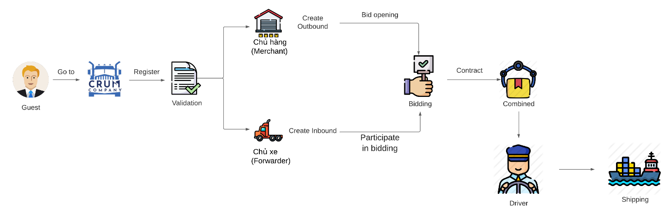

Figure 1.2 Business process

Guests will access CRuM and then sign up to become a Merchant or Forwarder. After registration is completed, the application form will be reviewed by the administrator.

After becoming a member:

* Merchant declares outbound and open bidding.
* Forwarder declares inbound and Participate in bidding.

After bidding, the contract will be created and goods are combined and will be shipped by the driver.

* + 1. Difficulties

1.4.2.1 Waste in transport

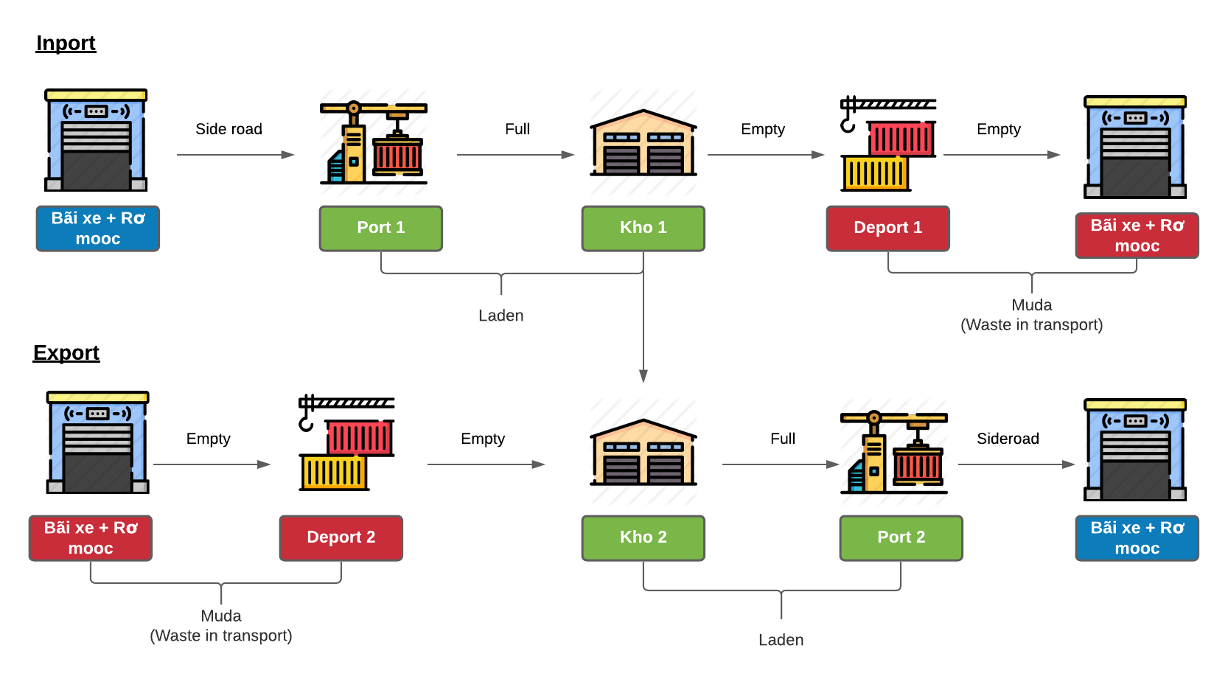

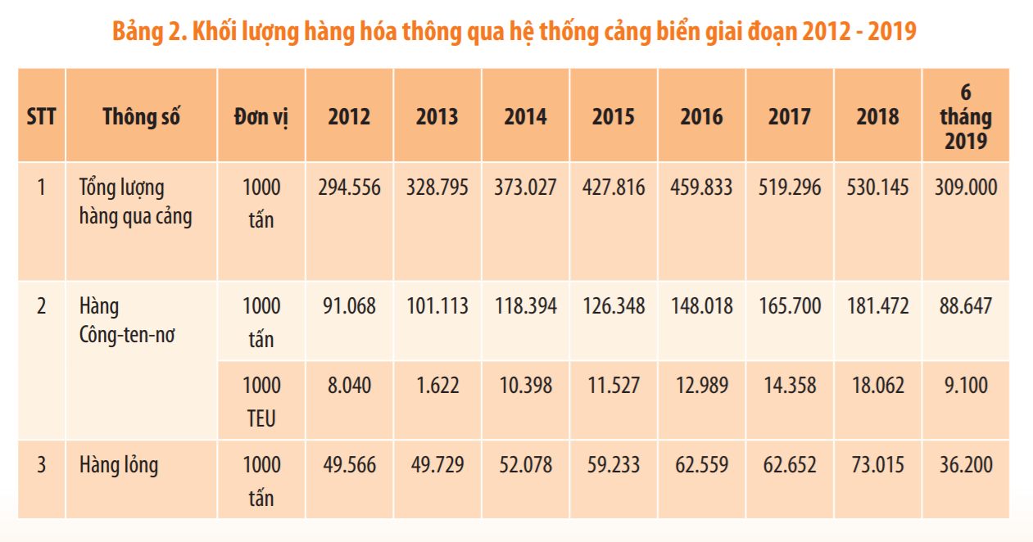

Info reference: <https://gosmartlog.com/wp-content/uploads/2019/12/Bao-cao-logistics-viet-nam-2019.pdf>

|  |  |  |
| --- | --- | --- |
| **Twenty-foot equivalent unit 2018 (TEU)** | **Transportation costs per TEU (vnđ)** | **Total transportation costs 2018 (vnđ)** |
| 18.062.000 | 3.500.000 | 63,217,000,000,000 |

|  |  |  |
| --- | --- | --- |
| **Waste in transport amount (%)** | **Total transportation costs 2018 (vnđ)** | **Waste amount (vnđ)** |
| 40% | 63,217,000,000,000 | 25,286,800,000,000 |

1.4.2.2 Increased emissions affect the environment

* 1. **The current system**

This section contains an overview of some of the applications available on the market today and analyzes their limitations, advantages and disadvantages.

Currently on the market it is very difficult to find a system that can meet the needs of users like CRuM. There is some application

* + 1. Vận tải Hà Nội

Link: <http://vantaihanoi.vn/>

VTHN is an intermediary website that coordinates the transportation and rental of different types of goods. However, this application has not automated the process, all stages are done rudimentarily and manually.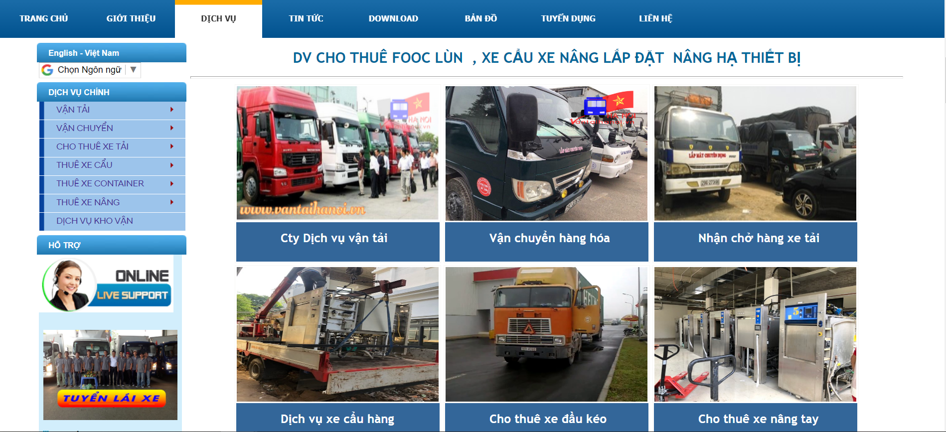

### 1.5.2 Logivan

Link AppStore:

<https://apps.apple.com/us/app/logivan-ch%E1%BB%A7-h%C3%A0ng/id1386678770>

<https://apps.apple.com/us/app/logivan-ch%E1%BB%A7-xe/id1333598414>

Link CHPlay:

<https://play.google.com/store/apps/details?id=com.logivan&hl=vi>

<https://play.google.com/store/apps/details?id=com.logivan.shipper&hl=vi>

Logivan is a mobile application that connects shippers and owners. The vehicle which Logivan helps to connect is the truck. Container is not yet developed.

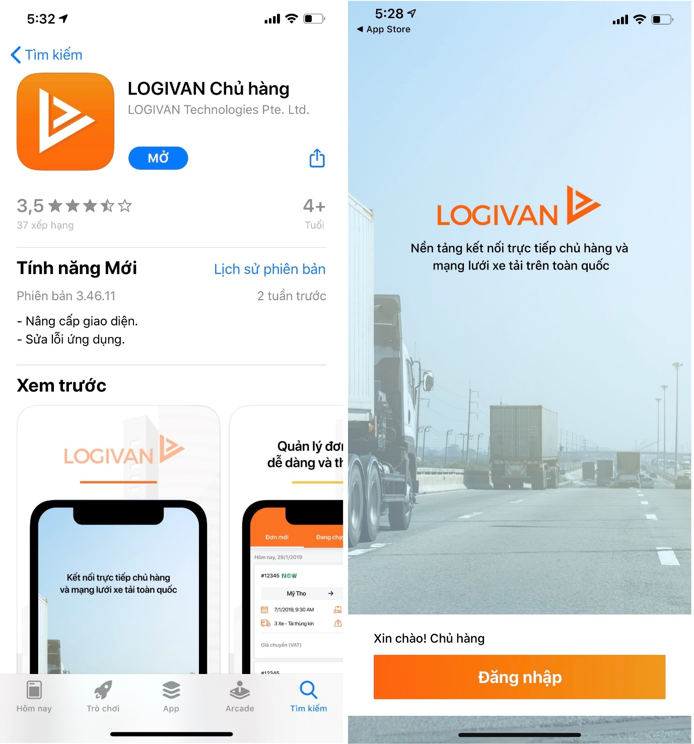

### 1.5.3 Competitor Analysis

|  |  |  |  |
| --- | --- | --- | --- |
|  | **CRuM** | **VTHN** | **Logivan** |
| Connect uses automatically | **Yes** | **No** | **Yes** |
| Bid opening | **Yes** | **No** | **Yes** |
| Connecting goods owner with container | **Yes** | **Yes** | **No** |

Table 1.2 Competitor analysis

* 1. **Proposed Solution**
     1. Solution Description

Creating a marketplace platform which is aimed at connecting goods owners and Empty container ones. It is able to help goods owners connect to the nearest empty containers, as well as make containers always be filled with goods, thus minimizing the case of empty containers returning to the port.

* + 1. System Actor

|  |  |  |
| --- | --- | --- |
| **No** | **Actor** | **Actor Description** |
| 1 | Merchant | The goods owner is looking for a container to export. |
| 2 | Forwarder | Container owners are looking for merchant who has the goods to optimize their empty containers. |
| 3 | Admin | System function manager |
| 4 | Moderator | System operator |
| 5 | Driver | The driver is the staff of the forwarder, the driver of the shipping container |
| 6 | Shipping line | Container shell owner. |
| 7 | Guest | User has not registered to join the system |

Table 1.3 System actor

* + 1. System function

Basic function: Login, Logout

|  |  |  |
| --- | --- | --- |
| **No** | **Actor** | **Function** |
| 1 | Guest | Register. |
| 2 | Merchant | Create/edit/delete outbound, open bidding, payment. |
| 3 | Forwarder | Create/edit/delete inbound, participate in bidding, payment. |
| 4 | Driver | Update shipping info, receive orders combined. |
| 5 | Shipping line | Receive notification of borrowing a container shell |
| 6 | Admin | Manage Admin/ Moderator/ Role/ Permission. |
| 7 | Moderator | Manage Registration form/ Report/ Shipping line/ Container type/ Port. |

Table 1.4 System fuction

* + 1. Out of scope

Due to time constraints, the following features are not included in the initial publishing of the project, but not permanently excluded, and will be developed in future versions of the project

# **2. Software Project Management Plan**

## **2.1. Problem Definition**

### 2.1.1. Name of this Capstone Project

* Container Round-use Marketplace.
* Chợ trao đổi container rỗng.

### 2.1.2. Problem Abstract

These days, the transport of goods in containers is becoming more and more popular. About 200 million containers are taken advantages of transporting goods every year. It is not deniable that container transport plays a vital role because of its safety, fastness and convenience.

It still exists a numerous of drawbacks; however, especially there is no assurance the close-knit interaction between cargo owners and container owners. As a result, it is difficult to be flexible in shipments. For example, it is common that an empty container is returned to a container yard empty after its cargo has been delivered to the destination. The transportation cost (labor costs and fuel costs, etc.) of returning an empty container is added to the entire service fee in general. This process results in the waste of hundreds of thousands of kilometres of one way, millions of dollars and releasing a lot of emissions from vehicles causing air pollution.

### 2.1.3. Project Overview

2.1.3.1. The Current System

* Meet, work, communicate directly or via email, phone, texting through the messaging software contact.

2.1.3.2. The Proposed System

* Create a platform to connect merchant and forwarder. Merchant can go to the website to post an outbound information to find forwarder and vice versa, forwarder can post an inbound information about their container, vehicle to find coincidence merchant.
* After merchant post their outbound information, they will create a bidding and send the bidding document (Hồ sơ mời thầu) information to the forwarders and the forwarder can send his bids to bid for orders.

2.1.3.3. Boundaries of the System

* System can be used by the user has registered and is verified by the operator with a smart phone, tablet or a laptop/ computer with Internet connection and browser.
  + All users can access the system via a browser with full functions by using a Laptop or PC.
  + Drivers can use the system's certain functions by smartphones The main language system using is Vietnamese.
* The complete product includes:
  + Website for all user roles.
  + Phone interface for drivers

2.1.3.4. Development Environment

2.1.3.4.1. Hardware requirements

* Internet Connection
* Asus
  + Window 10
  + Intel core i7
  + RAM 8G
  + 1T Disk Space

2.1.3.4.2. Software requirements

* Eclipse v4.15.0
* Visual Studio v1.48.0
* Android Studio v4.0.1
* Github

## **2.2. Project organization**

### 2.2.1. Software Process Model

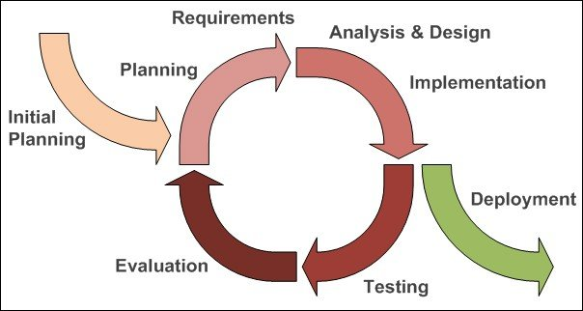

Figure 2.1 Iterative process model

More information: <https://en.wikipedia.org/wiki/Iterative_and_incremental_development>

### 2.2.2. Roles and Responsibilities

2.2.2.1 Organizational Structure

|  |  |
| --- | --- |
| **Role** | **Responsibility** |
| Project Manager | Planning, developing schedules, coordinating communication, generally responsible for keeping the team’s focus on the main goal. |
| Technical Leader | Responsible for choosing and deciding what technologies should be used, as well as for overseeing the work being done by other developers. |
| Quality Assurance Manager | Ensuring the product meets the certain standards of quality from requirements. |
| Developer | Involve in coding the product and reviewing code of other developers. |
| Designer | Involve in designing the product’s user interface. |
| Test Leader | Involve in testing the product. Reviewing software requirements and preparing test scenarios. Preparing reports on all aspects related to the software testing carried out and reporting to the design team. |
| Tester | Involve in testing the product. |
| Business Analyst -  Requirement Analyst | Eliciting requirement, analyzing and documenting requirements, communicate requirements, identifying solution and verifying solution meets the requirements. Outline the system’s functionality. |

Table 2.1 Organizational structure

2.2.2.2 Project Team member

|  |  |
| --- | --- |
| **Team member** | **Role** |
| Nghiem Thi Lan Phuong | Supervisor |
| Nguyen Van An | Project manager, Technical Leader, Designer, BA, Quality Assurance Manager |
| Nguyen Van Quyen | Developer, Tester |
| Nguyen Duc Duong | Developer, BA |
| Khong Quang Minh | Developer, BA, Tester, Designer |
| Dao Luong Duy | Developer, Designer, Test Leader |

Table 2.2 Project team member

### 2.2.3. Tools and Techniques

|  |  |  |
| --- | --- | --- |
| **Category** | **Tools & Technique** | **Detail** |
| General | Git | Github |
| Backend | Springboot | Springboot framework, Maven, Security |
|  | Hibernate | HQL |
|  | MySQL |  |
|  | RestAPI | JWT, CRUD, Json |
|  | WebSocket | RabbitMQ |
|  | HTTP/HTTPs |  |
|  | Junit | Testing |
|  | Postman |  |
| Frontend | Vue | VueJS, VueX, Router, Vuetify |
|  | Json | Axios |
|  | SCSS |  |
|  | JavaScript | ES6 |
|  | Jest | Testing |

Table 2.3 Tools and technique

## **2.3. Project management plan**

### 2.3.1. Tasks:

2.3.1.1 Task-n:

* Description
* Deliverables
* Resources Needed
* Dependencies and Constraints
* Risks

### 2.3.2. All Meeting Minutes

All meeting minutes will be written following this template:

|  |  |  |  |
| --- | --- | --- | --- |
| **Meeting:** | Supervisor 1 | | |
| **Date of Meeting:** | 15/05/2020 | **Time:** | 20:00-22:30 |
| **Note Taker:** | NguyenDucDuong | **Location:** | Online <Skype> |
| 1. **Meeting Objective** | | | |
| 1, Getting acquainted between team members and supervisor.  2, Determine the project topic. | | | |
| 1. **Attendance** | | | |
| **Name** | **Roles** | **E-mail** | **Phone** |
| Nghiem Thi Lan Phuong | Supervisor | phuongntl@fpt.edu.vn | 0989376681 |
| Nguyen Van An | Leader | [annvse05589@fpt.edu.vn](mailto:annvse05589@fpt.edu.vn) | 0967390098 |
| Nguyen Van Quyen | Team Member | [quyennvse04772@fpt.edu.vn](mailto:quyennvse04772@fpt.edu.vn) | 0965697976 |
| Nguyen Duc Duong | Team Member | [duongndse05132@fpt.edu.vn](mailto:duongndse05132@fpt.edu.vn) | 0352321262 |
| Khong Quang Minh | Team Member | [minhkqse05575@fpt.edu.vn](mailto:minhkqse05575@fpt.edu.vn) | 0915495698 |
| Dao Luong Duy | Team Member | [duydlse06128@fpt.edu.vn](mailto:duydlse06128@fpt.edu.vn) | 0359049292 |
| 1. **Tasks Done** | | | |
| 1, Determine the project theme and objectives.  2, A brief understanding of the project process.  3, Assignment of work.  4, Determine weekly meeting schedule | | | |
| 1. **To-do Tasks** | | | |
| 1, Determination of Customers  2, Market research | | | |
| 1. **Difficulty** | | | |
|  | | | |

Table 2.4 Meeting minute report 1

|  |  |  |  |
| --- | --- | --- | --- |
| **Meeting:** | Supervisor 2 | | |
| **Date of Meeting:** | 20/05/2020 | **Time:** | 15:00-17:00 |
| **Note Taker:** | NguyenDucDuong | **Location:** | Online <Skype> |
| 1. **Meeting Objective** | | | |
| 1, Estimate workload  2, Calculate the team's effort | | | |
| 1. **Attendance** | | | |
| **Name** | **Roles** | **E-mail** | **Phone** |
| Nghiem Thi Lan Phuong | Supervisor | phuongntl@fpt.edu.vn | 0989376681 |
| Nguyen Van An | Leader | [annvse05589@fpt.edu.vn](mailto:annvse05589@fpt.edu.vn) | 0967390098 |
| Nguyen Van Quyen | Team Member | [quyennvse04772@fpt.edu.vn](mailto:quyennvse04772@fpt.edu.vn) | 0965697976 |
| Nguyen Duc Duong | Team Member | [duongndse05132@fpt.edu.vn](mailto:duongndse05132@fpt.edu.vn) | 0352321262 |
| Khong Quang Minh | Team Member | [minhkqse05575@fpt.edu.vn](mailto:minhkqse05575@fpt.edu.vn) | 0915495698 |
| Dao Luong Duy | Team Member | [duydlse06128@fpt.edu.vn](mailto:duydlse06128@fpt.edu.vn) | 0359049292 |
| 1. **Tasks Done** | | | |
|  | | | |
| 1. **To-do Tasks** | | | |
| 1, Estimate workload  2, Calculate the team's effort | | | |
| 1. **Difficulty** | | | |
|  | | | |

Table 2.5 Meeting minute report 2

|  |  |  |  |
| --- | --- | --- | --- |
| **Meeting:** | Supervisor 3 | | |
| **Date of Meeting:** | 21/05/2020 | **Time:** | 15:00-17:00 |
| **Note Taker:** | NguyenDucDuong | **Location:** | Online <Skype> |
| 1. **Meeting Objective** | | | |
| 1, Guidelines for estimating workload  2, Define the process | | | |
| 1. **Attendance** | | | |
| **Name** | **Roles** | **E-mail** | **Phone** |
| Nghiem Thi Lan Phuong | Supervisor | phuongntl@fpt.edu.vn | 0989376681 |
| Nguyen Van An | Leader | [annvse05589@fpt.edu.vn](mailto:annvse05589@fpt.edu.vn) | 0967390098 |
| Nguyen Van Quyen | Team Member | [quyennvse04772@fpt.edu.vn](mailto:quyennvse04772@fpt.edu.vn) | 0965697976 |
| Nguyen Duc Duong | Team Member | [duongndse05132@fpt.edu.vn](mailto:duongndse05132@fpt.edu.vn) | 0352321262 |
| Khong Quang Minh | Team Member | [minhkqse05575@fpt.edu.vn](mailto:minhkqse05575@fpt.edu.vn) | 0915495698 |
| Dao Luong Duy | Team Member | [duydlse06128@fpt.edu.vn](mailto:duydlse06128@fpt.edu.vn) | 0359049292 |
| 1. **Tasks Done** | | | |
| 1, Calculate the team’s effort | | | |
| 1. **To-do Tasks** | | | |
| 1, Estimate workload  2, Calculate the team's effort | | | |
| 1. **Difficulty** | | | |
|  | | | |

Table 2.6 Meeting minute report 3

|  |  |  |  |
| --- | --- | --- | --- |
| **Meeting:** | Supervisor 4 | | |
| **Date of Meeting:** | 31/05/2020 | **Time:** | 9:00 – 11:30 |
| **Note Taker:** | NguyenDucDuong | **Location:** | Outside |
| 1. **Meeting Objective** | | | |
| 1, Idea analysis  2, Identify and review technology | | | |
| 1. **Attendance** | | | |
| **Name** | **Roles** | **E-mail** | **Phone** |
| Nghiem Thi Lan Phuong | Supervisor | phuongntl@fpt.edu.vn | 0989376681 |
| Nguyen Van An | Leader | [annvse05589@fpt.edu.vn](mailto:annvse05589@fpt.edu.vn) | 0967390098 |
| Nguyen Van Quyen | Team Member | [quyennvse04772@fpt.edu.vn](mailto:quyennvse04772@fpt.edu.vn) | 0965697976 |
| Nguyen Duc Duong | Team Member | [duongndse05132@fpt.edu.vn](mailto:duongndse05132@fpt.edu.vn) | 0352321262 |
| Khong Quang Minh | Team Member | [minhkqse05575@fpt.edu.vn](mailto:minhkqse05575@fpt.edu.vn) | 0915495698 |
| Dao Luong Duy | Team Member | [duydlse06128@fpt.edu.vn](mailto:duydlse06128@fpt.edu.vn) | 0359049292 |
| 1. **Tasks Done** | | | |
| 1, Idea analysis  2, Identify and review technology | | | |
| 1. **To-do Tasks** | | | |
| 1, Drawing UML Class Diagram | | | |
| 1. **Difficulty** | | | |
|  | | | |

|  |  |  |  |
| --- | --- | --- | --- |
| **Meeting:** | Supervisor 5 | | |
| **Date of Meeting:** | 06/06/2020 | **Time:** | 15:00-16:00 |
| **Note Taker:** | NguyenDucDuong | **Location:** | Outside |
| 1. **Meeting Objective** | | | |
| 1, Review Technology  2, Review Class diagram | | | |
| 1. **Attendance** | | | |
| **Name** | **Roles** | **E-mail** | **Phone** |
| Nghiem Thi Lan Phuong | Supervisor | phuongntl@fpt.edu.vn | 0989376681 |
| Nguyen Van An | Leader | [annvse05589@fpt.edu.vn](mailto:annvse05589@fpt.edu.vn) | 0967390098 |
| Nguyen Van Quyen | Team Member | [quyennvse04772@fpt.edu.vn](mailto:quyennvse04772@fpt.edu.vn) | 0965697976 |
| Nguyen Duc Duong | Team Member | [duongndse05132@fpt.edu.vn](mailto:duongndse05132@fpt.edu.vn) | 0352321262 |
| Khong Quang Minh | Team Member | [minhkqse05575@fpt.edu.vn](mailto:minhkqse05575@fpt.edu.vn) | 0915495698 |
| Dao Luong Duy | Team Member | [duydlse06128@fpt.edu.vn](mailto:duydlse06128@fpt.edu.vn) | 0359049292 |
| 1. **Tasks Done** | | | |
|  | | | |
| 1. **To-do Tasks** | | | |
| 1, Drawing UML Class Diagram, Work flow 2, SRS document  3, Design frontend  4, Code backend | | | |
| 1. **Difficulty** | | | |
|  | | | |

Table 2.7 Meeting minute report 4

|  |  |  |  |
| --- | --- | --- | --- |
| **Meeting:** | Supervisor 6 | | |
| **Date of Meeting:** | 19/06/2020 | **Time:** | 15:00-16:00 |
| **Note Taker:** | NguyenDucDuong | **Location:** | Outside |
| 1. **Meeting Objective** | | | |
| 1, Demo code | | | |
| 1. **Attendance** | | | |
| **Name** | **Roles** | **E-mail** | **Phone** |
| Nghiem Thi Lan Phuong | Supervisor | phuongntl@fpt.edu.vn | 0989376681 |
| Nguyen Van An | Leader | [annvse05589@fpt.edu.vn](mailto:annvse05589@fpt.edu.vn) | 0967390098 |
| Nguyen Van Quyen | Team Member | [quyennvse04772@fpt.edu.vn](mailto:quyennvse04772@fpt.edu.vn) | 0965697976 |
| Nguyen Duc Duong | Team Member | [duongndse05132@fpt.edu.vn](mailto:duongndse05132@fpt.edu.vn) | 0352321262 |
| Khong Quang Minh | Team Member | [minhkqse05575@fpt.edu.vn](mailto:minhkqse05575@fpt.edu.vn) | 0915495698 |
| Dao Luong Duy | Team Member | [duydlse06128@fpt.edu.vn](mailto:duydlse06128@fpt.edu.vn) | 0359049292 |
| 1. **Tasks Done** | | | |
|  | | | |
| 1. **To-do Tasks** | | | |
| 1, Learning new technology 2, Coding backend & frontend | | | |
| 1. **Difficulty** | | | |
|  | | | |

Table 2.8 Meeting minute report 5

2.3.2.1 Unscheduled Meeting

To discuss an important issue which needs solving immediately, the group usually spends 30 to 60 minutes having a meeting via Meet.

2.3.2.2 Communication Channels

The main communication channel of our group are Facebook Messenger. Besides, we also use Skype and Meet for Video calls. Email and drive are taken advantages of storing document data, and a Facebook group is used to store and pin essential information.

2.3.2.3 Weekly Meeting Schedule

On every Sunday afternoon at 3 o'clock, the group will have face-to-face meeting with supervisor to review the work of the past weeks together as well as consider working speed and assignments for next week.

2.3.2.4 Daily Meeting Schedule

Every day the whole group will have 2 online meetings together. An optional session is at 15:00 and a meeting is required at 9pm. During the meeting, the members will work together and solve problems immediately. From there, improve work efficiency and product quality.

## **2.4. Coding Convention**

### 2.4.1 Coding convention

* Naming convention: Camel case (<https://viblo.asia/p/coding-conventions-va-cac-chuan-viet-code-trong-php-naQZRbrGZvx>)
* Java coding standart: <https://gpcoder.com/1775-tieu-chuan-coding-trong-java-coding-standards/>

### 2.4.2 Document convention

* Font family: Times New Roman.
* Basic font size: 12pt.
* Title font size: 14-16pt.
* Page header font size: 20pt.

## **2.5. Other material**

### 2.5.1 Risk Management Plan

The project manager works with the project team and guarantees that risks are actively identified, analyzed, and controlled throughout the life of the project. Risks will be identified as early as possible in the project so as to minimize their impact. The steps for achieving this are described in the following sections. The project manager will serve as the Risk Manager for this project.

### 2.5.2 Risk Register

|  |  |  |  |  |  |  |  |
| --- | --- | --- | --- | --- | --- | --- | --- |
| No | Rank | Name | Description | Probability | Impact | Prevention | Correction |
| 1 | 2 | Requirement changes | The scope may change; some requirements may be added | High | Medium | All member discuss carefully in the beginning of each iteration to define scope and requirements | Ensure resource allocation is modified correctly to adapt to new requirement |
| R2 | 6 | Illness or absence of team members | The number of members decreases and not enough for work | Medium | Low | Member has to notice to the team about absence period and the plan of how to keep up with the work process. | Ensure that the absence of a  member won’t affect others and always have plans to deal with this  problem |
| R3 | 1 | Conflict among team members | Team member disagree with others and refuse to work or work below  their ability | Medium | High | Define clear tasks and unify the opinion before starting tasks | All  members  discuss to resolve the conflict.  Voting. |
| R4 | 5 | New  technology | Require to study new  technology  to fulfill the requirement | Medium | Medium | Choosing technology based on member’s qualification. All team  members must nurture by selfstudy. | When someone  chooses a new technology, he/she has to explain to all team members about the decision. |
| R5 | 3 | Team member  distraction | Team member do not commit enough working time. | Medium | Medium | Choose member  carefully | PM  reminds team  member about timeline. |
| R6 | 4 | Internet connection is down | Internet connection is down and team members cannot submit work or merge code. | Low | Medium | All developers have to set up  the isolated development environment and have an offline copy of the documentation | Use  alternative ways to connect to the internet, such as: using VPN or 3G. |
| R7 | 7 | Lack of skill | Member is lack of  knowledge and skill to complete a particular task. | High | Medium | Form team early, choose technology stack wisely and training before starting the project. | Member informs team about lack of skill, other team  member support |
| R8 | 8 | Library used in project is no longer supported | A library is no longer maintained. | Low | High | Choose reputable library with  active maintenance on GitHub. | Choose  alternative libraries or code from scratch. |

Table 2.9 Risk register

### 2.5.3 Probability - Impact matrix

|  |  |  |  |  |  |
| --- | --- | --- | --- | --- | --- |
| Probability | High |  |  | R1, R7 |  |
| Medium | R2 |  | R4, R5 | R3 |
| Low |  |  | R6 | R8 |
|  | Low |  | Medium | High |
|  |  |  | Impact | |  |

Table 2.10 Probability

# **3. Software Requirements Specifications (SRS)**

## **3.1. User Requirement Specification**

|  |  |  |
| --- | --- | --- |
| **No.** | **User** | **Requirement** |
| 1 | Guest | View home page |
| Register as a Merchant or Forwarder |
| 2 | Supplier | Manage supply:   * Declare supply * View supply * Edit supply * Delete supply |
| View combined |
| View detail combined |
| 3 | Merchant | Open bidding (Mở đấu thầu) |
| View list of bidding document (Hồ sơ mời thầu) |
| View bidding document detail |
| Cancel the bidding document (Hồ sơ mời thầu) |
| See account receivable and payment |
| 4 | Forwarder | View bidding document (Hồ sơ mời thầu) |
| Submit bid |
| View the list of bids <xem danh sách hồ sơ dự thầu> |
| View bid detail |
| See account receivable and payment |
| Report bidding document (Hồ sơ mời thầu) |
| Rating feedback |
| Create contract file |
| 5 | Admin | Add new admin and moderator |
| Add new role |
| Add new permission |
| 6 | Driver | Login  - Include: Login verification  - Extend: Show login error |
| Logout |
| Receive orders combined |
| Update combined status |
| 7 | Shipping line | Receive notification of borrowing an empty container |
| 8 | Moderator | View application form |
| View report |
| Declare shipping line |
| Declare container type |
| Declare port |
| 9 | General | Login |
| Forgot password |
| Reset password |
| Change password |
| Logout |

Table 3.1 Use case requirement

## **3.2. System Requirement Specification (Specific Requirements)**

### 3.2.1. External Interface Requirements

3.2.1.1. User Interfaces

* Interface should be clear, easy to understand and easy to use.
* Errors and warnings should be clear, easy to understand, do not obstruct and make users uncomfortable when using the system.
* The icon is clear, clear, and does not make the user confused when using it.
* Break down the steps for a complex action for a better user experience.

3.2.1.2. Hardware Interfaces

* System will use the standard hardware.

3.2.1.3. Software Interfaces

* Runs with browsers that support JavaScript and HTML5.

3.2.1.4. Communications Protocol

* Google API.

### 3.2.2. System Features

3.2.2.1. Use Case Diagram

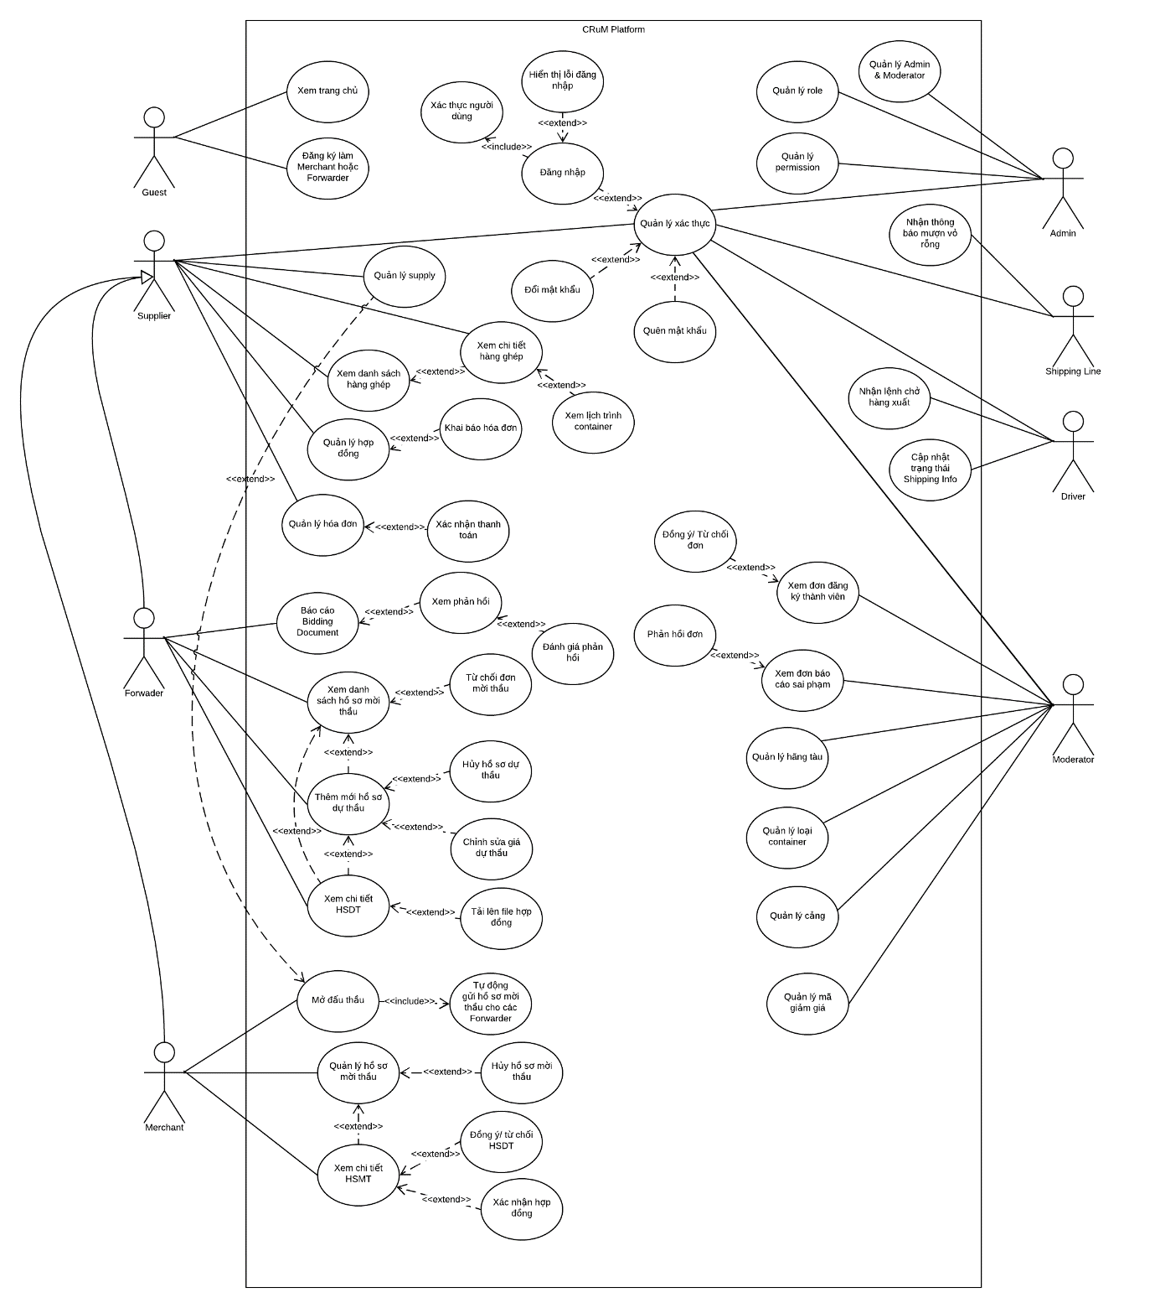

Figure 3.1 Use case diagram

Please refer to

the below website for more details:

<https://app.lucidchart.com/documents/edit/fa47289c-0de5-4075-8806-9fbe1624c69a/bO0hIHyQfgRm?shared=true&fbclid=IwAR0XTwtKGRnv8mOqn6_5LRryORK1-tZanuRk4jJs3IFQ0Xq4D9LVRBRjQT4>

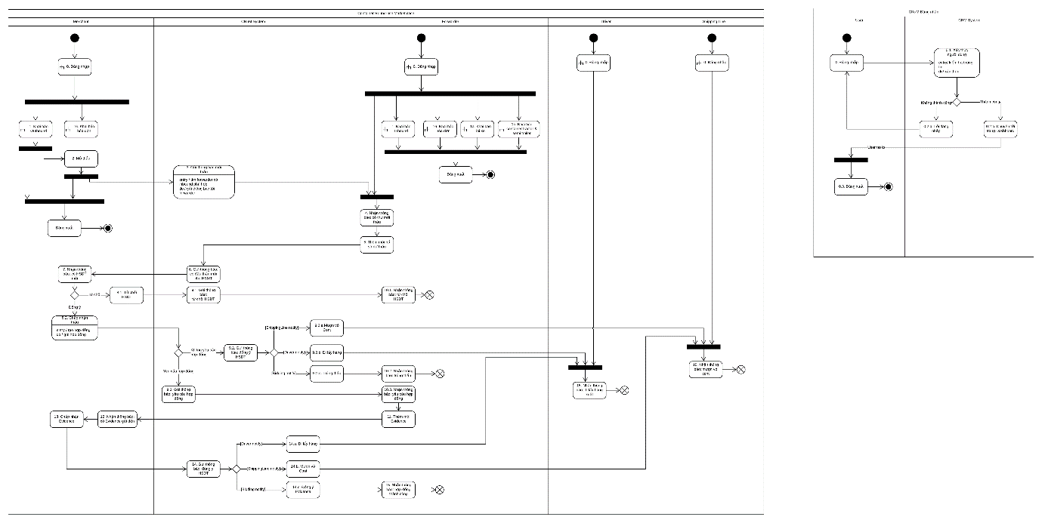

Figure 3.2 State diagram

Please refer to

the below website for more details:

<https://app.lucidchart.com/documents/edit/87aca837-469a-4cbc-a366-b0c802754031/-Ggi06TlVql0?shared=true&existing=1&token=35e3eb07da01278379da8fa193cc2c7a005d1d0a-eml%3Dduongndse05132%2540fpt.edu.vn%26ts%3D1596105282228%26uid%3D124960291&docId=87aca837-469a-4cbc-a366-b0c802754031>

3.2.2.2 Use Case Specification

3.2.2.2.1 Guest use case.

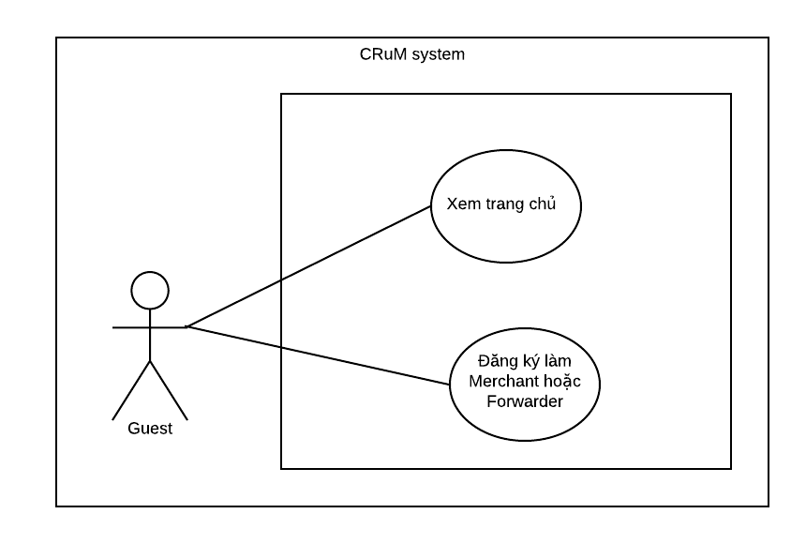

Figure 3.3 Guest usecase

|  |  |  |  |  |
| --- | --- | --- | --- | --- |
| **USE CASE-CRUM-GU-01 SPECIFICATION** | | | | |
| **Use-case No.** | CRUM-GU-01 | **Use-case Version** | 1.0 |
| **Use-case Name** | View Homepage | | |
| **Author** | Nguyen Duc Duong | | |
| **Date** | 27/05/2020 | **Priority** | Normal |
| **Actor:**  *Guest*  **Summary:**  *This use case allows guest to view homepage.*  **Goal:**  *Guest will be able to view the homepage to learn about the system information*  **Triggers:**  *Guest wants to find out system information.*  **Preconditions:**  *Internet connection.*  **Post Conditions:**  *Success: Guest successfully accesses the home page and sees the information at the home page.*  **Main Success Scenario:**     |  |  |  | | --- | --- | --- | | Step | Actor Action | System Response | | 1 | The user accesses the homepage link | Show homepage |   **Alternative Scenario:**  *N/A*  **Exceptions:**   |  |  |  | | --- | --- | --- | | No | Actor Action | System Response | | 1 | The user has accessed the wrong link to the homepage | Homepage not displayed |     **Business Rules:**  *N/A* | | | |

|  |  |  |  |  |
| --- | --- | --- | --- | --- |
| **USE CASE-CRUM-GU-02 SPECIFICATION** | | | | |
| **Use-case No.** | CRUM-GU-02 | **Use-case Version** | 1.0 |
| **Use-case Name** | Register to become Merchant | | |
| **Author** | Nguyen Duc Duong | | |
| **Date** | 27/05/2020 | **Priority** | Normal |
| **Actor:**  *Guest*  **Summary:**  *This use case allows guest to register to become merchant to be able to rent a container for the export of goods.*  **Goal:**  *The guest has successfully submitted the merchant application to the moderator for review.*  **Triggers:**  *Guest wants to become merchant, join the system to be able to use function.*  **Preconditions:**  *Guest visit homepage.*  **Post Conditions:**  *Success: Application form is sent to moderator.*  **Main Success Scenario:**     |  |  |  | | --- | --- | --- | | Step | Actor Action | System Response | | 1 | Click on button “ĐĂNG KÝ” on right conner of the homepage | Navigate to “Đăng ký tài khoản” page which contained 3 portion:   * Đăng ký tài khoản. * Thông tin chủ hàng. * Hoàn thành.   At portion 1 “Đăng ký tài khoản” contained:   * Tên đăng nhập: username. * Mật khẩu: password * Ratio button: * Đăng ký làm chủ xe * Đăng ký làm chủ hàng * Email * Số điện thoại * Địa chỉ * Button “TIẾP TỤC” | | 2 | Guest fills all Information, chooses “Đăng ký làm chủ hàng” and clicks button “TIẾP TỤC” | Portion 2 (Thông tin chủ hàng) is expanded and contained:   * Mã công ty * Tên công ty * Người liên hệ * Website * Tin * Fax * Mô tả * Địa chỉ công ty * Button “TIẾP TỤC” and “QUAY LẠI” | | 3 | Guest fills all information and click button “TIẾP TỤC” | Portion 3 (Hoàn thành) is expanded and contained:   * Checkbox: Bạn đồng ý rằng tất cả các thông tin đưa lên đều là chính xác. * Button “Hoàn tất” and “QUAY LẠI” | | 4 | Check on checkbox and click “Hoàn tẤt” | Show notification “Đăng ký thành công” and navigate to home page |   **Alternative Scenario:**   |  |  |  | | --- | --- | --- | | Step | Actor Action | System Response | | 1 | Click on button “ĐĂNG NHẬP” on right conner of the homepage. | Navigate to “Đăng nhập” page which contained:   * Tên đăng nhập * Mật khẩu * Link “Quên mật khẩu” and “Đăng ký” * Button “ĐĂNG NHẬP” | | 2 | Click on link “Đăng ký” | Navigate to “Đăng ký tài khoản” page which contained 3 portion:   * Đăng ký tài khoản * Thông tin chủ xe * Hoàn thành | | 4 | Follow step 2-3-4 on Main Success scenario |  |  |  |  |  | | --- | --- | --- | | Step | Actor Action | System Response | | 1 | Click on button “ĐĂNG NHẬP NGAY” on middle of the homepage. | Navigate to “Đăng nhập” page which contained:   * Tên đăng nhập * Mật khẩu * Link “Quên mật khẩu” and “Đăng ký” | | 2 | Click on link “Đăng ký” | Navigate to “Đăng ký tài khoản” page which contained 3 portion:   * Đăng ký tài khoản * Thông tin chủ xe * Hoàn thành | | 4 | Follow step 2-3-4 on Main Success scenario |  |   **Extension Flows:**   |  |  |  | | --- | --- | --- | | ET1 | At step 3 | | | No | Actor Action | System Response | | 1 | Click on button “QUAY LẠI” | Back to portion 1: Đăng ký tài khoản |  |  |  |  | | --- | --- | --- | | ET2 | At step 4 | | | No | Actor Action | System Response | | 1 | Click on button “QUAY LẠI” | Back to portion 2: Thông tin chủ hàng |   **Exceptions:**     |  |  |  | | --- | --- | --- | | No | Actor Action | System Response | | 1 | Duplicate user | Show notification user already existed |   **Business Rules:**  *BI-1, BI-2, BI-3, BI-4, BI-5* | | | |

|  |  |  |  |  |
| --- | --- | --- | --- | --- |
| **USE CASE-CRUM-GU-03 SPECIFICATION** | | | | |
| **Use-case No.** | CRUM-GU-03 | **Use-case Version** | 1.0 |
| **Use-case Name** | Register to become Forwarder | | |
| **Author** | Nguyen Duc Duong | | |
| **Date** | 27/05/2020 | **Priority** | Normal |
| **Actor:**  *Guest.*  **Summary:**  *This use case allows guest to register to become forwarder to find goods to optimize empty containers.*  **Goal:**  *Guest has successfully submitted the forwarder application to the moderator for review.*  **Triggers:**  *Guest wants to become forwarder, join the system to be able to use function.*  **Preconditions:**  *Guest visit homepage.*  **Post Conditions:**  *Success: Application form is sent to moderator.*  **Main Success Scenario:**     |  |  |  | | --- | --- | --- | | Step | Actor Action | System Response | | 1 | Click on button “ĐĂNG KÝ” on right conner of the homepage | Navigate to “Đăng ký tài khoản” page which contained 3 portion:   * Đăng ký tài khoản * Thông tin chủ xe * Hoàn thành   At portion 1 “đăng ký tài khoản” contained:   * Tên đăng nhập * Mật khẩu * Ratio button: * Đăng ký làm chủ xe * Đăng ký làm chủ hàng * Email * Số điện thoại * Địa chỉ * Button “TIẾP TỤC” | | 2 | Guest fills all information, chooses “Đăng ký làm chủ xe” and clicks button “TIẾP TỤC” | Portion 2 (Thông tin chủ hàng) is expanded and contained:   * Mã công ty * Tên công ty * Người liên hệ * Website * Tin * Fax * Mô tả * Địa chỉ công ty * Button “TIẾP TỤC” and “QUAY LẠI” | | 3 | Guest fill all information, clicks button “TIẾP TỤC” | Portion 3 (Hoàn thành) is expanded and contained:   * Checkbox: Bạn đồng ý rằng tất cả các thông tin đưa lên đều là chính xác. * Button “Hoàn tất” and “QUAY LẠI” | | 4 | Guest checks on checkbox and clicks button “Hoàn tất” | Show notification “Đăng ký thành công” and navigate to homepage |   **Alternative Scenario:**   |  |  |  | | --- | --- | --- | | Step | Actor Action | System Response | | 1 | Click on button “ĐĂNG NHẬP” on right conner of the homepage. | Navigate to “Đăng nhập” page which contained:   * Tên đăng nhập * Mật khẩu * Link “Quên mật khẩu” and “Đăng ký” * Button “ĐĂNG NHẬP” | | 2 | Click on link “Đăng ký” | Navigate to “Đăng ký tài khoản” page which contained 3 portion:   * Đăng ký tài khoản * Thông tin chủ xe * Hoàn thành | | 4 | Follow step 2-3-4 on Main Success scenario |  |  |  |  |  | | --- | --- | --- | | Step | Actor Action | System Response | | 1 | Click on button “ĐĂNG NHẬP NGAY” on middle of the homepage. | Navigate to “Đăng nhập” page which contained:   * Tên đăng nhập * Mật khẩu * Link “Quên mật khẩu” and “Đăng ký” | | 2 | Click on link “Đăng ký” | Navigate to “Đăng ký tài khoản” page which contained 3 portion:   * Đăng ký tài khoản * Thông tin chủ xe * Hoàn thành | | 4 | Follow step 2-3-4 on Main Success scenario |  |   **Extension Flows:**   |  |  |  | | --- | --- | --- | | ET1 | At step 4 | | | No | Actor Action | System Response | | 1 | Click on “QUAY LẠI” | Back to portion 1: Đăng ký tài khoản |  |  |  |  | | --- | --- | --- | | ET2 | At step 5 | | | No | Actor Action | System Response | | 1 | Click on “QUAY LẠI” | Back to portion 2: Thông tin chủ hàng |   **Exceptions:**     |  |  |  | | --- | --- | --- | | No | Actor Action | System Response | | 1 | Duplicate user | Show notification user already existed |   **Business Rules:**  *BI-1, BI-2, BI-3, BI-4.* | | | |

3.2.2.2.2 General use case to all users

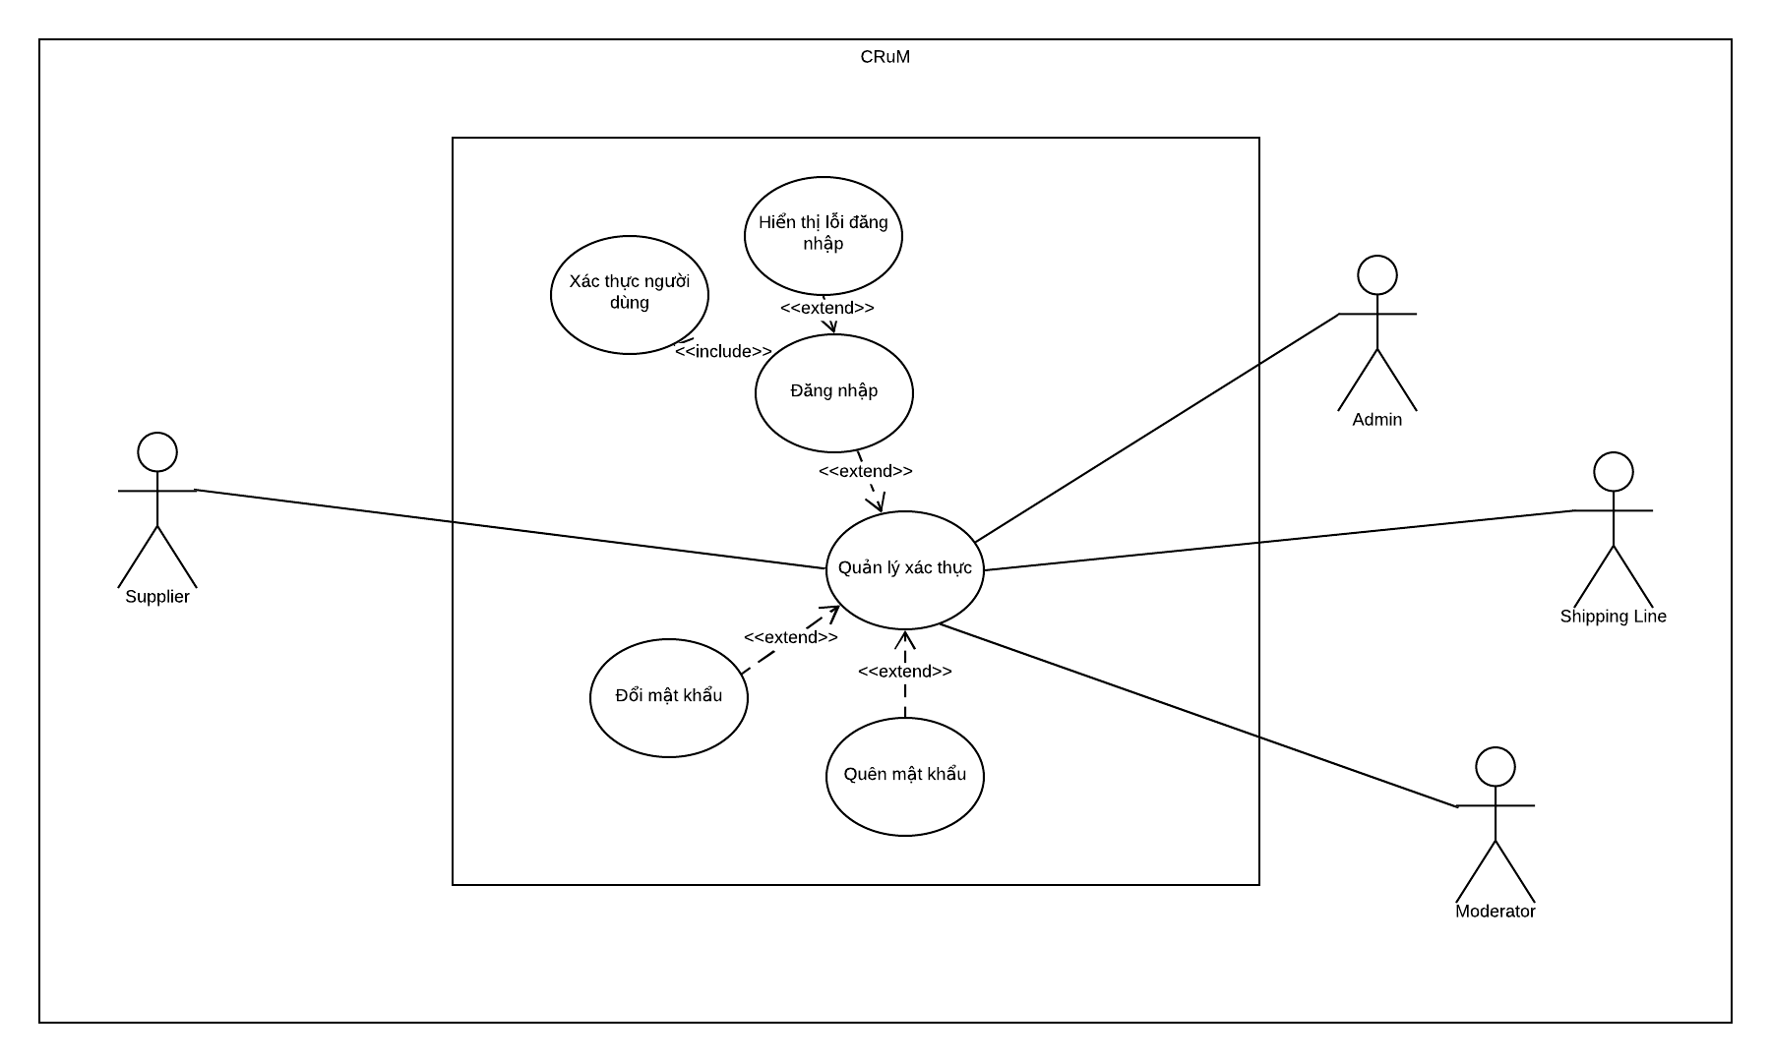

Figure 3.4 General usecase

|  |  |  |  |  |
| --- | --- | --- | --- | --- |
| **USE CASE-CRUM-ALL-01 SPECIFICATION** | | | | |
| **Use-case No.** | CRUM-ALL-01 | **Use-case Version** | 1.0 |
| **Use-case Name** | Login | | |
| **Author** | Nguyen Duc Duong | | |
| **Date** | 27/05/2020 | **Priority** | Normal |
| **Actor:**  *Supplier (Merchant, Forwarder), Admin, Shipping Line.*  **Summary:**  *This use case allows users to be able to log in to the system and use the functions.*  **Goal:**  *Users can access the system and use functions based on user roles.*  **Triggers:**  *Users want to use the functions of the system.*  **Preconditions:**  *User has registered.*  *The account has been authorized.*  *User's device is connected to the internet.*  **Post Conditions:**  *Success: Users can access the dashboard and use functions of the system.*  **Main Success Scenario:**     |  |  |  | | --- | --- | --- | | Step | Actor Action | System Response | | 1 | Click on button “ĐĂNG NHẬP” on right conner of the homepage | Navigate to “Đăng nhập” page which contained:   * Tên đăng nhập: username. * Mật khẩu: password. * Button “ĐĂNG NHẬP” * Link “Quên mật khẩu” and “Đăng ký” | | 2 | Fill “Tên đăng nhập” and “Mật khẩu” with registed account and click button “Đăng nhập”. | Navigate to Dashboard page. |   **Alternative Scenario:**     |  |  |  | | --- | --- | --- | | Step | Actor Action | System Response | | 1 | Click on button “ĐĂNG NHẬP NGAY” on the middle of the homepage | Show box “Đăng nhập” which contained:   * Tên đăng nhập: username. * Mật khẩu: password. * Button “ĐĂNG NHẬP” * Link “Quên mật khẩu” and “Đăng ký” | | 2 | Fill “Tên đăng nhập” and “Mật khẩu” with registed account and click button “Đăng nhập”. | Navigate to Dashboard page. |   **Extension Flows:**   |  |  |  | | --- | --- | --- | | ET1 | At step 1 | | | Step | Actor Action | System Response | | 1 | Click on “Đăng ký” | Navigate to “Đăng ký tài khoản” |  |  |  |  | | --- | --- | --- | | ET1 | At step 1 | | | No | Actor Action | System Response | | 1 | Click on “Quên mật khẩu” | Navigate to “Quên mật khẩu” page. |   **Exceptions:**     |  |  |  | | --- | --- | --- | | No | Actor Action | System Response | | 1 | Enter wrong “Tên đăng nhập” or “Password” | Show notification wrong username or password. | | 2 | Login session lasts about 1 day | After 1 day notification the login session is expired and ask the user to login again. |   **Business Rules:**  *BR-4, BI-1.* | | | |

|  |  |  |  |  |
| --- | --- | --- | --- | --- |
| **USE CASE-CRUM-ALL-02 SPECIFICATION** | | | | |
| **Use-case No.** | CRUM-ALL-02 | **Use-case Version** | 1.0 |
| **Use-case Name** | Logout | | |
| **Author** | Nguyen Duc Duong | | |
| **Date** | 27/05/2020 | **Priority** | Normal |
| **Actor:**  *Supplier (Merchant, Forwarder), Admin, Shipping Line.*  **Summary:**  *Allow users to logout from the system.*  **Goal:**  *User can logout of the current account*  **Triggers:**  *Users want to logout of the current account*  **Preconditions:**  *User has registered.*  *User already login*  *User's device is connected to the internet.*  **Post Conditions:**  *Success: Users can logout of the current*  **Main Success Scenario:**     |  |  |  | | --- | --- | --- | | Step | Actor Action | System Response | | 1 | Click username on right conner of the menubar | Show list:   * Trang cá nhân * Đổi mật khẩu * Đăng xuất | | 2 | Click on button “Đăng xuất” | Navigate to “Đăng nhập” page which contained:   * Tên đăng nhập: username. * Mật khẩu: password. * Checkbox “Ghi nhớ đăng nhập” * Link “Quên mật khẩu” * Button: “Đăng nhập” and “QUÊN MẬT KHẨU” |   **Alternative Scenario:**     |  |  |  | | --- | --- | --- | | No | Actor Action | System Response | | 1 | Click on button “ĐĂNG XUẤT” at bottom of menubar | Navigate to “Đăng nhập” page which contained:   * Tên đăng nhập: username. * Mật khẩu: password. * Checkbox “Ghi nhớ đăng nhập” * Link “Quên mật khẩu”   Button: “Đăng nhập” and “QUÊN MẬT KHẨU” |   **Extension Flows:**   |  |  |  | | --- | --- | --- | | ET1 | At step 3 | | | Step | Actor Action | System Response | | 1 | Click on “Đăng ký” | Navigate to “Đăng ký tài khoản” |   **Exceptions:**  *N/A*  **Business Rules:**  *BR-4, BI-1.* | | | |

|  |  |  |  |  |
| --- | --- | --- | --- | --- |
| **USE CASE-CRUM-ALL-03 SPECIFICATION** | | | | |
| **Use-case No.** | CRUM-ALL-03 | **Use-case Version** | 1.0 |
| **Use-case Name** | Change password | | |
| **Author** | Nguyen Duc Duong | | |
| **Date** | 27/05/2020 | **Priority** | Normal |
| **Actor:**  *Supplier (Merchant, Forwarder), Admin, Shipping Line, Driver.*  **Summary:**  *Allow users to change account password.*  **Goal:**  *User can login with new password.*  **Triggers:**  *Users want to change password*  **Preconditions:**  *User has registered.*  *User already login*  *User's device is connected to the internet.*  **Post Conditions:**  *Success: User can login with new password*  **Main Success Scenario:**     |  |  |  | | --- | --- | --- | | Step | Actor Action | System Response | | 1 | Click username on right conner of the menubar | Show list:   * Trang cá nhân * Đổi mật khẩu * Đăng xuất | | 2 | Click on button “Đổi mật khẩu” | Navigate to “Đổi mật khẩu” page which contained:   * Mật khẩu cũ * Mật khẩu mới * Nhập lại mật khẩu * Link: “Trang chủ” * Button: “THAY ĐỔI” | | 3 | User fills all information and click “THAY ĐỔI” | Show notification: “Thay đổi mật khẩu thành công” and navigate to Dashboard page. |   **Alternative Scenario:**  *N/A*  **Extension Flows:**   |  |  |  | | --- | --- | --- | | ET1 | At step 3 | | | Step | Actor Action | System Response | | 1 | Click on “Trang chủ” | Navigate to homepage |   **Exceptions:**  *N/A*  **Business Rules:**  *BR-4, BI-1.* | | | |

|  |  |  |  |  |
| --- | --- | --- | --- | --- |
| **USE CASE-CRUM-ALL-04 SPECIFICATION** | | | | |
| **Use-case No.** | CRUM-ALL-04 | **Use-case Version** | 1.0 |
| **Use-case Name** | Forgot password | | |
| **Author** | Nguyen Duc Duong | | |
| **Date** | 27/05/2020 | **Priority** | Normal |
| **Actor:**  *Supplier (Merchant, Forwarder), Admin, Shipping Line, Driver.*  **Summary:**  *Allow users to receive email to change password.*  **Goal:**  *User can receive mail to change password.*  **Triggers:**  *Users forgot password*  **Preconditions:**  *User exits*  *The email must be the email used to register for the account*  *User's device is connected to the internet.*  **Post Conditions:**  *Success: User can receive mail to change password*  **Main Success Scenario:**     |  |  |  | | --- | --- | --- | | Step | Actor Action | System Response | | 1 | Click on button “ĐĂNG NHẬP” on right conner of the homepage | Navigate to “Đăng nhập” page which contained:   * Tên đăng nhập: username. * Mật khẩu: password. * Button “ĐĂNG NHẬP” * Link “Quên mật khẩu” and “Đăng ký” | | 2 | Click on “Quên mật khẩu” | Navigate to “Quên mật khẩu” page contained:   * Địa chỉ email * Link “Đã nhớ mật khẩu” * Button “gửi vào email” | | 3 | User enters email and clicks “GỬI VÀO EMAIL” | Show notification: “Tạo đường dẫn cài lại mật khẩu thành công, xin hãy kiểm tra lại email” |   **Alternative Scenario:**  *N/A*  **Extension Flows:**   |  |  |  | | --- | --- | --- | | ET1 | At step 3 | | | Step | Actor Action | System Response | | 1 | Click on “Đã nhớ mật khẩu” | Navigate to login page |   **Exceptions:**  *N/A*  **Business Rules:**  *BR-4, BI-1.* | | | |

|  |  |  |  |  |
| --- | --- | --- | --- | --- |
| **USE CASE-CRUM-ALL-05 SPECIFICATION** | | | | |
| **Use-case No.** | CRUM-ALL-05 | **Use-case Version** | 1.0 |
| **Use-case Name** | Reset password | | |
| **Author** | Nguyen Duc Duong | | |
| **Date** | 27/05/2020 | **Priority** | Normal |
| **Actor:**  *Supplier (Merchant, Forwarder), Admin, Shipping Line, Driver.*  **Summary:**  *Allow users to reset password when user forgot password.*  **Goal:**  *User can reset password and login with new password.*  **Triggers:**  *Users receive email to reset password*  **Preconditions:**  *User exits*  *The email must be the email used to register for the account.*  *Reset password email received to user.*  *User's device is connected to the internet.*  **Post Conditions:**  *Success: User can reset password and login with new password.*  **Main Success Scenario:**     |  |  |  | | --- | --- | --- | | Step | Actor Action | System Response | | 1 | The user clicks on the password reset link that the system sends to the user | Navigate to “Đặt lại mật khẩu” page which contained:   * Mật khẩu mới * Nhập lại Mật khẩu * Link “TRANG CHỦ” * Button “THAY ĐỔI” | | 2 | User enters new password and click “THAY ĐỔI” | Show notification: “Thay đổi mật khẩu thành công”.  Navigate to homepage |   **Alternative Scenario:**  *N/A*  **Extension Flows:**   |  |  |  | | --- | --- | --- | | ET1 | At step 2 | | | Step | Actor Action | System Response | | 1 | Click on “TRANG CHỦ” | Navigate to homepage |   **Exceptions:**  *N/A*  **Business Rules:**  *BR-4, BI-1.* | | | |

3.2.2.2.3 Supplier use case.

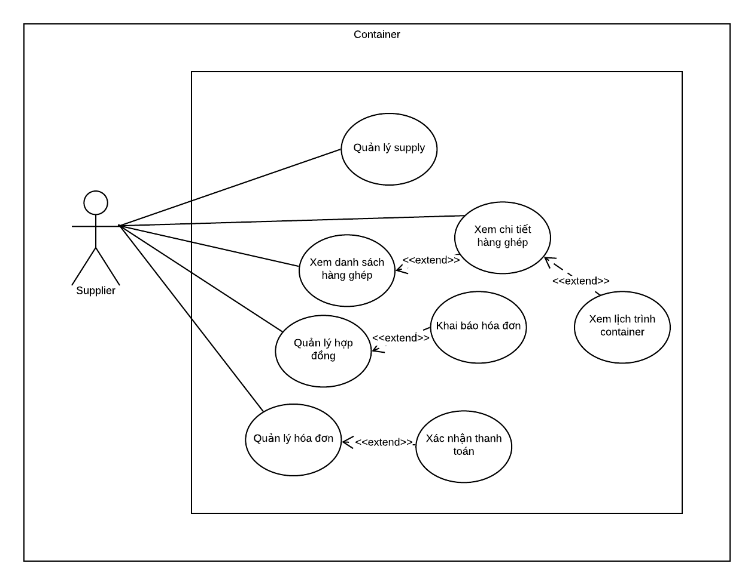

Figure 3.5 Supplier usecase

|  |  |  |  |  |
| --- | --- | --- | --- | --- |
| **USE CASE-CRUM-SU-01 SPECIFICATION** | | | | |
| **Use-case No.** | CRUM-SU-01 | **Use-case Version** | 1.0 |
| **Use-case Name** | Merchant declares supply (Outbound) | | |
| **Author** | Nguyen Duc Duong | | |
| **Date** | 28/05/2020 | **Priority** | Normal |
| **Actor:**  *Supplier – Merchant*  **Summary:**  *This use case allows merchant to add new outbound to open the bidding (đấu thầu) and find empty container.*  **Goal:**  *Outbound information will add to database and “Danh sách hàng xuất” list.*  **Triggers:**  *Merchant want to add new outbound to find empty container.*  **Preconditions:**  *User login with merchant account.*  *Port, Shipping line, Container type already declared.*  **Post Conditions:**  *Success: New outbound created and added to database*  *Fail: Outbound not created and added to database*  **Main Success Scenario:**     |  |  |  | | --- | --- | --- | | Step | Actor Action | System Response | | 1 | Click “Quản lý hàng xuất” at the sidebar of the page. | Navigate to “Danh sách hàng xuất" page. | | 2 | Click “Thêm mới” button at the right conner of the page | Open “Hộp thoại khai báo hàng xuất” dialog which contained 3 portion:   * Tạo hàng xuất: Enable * Điền booking: Disable * Hoàn thành: Disable   At portion 1: Tạo hàng xuất contained:   * Hãng tàu: Selection list * Loại container: Selection list * Ngày đóng hàng: Default current date. * Giờ đóng hàng: Default current time. * Nơi đóng hàng. * Khối lượng hàng * Đơn vị đo: Default KG * Mô tả hàng * Button “TIẾP TỤC” | | 3 | Merchant fills and chooses all information of portion 1 and clicks button “TIẾP TỤC” | Portion 2 (Điền booking) is expanded and contained:   * Số booking * Cảng xuất hàng: Selection list * Ngày tàu cắt máng: Default current date * Giờ cắt máng: Default current time * Số lượng container: Default 0. * Checkbox: hàng nguyên cont (Optional). Default Checked * Button: “TIẾP TỤC” and “QUAY LẠI” | | 4 | Merchant fills and chooses all information of portion 2 and clicks button “TIẾP TỤC” | Portion 3 (Hoàn thành) is expanded and contained:   * Mã hàng xuất: auto generate from upper information. * Checkbox: Bạn đồng ý rằng tất cả các thông tin đưa lên đều là chính xác. * Button “Hoàn tất” and “QUAY LẠI” | | 5 | Merchant checks the box and clicks button “Hoàn tất” | Show notification: “Khai báo hàng xuất thành công”.  Outbound success added in “Danh sách hàng xuất” list and database. |   **Alternative Scenario:**  *N/A*  **Extension Flows:**   |  |  |  | | --- | --- | --- | | ET1 | At step 4 | | | No | Actor Action | System Response | | 1 | Click on button “QUAY LẠI” | Back to portion 1 |  |  |  |  | | --- | --- | --- | | ET2 | At step 5 | | | No | Actor Action | System Response | | 1 | Click on button “QUAY LẠI” | Back to portion 2 |     **Exceptions:**     |  |  |  | | --- | --- | --- | | No | Actor Action | System Response | | 1 | Duplicate supply code | Show notification supply code already exits | | 2 | Packing time after delivery time | Show notification delivery time must be after packing time. |   **Business Rules:**  *BR-3, BI-1, BI-3, BI-5, BI-6, BI-7* | | | |

|  |  |  |  |  |
| --- | --- | --- | --- | --- |
| **USE CASE-CRUM-SU-02 SPECIFICATION** | | | | |
| **Use-case No.** | CRUM-SU-02 | **Use-case Version** | 1.0 |
| **Use-case Name** | Forwarder declares supply (Inbound). | | |
| **Author** | Nguyen Duc Duong | | |
| **Date** | 28/05/2020 | **Priority** | Normal |
| **Actor:**  *Supplier – Forwarder*  **Summary:**  *This use case allows forwarder to declares new inbound to participate in bidding, search for goods to optimize empty containers.*  **Goal:**  *Inbound information will add to database and “Danh sách hàng nhập” list*  **Triggers:**  *Forwarder want to add new inbound to optimize empty containers.*  **Preconditions:**  *User login with forwarder account.*  *Driver, Container list, Shipping line, Container type, Port already created.*  **Post Conditions:**  *Success: New inbound is declared and added to database.*  *Fail: Inbound is not declared and added to database.*  **Main Success Scenario:**     |  |  |  | | --- | --- | --- | | Step | Actor Action | System Response | | 1 | Click “Quản lý hàng nhập” at the sidebar. | Navigate to “Danh sách hàng nhập" page. | | 2 | Click “Thêm mới” button at the right conner of the page. | Open box “Hộp thoại thêm mới hàng nhập” dialog which contained 4 portion:   * Khai báo hàng nhập: Enable * Điền B/L: Disable * Tạo hàng nhập: Disable * Thêm mới Containers hàng nhập: Disable   At portion 1: Khai báo hàng xuất:   * Hãng tàu: Selection list * Loại container: Selection list * Nơi trả hàng: * Ngày lấy cont đặc: Default current date * Giờ lấy cont: Default current time * Button “TIẾP TỤC” | | 3 | Forwarder fills and chooses all information of portion 1 and clicks button “TIẾP TỤC” | Portion 2 (Điền B/L) is expanded and contained:   * B/L No * Cảng lấy cont đặc: Selection list * Ngày DEM/DET (freetime): Default current date * Giờ freetime: Default current time * Số lượng container: Default 0 * Button “TIẾP TỤC” and “QUAY LẠI” | | 4 | Forwarder fills and chooses all information of portion 2 and clicks button “TIẾP TỤC” | Portion 3 (Tạo hàng nhập) is expanded and contained:   * Mã hàng nhập: Auto generate base on upper information * Checkbox: Bạn đồng ý rằng tất cả các thông tin đưa lên đều là chính xác. * Button “Tạo hàng nhập” and “QUAY LẠI” | | 5 | Forwarder checks the box and clicks button “Tạo hàng nhập” | Show notification: “Khai báo thành công hàng nhập”.  Portion 4(Thêm mới Containers hàng nhập) is expanded and contained:   * Danh sách container * Button “Thêm mới”. | | 6 | Forwarder clicks button “Thêm mới” | Open dialog “Thêm mới Container” contained:   * Container No. * Tài xế: Selection List * Chọn đầu kéo: Selection list * Chọn rơ moóc: Selection list * Button “Trở về” and “Thêm mới”. | | 7 | Forwarder clicks button “Thêm mới” | Show notification: “Thêm mới thành công Container” | | 8 | Forwarder clicks button “Hoàn tất” | Inbound success add in “Danh sách hàng nhập” list and database. |   **Alternative Scenario:**  *N/A*  **Extension Flows:**   |  |  |  | | --- | --- | --- | | ET1 | At step 4 | | | No | Actor Action | System Response | | 1 | Click on button “QUAY LẠI” | Back to portion 1 |  |  |  |  | | --- | --- | --- | | ET1 | At step 5 | | | No | Actor Action | System Response | | 1 | Click on button “QUAY LẠI” | Back to portion 2 |  |  |  |  | | --- | --- | --- | | ET2 | At step 7 | | | No | Actor Action | System Response | | 1 | Click on button “Trở về” | Back to portion 4 and no container added |  |  |  |  | | --- | --- | --- | | ET3 | At step 8 | | | No | Actor Action | System Response | | 1 | Click on “QUAY LẠI” | Back to portion 3 |     **Exceptions:**     |  |  |  | | --- | --- | --- | | No | Actor Action | System Response | | 1 | Duplicate supply code | Show notification Supply code already exits | | 2 | Pickup time after Free time | Show notification Free time must be after pickup time |   **Business Rules:**  *BR-2, BI-1, BI-3, BI-5, BI-6, BI-7* | | | |

|  |  |  |  |  |
| --- | --- | --- | --- | --- |
| **USE CASE-CRUM-SU-03 SPECIFICATION** | | | | |
| **Use-case No.** | CRUM-SU-03 | **Use-case Version** | 1.0 |
| **Use-case Name** | Merchant view and edits supply (Outbound) | | |
| **Author** | Nguyen Duc Duong | | |
| **Date** | 28/05/2020 | **Priority** | Normal |

|  |  |  |  |  |  |  |  |  |  |  |  |  |  |  |  |  |  |  |  |  |  |  |  |  |  |  |  |  |  |  |  |  |  |  |  |  |
| --- | --- | --- | --- | --- | --- | --- | --- | --- | --- | --- | --- | --- | --- | --- | --- | --- | --- | --- | --- | --- | --- | --- | --- | --- | --- | --- | --- | --- | --- | --- | --- | --- | --- | --- | --- | --- |
| **Actor:**  *Supplier – Merchant*  **Summary:**  *When outbound information has changed, or merchant entered incorrect outbound information, this use case allows merchant to edits already created outbound.*  **Goal:**  *Merchant will be able to edit outbound information and added to database.*  **Triggers:**  *Outbound information has changed or merchant entered incorrect infomation.*  **Preconditions:**  *Merchant must log in to an outbound created account that is about to be edited.*  *Outbound has been declared.*  *Outbound status must be “Đã tạo”.*  **Post Conditions:**  *Success: Outbound is edited and saved to the database.*  *Fail: Outbound editing failed and sent a notification to the user.*  **Main Success Scenario:**     |  |  |  | | --- | --- | --- | | Step | Actor Action | System Response | | 1 | Click “Quản lý hàng xuất” at the sidebar | Navigate to “Danh sách hàng xuất" page. | | 2 | Click on 3 dots icon at “Hành động” column | Selection list is showed contained:   * Mở đấu thầu * Chỉnh sửa * Xóa bỏ | | 3 | Choose button “Chỉnh sửa” | Open dialog “Hộp thoại chỉnh sửa hàng xuất” which contained 2 portion:   * Thông tin hàng xuất: Enable * Thông tin booking: Disable   At portion 1: Thông tin hàng xuất contained all the selected and inputted information:   * Hãng tàu: * Loại container: * Ngày đóng hàng: disable * Giờ đóng hàng: disable * Nơi đóng hàng * Khối lượng hàng * Đơn vị đo * Mô tả hàng * Button “Lưu và TIẾP TỤC” | | 4 | Merchant edits information and clicks “Lưu và TIẾP TỤC” | Show notification: “Cập nhật hàng xuất thành công”.  Portion 2 (Thông tin booking) is expanded and contained all the selected and inputted information:   * Số booking: disable * Cảng xuất hàng * Ngày tàu cắt máng: disable * Giờ cắt máng: disable * Số lượng container * Checkbox hàng nguyên cont * Button “LƯU VÀ HOÀN TẤT” and “QUAY LẠI” | | 5 | Click button “LƯU VÀ HOÀN TẤT” | Show notification: “Cập nhật đơn đặt container thành công” |   **Alternative Scenario:**  *N/A*  **Extension Flows:**   |  |  |  | | --- | --- | --- | | ET1 | At step 5 | | | No | Actor Action | System Response | | 1 | Click on button “QUAY LẠI” | Back to portion 1 |   **Exceptions:**     |  |  |  | | --- | --- | --- | | No | Actor Action | System Response | | 1 | Outbound is bidding | Show notification cannot edit Outbound when status is bidding | | 2 | Packing time after delivery time | Show notification delivery time must be after packing time. |   **Business Rules:**  *BR-3, BI-1, BI-3, BI-5, BI-6, BI-7* |

|  |  |  |  |  |
| --- | --- | --- | --- | --- |
| **USE CASE-CRUM-SU-04 SPECIFICATION** | | | | |
| **Use-case No.** | CRUM-SU-04 | **Use-case Version** | 1.0 |
| **Use-case Name** | Merchant deletes supply (Outbound) | | |
| **Author** | Nguyen Duc Duong | | |
| **Date** | 28/05/2020 | **Priority** | Normal |
| **Actor:**  *Supplier - Merchant*  **Summary:**  *When the merchant no longer needs to find containers for the supply, this use case allows merchant to delete already created outbound.*  **Goal:**  *Merchant will be able to delete outbound and remove from database.*  **Triggers:**  *Merchant no longer needs to find containers.*  **Preconditions:**  *Merchant must log in to an outbound created account that is about to be edited.*  *Outbound has been declared.*  *Outbound status must be “Đã tạo”.*  **Post Conditions:**  *Success: Outbound is deleted from “Danh sách hàng xuất” list and remove from the database.*  **Main Success Scenario:**     |  |  |  | | --- | --- | --- | | Step | Actor Action | System Response | | 1 | Click on “Quản lý hàng xuất” at the sidebar. | Navigate to “Danh sách hàng xuất" page. | | 2 | Click on 3 dots icon on column “Hành động” | Selection list showed contained:   * Mở đấu thầu * Chỉnh sửa * Xóa bỏ | | 3 | Choose “Xóa bỏ” | Show dialog: “Xóa hàng” contained:   * Bạn có chắc chắn muốn xóa hàng xuất này. * Booking No * Button: “TRỞ VỀ” and “Xóa BỎ” | | 4 | Merchant clicks on button “Xóa BỎ” | Show notification: “Xóa hàng xuất thành công”  Deleted success from “Danh sách hàng xuất” and Database |   **Alternative Scenario:**  *N/A*  **Extension Flows:**   |  |  |  | | --- | --- | --- | | ET1 | At step 4 | | | No | Actor Action | System Response | | 1 | Click on button “trở về” | Back to “Danh sách hàng xuất” and nothing happen. |   **Exceptions:**     |  |  |  | | --- | --- | --- | | No | Actor Action | System Response | | 1 | Delete outbound when status is “Đang đấu thầu” or “Đã ghép". | “Xóa bỏ” is not displayed |   **Business Rules:**  *BR-6* | | | |

|  |  |  |  |  |
| --- | --- | --- | --- | --- |
| **USE CASE-CRUM-SU-05 SPECIFICATION** | | | | |
| **Use-case No.** | CRUM-SU-05 | **Use-case Version** | 1.0 |
| **Use-case Name** | Forwarder edits supply (Inbound) | | |
| **Author** | Nguyen Duc Duong | | |
| **Date** | 28/05/2020 | **Priority** | Normal |

|  |  |  |  |  |  |  |  |  |  |  |  |  |  |  |  |  |  |  |  |  |  |  |  |  |  |  |  |  |  |  |  |  |  |  |  |  |  |  |  |  |  |  |  |  |  |
| --- | --- | --- | --- | --- | --- | --- | --- | --- | --- | --- | --- | --- | --- | --- | --- | --- | --- | --- | --- | --- | --- | --- | --- | --- | --- | --- | --- | --- | --- | --- | --- | --- | --- | --- | --- | --- | --- | --- | --- | --- | --- | --- | --- | --- | --- |
| **Actor:**  *Supplier – Forwarder*  **Summary:**  *When inbound information has changed, or forwarder entered incorrect inbound information, this use case allows forwarder to edit already created inbound.*  **Goal:**  *Forwarder will be able to edit inbound information and added to database.*  **Triggers:**  *Inbound information has changed or forwarder entered incorrect infomation*  **Preconditions:**  *Forwarder must log in to an inbound created account that is about to be edited.*  *Outbound has been declared.*  *Outbound status must be Đã tạo.*  **Post Conditions:**  *Success: Inbound is edited and saved to the database.*  *Fail: Inbound editing failed and sent a notification to the user.*  **Main Success Scenario:**     |  |  |  | | --- | --- | --- | | Step | Actor Action | System Response | | 1 | Click on “Quản lý hàng nhập” at the sidebar | Navigate to “Danh sách hàng nhập" page. | | 2 | Click on 3 dots icon at column “Hành động” | Selection list is showed contained:   * Chỉnh sửa * Xóa | | 3 | Choose button “Chỉnh sửa” | Open dialog “Hộp thoại chỉnh sửa hàng nhập” page which contained 2 portion:   * Thông tin hàng nhập: Enable * Thông tin B/L: Disable   At portion 1: Khai báo hàng xuất contained all selected and inputted information:   * Hãng tàu * Loại container * Nơi trả hàng * Ngày lấy cont đặc: disable * Giờ lấy cont: disable * Button “LƯU VÀ TIẾP TỤC” | | 4 | Forwarder edit information and click button “LƯU VÀ TIẾP TỤC” | Show notification: “Cập nhật hàng nhập thành công.”  Portion 2 (Điền B/L) is expanded and contained all selected and inputted information:   * Số B/L: disable * Cảng lấy cont đặc * Ngày DEM/DET (freetime): disable * Giờ freetime: disable * Số lượng container   Button “LƯU VÀ HOÀN TẤT” and “QUAY LẠI” | | 5 | Forwarder click button “LƯU VÀ HOÀN TẤT” | Show notification: “Cập nhật đơn vận thành công”.  Inbound success edit in “Danh sách hàng nhập” list and database. |   **Alternative Scenario:**  *N/A*  **Extension Flows:**   |  |  |  | | --- | --- | --- | | ET1 | At step 5 | | | No | Actor Action | System Response | | 1 | Click on button “QUAY LẠI” | Back to portion 1 |     **Exceptions:**     |  |  |  | | --- | --- | --- | | No | Actor Action | System Response | | 1 | Pickup time after free time | Show notification “Thời hạn dùng container phải sau thời gian nhận hàng” | | 2 | Container is already used in another bidding | Show notification “Container đã được dùng trong hồ sơ đấu thầu khác” | | 3 | Driver is busy | Show notification “Lái xe đã được dùng trong hồ sơ đấu thầu khác” | | 4 | Tractor is busy | Show notification “Đầu kéo đã được dùng trong hồ sơ đấu thầu khác” | | 5 | Trailer is busy | Show notification “Rơ moóc đã được dùng trong hồ sơ đấu thầu khác” |   **Business Rules:**  *BR-3, BI-1, BI-3, BI-5, BI-6, BI-7* |

|  |  |  |  |  |
| --- | --- | --- | --- | --- |
| **USE CASE-CRM-SU-06 SPECIFICATION** | | | | |
| **Use-case No.** | CRM-SU-06 | **Use-case Version** | 1.0 |
| **Use-case Name** | Merchant view combined detail | | |
| **Author** | Nguyen Duc Duong | | |
| **Date** | 28/05/2020 | **Priority** | Normal |
| **Actor:**  *Supply - Merchant*  **Summary:**  *This use case allows merchant to see all information about combined include schedule, bidding document, contract, bid-winning document.*  **Goal:**  *Merchant will be able to view homepage schedule, bidding document, contract, bid-winning document.*  **Triggers:**  *Users want to view combined schedual, bidding document, contract, bid-winning document.*  **Preconditions:**  *Combined has been created.*  **Post Conditions:**  *Success: All information about combined include schedule, bidding document, contract, bid-winning document showed.*  **Main Success Scenario:**     |  |  |  | | --- | --- | --- | | Step | Actor Action | System Response | | 1 | Merchant clicks on “Quản lý Hàng ghép” from sidebar | Navigate to “Danh sách hàng đã ghép” contained all combined. | | 2 | Click on combined merchant wants to see detail | Combined expands contain bid winner information. | | 3 | Click on button “CHI TIẾT” on column “Hành động” | Navigate to combined detail page contained:   * Menubar: * LỊCH TRÌNH * Lịch trình container * Hàng Xuất * Thông tin hàng xuất * HỢP ĐỒNG * Thông tin hợp đồng * Mã đơn vận chuyển * Danh sách đối tác * Mã * Container No. * Lái xe * SĐT liên hệ * Đầu kéo * Trạng thái * Lịch trình * Hành động |   **Alternative Scenario:**  *N/A*  **Exceptions:**  *N/A*  **Business Rules:**  *BR-1* | | | |

|  |  |  |  |  |
| --- | --- | --- | --- | --- |
| **USE CASE-CRM-SU-07 SPECIFICATION** | | | | |
| **Use-case No.** | CRM-SU-07 | **Use-case Version** | 1.0 |
| **Use-case Name** | Forwarder view combined detail | | |
| **Author** | Nguyen Duc Duong | | |
| **Date** | 28/05/2020 | **Priority** | Normal |
| **Actor:**  *Supply - Forwarder*  **Summary:**  *This use case allows forwarder to see all information about combined include schedule, bidding document, contract, bid-winning document.*  **Goal:**  *Forwarder will be able to view homepage schedule, bidding document, contract, bid-winning document.*  **Triggers:**  *Users want to view combined schedual, bidding document, contract, bid-winning document.*  **Preconditions:**  *Combined has been created.*  **Post Conditions:**  *Success: All information about combined include schedule, bidding document, contract, bid-winning document showed.*  **Main Success Scenario:**     |  |  |  | | --- | --- | --- | | Step | Actor Action | System Response | | 1 | Forwarder clicks on “Quản lý Hàng ghép” from sidebar | Navigate to “Danh sách hàng đã ghép” contained all combined. | | 2 | Click on combined forwarder wants to see detail | Combined expands contain bid winner information. | | 3 | Click on button “CHI TIẾT” on column “Hành động” | Navigate to combined detail page contained:   * Menubar: * LỊCH TRÌNH * Lịch trình container * HÀNG XUẤT * Thông tin hàng xuất * HỢP ĐỒNG * Thông tin hợp đồng * Mã đơn vận chuyển * Danh sách vận chuyển * Mã * Container No. * Lái xe * SĐT liên hệ * Đầu kéo * Trạng thái * Lịch trình * Hành động | | 3 | Click on button “XEM” on column lịch trình | Show container schedual on “LỊCH TRÌNH” from menubar. |   **Alternative Scenario:**  *N/A*  **Exceptions:**  *N/A*  **Business Rules:**  *BR-1* | | | |

|  |  |  |  |  |
| --- | --- | --- | --- | --- |
| **USE CASE-CRUM-SU-08 SPECIFICATION** | | | | |
| **Use-case No.** | CRUM-SU-04 | **Use-case Version** | 1.0 |
| **Use-case Name** | Forwarder deletes supply (Inbound) | | |
| **Author** | Nguyen Duc Duong | | |
| **Date** | 28/05/2020 | **Priority** | Normal |
| **Actor:**  *Supplier - Forwarder*  **Summary:**  *When the forwarder no longer needs to the supply, this use case allows forwarder to delete already created inbound.*  **Goal:**  *Forwarder will be able to delete inbound and remove from database.*  **Triggers:**  *Forwarder no longer needs to find supply.*  **Preconditions:**  *Forwarder must log in to an inbound created account that is about to be edited.*  *Inbound has been declared.*  *Inbound status must be “Đã tạo”.*  **Post Conditions:**  *Success: Inbound is deleted from “Danh sách hàng nhập” list and remove from the database.*  **Main Success Scenario:**     |  |  |  | | --- | --- | --- | | Step | Actor Action | System Response | | 1 | Click on “Quản lý hàng nhập” at the sidebar. | Navigate to “Danh sách hàng nhập" page. | | 2 | Click on 3 dots icon on column “Hành động” | Selection list showed contained:   * Mở đấu thầu * Chỉnh sửa * Xóa bỏ | | 3 | Choose “Xóa bỏ” | Show dialog: “Xóa hàng” contained:   * Bạn có chắc chắn muốn xóa hàng nhập này. * B/L No. * Button: “TRỞ VỀ” and “Xóa BỎ” | | 4 | Forwarder clicks on button “Xóa BỎ” | Show notification: “Xóa hàng nhập thành công”  Deleted success from “Danh sách hàng nhập” and Database |   **Alternative Scenario:**  *N/A*  **Extension Flows:**   |  |  |  | | --- | --- | --- | | ET1 | At step 4 | | | No | Actor Action | System Response | | 1 | Click on button “trở về” | Back to “Danh sách hàng nhập” and nothing happen. |   **Exceptions:**     |  |  |  | | --- | --- | --- | | No | Actor Action | System Response | | 1 | Delete outbound when status is “Đang đấu thầu” or “Đã ghép". | Show notification: “Container đã được dùng trong hồ sơ đấu thầu khác” |   **Business Rules:**  *BR-6* | | | |

3.2.2.2.4 Forwarder use case

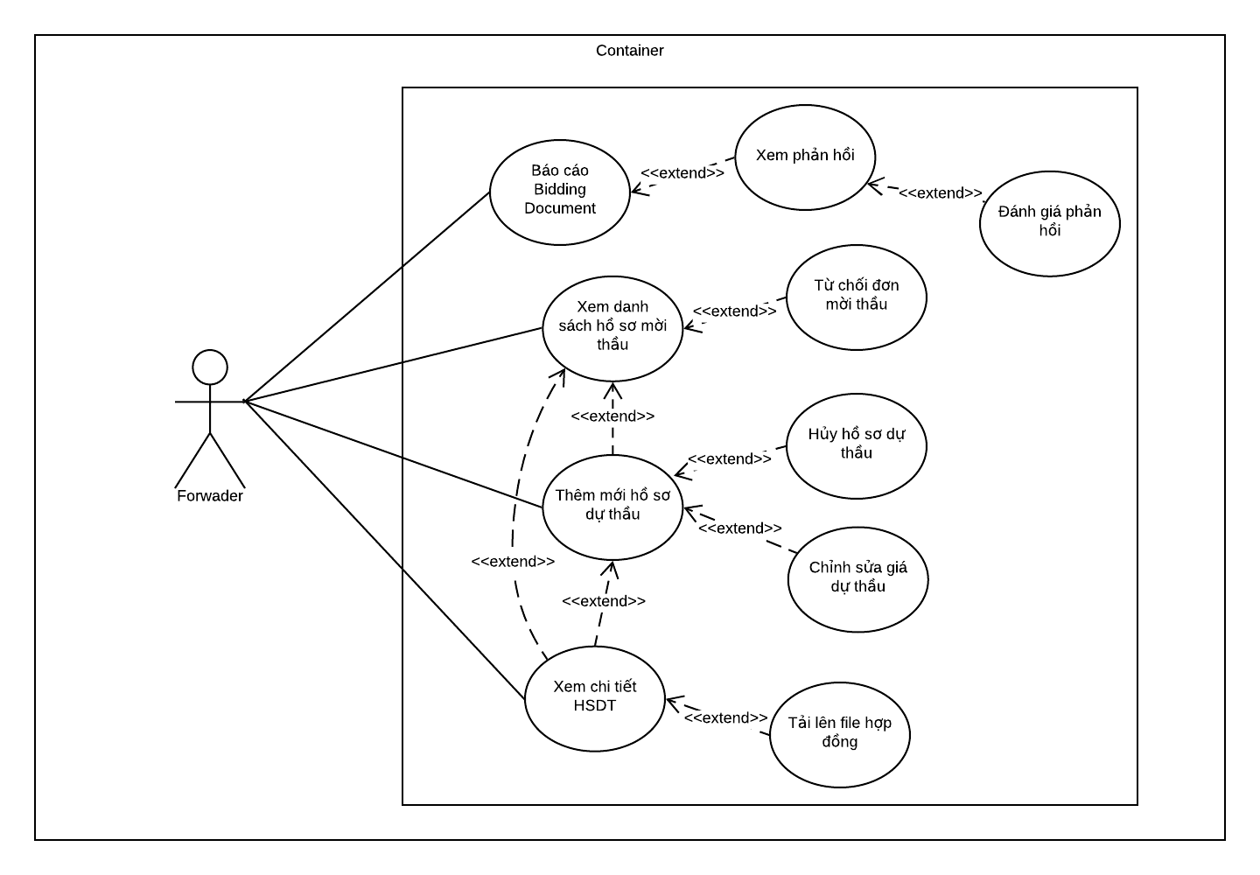

Figure 3.6 Forwarder usecase

|  |  |  |  |  |
| --- | --- | --- | --- | --- |
| **USE CASE-CRUM-FO-01 SPECIFICATION** | | | | |
| **Use-case No.** | CRUM-FO-01 | **Use-case Version** | 1.0 |
| **Use-case Name** | View bidding document (Hồ sơ mời thầu) and submit bid (Gửi hồ sơ dự thầu) | | |
| **Author** | Nguyen Duc Duong | | |
| **Date** | 29/05/2020 | **Priority** | High |
| **Actor:**  *Forwarder*  **Summary:**  *After the merchant has created a bidding document (Hồ sơ mời thầu) for the outbound, the forwarder with the matching conditions will be able to participate in a bid to receive the shipment.*  **Goal:**  *The Forwarder successfully submits the bid and Merchant receives the notification and is able to view it.*  **Triggers:**  *Forwarder received the invitation to bidding (tham gia đấu thầu).*  **Preconditions:**  *Inbound, Outbound, Bidding document (Hồ sơ mời thầu) already created.*  *Inbound and Outbound conditions match each other.  System sends notification to Forwarder to participate to bidding.*  **Post Conditions:**  *Success: Forwarder sent bid and merchant can view bid.*  *Fail: Forwarder does not submit bids.*  **Main Success Scenario:**   |  |  |  | | --- | --- | --- | | Step | Actor Action | System Response | | 1 | Click on “Quản lý đấu thầu” from sidebar | Extend list contained:   * HSMT Nhận được * Quản lý HSDT * Quản lý Report * Quản lý hợp đồng * Quản lý hóa đơn | | 2 | Forwarder clicks “HSMT nhận được” | Navigate to “HSMT nhận được” page contained all bidding document (Hồ sơ mời thầu) received.   * Mã * Bên gửi HSMT * Hãng tàu * Số cont * Giá gói thầu * Giá sàn * Mở thầu * Đóng thầu * Nhiều thầu thắng * Chi tiết HSDT * Hành động “Đồng ý” and “Từ chối" | | 3 | Forwarder clicks button “Đồng ý”. | Open dialog “Thêm mới HSDT” contained 4 portions:   * Portion 1: Chọn HSMT * Portion 2: Thông tin HSMT * Portion 3: Chọn Container mong muốn * Portion 4: Hoàn thành.   Portion 1 expand show the bidding document (Hồ sơ mời thầu) info. | | 4 | Choose the bidding document (Hồ sơ mời thầu) and click button “TIẾP TỤC” | Portion 2 expand contained   * Bidding price * Validity period (Sau thời gian này, HSDT của bạn sẽ không còn giá trị): Bid’s validity period * Button “TIẾP TỤC” and “QUAY LẠI” | | 5 | Enter suitable price (Lower than Bid package price and higher bid floor price) and click button “TIẾP TỤC” | Portion 3 expand contained inbound list | | 6 | Click on suitable inbound | Expand containers information | | 7 | Choose desired container and click button “TIẾP TỤC” | Portion 4 expand contained   * Checkbox Bạn đồng ý rằng tất cả các thông tin đưa lên đều chính xác | | 8 | Check the checkbox and Click “Hoàn tất” | Navigate “Danh sách đấu thầu” and show notification “Thêm mới thành công hồ sơ dự thầu”. |     **Alternative Scenario:**     |  |  |  | | --- | --- | --- | | Step | Actor Action | System Response | | 1 | After Merchant creates bidding document (Hồ sơ mời thầu), notification icon at the right conner of menu bar. |  | | 2 | Forwarder clicks the notification icon | Show notification box with notification: “Bạn nhận được hồ sơ mời thầu từ <Merchant username>” | | 3 | Click the notification | Navigate to Bidding document detail page with all the information of Outbound and Bidding document (Hồ sơ mời thầu) | | 4 | Click button “Thêm mới” | Navigate to “Thêm mới HSDT” box contained 4 portions:   * Portion 1: Chọn HSMT * Portion 2: Thông tin HSMT * Portion 3: Chọn Container mong muốn * Portion 4: Hoàn thành.   Portion 1 expand show the bidding document (Hồ sơ mời thầu) info. | | 5 | Choose the bidding document (Hồ sơ mời thầu) and click “TIẾP TỤC” | Portion 2 expand contained   * Bidding price * Validity period (Sau thời gian này, HSDT của bạn sẽ không còn giá trị): Bid’s validity period * Button “TIẾP TỤC” and “QUAY LẠI” | | 6 | Enter suitable price and click “TIẾP TỤC” | Portion 3 expand contained inbound list | | 7 | Click on suitable inbound | Expand Containers information | | 8 | Choose desired Container and click “TIẾP TỤC” | Portion 4 expand contained   * Checkbox: Bạn đồng ý rằng tất cả các thông tin đưa lên đều chính xác | | 9 | Click “Hoàn tất” | Navigate “Danh sách đấu thầu” and show notification “Thêm mới thành công hồ sơ dự thầu”. |  |  |  |  | | --- | --- | --- | | Step | Actor Action | System Response | | 1 | Forwarder clicks on “Quản lý hàng nhập” on the side bar | Navigate to “Danh sách hàng nhập” page | | 2 | Forwarder chooses outbound want to submit bid and clicks 3 dots button on Hành động colume | Show selection list:   * Tìm thầu * Chỉnh sửa * Xóa bỏ * Khai báo container | | 3 | Forwarder clicks on “Tìm thầu” | Open dialog “Thêm mới HSDT” contained 4 portions:   * Portion 1: Chọn HSMT * Portion 2: Thông tin HSMT * Portion 3: Chọn Container mong muốn * Portion 4: Hoàn thành.   Portion 1 expand show the bidding document (Hồ sơ mời thầu) info. | | 4 | Forwarder choose bidding document by check the checkbox and clicks “TIẾP TỤC” | Portion 2 expand contained   * Bidding price * Validity period (Sau thời gian này, HSDT của bạn sẽ không còn giá trị): Bid’s validity period   Button “TIẾP TỤC” and “QUAY LẠI” | |  | Follow step 5-6-7-8 on Main scenario |  |   **Extension Flows:**   |  |  |  | | --- | --- | --- | | ET1 | At step 5 | | | No | Actor Action | System Response | | 1 | Click on “QUAY LẠI” | Back to Portion 1 |  |  |  |  | | --- | --- | --- | | ET2 | At step 7 | | | No | Actor Action | System Response | | 1 | Click on “QUAY LẠI” | Back to Portion 2 |  |  |  |  | | --- | --- | --- | | ET3 | At step 8 | | | No | Actor Action | System Response | | 1 | Click on “QUAY LẠI” | Back to Portion 3 |   **Exceptions:**     |  |  |  | | --- | --- | --- | | No | Actor Action | System Response | | 1 | Bidding document (Hồ sơ mời thầu) time out | Show notification Bidding document (Hồ sơ mời thầu) have expired | | 2 | Bid already sent | Show notification Only one bid may be created for each bidding document (Hồ sơ mời thầu) | | 3 | The number of containers is more or less than needed. | Show notification The number of containers exceeds the allowed or not enough | | 4 | Container not suitable | Show notification Container not suitable |   **Business Rules:**  *BR-1, BI-1, BI-2, BI-3* | | | |

|  |  |  |  |  |
| --- | --- | --- | --- | --- |
| **USE CASE-CRUM-FO-02 SPECIFICATION** | | | | |
| **Use-case No.** | CRUM-FO-02 | **Use-case Version** | 1.0 |
| **Use-case Name** | Forwarder rejects Bidding document (Hồ sơ mời thầu) | | |
| **Author** | Nguyen Duc Duong | | |
| **Date** | 30/05/2020 | **Priority** | Normal |
| **Actor:**  *Forwarder*  **Summary:**  *After receiving the bidding document (Hồ sơ mời thầu, the forwarder does not want to participate, this use case allows forwarder to Rejects bidding document (Hồ sơ mời thầu) from merchant.*  **Goal:**  *Forwarder rejects the bidding document (Hồ sơ mời thầu) from merchant. Bidding document (Hồ sơ mời thầu) have been deleted from “HSMT nhận được” list.*  **Triggers:**  *Forwarder received the invitation to bidding (tham gia đấu thầu).*  *Inbound and outbound conditions match each other.*  **Preconditions:**  *Bidding document (Hồ sơ mời thầu), Outbound and Inbound is already created.*  *Inbound and Outbound conditions match each other.*  *System sends notification to Forwarder to participate to bidding.*  **Post Conditions:**  *Success: Forwarder rejects the bidding document (Hồ sơ mời thầu) from merchant and bidding document have been deleted from “HSMT nhận được list”.*  **Main Success Scenario:**     |  |  |  | | --- | --- | --- | | Step | Actor Action | System Response | | 1 | Click on “Quản lý đấu thầu” from sidebar. | Extend list contained:   * HSMT Nhận được * Quản lý HSDT * Quản lý Report * Quản lý hợp đồng * Quản lý hóa đơn | | 2 | Forwarder clicks “HSMT nhận được” | Navigate to “HSMT nhận được” page contained all bidding document (Hồ sơ mời thầu) received.   * Mã * Bên gửi HSMT * Hãng tàu * Số cont * Giá gói thầu * Giá sàn * Mở thầu * Đóng thầu * Nhiều thầu thắng * Chi tiết HSDT * Hành động “Đồng ý” and “Từ chối" | | 3 | Forwarder clicks button “Từ chối” | Show dialog “Xác nhận từ chối tham gia thầu”   * Mã HSMT * Button “TRỞ VỀ” and “TỪ CHỐI” | | 4 | Click button “Từ Chối” | Show notification: “Từ chối thành công” |   **Alternative Scenario:**  *N/A*  **Extension Flows:**   |  |  |  | | --- | --- | --- | | ET1 | At step 4 | | | No | Actor Action | System Response | | 1 | Click on “trở về” | Back to “HSMT nhận được” page |   **Exceptions:**  *N/A*  **Business Rules:**  *BR-1* | | | |

|  |  |  |  |  |
| --- | --- | --- | --- | --- |
| **USE CASE-CRUM-FO-03 SPECIFICATION** | | | | |
| **Use-case No.** | CRUM-FO-03 | **Use-case Version** | 1.0 |
| **Use-case Name** | Report bidding document (Hồ sơ mời thầu) | | |
| **Author** | Nguyen Duc Duong | | |
| **Date** | 30/05/2020 | **Priority** | High |
| **Actor:**  *Forwarder*  **Summary:**  *This use case allows Forwarder to report bidding document (Hồ sơ mời thầu) to the moderator to request handling of issues occurring with the Bidding Documents.*  **Goal:**  *New report added to Report list and sent to Moderator. Moderator receives a notification about the report.*  **Triggers:**  *There was an issue that caused the forwarder to wants to report bidding document (Hồ sơ mời thầu).*  **Preconditions:**  *Forwarder received bidding document (Hồ sơ mời thầu).*  *Bidding document (Hồ sơ mời thầu) already created.*  **Post Conditions:**  *Success: Report is added to Report list and sent to Moderator.*s  **Main Success Scenario:**     |  |  |  | | --- | --- | --- | | Step | Actor Action | System Response | | 1 | Click “Quản lý đấu thầu” at the sidebar. | Extend list contained:   * HSMT Nhận được * Quản lý HSDT * Quản lý Report * Quản lý hợp đồng * Quản lý hóa đơn | | 2 | Choose “Quản lý HSDT” | Navigate to “Danh sách Hồ sơ dự thầu” | | 3 | Select the bidding document (Hồ sơ mời thầu) to report and click button “CHI TIẾT” | Navigate to bidding document detail | | 4 | Click on report icon on the right conner of the page | Show box “Thêm mới report” contain 3 portion:   * Chọn HSMT * Thông tin report * Hoàn thành   Portion 1 contained:   * Bidding document info * Button “TIẾP TỤC” | | 5 | Forwarder clicks button “TIẾP TỤC" | Expand portion 2 contained:   * Tiêu đề * Nội dung * Button “TIẾP TỤC” and “QUAY LẠI” | | 6 | Forwarder fills all information and clicks “TIẾP TỤC” | Expand portion 3 contained   * Checkbox (Bạn đồng ý rằng tất cả các thông tin đưa lên đều chính xác” * Button “HOÀN TẤT” and “QUAY LẠI” | | 7 | Forwarder checks the checkbox and clicks button “HOÀN TẤT” | Show notification: “Tạo mới báo cáo thành công” |   **Alternative Scenario:**  *N/A*  **Extension Flows:**   |  |  |  | | --- | --- | --- | | ET1 | At step 6 | | | No | Actor Action | System Response | | 1 | Click on “QUAY LẠI” | Back to Portion 1 |  |  |  |  | | --- | --- | --- | | ET2 | At step 7 | | | No | Actor Action | System Response | | 1 | Click on “QUAY LẠI” | Back to Portion 2 |   **Exceptions:**     |  |  |  | | --- | --- | --- | | No | Actor Action | System Response | | 1 | Title is blank | Show notification The title of the report is invalid |   **Business Rules:**  *BI-1, BI-5* | | | |

|  |  |  |  |  |
| --- | --- | --- | --- | --- |
| **USE CASE-CRUM-FO-04 SPECIFICATION** | | | | |
| **Use-case No.** | CRUM-FO-04 | **Use-case Version** | 1.0 |
| **Use-case Name** | View list of bids and edit bid | | |
| **Author** | Nguyen Duc Duong | | |
| **Date** | 30/05/2020 | **Priority** | High |
| **Actor:**  *Forwarder*  **Summary:**  *When bid information has changed, or forwarder wants to edit bid price, this use case allows Forwarder to view list of bids and edit bid.*  **Goal:**  *Forwarder will be able view list of bids and edit bid and added to database. Merchant is able to see new information of the bid.*  **Triggers:**  *Bid information has changed, or forwarder wants to edit bid price.*  **Preconditions:**  *Forwarder must log in to an bid created account that is about to be edited.*  *Bid already created.*  *The Bidding process has not ended.*  *Freezing time has expired.*  **Post Conditions:**  *Success: Outbound is edited and saved to the database. Merchant is able to see new information of the bid.*  **Main Success Scenario:**     |  |  |  | | --- | --- | --- | | Step | Actor Action | System Response | | 1 | Click on “Quản lý đấu thầu” from dashboard bar on the left side of page | Extend list contained:   * HSMT Nhận được * Quản lý HSDT * Quản lý Report * Quản lý hợp đồng * Quản lý hóa đơn | | 2 | Forwarder clicks “Quản lý HSDT” | Navigate to “Danh sách Hồ sơ dự thầu” page contained all bidding document (Hồ sơ mời thầu) received.   * Mã * Hãng tàu * Loại cont * Giá gói thầu * Giá sàn * Ngày mở thầu * Đóng thầu * Nhiều thầu thắng * Hành động | | 3 | Forwarder click on bid they want to edit | Extend list bid contained:   * Mã * Số lượng cont * Giá thầu * Ngày gửi thầu * Hiệu lực HSDT tới * Khóa chỉnh sửa tới: Freezing time * Hành động | | 4 | Click on button “Sửa” on Hành động column | Navigate to “Chỉnh sửa bid” page contained 4 portions:   * Portion 1: Chọn HSMT with Bidding document (Hồ sơ mời thầu) information * Portion 2: Thông tin HSDT * Portion 3: Danh sách container | | 5 | Click button “TIẾP TỤC” | Portion 2 expand contained   * Giá gửi thầu * Ngày hiệu lực * Giờ hiệu lực * Button “LƯU VÀ TIẾP TỤC” and “QUAY LẠI | | 6 | Edit “Giá gửi thầu”, “Ngày hiệu lực” and “Giờ hiệu lực” click button “TIẾP TỤC” | Show notification: “Cập nhật hồ sơ dự thầu thành công”  Portion 3 expanded and contained list selected container | | 7 | Click on 3 dots button at column Hành động | Show selection list contained:   * Đổi container | | 8 | Click on “Đôi container” | Show box “Danh sách inbound” | | 9 | Click on inbound and change container | Back to “Chỉnh sửa HSDT” | | 10 | Click button “HOÀN TẤT” | Navigate to “Danh sách HSDT” page |   **Alternative Scenario:**     |  |  |  | | --- | --- | --- | | Step | Actor Action | System Response | | 1 | Click on “Quản lý đấu thầu” from dashboard bar on the left side of page | Extend list contained:   * HSMT Nhận được * Quản lý HSDT * Quản lý Report * Quản lý hợp đồng * Quản lý hóa đơn | | 2 | Forwarder clicks “Quản lý HSDT” | Navigate to “Danh sách Hồ sơ dự thầu” page contained all bidding document (Hồ sơ mời thầu) received.   * Mã * Hãng tàu * Loại cont * Giá gói thầu * Giá sàn * Ngày mở thầu * Đóng thầu * Nhiều thầu thắng * Hành động | | 3 | Forwarder clicks on button “CHI TIẾT” at column Hành động | Navigate to Bidding document detail page | | 4 | Click on button “Sửa” on Hành động column at “Danh sách HSDT” |  | |  | Follow step 5-6-7-8-9-10 on main scenario |  |   **Extension Flows:**     |  |  |  | | --- | --- | --- | | ET1 | At step 6 | | | No | Actor Action | System Response | | 1 | Click on “QUAY LẠI” | Back to Portion 1 |  |  |  |  | | --- | --- | --- | | ET2 | At step 10 | | | No | Actor Action | System Response | | 1 | Click on “QUAY LẠI” | Back to Portion 2 |   **Exceptions:**     |  |  |  | | --- | --- | --- | | No | Actor Action | System Response | | 1 | The number of containers is more or less than needed. | Show notification The number of containers exceeds the allowed or not enough |   **Business Rules:**  *BR-1, BR-7, BI-1, BI-2, BI-3, BI-5* | | | |

|  |  |  |  |  |
| --- | --- | --- | --- | --- |
| **USE CASE-CRUM-FO-05 SPECIFICATION** | | | | |
| **Use-case No.** | CRUM-FO-05 | **Use-case Version** | 1.0 |
| **Use-case Name** | View list of bids and cancel bid | | |
| **Author** | Nguyen Duc Duong | | |
| **Date** | 30/05/2020 | **Priority** | Normal |
| **Actor:**  *Forwarder*  **Summary:**  *Forwarder does not want to participate in bidding anymore,* *this use case allows Forwarder to view list of bids and cancel bid.*  **Goal:**  *Forwarder will be able view list of bids and cancel bid.*  **Triggers:**  *Forwarder does not want to participate in bidding anymore.*  **Preconditions:**  *Forwarder must log in to an bid created account that is about to be edited.*  *Bid already created.*  *The Bidding process has not ended.*  *Bid status must be BIDDING.*  *Freezing time has expired.*  **Post Conditions:**  *Success: Forwarder can view all bids and cancel bid and Merchant received a bid cancellation notice from the Forwarder.*  **Main Success Scenario:**     |  |  |  | | --- | --- | --- | | Step | Actor Action | System Response | | 1 | Click on “Quản lý đấu thầu” from sidebar. | Extend list contained:   * HSMT Nhận được * Quản lý HSDT * Quản lý Report * Quản lý hợp đồng * Quản lý hóa đơn | | 2 | Forwarder clicks “Quản lý HSDT” | Navigate to “Danh sách Hồ sơ dự thầu” page contained all bidding document (Hồ sơ mời thầu) received.   * Mã * Hãng tàu * Loại cont * Giá gói thầu * Giá sàn * Ngày mở thầu * Đóng thầu * Nhiều thầu thắng * Hành động | | 3 | Forwarder clicks on bid they want to cancel | Extend detail of bid | | 4 | Click button “Hủy” on column Hành động | Show “Hủy bỏ HSDT” box contained:   * “Bạn có chắc chắn muốn hủy HSDT này?” * Mã * Button “TRỞ VỀ” and “HỦY BỎ” | | 5 | Click “Hủy Bỏ” | Show notify: “Hủy thầu thành công” |   **Alternative Scenario:**     |  |  |  | | --- | --- | --- | | Step | Actor Action | System Response | | 1 | Click on “Quản lý đấu thầu” from sidebar. | Extend list contained:   * HSMT Nhận được * Quản lý HSDT * Quản lý Report * Quản lý hợp đồng * Quản lý hóa đơn | | 2 | Forwarder clicks “Quản lý HSDT” | Navigate to “Danh sách Hồ sơ dự thầu” page contained all bidding document (Hồ sơ mời thầu) received.   * Mã * Hãng tàu * Loại cont * Giá gói thầu * Giá sàn * Ngày mở thầu * Đóng thầu * Nhiều thầu thắng * Hành động | | 3 | Forwarder clicks on “CHI TIẾT” button | Navigate to Bidding document detail page | | 4 | Click on button “HỦY” on Hành động column at “Danh sách HSDT” | Show “Hủy bỏ HSDT” box contained:   * “Bạn có chắc chắn muốn hủy HSDT này?” * Mã * Button “TRỞ VỀ” and “HỦY BỎ” | | 5 | Click “Hủy Bỏ” | Show notify: “Hủy thầu thành công” |   **Extension Flows:**   |  |  |  | | --- | --- | --- | | ET1 | At step 5 | | | No | Actor Action | System Response | | 1 | Click on “Trở về” | Back to Bid List |   **Exceptions:**     |  |  |  | | --- | --- | --- | | No | Actor Action | System Response | | 1 | Multi-bid winning mode is not selected. | Only a new container can be added or deleted with the Bidding document (Hồ sơ mời thầu) having multiple contractors winning. |   **Business Rules:**  *BR-7* | | | |

|  |  |  |  |  |
| --- | --- | --- | --- | --- |
| **USE CASE-CRUM-FO-06 SPECIFICATION** | | | | |
| **Use-case No.** | CRUM-FO-06 | **Use-case Version** | 1.0 |
| **Use-case Name** | See account receivable and fines to pay and declare the fines invoice | | |
| **Author** | Nguyen Duc Duong | | |
| **Date** | 31/05/2020 | **Priority** | Normal |
| **Actor:**  *Forwarder*  **Summary:**  *When the merchant charges a fine (tính tiền phạt) for the forwarder, this use case will allow the forwarder to see payment and declare the fines invoice.*  **Goal:**  *Forwarder will be able see payment history and declare the fines invoice.*  **Triggers:**  *Forwarder declare fines invoice to let merchant confirm.*  **Preconditions:**  *Combined, contract and Shipping info has been created.*  *Shipping info must be DELIVERED.*  **Post Conditions:**  *Success: Forwarder can declare the fine invoice and merchant can receive it.*  **Main Success Scenario:**     |  |  |  | | --- | --- | --- | | Step | Actor Action | System Response | | 1 | Click on “Quản lý đấu thầu” from sidebar. | Extend list contained:   * HSMT Nhận được * Quản lý HSDT * Quản lý Report * Quản lý hợp đồng * Quản lý hóa đơn | | 2 | Click on “Quản lý hợp đồng” | Navigate to Contract list “Danh sách hợp đồng” page contained contract information:   * Mã * Bên chủ hàng * Bên chủ xe * Y/c hợp đồng * Giá hợp đồng * % tiền phạt * Ngày tạo hợp đồng * Hành động | | 3 | Forwarder click 3 dots icon on column “Hành động” | Show selection menu:   * Tạo hóa đơn * Xem chi tiết * Tải lên hợp đồng | | 4 | Forwarder clicks on “Tạo hóa đơn” | Show “Thêm mới hóa đơn” dialog contained:   * Người gửi: Default: forwarder username. * Người nhận: Default: merchant username * Loại hóa đơn: Tiền phạt hợp đồng * Số tiền * Thời gian thanh toán: Datetime. * Giờ thanh toán: Default current time * Nội dung * Button “TRỞ về” and “THÊM MỚI” | | 5 | Forwarder fills all information and clicks “Thêm mới” | Show notification: “Khai báo hóa đơn thành công”. |   **Alternative Scenario:**  *N/A*  **Extension Flows:**   |  |  |  | | --- | --- | --- | | ET1 | At step 4 | | | No | Actor Action | System Response | | 1 | Click on “Trở về” | Back to Danh sách hợp đồng |   **Exceptions:**     |  |  |  | | --- | --- | --- | | No | Actor Action | System Response | | 1 | Payment invalid amount | Show notification the mount is not valid | | 2 | Payment type not found | Show notification invoice type not found |   **Business Rules:**  *BI-3, BI-5, BI-6, BI-7* | | | |

|  |  |  |  |  |
| --- | --- | --- | --- | --- |
| **USE CASE-CRUM-FO-07 SPECIFICATION** | | | | |
| **Use-case No.** | CRUM-FO-07 | **Use-case Version** | 1.0 |
| **Use-case Name** | See account receivable and fine to pay and confirm payment | | |
| **Author** | Nguyen Duc Duong | | |
| **Date** | 31/05/2020 | **Priority** | Normal |
| **Actor:**  *Forwarder*  **Summary:**  *When merchant makes payment to forwarder, an invoice will be sent to the Forwarder and this use case allows Forwarder see payment and confirm payment.*  **Goal:**  *Forwarder will be able see payment history and confirm payment.*  **Triggers:**  *Merchant sends the payment invoice for the forwarder to confirm*  **Preconditions:**  *Combined, Contract, Shipping info has been created.*  *Merchant already declared invoice.*  **Post Conditions:**  *Success: Forwarder can confirm the fine invoice and merchant invoice status updated.*  **Main Success Scenario:**     |  |  |  | | --- | --- | --- | | Step | Actor Action | System Response | | 1 | Click on “Quản lý đấu thầu” from sidebar. | Extend list contained:   * HSMT Nhận được * Quản lý HSDT * Quản lý Report * Quản lý hợp đồng * Quản lý hóa đơn | | 2 | Click on “Quản lý hóa đơn” from sidebar. | Navigate to Contract list “Danh sách hợp đồng” page contained contract information:   * Mã * Bên chủ hàng * Bên chủ xe * Y/c hợp đồng * Giá hợp đồng * % tiền phạt * Ngày tạo hợp đồng * Hành động | | 3 | Forwarder clicks 3 dots icon on column “Hành động” | Show selection menu:   * Xem chi tiết * Xác nhận thanh toán | | 4 | Forwarder clicks on “Xác nhận thanh toán” | Show “Xác nhận hóa đơn” box with notify:   * “Bạn xác nhận đã nhận đủ tiền theo đơn này?” * Mã * Button “TRỞ VỀ” and “XÁC NHẬN” | | 5 | Click “Xác nhận” | Show notification: “Cập nhật hóa đơn thành công”  Trạng thái change from “Đang chờ” to “Đã thanh toán”. |   **Alternative Scenario:**  *N/A*  **Extension Flows:**   |  |  |  | | --- | --- | --- | | ET1 | At step 4 | | | No | Actor Action | System Response | | 1 | Click on “Xem chi tiết” | Open box “Thông tin Hóa đơn” with invoice detail. |  |  |  |  | | --- | --- | --- | | ET2 | At step 5 | | | No | Actor Action | System Response | | 1 | Click on “Trở về” | Back to Danh sách hóa đơn |   **Exceptions:**  *N/A*  **Business Rules:**  *N/A* | | | |

|  |  |  |  |  |
| --- | --- | --- | --- | --- |
| **USE CASE-CRUM-FO-08 SPECIFICATION** | | | | |
| **Use-case No.** | CRUM-FO-08 | **Use-case Version** | 1.0 |
| **Use-case Name** | View bid detail | | |
| **Author** | Nguyen Duc Duong | | |
| **Date** | 31/05/2020 | **Priority** | High |
| **Actor:**  *Forwarder*  **Summary:**  *This use case allows forwarder to view detail of bid include bidding document, bidding information and list of bids.*  **Goal:**  *Forwarder will be able to see all the information about bid.*  **Triggers:**  *Forwarder want to see some information about information relating to submitted bid.*  **Preconditions:**  *Forwarder sent the bid.*  **Post Conditions:**  *Success:* *All the information about bid showed and forwarder can see it.*  **Main Success Scenario:**     |  |  |  | | --- | --- | --- | | Step | Actor Action | System Response | | 1 | Click on “Quản lý đấu thầu” from sidebar. | Extend list contained:   * HSMT Nhận được * Quản lý HSDT * Quản lý Report * Quản lý hợp đồng * Quản lý hóa đơn | | 2 | Click on “Quản lý HSDT” | Navigate to “Danh sách Hồ sơ dự thầu” page contain information of bid. | | 3 | Click on button “CHI TIẾT” on column “Hành động” | Navigate to detail page contained:   * Hồ sơ mời thầu: * Thông tin HSMT * Thông tin hàng xuất * Giá dẫn đầu * Tham gia: Number of people participating in bidding. * Còn lại: Bidding time remaining * Danh sách HSDT * Mã * Bên gửi HSMT * SĐT liên hệ * Giá thầu * Ngày thầu * Hiệu lực đến * Trạng thái * Hành động |   **Alternative Scenario:**  *N/A*  **Exceptions:**  *N/A*  **Business Rules:**  *BR-1* | | | |

|  |  |  |  |  |
| --- | --- | --- | --- | --- |
| **USE CASE-CRUM-FO-09 SPECIFICATION** | | | | |
| **Use-case No.** | CRUM-FO-09 | **Use-case Version** | 1.0 |
| **Use-case Name** | View detail received invoice | | |
| **Author** | Nguyen Duc Duong | | |
| **Date** | 31/05/2020 | **Priority** | Normal |
| **Actor:**  *Forwarder*  **Summary:**  *This use case allows forwarder to view detail see invoice details sent from merchant*  **Goal:**  *Forwarder will be able to all the information about invoice.*  **Triggers:**  *Forwarder want to see some information about invoice sent from merchant*  **Preconditions:**  *Forwarder has received an invoice from merchant.*  **Post Conditions:**  *Success:* *All the information about invoice showed and forwarder can see it.*  **Main Success Scenario:**     |  |  |  | | --- | --- | --- | | Step | Actor Action | System Response | | 1 | Click on “Quản lý đấu thầu” from sidebar. | Extend list contained:   * HSMT Nhận được * Quản lý HSDT * Quản lý Report * Quản lý hợp đồng * Quản lý hóa đơn | | 2 | Click on “Quản lý hóa đơn” from sidebar. | Navigate to Contract list “Danh sách hợp đồng” page contained contract information:   * Mã * Bên chủ hàng * Bên chủ xe * Y/c hợp đồng * Giá hợp đồng * % tiền phạt * Ngày tạo hợp đồng * Hành động | | 3 | Forwarder clicks 3 dots icon on column “Hành động” | Show selection menu:   * Xem chi tiết * Xác nhận thanh toán | | 4 | Forwarder clicks on “Xem chi tiết” | Show “Thông tin hóa đơn” box contained:   * Người gửi * Người nhận * Loại hóa đơn * Số tiền * Thời gian thanh toán * Giờ thanh toán * Nội dung |   **Alternative Scenario:**  *N/A*  **Extension Flows:**   |  |  |  | | --- | --- | --- | | ET1 | At step 4 | | | No | Actor Action | System Response | | 1 | Click on “Xác nhận thanh toán” | Show “Xác nhận hóa đơn” box with notify:   * “Bạn xác nhận đã nhận đủ tiền theo đơn này?” * Mã * Button “TRỞ VỀ” and “XÁC NHẬN” |   **Exceptions:**  *N/A*  **Business Rules:**  *BI-1* | | | |

|  |  |  |  |  |
| --- | --- | --- | --- | --- |
| **USE CASE-CRUM-FO-10 SPECIFICATION** | | | | |
| **Use-case No.** | CRUM-FO-10 | **Use-case Version** | 1.0 |
| **Use-case Name** | Rating feedback | | |
| **Author** | Nguyen Duc Duong | | |
| **Date** | 31/05/2020 | **Priority** | Normal |
| **Actor:**  *Forwarder*  **Summary:**  *This use case allows forwarder to rate the feedback after receiving it.*  **Goal:**  *Forwarder will be able to rate the feedback.*  **Triggers:**  *Forwarder want to show how satisfied they are with the feedback they receive*  **Preconditions:**  *Forwarder has received a feedback from moderator.*  **Post Conditions:**  *Success:* *Forwarder will be able to rate the feedback.*  **Main Success Scenario:**     |  |  |  | | --- | --- | --- | | Step | Actor Action | System Response | | 1 | Click on “Quản lý đấu thầu” from sidebar. | Extend list contained:   * HSMT Nhận được * Quản lý HSDT * Quản lý Report * Quản lý hợp đồng * Quản lý hóa đơn | | 2 | Click on “Quản lý report” from sidebar. | Navigate to “Danh sách Report” page contained contract information:   * Mã * Người gửi * Nguồn liên quan * Tiêu đề * Nội dung * Ngày gửi * Trạng thái * Hành động | | 3 | Forwarder clicks 3 dots icon on column “Hành động” | Show selection menu:   * Xem chi tiết * Chỉnh sửa * Xóa bỏ | | 4 | Forwarder clicks on “Xem chi tiết” | Navigate to Feedback detail page | | 5 | Forwarder clicks on 3 dots icon on the moderator's feedback line | Show “Đánh giá phản hổi” | | 6 | Click on “Đánh giá phản hồi” | Open dialog “Đánh giá feedback” which contained:   * 5 star icon for used to rate * Button “TRỞ VỀ” and “ĐÁNH GIÁ” | | 7 | The forwarder chooses the number of stars corresponding to the satisfaction and clicks button “ĐÁNH GIÁ” | Show notice “Cập nhật phản hồi thành công” |   **Alternative Scenario:**     |  |  |  | | --- | --- | --- | | Step | Actor Action | System Response | | 1 | After moderator feedback | Notification icon of forwarder display with notification “Bạn nhận được phản hồi từ moderator” | | 2 | Click on “Bạn nhận được phản hồi từ moderator” from notification list. | Navigate to Feedback detail page | | 3 | Follow step 5-6-7 from Main scenario |  |   **Extension Flows:**   |  |  |  | | --- | --- | --- | | ET1 | At step 6 | | | No | Actor Action | System Response | | 1 | Click on “TRỞ VỀ” | Back to Feedback detail page |   **Exceptions:**  *N/A*  **Business Rules:**  *N/A* | | | |
| **USE CASE-CRUM-FO-11 SPECIFICATION** | | | |
| **Use-case No.** | CRUM-FO-11 | **Use-case Version** | 1.0 |
| **Use-case Name** | Create contract file | | |
| **Author** | Nguyen Duc Duong | | |
| **Date** | 31/05/2020 | **Priority** | Normal |
| **Actor:**  *Forwarder*  **Summary:**  *This use case allows forwarder to upload file contract.*  **Goal:**  *Forwarder will be able to upload file contract and merchant can see it.*  **Triggers:**  *Forwarder want to upload contract file to let merchant confirm it.*  **Preconditions:**  *Forwarder has received a feedback from moderator.*  *Combined already create*  **Post Conditions:**  *Success:* *Forwarder will be able to upload file contract.*  **Main Success Scenario:**     |  |  |  | | --- | --- | --- | | Step | Actor Action | System Response | | 1 | Click on “Quản lý đấu thầu” from sidebar. | Extend list contained:   * HSMT Nhận được * Quản lý HSDT * Quản lý Report * Quản lý hợp đồng * Quản lý hóa đơn | | 2 | Click on “Quản lý Hợp đồng” from sidebar. | Navigate to “Danh sách Hợp đồng” page contained contract information:   * Mã * Bên chủ hàng * Bên chủ xe * Y/c hợp đồng * % Tiền phạt * Đã thanh toán * Ngày tạo hợp đồng * Hành động | | 3 | Forwarder clicks 3 dots icon on column “Hành động” | Show selection menu:   * Tạo hóa đơn * Xem chi tiết * Tải lên hợp đồng * Đánh giá nhà cung cấp | | 4 | Forwarder clicks on “Tải lên hợp đồng” | Open dialog “Tải lên file hợp đồng” contained:   * Người gửi: Auto generate * Hợp đồng: file attach * Button “TRỞ VỀ” and “GỬI HỢP ĐỒNG” | | 5 | Forwarder attachs contract file and clicks on button “GỬI HỢP ĐỒNG” | Show notification “Thêm mới bằng chứng thành công” |   **Alternative Scenario:**     |  |  |  | | --- | --- | --- | | Step | Actor Action | System Response | | 1 | Click on “Quản lý Hàng ghép” from sidebar. | Navigate to “Danh sách Hàng đã ghép” page contained:   * Mã * Hãng tàu * Số cont * Khối lượng hàng * Thời gian đóng hàng * Nơi đóng hàng * Thời gian cut-off * Cảng trả hàng | | 2 | Click on combined you want to upload contract file | Expanded bidder information contained   * Mã * Nhà thầu * Ngày trúng thầu * Giá trúng thầu * Y/c hợp đồng * Trạng thái * Hành động | | 3 | Forwarder clicks on button “CHI TIẾT” on column “Hành động” | Navigate to combined detail page contained:   * Menubar contained: * lịch Trình * Hàng xuất * hợp đồng * Mã đơn vận chuyển * Danh sách vận chuyển | | 4 | Forwarder clicks on “HỢP ĐỒNG” from menubar | Navigate to “Thông tin hợp đồng” contained:   * Thông tin chủ xe * Thông tin chung contained: * Bên chủ hàng * Yêu cầu hợp đồng * Danh sách file hợp đồng: * Button “THÊM MỚI” * Mã * Người gửi * Trạng thái * Hành động | | 5 | Forwarder clicks on button “THÊM MỚI” | Open dialog “Tải lên file hợp đồng” contained:   * Người gửi: Auto generate * Hợp đồng: file attach   Button “TRỞ VỀ” and “GỬI HỢP ĐỒNG” | | 6 | Forwarder attachs contract file and clicks on button “GỬI HỢP ĐỒNG” | Show notification “Thêm mới bằng chứng thành công” |   **Extension Flows:**   |  |  |  | | --- | --- | --- | | ET1 | At step 5 | | | No | Actor Action | System Response | | 1 | Click on “TRỞ VỀ” | Back to “Danh sách hợp đồng” page |   **Exceptions:**  *N/A*  **Business Rules:**  *N/A* | | | |

3.2.2.2.5 Merchant use case

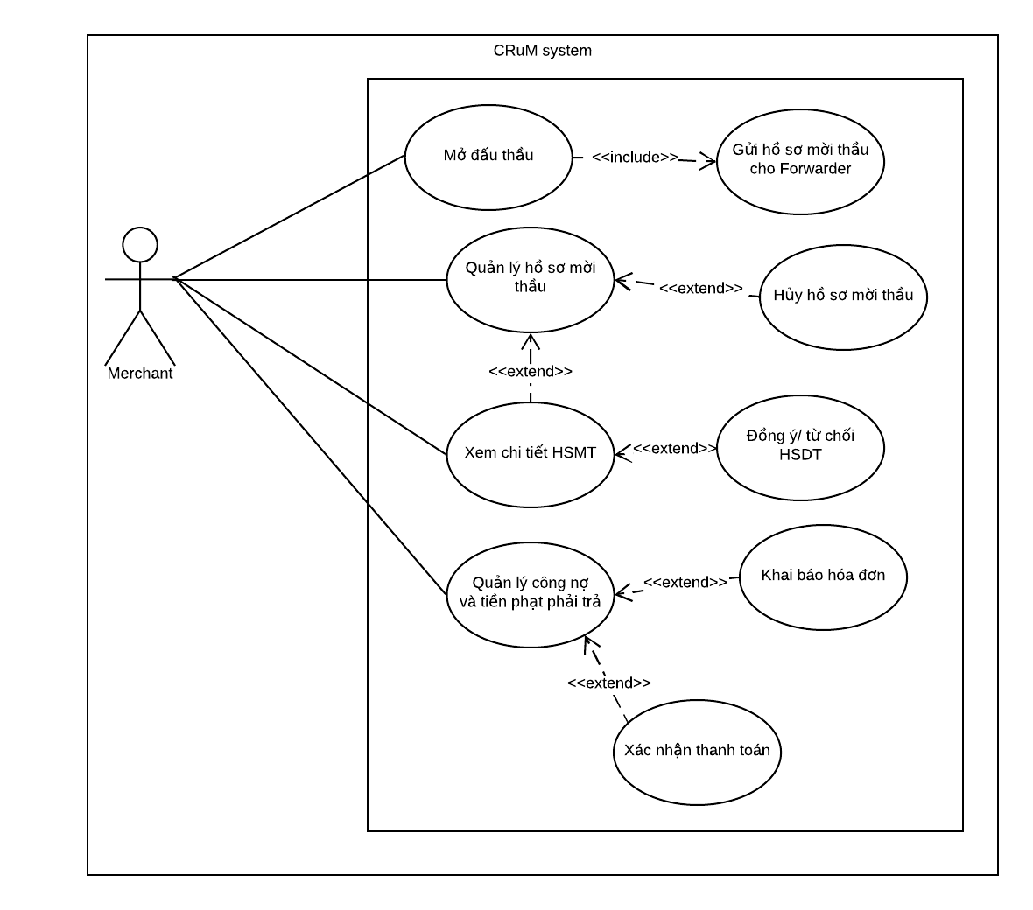

Figure 3.7 Merchant usecase

|  |  |  |  |  |
| --- | --- | --- | --- | --- |
| **USE CASE-CRUM-ME-01 SPECIFICATION** | | | | |
| **Use-case No.** | CRUM-ME-01 | **Use-case Version** | 1.0 |
| **Use-case Name** | Open bidding (Mở đấu thầu) | | |
| **Author** | Nguyen Duc Duong | | |
| **Date** | 31/05/2020 | **Priority** | High |
| **Actor:**  *Merchant*  **Summary:**  *This use case allows merchant to open bidding to find the best price for outbound shipment.*  **Goal:**  *Merchant will be able to open bidding for outbound and forwarder with matching condition can receive notification about bidding.*  **Triggers:**  *Merchant wants to find the best bid for the shipment.*  **Preconditions:**  *Merchant must log in with an outbound declared account that wants to open the bid*  *Outbound already created.*  *Outbound status must be “Đã tạo”.*  **Post Conditions:**  *Success: Bidding document (Hồ sơ mời thầu) created and notification of bidding sent to the forwarder.*  **Main Success Scenario:**     |  |  |  | | --- | --- | --- | | Step | Actor Action | System Response | | 1 | Click on “Quản lý HSMT” from sidebar. | Navigate to list bidding document (Hồ sơ mời thầu) page. | | 2 | Click button “Thêm mới”. | Open dialog “Thêm mới” contained 3 portions:   * Portion 1: Chọn hàng xuất đấu thầu * Portion 2: Chi tiết đấu thầu * Portion 3: Hoàn thành   Portion 1 contain Outbound infomation | | 3 | Choose outbound and click button “TIẾP TỤC” | Portion 2 expand contained:   * Ngày/ giờ mở thầu: Default current time – Cannot edit * Ngày/ giờ đóng thầu: Default current time – Cannot edit * Giá gói thầu: Default 0 * Giá sàn: Default 0 - optional * Checkbox allow multiple bidder to win | | 4 | Fill all the information and click button “TIẾP TỤC”. | Portion 3 expanded and contained:   * Checkbox Tự động gửi thư mời thầu: Default checked * Checkbox bạn đồng ý tất cả các thông tin đưa lên đều là chính xác | | 5 | Check the Checkbox and click button “Hoàn tất” | Show notification: “Tạo hồ sơ đấu thầu thành công ” |   **Alternative Scenario:**   |  |  |  | | --- | --- | --- | | Step | Actor Action | System Response | | 1 | After creating the outbound | Navigate to outbound list | | 2 | Click 3 dots icon | Show selection box contained:   * Mở đấu thầu * Chỉnh sửa * Xóa | | 3 | Click button “Thêm mới”. | Open dialog “Thêm mới” contained 3 portions:   * Portion 1: Chọn hàng xuất đấu thầu * Portion 2: Chi tiết đấu thầu * Portion 3: Hoàn thành   Portion 1 contain Outbound infomation | | 4 | Choose outbound and click button “TIẾP TỤC” | Portion 2 expand contained:   * Ngày/ giờ mở thầu: Default current time – Cannot edit * Ngày/ giờ đóng thầu: Default current time – Cannot edit * Giá gói thầu: Default 0 * Giá sàn: Default 0 - optional * Checkbox allow multiple bidder to win | | 5 | Fill all the information and click button “TIẾP TỤC” | Portion 3 expanded and contained:   * Checkbox: Tự động gửi thư mời thầu * Checkbox: bạn đồng ý tất cả các thông tin đưa lên đều là chính xác. | | 6 | Check the checkbox and click button “Hoàn tất” | Show notification: “Thêm mới thành công” |     **Exceptions:**   |  |  |  | | --- | --- | --- | | No | Actor Action | System Response | | 1 | “Ngày đóng thầu” earlier than current time and later than packing time. | Show notification: “Thời gian đóng thầu phải sau thời gian hiện tại và trước thời gian đóng hàng” | | 2 | “Ngày đóng thầu” earlier than “Ngày mở thầu” | Show notification: “Thời gian đóng thầu phải sau thời gian mở thầu” |   **Business Rules:**  *BR-8, BI-1, BI-2, BI-3, BI-5, BI-6, BI-7* | | | |

|  |  |  |  |  |
| --- | --- | --- | --- | --- |
| **USE CASE-CRUM-ME-02 SPECIFICATION** | | | | |
| **Use-case No.** | CRUM-ME-02 | **Use-case Version** | 1.0 |
| **Use-case Name** | View list of bidding document (Hồ sơ mời thầu) | | |
| **Author** | Nguyen Duc Duong | | |
| **Date** | 31/05/2020 | **Priority** | High |
| **Actor:**  *Merchant*  **Summary:**  *This use case allows merchant to view all bidding document (Hồ sơ mời thầu).*  **Goal:**  *Merchant can view all bidding document (Hồ sơ mời thầu) that have been created so far.*  **Triggers:**  *Merchant want to view bidding document (Hồ sơ mời thầu) information.*  **Preconditions:**  *Bidding document (Hồ sơ mời thầu) already created*  **Post Conditions:**  *Success: Show all bidding document (Hồ sơ mời thầu).*  **Main Success Scenario:**     |  |  |  | | --- | --- | --- | | Step | Actor Action | System Response | | 1 | Click on “Quản lý HSMT” from sidebar | Navigate to list bidding document (Hồ sơ mời thầu) page contained:   * Mã * Mã hàng xuất * Hãng tàu * Số cont * Giá gói thầu * Đóng thầu * Nhiều thầu thắng * Trạng thái * Hành động |   **Alternative Scenario:**  *N/A*  **Exceptions:**  *N/A*  **Business Rules:**  *BI-6, BI-7* | | | |

|  |  |  |  |  |
| --- | --- | --- | --- | --- |
| **USE CASE-CRUM-ME-03 SPECIFICATION** | | | | |
| **Use-case No.** | CRUM-ME-03 | **Use-case Version** | 1.0 |
| **Use-case Name** | Cancel bidding document (Hồ sơ mời thầu) | | |
| **Author** | Nguyen Duc Duong | | |
| **Date** | 31/05/2020 | **Priority** | Normal |
| **Actor:**  *Merchant*  **Summary:**  *Merchant does not want to open bidding anymore; this use case will allow merchant cancel bidding document (Hồ sơ mời thầu).*  **Goal:**  *Merchant will be able to cancel bidding document (Hồ sơ mời thầu). Bidding document status changed to CANCELED, notifications are sent to the forwarders who have entered the bid.*  **Triggers:**  *Merchant want to cancel bidding document (Hồ sơ mời thầu).*  **Preconditions:**  *Bidding document (Hồ sơ mời thầu) already created*  *Bidding document (Hồ sơ mời thầu) status has not changed to “Đã ghép”.*  **Post Conditions:**  *Success: Bidding document (Hồ sơ mời thầu) status change to “Đã hủy” and forwarder cannot bid anymore.*  **Main Success Scenario:**     |  |  |  | | --- | --- | --- | | Step | Actor Action | System Response | | 1 | Click on “Quản lý HSMT” from sidebar | Navigate to list bidding document (Hồ sơ mời thầu) page contained:   * Mã * Mã hàng xuất * Hãng tàu * Số cont * Giá gói thầu * Đóng thầu * Nhiều thầu thắng * Trạng thái * Hành động | | 2 | Click on icon on column “Hành động”. | Selection box showed:   * Chỉnh sửa * Chi tiết * Hủy bỏ * Xóa | | 3 | Choose button “Hủy thầu”. | Show “Hủy HSMT” dialog: “Bạn có chắc muốn hủy HSMT này?”   * Button: “Trở về”, “Hủy thầu” | | 4 | Choose “Hủy bỏ” button. | Show notification: “Hủy thầu thành công”  Bidding document (Hồ sơ mời thầu) status change to “Đã hủy” |   **Alternative Scenario:**  *N/A*  **Extension Flows:**   |  |  |  | | --- | --- | --- | | ET1 | At step 4 | | | No | Actor Action | System Response | | 1 | Click on “Trở về” | Back to Danh sách đấu thầu and nothing change |   **Exceptions:**   |  |  |  | | --- | --- | --- | | No | Actor Action | System Response | | 1 | Bidding document (Hồ sơ mời thầu) status is “Đã ghép” | Do not show “Hủy bỏ” |     **Business Rules:**  *BR-5***,** *BI-6, BI-7* | | | |

|  |  |  |  |  |
| --- | --- | --- | --- | --- |
| **USE CASE-CRUM-ME-04 SPECIFICATION** | | | | |
| **Use-case No.** | CRUM-ME-04 | **Use-case Version** | 1.0 |
| **Use-case Name** | See account receivable and payment extend declare the fines invoice | | |
| **Author** | Nguyen Duc Duong | | |
| **Date** | 31/05/2020 | **Priority** | Normal |
| **Actor:**  *Merchant*  **Summary:**  *When the forwarder charges a paymet for the merchant, this use case will allow the merchant to see payment and declare the payment invoice.*  **Goal:**  *Merchant will be able see all payment history and declare the payment invoice.*  **Triggers:**  *Merchant declare payments invoice to let forwarder confirm.*  **Preconditions:**  *Combined, Contract, Shipping info has been created.*  *Combined has been contracted.*  **Post Conditions:**  *Success: Merchant can declare the fine invoice and forwarder can receive it.*  *Fail: Merchant cannot declare the fine invoice and forwarder cannot receive it* **Main Success Scenario:**     |  |  |  | | --- | --- | --- | | Step | Actor Action | System Response | | 1 | Click on “Quản lý đấu thầu” from sidebar. | Extend list contained:   * Quản lý HSMT * Quản lý Hợp đồng * Quản lý Hóa đơn | | 2 | Click on “Quản lý hợp đồng” | Navigate to Contract list “Danh sách hợp đồng” page contained contract information:   * Mã * Bên chủ hàng * Bên chủ xe * Y/c hợp đồng * Giá hợp đồng * % tiền phạt * Ngày tạo hợp đồng * Hành động | | 3 | Merchant click 3 dots icon on column “Hành động” | Show selection menu:   * Tạo hóa đơn * Chỉnh sửa | | 4 | Merchant clicks on “Tạo hóa đơn” | Show “Thêm mới hóa đơn” dialog contained:   * Người gửi: Default: merchant username. * Người nhận: Default: forwarder username * Loại hóa đơn: Tiền phạt hợp đồng/ Thanh toán phí * Số tiền * Thời gian thanh toán: Datetime. * Giờ thanh toán: Default current time * Nội dung * Button “TRỞ về” and “THÊM MỚI” | | 5 | Merchant fills all information and clicks “Thêm mới” | Show notification: “Khai báo hóa đơn thành công”. |   **Alternative Scenario:**  *N/A*  **Extension Flows:**   |  |  |  | | --- | --- | --- | | ET1 | At step 5 | | | No | Actor Action | System Response | | 1 | Click on “Trở về” | Back to Danh sách hợp đồng |   **Exceptions:**     |  |  |  | | --- | --- | --- | | No | Actor Action | System Response | | 1 | Payment invalid amount | Show notification The mount is not valid | | 2 | Payment type not found | Show notification Invoice type not found |   **Business Rules:**  *BI-3, BI-5, BI-6, BI-7* | | | |

|  |  |  |  |  |
| --- | --- | --- | --- | --- |
| **USE CASE-CRUM-ME-05 SPECIFICATION** | | | | |
| **Use-case No.** | CRUM-ME-05 | **Use-case Version** | 1.0 |
| **Use-case Name** | See account receivable and fine to pay extend confirm the fine invoice | | |
| **Author** | Nguyen Duc Duong | | |
| **Date** | 31/05/2020 | **Priority** | Normal |
| **Actor:**  *Merchant*  **Summary:**  *When forwarder makes payment to merchant, an invoice will be sent to the merchant and this use case allows merchant see payment and confirm payment.*  **Goal:**  *Merchant will be able see payment history and confirm payment.*  **Triggers:**  *Forwarder sends the payment invoice for the merchant to confirm.*  **Preconditions:**  *Combined, Contract, Shipping info has been created.*  *Forwarder already declared invoice.*  **Post Conditions:**  *Success: Merchant can confirm the fine invoice and merchant invoice status updated.*  **Main Success Scenario:**     |  |  |  | | --- | --- | --- | | Step | Actor Action | System Response | | 1 | Click on “Quản lý đấu thầu” from sidebar. | Extend list contained:   * Quản lý HSMT * Quản lý Hợp đồng * Quản lý Hóa đơn | | 2 | Click on “Quản lý hóa đơn” from sidebar. | Navigate to Contract list “Danh sách hợp đồng” page contained contract information:   * Mã * Bên chủ hàng * Bên chủ xe * Y/c hợp đồng * Giá hợp đồng * % tiền phạt * Ngày tạo hợp đồng * Hành động | | 3 | Merchant clicks 3 dots icon on column “Hành động” | Show selection menu:   * Xem chi tiết * Xác nhận thanh toán | | 4 | Merchant clicks on “Xác nhận thanh toán” | Show “Xác nhận hóa đơn” box with notify:   * “Bạn xác nhận đã nhận đủ tiền theo đơn này?” * Mã * Button “TRỞ VỀ” and “XÁC NHẬN” | | 5 | Click “Xác nhận” | Show notification: “Cập nhật hóa đơn thành công”  Trạng thái change from “Đang chờ” to “Đã thanh toán”. |   **Alternative Scenario:**  *N/A*  **Extension Flows:**   |  |  |  | | --- | --- | --- | | ET1 | At step 4 | | | No | Actor Action | System Response | | 1 | Click on “Trở về” | Back to Danh sách hóa đơn |   **Exceptions:**  *N/A*  **Business Rules:**  *N/A* | | | |

|  |  |  |  |  |
| --- | --- | --- | --- | --- |
| **USE CASE-CRUM-ME-06 SPECIFICATION** | | | | |
| **Use-case No.** | CRUM-ME-06 | **Use-case Version** | 1.0 |
| **Use-case Name** | View bidding document (Hồ sơ mời thầu) detail | | |
| **Author** | Nguyen Duc Duong | | |
| **Date** | 31/05/2020 | **Priority** | High |
| **Actor:**  *Merchant*  **Summary:**  *This use case allows merchant to view detail of bidding document include bidding document, bidding information and list of bids.*  **Goal:**  *Merchant will be able to all the information about bidding document.*  **Triggers:**  *Merchant want to see some information about information relating to created bidding document.*  **Preconditions:**  *Merchant created bidding document.*  **Post Conditions:**  *Success:* *All the information about bidding document showed and merchant can see it.*  **Main Success Scenario:**     |  |  |  | | --- | --- | --- | | Step | Actor Action | System Response | | 1 | Merchant clicks on “Quản lý HSMT” from sidebar | Navigate to “Danh sách đấu thầu” page contain information of bidding document. | | 2 | Click on 3 dots icon on column “Hành động” | Show list contained:   * Chỉnh sửa * Xem chi tiết * Hủy bỏ * Xóa | | 3 | Click on “Xem chi tiết” | Navigate to detail page contained:   * Hồ sơ mời thầu: * Thông tin HSMT * Thông tin hàng xuất * Giá dẫn đầu: * Tham gia: * Còn lại: remaining time * Danh sách HSDT * Mã * Bên gửi HSMT * SĐT liên hệ * Giá thầu * Ngày thầu * Hiệu lực đến * Trạng thái |   **Alternative Scenario:**  *N/A*  **Exceptions:**  *N/A*  **Business Rules:**  *BR-1* | | | |

3.2.2.2.6 Admin use case

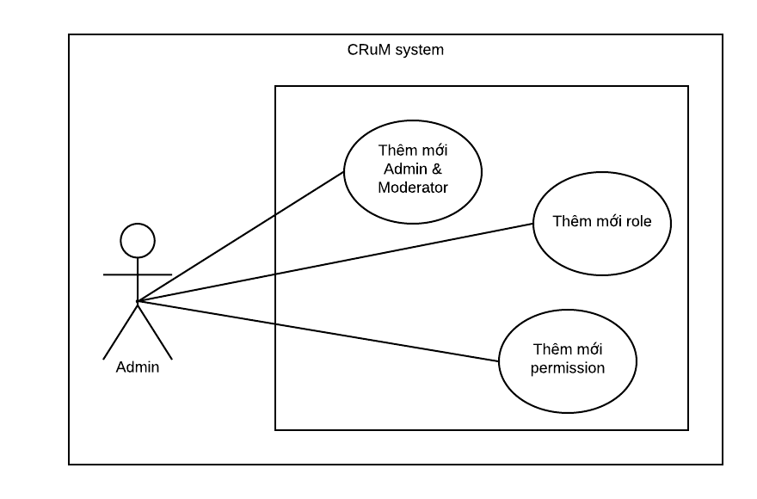

Figure 3.8 Admin usecase

|  |  |  |  |  |
| --- | --- | --- | --- | --- |
| **USE CASE-CRUM-AD-01 SPECIFICATION** | | | | |
| **Use-case No.** | CRUM-AD-01 | **Use-case Version** | 1.0 |
| **Use-case Name** | Add new Admin or Moderator | | |
| **Author** | Nguyen Duc Duong | | |
| **Date** | 31/05/2020 | **Priority** | Normal |
| **Actor:**  *Admin*  **Summary:**  *This use case allows admin to add new admin or moderator.*  **Goal:**  *New admin or moderator added.*  **Triggers:**  *Admin want to add new admin.*  **Preconditions:**  *Login as Admin*  **Post Conditions:**  *Success: New admin added*  **Main Success Scenario:**     |  |  |  | | --- | --- | --- | | Step | Actor Action | System Response | | 1 | Click on Quản lý quản trị viên from sidebar | Navigate to “Danh sách quản trị viên” page contained list of all admin and moderator. | | 2 | Click “Thêm mới” button | Open dialog “Thêm mới quản trị viên” contained:   * Tên đăng nhập * Mật khẩu * Email * Số điện thoại * Họ và tên * Địa chỉ * Phân quyền: selection box * Role_ADMIN * Role_MODERATOR | | 3 | Fill all information and Click “Thêm mới” | Show notification: “Thêm mới quản trị viên thành công” and new Admin/Moderator add in “Danh sách quản trị viên”. |   **Alternative Scenario:**  *N/A*  **Extension Flows:**   |  |  |  | | --- | --- | --- | | ET1 | At step 3 | | | No | Actor Action | System Response | | 1 | Click on “Trở về” | Back to Danh sách quản trị viên |   **Exceptions:**     |  |  |  | | --- | --- | --- | | No | Actor Action | System Response | | 1 | Duplicate username, phone, email, company code. | Show notification: Username, phone number, email or company code already exists. |   **Business Rules:**  *BI-1, BI-2, BI-3, BI-4, BI-5* | | | |

|  |  |  |  |  |
| --- | --- | --- | --- | --- |
| **USE CASE-CRUM-AD-02 SPECIFICATION** | | | | |
| **Use-case No.** | CRUM-AD-02 | **Use-case Version** | 1.0 |
| **Use-case Name** | Add new Role | | |
| **Author** | Nguyen Duc Duong | | |
| **Date** | 31/05/2020 | **Priority** | Normal |
| **Actor:**  *Admin*  **Summary:**  *This use case allows admin to add new Role for CRuM system.*  **Goal:**  *New Role added List of Role.*  **Triggers:**  *System need new Role.*  **Preconditions:**  *Login as Admin*  *Permission already created*  **Post Conditions:**  *Success: New Role added*  **Main Success Scenario:**     |  |  |  | | --- | --- | --- | | Step | Actor Action | System Response | | 1 | Click on “Quản lý vai trò” from sidebar | Navigate to “Danh sách vai trò” page contained list of all roles. | | 2 | Click “Thêm mới” button | Show pop up box “Thêm mới Đặc quyền” contained:   * Tên đặc quyền * Phân vai trò * Button “TRỞ VỀ” and “THÊM MỚI” | | 3 | Fill all information and Click “Thêm mới” | Show notification: “Tạo mới vai trò thành công” and new permission add in “Danh sách quyền”. |   **Alternative Scenario:**  *N/A*  **Extension Flows:**   |  |  |  | | --- | --- | --- | | ET1 | At step 3 | | | No | Actor Action | System Response | | 1 | Click on “Trở về” | Back to Danh sách quyền |   **Exceptions:**     |  |  |  | | --- | --- | --- | | No | Actor Action | System Response | | 1 | Duplicate role | Show notification: “Vai trò đã tồn tại” |   **Business Rules:**  *BI-1, BI-5* | | | |

|  |  |  |  |  |
| --- | --- | --- | --- | --- |
| **USE CASE-CRUM-AD-03 SPECIFICATION** | | | | |
| **Use-case No.** | CRUM-AD-03 | **Use-case Version** | 1.0 |
| **Use-case Name** | Add new Permission | | |
| **Author** | Nguyen Duc Duong | | |
| **Date** | 01/06/2020 | **Priority** | Normal |
| **Actor:**  *Admin*  **Summary:**  *This use case allows admin to add new permission for role.*  **Goal:**  *New Permission added List of permission.*  **Triggers:**  *Role need new permission.*  **Preconditions:**  *Login as Admin*  **Post Conditions:**  *Success: New permission added*  **Main Success Scenario:**     |  |  |  | | --- | --- | --- | | Step | Actor Action | System Response | | 1 | Click on “Quản lý đặc quyền” from sidebar | Navigate to “Danh sách đặc quyền” page contained list of all permission. | | 2 | Click “Thêm mới” button | Show pop up box “Thêm mới Đặc quyền” contained:   * Tên đặc quyền * Mô tả * Button “TRỞ VỀ” and “THÊM MỚI” | | 3 | Fill all information and Click “Thêm mới” | Show notification: “Thêm mới quyền hạn thành công” and new Permission add in “Danh sách vai trò”. |   **Alternative Scenario:**  *N/A*  **Extension Flows:**   |  |  |  | | --- | --- | --- | | ET1 | At step 3 | | | No | Actor Action | System Response | | 1 | Click on “Trở về” | Back to Danh sách đặc quyền |   **Exceptions:**   |  |  |  | | --- | --- | --- | | No | Actor Action | System Response | | 1 | Duplicate permission | Show notification: “Phân quyền đã tồn tại” |   **Business Rules:**  *BI-1, BI-5* | | | |

3.2.2.2.7 Moderator use case

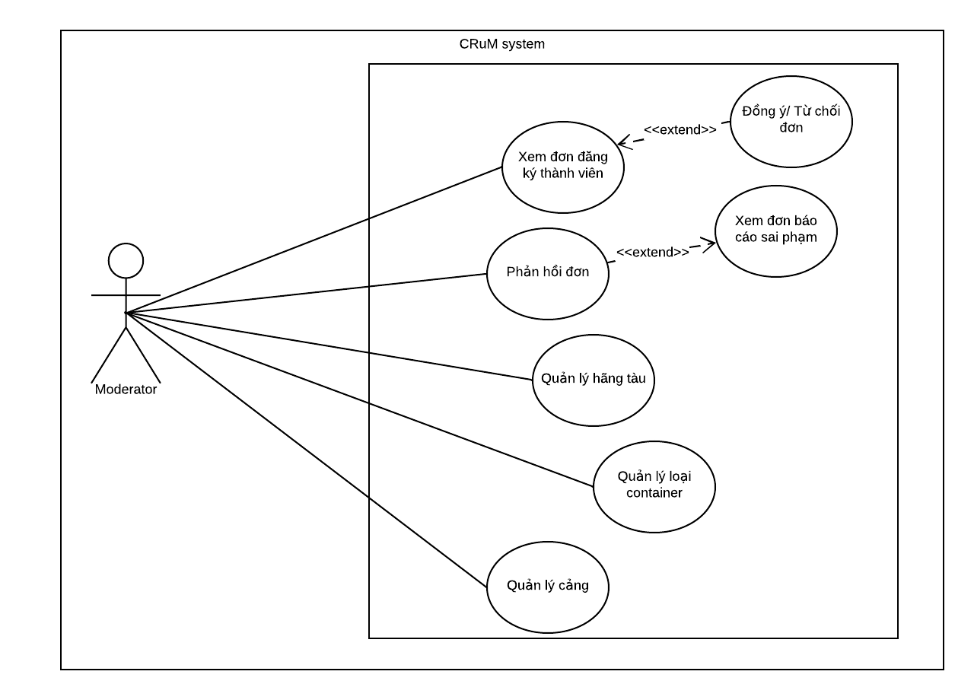

Figure 3.9 Moderator usecase

|  |  |  |  |  |
| --- | --- | --- | --- | --- |
| **USE CASE-CRUM-MOD-01 SPECIFICATION** | | | | |
| **Use-case No.** | CRUM-MOD-01 | **Use-case Version** | 1.0 |
| **Use-case Name** | View application form and agree to the registration form | | |
| **Author** | Nguyen Duc Duong | | |
| **Date** | 01/06/2020 | **Priority** | Normal |

|  |  |  |  |  |  |  |  |  |  |  |  |  |  |  |  |  |  |  |  |  |  |  |  |  |  |  |  |  |  |  |  |  |  |
| --- | --- | --- | --- | --- | --- | --- | --- | --- | --- | --- | --- | --- | --- | --- | --- | --- | --- | --- | --- | --- | --- | --- | --- | --- | --- | --- | --- | --- | --- | --- | --- | --- | --- |
| **Actor:**  *Moderator*  **Summary:**  *After the guest registers to become merchant or forwarder, the application will be sent to the moderator for approval, this use case allows moderator to view/ agree to the application.*  **Goal:**  *Moderator can see all information of application form and Account is validated, and can use functions of the role.*  **Triggers:**  *There is a registration form sent to the moderator.*  **Preconditions:**  *Login as Moderator.*  *A registration form been submitted.*  **Post Conditions:**  *Success: Moderator can see all information of registration form and account is validated.*  **Main Success Scenario:**     |  |  |  | | --- | --- | --- | | Step | Actor Action | System Response | | 1 | Click on “Quản lý đơn đăng ký” from sidebar | Navigate to “Danh sách đơn đăng ký” page contained list of all application form.   * Mã * Tên đăng nhập * Email * Người liên hệ * Tên công ty * Mã số thuế * Trang web * Vai trò * Trạng thái * Hành động | | 2 | Click 3 dots button under hành động. | Show selection list contained:   * Xem chi tiết * Đồng ý đơn * Từ chối đơn | | 3 | Click “Đồng ý đơn” | Show dialog “Xác nhận đồng ý đơn đăng ký contained:   * Bạn có chắc chắn muốn đồng ý tài khoản này * Tên công ty * Button: “TRỞ VỀ” and “ĐỒNG Ý” | | 4 | Click “ĐỒNG Ý” | Show notification: “Đơn đăng ký đã được chấp nhận” |   **Alternative Scenario:**  *N/A*  **Extension Flows:**   |  |  |  | | --- | --- | --- | | ET1 | At step 3 | | | No | Actor Action | System Response | | 1 | Click on “Xem chi tiết” | Open box contain registration form detail |  |  |  |  | | --- | --- | --- | | ET2 | At step 4 | | | No | Actor Action | System Response | | 1 | Click on “Trở về” | Back to Danh sách đơn đăng ký |   **Exceptions:**  *N/A*  **Business Rules:**  *BI-1, BI-2, BI-3, BI-4, BI-5* |

|  |  |  |  |  |
| --- | --- | --- | --- | --- |
| **USE CASE-CRUM-MOD-02 SPECIFICATION** | | | | |
| **Use-case No.** | CRUM-MOD-02 | **Use-case Version** | 1.0 |
| **Use-case Name** | View application form and rejects the registration form. | | |
| **Author** | Nguyen Duc Duong | | |
| **Date** | 01/06/2020 | **Priority** | Normal |
| **Actor:**  *Moderator*  **Summary:**  *After the guest registers to become merchant or forwarder, the application will be sent to the moderator for approval, this use case allows moderator to view/ rejects to the application*  **Goal:**  *Moderator can see all information of application form and account is rejected.*  **Triggers:**  *There is a registration form sent to the moderator.*  **Preconditions:**  *Login as Moderator.*  *A registration form has been submitted.*  **Post Conditions:**  *Success: Moderator can see all information of registration form and account is denied*  **Main Success Scenario:**     |  |  |  | | --- | --- | --- | | Step | Actor Action | System Response | | 1 | Click on “Quản lý đơn đăng ký” from sidebar | Navigate to “Danh sách đơn đăng ký” page contained list of all application form.   * Mã * Tên đăng nhập * Email * Người liên hệ * Tên công ty * Mã số thuế * Trang web * Vai trò * Trạng thái * Hành động | | 2 | Click 3 dots button under hành động. | Show selection list contained:   * Xem chi tiết * Đồng ý đơn * Từ chối đơn | | 3 | Click “Từ chối đơn” | Show dialog “Xác nhận từ chối đơn đăng ký contained:   * Bạn có chắc chắn muốn từ chối tài khoản này * Tên công ty * Button: “TRỞ VỀ” and “từ chối” | | 4 | Click “từ CHỐI” | Show notification: “Đơn đăng ký đã bị từ chối” |   **Alternative Scenario:**  *N/A*  **Extension Flows:**   |  |  |  | | --- | --- | --- | | ET1 | At step 3 | | | No | Actor Action | System Response | | 1 | Click on “Xem chi tiết” | Open box contain registration form detail |  |  |  |  | | --- | --- | --- | | ET2 | At step 4 | | | No | Actor Action | System Response | | 1 | Click on “Trở về” | Back to Danh sách đơn đăng ký |  |  |  |  | | --- | --- | --- | | ET2 | At step 5 | | | No | Actor Action | System Response | | 1 | Click on “Trở về” | Back to detail application form. |   **Exceptions:**  *N/A*  **Business Rules:**  *BI-1, BI-2, BI-3, BI-4, BI-5* | | | |

|  |  |  |  |  |
| --- | --- | --- | --- | --- |
| **USE CASE-CRUM-MOD-03 SPECIFICATION** | | | | |
| **Use-case No.** | CRUM-MOD-03 | **Use-case Version** | 1.0 |
| **Use-case Name** | View and reply report | | |
| **Author** | Nguyen Duc Duong | | |
| **Date** | 01/06/2020 | **Priority** | Normal |
| **Actor:**  *Moderator*  **Summary:**  *This use case allows a moderator to view and reply to a report that forwarder was sent.*  **Goal:**  *Moderator can see all information of report form and reply it, forwarder receives a notification when the moderator responds to the report.*  **Triggers:**  *A report has been sent.*  **Preconditions:**  *Login as Moderator.*  *A report form has been submitted.*  **Post Conditions:**  *Success: Moderator can see all information of report form and reply it to sender.*  *Fail: Cannot see report or feedback to the report*  **Main Success Scenario:**     |  |  |  | | --- | --- | --- | | Step | Actor Action | System Response | | 1 | Click “Quản lý report” from sidebar | Navigate to “Danh sách report” page | | 2 | Click on 3 dots button on Hành động column | Show selection list:   * Xem chi tiết | | 3 | Click on “Xem chi tiết” | Navigate to feedback detail | | 4 | Enter feedback in the "Phản hồi tới forwarder" section at the bottom of the page and press enter | Feedback is displayed in the feedback box. |   **Alternative Scenario:**     |  |  |  | | --- | --- | --- | | Step | Actor Action | System Response | | 1 | After report sent, notification icon in menu bar show notification. Click on that icon | Message show: You got a new Report from forwarder. | | 2 | Click on the message | Navigate to report detail | | 3 | Enter feedback in the "Feedback" section at the bottom of the page and press enter | Feedback is displayed in the feedback box. |   **Extension Flows:**   |  |  |  | | --- | --- | --- | | ET1 | At step 2 | | | No | Actor Action | System Response | | 1 | Click on “Xem HSMT” button | Navigate to Bidding document (Hồ sơ mời thầu) detail. |   **Exceptions:**   |  |  |  | | --- | --- | --- | | No | Actor Action | System Response | | 1 | Report status not found | Show notification: Not found report status |   **Business Rules:**  *BI-1* | | | |

|  |  |  |  |  |
| --- | --- | --- | --- | --- |
| **USE CASE-CRUM-MOD-04 SPECIFICATION** | | | | |
| **Use-case No.** | CRUM-MOD-04 | **Use-case Version** | 1.0 |
| **Use-case Name** | Declare shipping line | | |
| **Author** | Nguyen Duc Duong | | |
| **Date** | 01/06/2020 | **Priority** | Normal |
| **Actor:**  *Moderator*  **Summary:**  *This use case allows moderator declare new shipping line*  **Goal:**  *The new shipping line has been declared.*  **Triggers:**  *New shipping line need to be declared.*  **Preconditions:**  *Login as Moderator.*  **Post Conditions:**  *Success: New shipping line has been declared.*  *Fail: No shipping line has been declared*  **Main Success Scenario:**     |  |  |  | | --- | --- | --- | | Step | Actor Action | System Response | | 1 | Click on “Quản lý hãng tàu” from sidebar | Navigate to “Danh sách hãng tàu” dialog contained list of all shipping line.   * Mã * Tên đăng nhập * Email * Người liên hệ * Tên công ty * Mã số thuế * Trang web * Trạng thái * Hành động | | 2 | Click “Thêm mới” button | Navigate to “Thêm mới hãng tàu” dialog contained 3 portions:   * Portion 1: Thêm mới hãng tàu. * Portion 2: Thông tin hãng tàu. * Portion 3: Hoàn thành.   Portion 1: Thêm mới hãng tàu contained:   * Tên đăng nhập. * Mật khẩu. * Email. * Số điện thoại. * Địa chỉ. * Button: TIẾP TỤC | | 3 | Fill all information and click “TIẾP TỤC” | Portion 2 expand contained:   * Mã công ty * Tên công ty * Người liên hệ * Website * Mô tả * Địa chỉ công ty * Mã số thuế * Fax * Button: “TIẾP TỤC” and “QUAY LẠI” | | 4 | Fill all information and click “TIẾP TỤC” | Portion 3 expand contained:   * Checkbox: Bạn đồng ý muốn thêm hãng tàu với những thông tin trên. * Button: “Hoàn tất” and “QUAY LẠI” | | 5 | Check the checkbox and click “Hoàn tất” | Show notification: “Thêm mới hãng tàu thành công” Navigate to “Danh sách hãng tàu” and new shipping line has been declared. |   **Alternative Scenario:**  *N/A*  **Extension Flows:**   |  |  |  | | --- | --- | --- | | ET1 | At step 3 | | | No | Actor Action | System Response | | 1 | Click on “QUAY LẠI” | Back to portion 1. |  |  |  |  | | --- | --- | --- | | ET2 | At step 4 | | | No | Actor Action | System Response | | 1 | Click on “QUAY LẠI” | Back to portion 2. |   **Exceptions:**   |  |  |  | | --- | --- | --- | | No | Actor Action | System Response | | 1 | Duplicate Shippingline | Show notification: “Hãng tàu đã tồn tại” |   **Business Rules:**  *BI-1, BI-2, BI-3, BI-4, BI-5* | | | |

|  |  |  |  |  |
| --- | --- | --- | --- | --- |
| **USE CASE-CRUM-MOD-05 SPECIFICATION** | | | | |
| **Use-case No.** | CRUM-MOD-05 | **Use-case Version** | 1.0 |
| **Use-case Name** | Declare Container type | | |
| **Author** | Nguyen Duc Duong | | |
| **Date** | 01/06/2020 | **Priority** | Normal |
| **Actor:**  *Moderator*  **Summary:**  *This use case allows moderator declare new container type*  **Goal:**  *The new container type has been declared.*  **Triggers:**  *New container type need to be declared.*  **Preconditions:**  *Login as Moderator.*  **Post Conditions:**  *Success: New container type has been declared.*  *Fail: New container types are not declared.*  **Main Success Scenario:**     |  |  |  | | --- | --- | --- | | Step | Actor Action | System Response | | 1 | Click on “Quản lý loại cont” from Sidebar | Navigate to “Danh sách loại Container” dialog contained list of all container type.   * Mã * Tên loại: Name * Mô tả: description * Khối lượng vỏ: tareWeight * Sức chứa: grossWeight * Thể tích: cubicCapacity * Dài trong: internalLength * Rộng trong: internalWidth * Cao trong: internalHeight * Rộng cửa mở: doorOpeningWidth. * Cao cửa mở: doorOpeningHeight. | | 2 | Click “Thêm mới” button | Navigate to “Thêm mới loại Container” contained:   * Tên loại: Name * Khối lượng vỏ: tareWeight * Trọng tải: grossWeight * Thể tích khối: cubicCapacity * Chiều dài trong: internalLength * Chiều rộng trong: internalWidth * Chiều cao trong: internalHeight * Chiều rộng cửa mở: doorOpeningWidth. * Chiều cao cửa mở: doorOpeningHeight. * Chi tiết * Button “TRỞ về” and “Thêm mới” | | 3 | Fill all information and click “Thêm mới” | Show notification: Thêm mới thành công loại Container. |   **Alternative Scenario:**  *N/A*  **Extension Flows:**   |  |  |  | | --- | --- | --- | | ET1 | At step 3 | | | No | Actor Action | System Response | | 1 | Click on “Trở về” | Back to “Danh sách loại container” |   **Exceptions:**     |  |  |  | | --- | --- | --- | | No | Actor Action | System Response | | 1 | Duplicate container type | Show notification: “Container đã tồn tại” |   **Business Rules:**  *BI-1, BI-2, BI-3, BI-4, BI-5* | | | |

|  |  |  |  |  |
| --- | --- | --- | --- | --- |
| **USE CASE-CRUM-MOD-06 SPECIFICATION** | | | | |
| **Use-case No.** | CRUM-MOD-06 | **Use-case Version** | 1.0 |
| **Use-case Name** | Declare port | | |
| **Author** | Nguyen Duc Duong | | |
| **Date** | 01/06/2020 | **Priority** | Normal |
| **Actor:**  *Moderator*  **Summary:**  *This use case allows moderator declare new port.*  **Goal:**  *The new port has been declared.*  **Triggers:**  *New port need to be declared.*  **Preconditions:**  *Login as Moderator.*  **Post Conditions:**  *Success: New container type has been declared.*  **Main Success Scenario:**     |  |  |  | | --- | --- | --- | | Step | Actor Action | System Response | | 1 | Click on “Quản lý cảng” from sidebar | Navigate to “Danh sách bến cảng” page contained list of all port.   * Mã * Mã cảng: nameCode. * Tên cảng: fullname. * Địa chỉ: address. * Hành động: action (Chỉnh sửa/ Xóa bỏ) | | 2 | Click “Thêm mới” button | Pop-up box “Thêm mới cảng” showed contained:   * Mã cảng: nameCode * Tên cảng: fullname * Vị trí cảng: address * Map * Button “TRỞ VỀ” and “Thêm mới” | | 3 | Fill all information | Map show location of port | | 4 | Click “Thêm mới” button | Show notification: “Thêm mới cảng thành công”  Pop-up box closed and back to “Danh sách bến cảng” |   **Alternative Scenario:**  *N/A*  **Extension Flows:**   |  |  |  | | --- | --- | --- | | ET1 | At step 4 | | | No | Actor Action | System Response | | 1 | Click on “Hủy” | Back to “Danh sách bến cảng” |   **Exceptions:**   |  |  |  | | --- | --- | --- | | No | Actor Action | System Response | | 1 | Duplicate port | Show notification: Port already exits |   **Business Rules:**  *BI-1, BI-2, BI-3* | | | |

3.2.2.2.8 Shipping line use case

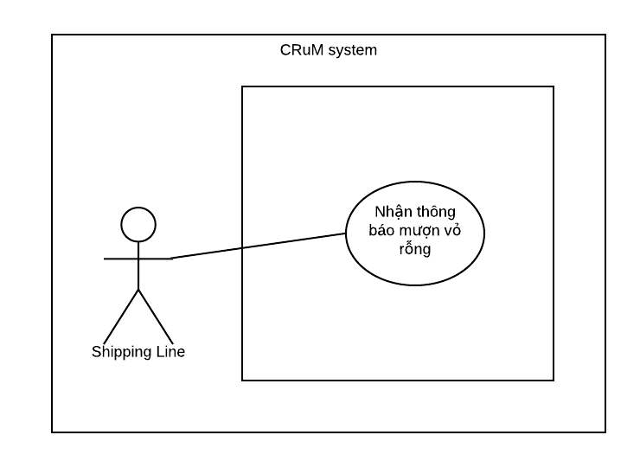

Figure 3.10 Shipping line usecase

|  |  |  |  |  |
| --- | --- | --- | --- | --- |
| **USE CASE-CRUM-SL-01 SPECIFICATION** | | | | |
| **Use-case No.** | CRUM-SL-01 | **Use-case Version** | 1.0 |
| **Use-case Name** | Receive notification of borrowing a container shell | | |
| **Author** | Nguyen Duc Duong | | |
| **Date** | 01/06/2020 | **Priority** | Normal |
| **Actor:**  *Shipping line*  **Summary:**  *This use case allows Shipping receive notification of borrowing a container shell.*  **Goal:**  *Information about request for container shell is sent to the shipping line*  **Triggers:**  *Combined already create*  **Preconditions:**  *Login as Shipping line*  **Post Conditions:**  *Success: Borrowing notification are sent to the shipping line.*  **Main Success Scenario:**     |  |  |  | | --- | --- | --- | | Step | Actor Action | System Response | | 1 | Click on “Thông báo mượn” from sidebar | Navigate to “Danh sách yêu cầu mượn container” page contained:   * Mã * Bến mượn * Nội dung * Ngày gửi y/c * Loại yêu cầu |   **Alternative Scenario:**     |  |  |  | | --- | --- | --- | | Step | Actor Action | System Response | | 1 | Click on notification icon on menubar | Show notification: “” | | 2 | Click on notification | Navigate to “Danh sách yêu cầu mượn container” page contained:   * Mã * Bến mượn * Nội dung * Ngày gửi y/c * Loại yêu cầu |   **Extension Flows:**  *N/A*  **Exceptions:**  *N/A*  **Business Rules:**  *N/A* | | | |

3.2.2.2.9 Driver use case

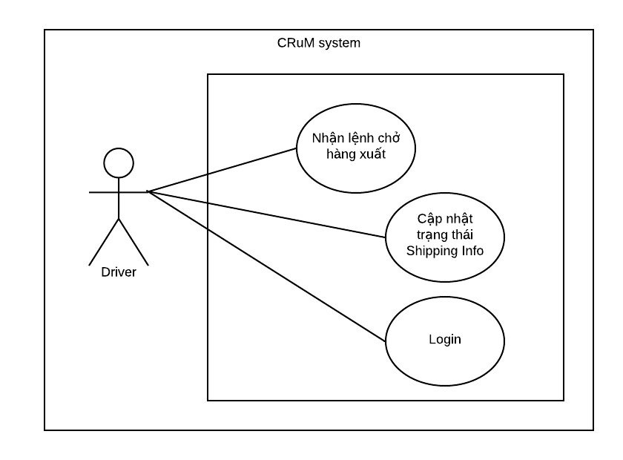

Figure 3.11 Driver usecase

|  |  |  |  |  |
| --- | --- | --- | --- | --- |
| **USE CASE-CRUM-DR-01 SPECIFICATION** | | | | |
| **Use-case No.** | CRUM-DR-01 | **Use-case Version** | 1.0 |
| **Use-case Name** | Login | | |
| **Author** | Nguyen Duc Duong | | |
| **Date** | 27/05/2020 | **Priority** | Normal |
| **Actor:**  *Driver.*  **Summary:**  *This use case allows driver to be able to log in to the system and use the functions.*  **Goal:**  *Driver can access the system and use functions based on user roles.*  **Triggers:**  *Driver want to use the functions of the system.*  **Preconditions:**  *Driver has declared.*  *Driver device is connected to the internet.*  **Post Conditions:**  *Success: Driver can access the application and use functions of the system.*  **Main Success Scenario:**     |  |  |  | | --- | --- | --- | | Step | Actor Action | System Response | | 1 | Click on application on Android mobile device | Open the app and login page contained:   * Tên đăng nhập * Mật khẩu * Button: “ĐĂNG NHẬP” | | 2 | Fill “Tên đăng nhập” and “Mật khẩu” with declared account and click button “Đăng nhập”. | Access application |   **Alternative Scenario:**  *N/A*  **Extension Flows:**  *N/A*  **Exceptions:**     |  |  |  | | --- | --- | --- | | No | Actor Action | System Response | | 1 | Enter wrong “Tên đăng nhập” or “Password” | Show notification wrong username or password. |   **Business Rules:**  *BR-4, BI-1.* | | | |

### 3.2.3. Software System Attributes

3.2.3.1 Reliability

3.2.3.1.1 Graphic User Interface

* The main language of texts, labels, button… is Vietnamese.

3.2.3.1.2 Usability

* Admin, moderator need less than one week of training to be productive with the system.
* Guest and member can use the system easily.
* A function is divided into small sections for users to easily access and use

3.2.3.2 Availability

* System should be available 24/7.
* The annual downtime is no more than 1 hour.

3.2.3.3 Security

* System always check authentication before doing anything
* Each user role has a specific permission to interact with system
* Any user who wants to participate in the system must be approved for registration by the moderator.
* When a user forgets his password, the link to reset password must be sent to only the registered email address.

3.2.3.4 Maintainability

* The system is divided into separated modules.
* The code is easy to maintain and upgrade.
* All code must be written according to the java coding standards

3.2.3.5 Portability

* User can use everywhere with web browsers and internet.

3.2.3.6 Performance

* All data input and output screens need to be ready to display to the user within 3 seconds, provided the load and connection between the cilent / server is normal, namely:
  + For the input screen: up to 30 data fields, no complicated data calculations, no interaction with external systems, can store data directly to the DB, and not store large content files like: pictures, videos, files exceeding 3MB.
  + For screen output:
    - data is queried directly from DB, limiting complex queries, queries from external systems.
    - Displays up to 50 rows of data, up to 10 columns per row, and each data less than 100 characters in length.
  + Normal load condition: 300 CCU (concurrent user - concurrent users) when load balancing is not used.
  + Minimum server condition: Intel Core i5, 4GB RAM, 500GB hard disk.
  + Client / Server Connection: 500KB / s

## **3.3. Entity Relationship Diagram or Data Structures**

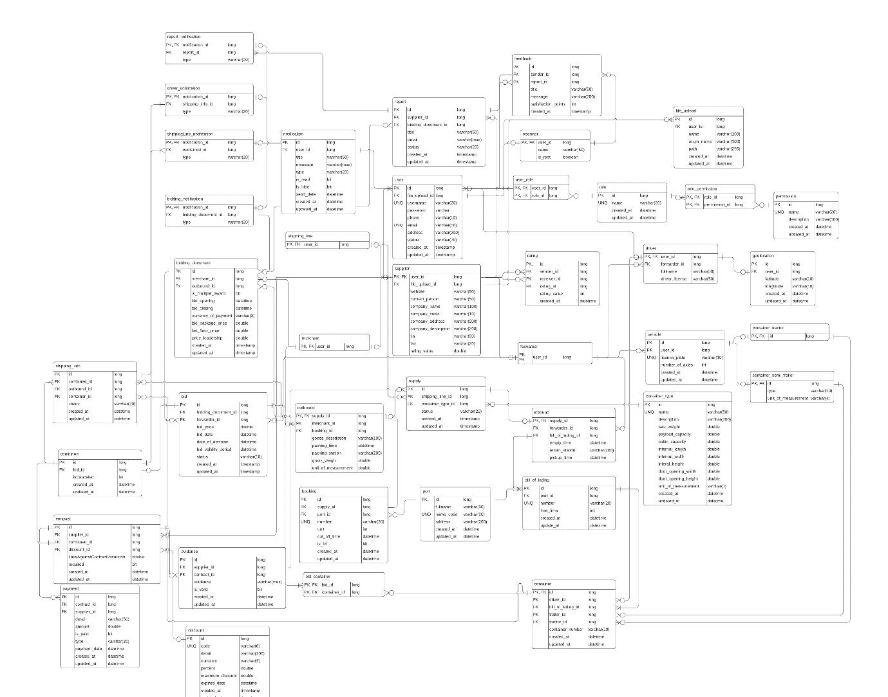

Figure 3.12 Entity relationship diagram

Please refer to the below website for more details: <https://app.lucidchart.com/documents/edit/15640228-e2bc-41c5-8668-fe04bb582303/hoEaFE57LY~~?shared=true&fbclid=IwAR1_B8VPmgeDDMP6e7FlsHeH6W6Fz4ErbLd34dYy55iZDc5uooxxIVq_YC0>

## **3.4. Other material**

### 3.4.1. Business rule repository

**Domain business rule:**

|  |  |
| --- | --- |
| **No** | **Description** |
| BR-1 | One combined has only one bid. |
| BR-2 | One Inbound has only one bill of lading |
| BR-3 | One Outbound has only one Booking |
| BR-4 | A login session will expire in 1 day if no action is taken. |
| BR-5 | Bidding document (Hồ sơ mời thầu) cannot be deleted if there are bidders |
| BR-6 | Supply cannot be deleted if status different than CREATED. |
| BR-7 | Cannot edit when validity not come yet. |
| BR-8 | Bid closing time must later than current time and earlier than packing time. |

Table 3.2 Domain business rule

**Specific business rule:**

|  |  |
| --- | --- |
| **No** | **Description** |
| BI-1 | The field must be filled by characters consist of alphabet, numbers and space. |
| BI-2 | The field must be filled by characters consist of alphabet and numbers. |
| BI-3 | The field must be filled by characters consist of numbers. |
| BI-4 | The field must be filled, follow by format “X@X.Y”, where X is characters and Y is alphabets. X and Y are at least 1 character. |
| BI-5 | Must enter from 2 to 200 characters. |
| BI-6 | Date follow format YYYY-mm-dd. |
| BI-7 | Time follow format hh:mm a |

Table 3.3 Specific business rule

# **4. Software Design Description**

## **4.1. Design Overview**

* This document describes the technique and user interface design of COID System. It includes the architectural design, and detailed design of common functions, business functions and the design of database model.
* The architectural design describes the overall architecture of the system, each main component and subsystem.
* The detailed design describes static and dynamic structure for each component and function. It includes class diagrams, class explanation and sequence diagrams for each use cases.
* The database design describes the relationships between entities and their details.

## **4.2. System Architectural Design**

### 4.2.1 Architecture Pattern

* Single Page Application is selected as the architectural pattern of system

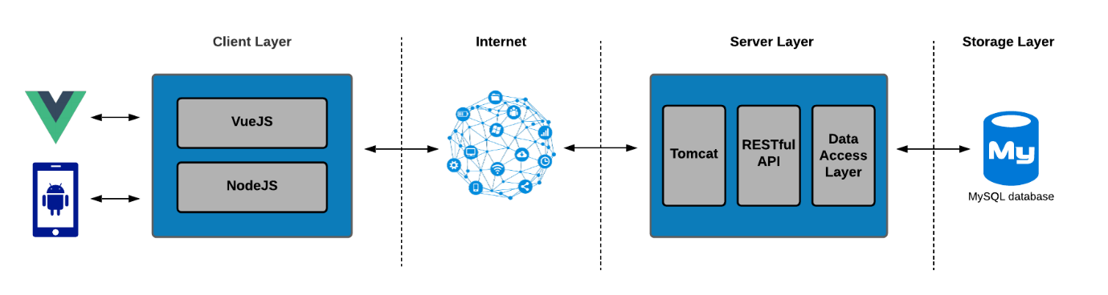

Figure 4.1 Architechture pattern

* CRuM using Single Page Application because it has some advantages suitable for the system
  + Use the website faster.
  + User friendly
  + Suitable for team frameworks and programming languages

### 4.2.2 Technology Stack

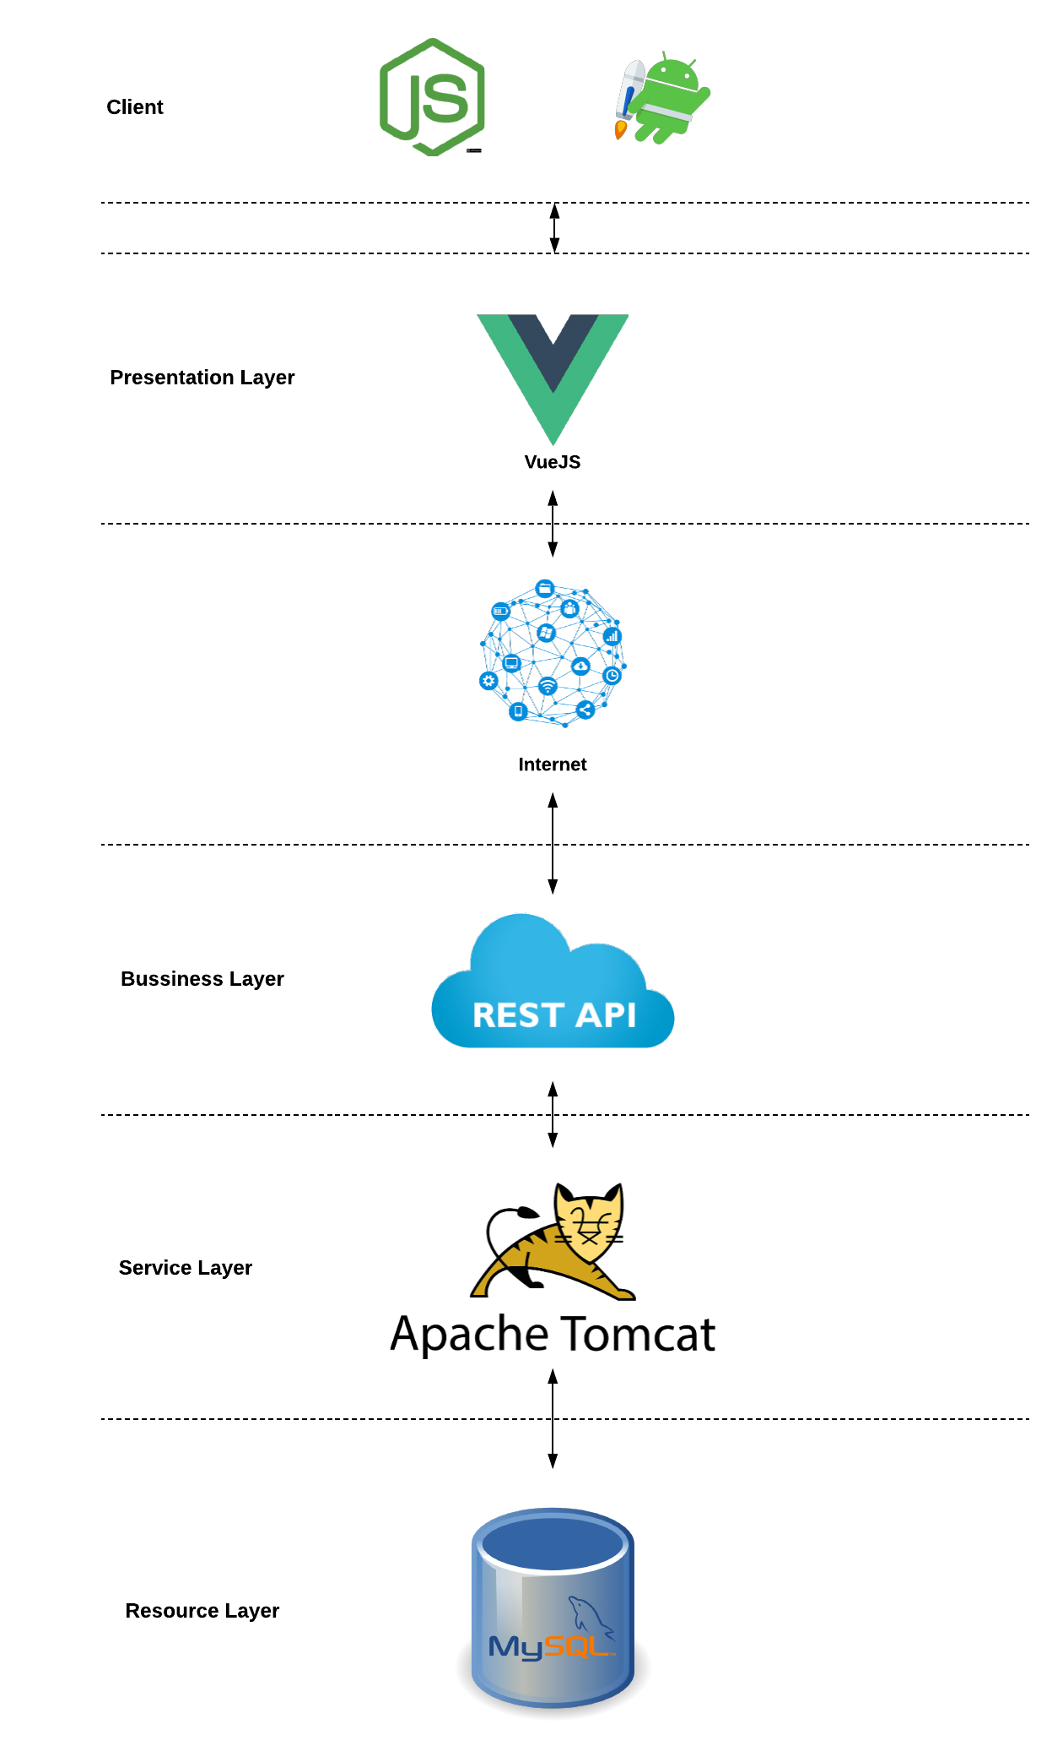

Figure 4.2 Technology stack

4.2.2.1 Presentation layer

* Front-end code using VueJS.
* Using Component Library of VueJS
  + VueJS
  + Vuetify
  + Vue Axios
  + Vue Router
  + VueX
  + Vue Property Decorator
  + SockJS
* The frontend (worker) code is a NodeJS version v12.18.3.
* Frontend package manager is npm.

4.2.2.2 Bussiness Layer

* The development components include the Rest APIs.
* Backend package manager is mvn.

4.2.2.3 Service Layer

* The Backend (worker) code is a Tomcat version v9.0.37.

4.2.2.4 Storage Layer

* Data will store in MySQL Workbench 8.0CE

### 4.2.3 Component

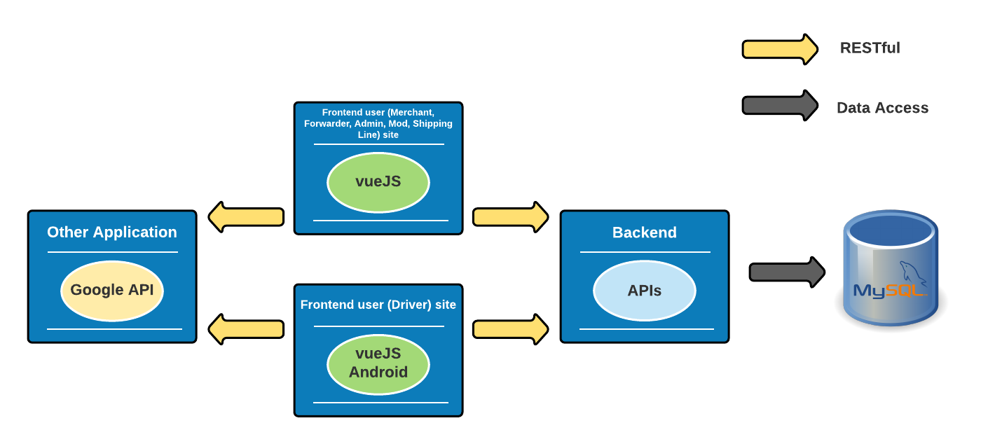

Figure 4.3 Component

|  |  |  |
| --- | --- | --- |
| **No** | **Actor** | **Description** |
| 1 | Backend API | RESTful API |
| 2 | Frontend Driver site | Android frontend component for Driver |
| 3 | Frontend Other user site | Frontend site for all User |
| 4 | Other Applications | Google API |

Table 4.1 Component description

### 4.2.4 Backend Modules

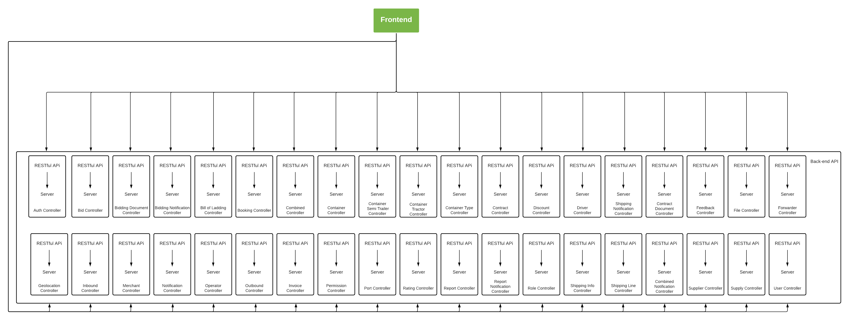

Figure 4.4 Backend modules

Each business module is composed by two main sub-modules:

* + Rest Controller: Rest API endpoint implementation.
  + Service: Business logic implementation.

Business modules use Repository layer to access DB.

### 4.2.5 Front-end sites

* + Following 2Kick pattern, the front-end component handles and Component Library all UI tasks in the application, using VueJS.

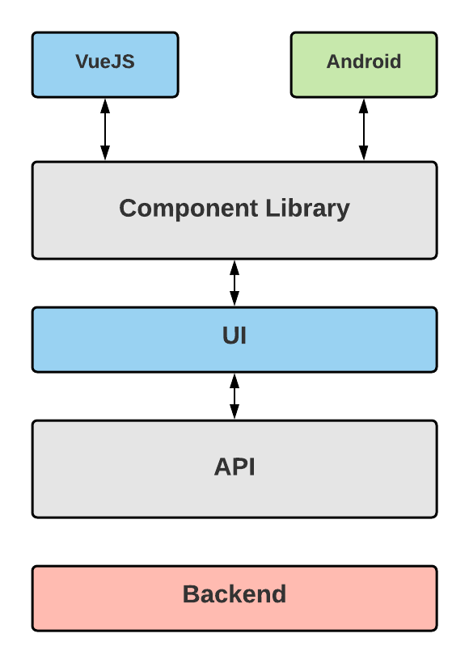

Figure 4.5 Front-end sites

### 4.2.5 Deployment View

Deploy Backend

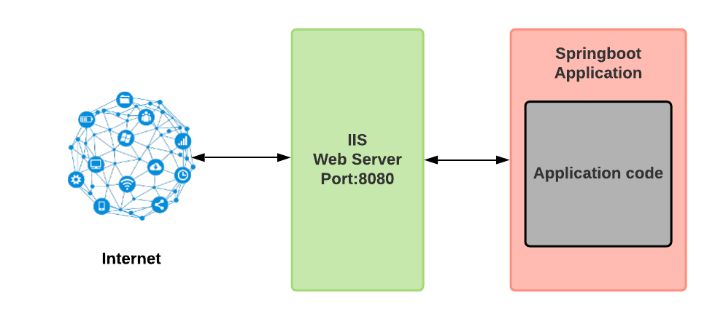

Figure 4.6 Deployment view

**-** Connect Virtual Private Cloud to build back-end api.

- Use IIS web server to deploy back-end.

You can refer the links Github of our team:

<https://github.com/jounger/container-rounduse-marketplace-backend.git>

<https://github.com/jounger/container-rounduse-marketplace-frontend-typescript.git>

<https://github.com/jounger/container-rounduse-marketplace-android.git>

## **4.3. Detailed Description of Components**

### 4.3.1*.* Component

4.3.1.1. Class Diagram

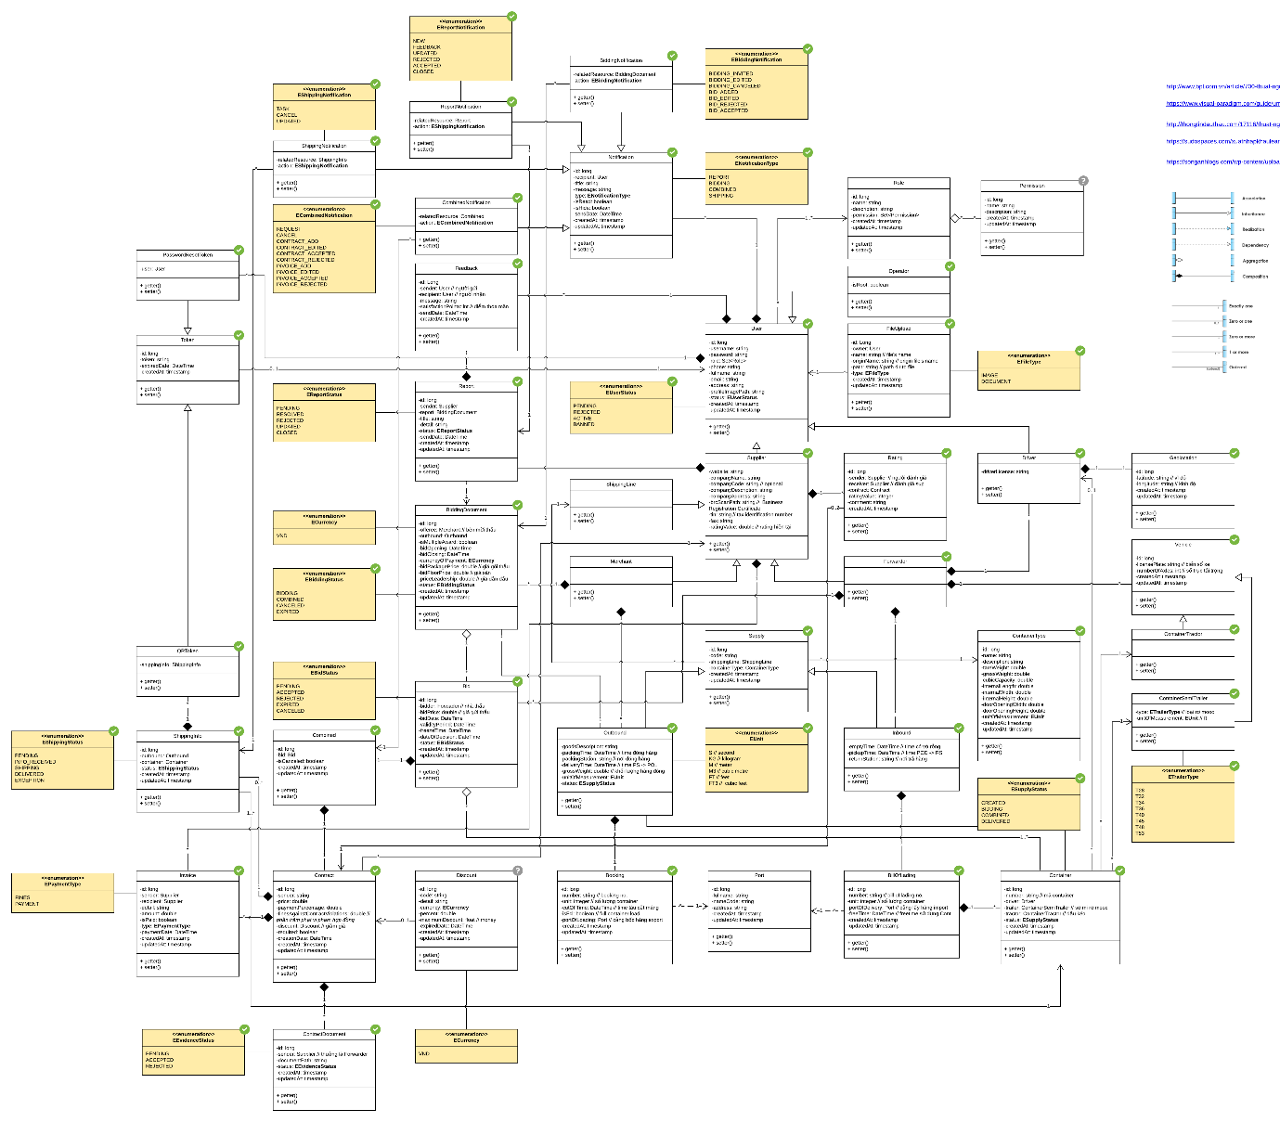

Figure 4.7 Class diagram

Please refer to

the below website for more details: <https://app.lucidchart.com/documents/edit/a7bcd07d-fc6c-475d-8e6c-36780e84bf97/NnuadfToULnm?shared=true&fbclid=IwAR19O9jq6EAgiwOv3vEFPsaUWRjjIUIhJiwgM07vmfiLk4i_nR5NCfpC3zE>

4.3.2.2. Class Diagram Explanation

4.3.2.2.1 EShipping status

|  |  |  |  |
| --- | --- | --- | --- |
| **Attribute** | **Type** | **Visibility** | **Description** |
| Pending | Enum | Public |  |
| Info_Received | Enum | Public |  |
| Shipping | Enum | Public |  |
| Delivered | Enum | Public |  |
| Exeption | Enum | Public |  |

4.3.2.2.2 EPaymentType

|  |  |  |  |
| --- | --- | --- | --- |
| **Attribute** | **Type** | **Visibility** | **Description** |
| Fines | Enum | Public |  |
| Payment | Enum | Public |  |

4.3.2.2.3 ShippingInfo

|  |  |  |  |
| --- | --- | --- | --- |
| **Attribute** | **Type** | **Visibility** | **Description** |
| id | long | private |  |
| outbound | Outbound | private | Outbound info |
| container | Container | private | Container info |
| status | EShippingStatus | private |  |
| createAt | timestamp | private | Create time |
| updateAt | timestamp | private | Update time |

|  |  |  |  |
| --- | --- | --- | --- |
| **Method** | **Type** | **Visibility** | **Description** |
| getter | Attribute | public | Getter attribute |
| setter | Void | public | Setter value attribute |

4.3.2.2.4 Invoice

|  |  |  |  |
| --- | --- | --- | --- |
| **Attribute** | **Type** | **Visibility** | **Description** |
| id | long | private |  |
| sender | Supplier | private |  |
| recipient | Supplier | private |  |
| detail | string | private |  |
| amount | double | private | Payment amount |
| isPaid | boolean | private | True/ False |
| type | EPaymentType | private |  |
| paymentDate | Datetime | private | Payment time |
| createAt | timestamp | private | Create time |
| updateAt | timestamp | private | Update time |

|  |  |  |  |
| --- | --- | --- | --- |
| **Method** | **Type** | **Visibility** | **Description** |
| getter | Attribute | public | Getter attribute |
| setter | Void | public | Setter value attribute |

4.3.2.2.5 EShippingNotification

|  |  |  |  |
| --- | --- | --- | --- |
| **Attribute** | **Type** | **Visibility** | **Description** |
| TASK | Enum | Public | Driver's job notification status |
| CANCel | Enum | Public |  |
| Updated | Enum | Public |  |

4.3.2.2.6 ShippingNotification

|  |  |  |  |
| --- | --- | --- | --- |
| **Attribute** | **Type** | **Visibility** | **Description** |
| relateResource | ShippingInfo | private | Resources related from Shipping info |
| action | EShippingNotification | private |  |

|  |  |  |  |
| --- | --- | --- | --- |
| **Method** | **Type** | **Visibility** | **Description** |
| getter | Attribute | public | Getter attribute |
| setter | Void | public | Setter value attribute |

4.3.2.2.7 ECombinedNotification

|  |  |  |  |
| --- | --- | --- | --- |
| **Attribute** | **Type** | **Visibility** | **Description** |
| Request | Enum | Public | Request notification |
| CANCel | Enum | Public |  |
| contract_Add | Enum | Public |  |
| contract_edited | Enum | Public |  |
| contract_accepted | Enum | Public |  |
| contract_rejected | Enum | Public |  |
| invoice_add | Enum | Public |  |
| invoice_edited | Enum | Public |  |
| invoice_accepted | Enum | Public |  |
| invoice_rejectec | Enum | Public |  |

4.3.2.2.8 EReportStatus

|  |  |  |  |
| --- | --- | --- | --- |
| **Attribute** | **Type** | **Visibility** | **Description** |
| Pending | Enum | Public |  |
| resolved | Enum | Public |  |
| rejected | Enum | Public |  |
| updated | Enum | Public |  |
| Closed | Enum | Public |  |

4.3.2.2.9 ECurrency

|  |  |  |  |
| --- | --- | --- | --- |
| **Attribute** | **Type** | **Visibility** | **Description** |
| VND | Enum | Public |  |

4.3.2.2.10 EBiddingStatus

|  |  |  |  |
| --- | --- | --- | --- |
| **Attribute** | **Type** | **Visibility** | **Description** |
| Bidding | Enum | Public |  |
| Combined | Enum | Public |  |
| Canceled | Enum | Public |  |
| Expired | Enum | Public |  |

4.3.2.2.11 EBidStatus

|  |  |  |  |
| --- | --- | --- | --- |
| **Attribute** | **Type** | **Visibility** | **Description** |
| Pending | Enum | Public |  |
| accepted | Enum | Public |  |
| rejected | Enum | Public |  |
| Expired | Enum | Public |  |
| canceled | Enum | Public |  |

4.3.2.2.12 Combined

|  |  |  |  |
| --- | --- | --- | --- |
| **Attribute** | **Type** | **Visibility** | **Description** |
| id | long | private |  |
| bid | Bid | private |  |
| isCanceled | Boolean | private |  |
| createdAt | timestamp | private |  |
| updatedAt | timestamp | private |  |

|  |  |  |  |
| --- | --- | --- | --- |
| **Method** | **Type** | **Visibility** | **Description** |
| getter | Attribute | public | Getter attribute |
| setter | Void | public | Setter value attribute |

4.3.2.2.13 Contract

|  |  |  |  |
| --- | --- | --- | --- |
| **Attribute** | **Type** | **Visibility** | **Description** |
| id | long | private |  |
| sender | string | private |  |
| price | double | private |  |
| finesAgainstContractViolations | double | private | percent of contract violation penalty |
| discount | Discount | private |  |
| required | boolean | private |  |
| createdDate | Datetime | private |  |
| createdAt | timestamp | private |  |
| updatedAt | timestamp | private |  |

|  |  |  |  |
| --- | --- | --- | --- |
| **Method** | **Type** | **Visibility** | **Description** |
| getter | Attribute | public | Getter attribute |
| setter | Void | public | Setter value attribute |

4.3.2.2.14 ContractDocument

|  |  |  |  |
| --- | --- | --- | --- |
| **Attribute** | **Type** | **Visibility** | **Description** |
| id | long | private |  |
| sender | string | private |  |
| documentPath | string | private |  |
| status | EEvidenceStatus | private | The contract is valid or not |
| createdAt | timestamp | private |  |
| updatedAt | timestamp | private |  |

|  |  |  |  |
| --- | --- | --- | --- |
| **Method** | **Type** | **Visibility** | **Description** |
| getter | Attribute | public | Getter attribute |
| setter | Void | public | Setter value attribute |

4.3.2.2.15 EReportNotification

|  |  |  |  |
| --- | --- | --- | --- |
| **Attribute** | **Type** | **Visibility** | **Description** |
| New | Enum | Public |  |
| Feedback | Enum | Public |  |
| updated | Enum | Public |  |
| rejected | Enum | Public |  |
| Accepted | Enum | Public |  |
| closed | Enum | Public |  |

4.3.2.2.16 ReportNotification

|  |  |  |  |
| --- | --- | --- | --- |
| **Attribute** | **Type** | **Visibility** | **Description** |
| relatedResource | Report | private | Resources related from Report |
| action | EReportNotification | private |  |

|  |  |  |  |
| --- | --- | --- | --- |
| **Method** | **Type** | **Visibility** | **Description** |
| getter | Attribute | public | Getter attribute |
| setter | Void | public | Setter value attribute |

4.3.2.2.17 CombinedNotification

|  |  |  |  |
| --- | --- | --- | --- |
| **Attribute** | **Type** | **Visibility** | **Description** |
| relatedResource | Combined | private | Resources related from Combined |
| action | ECombinedNotification | private |  |

|  |  |  |  |
| --- | --- | --- | --- |
| **Method** | **Type** | **Visibility** | **Description** |
| getter | Attribute | public | Getter attribute |
| setter | Void | public | Setter value attribute |

4.3.2.2.18 Feedback

|  |  |  |  |
| --- | --- | --- | --- |
| **Attribute** | **Type** | **Visibility** | **Description** |
| id | long | private |  |
| sender | User | private |  |
| recipient | User | private |  |
| message | string | private |  |
| satisfactionPoints | int | private | score satisfied with report |
| sendDate | Datetime | private |  |
| createdAt | timestamp | private |  |

|  |  |  |  |
| --- | --- | --- | --- |
| **Method** | **Type** | **Visibility** | **Description** |
| getter | Attribute | public | Getter attribute |
| setter | Void | public | Setter value attribute |

4.3.2.2.19 Report

|  |  |  |  |
| --- | --- | --- | --- |
| **Attribute** | **Type** | **Visibility** | **Description** |
| id | long | private |  |
| sender | Supplier | private |  |
| report | BiddingDocument | private |  |
| title | string | private |  |
| detail | string | private |  |
| status | EReportStatus | private |  |
| sendDate | DateTime | private |  |
| createdAt | timestamp | private |  |
| updateAt | timestamo | private |  |

|  |  |  |  |
| --- | --- | --- | --- |
| **Method** | **Type** | **Visibility** | **Description** |
| getter | Attribute | public | Getter attribute |
| setter | Void | public | Setter value attribute |

4.3.2.2.20 BiddingDocument

|  |  |  |  |
| --- | --- | --- | --- |
| **Attribute** | **Type** | **Visibility** | **Description** |
| id | long | private |  |
| offeree | Merchant | private | bid solicitors – bên mời thầu |
| outbound | Outbound | private | hàng xuất |
| isMultipleAward | boolean | private | Many bid winners |
| bidOpening | DateTime | private | Bid opening time |
| bidClosing | DateTime | private | Bid closing time |
| currencyOfPayment | ECurrency | private | Currency used |
| bidPackedPrice | double | private | Giá gói thầu |
| bidFloorPrice | double | private | Giá sàn |
| priceLeadership | double | private | Highest bid price |
| status | EBiddingStatus | private |  |
| createdAt | timestamp | private |  |
| updateAt | timestamp | private |  |

|  |  |  |  |
| --- | --- | --- | --- |
| **Method** | **Type** | **Visibility** | **Description** |
| getter | Attribute | public | Getter attribute |
| setter | Void | public | Setter value attribute |

4.3.2.2.21 Bid

|  |  |  |  |
| --- | --- | --- | --- |
| **Attribute** | **Type** | **Visibility** | **Description** |
| id | long | private |  |
| bidder | Forwarder | private |  |
| bidPrice | double | private |  |
| bidDate | DateTime | private |  |
| bidValidityPeriod | DateTime | private | The validity period of bid and bid cannot be edited until it has expired |
| dateOfDecision | DateTime | private | Status date changed |
| status | EBidStatus | private |  |
| createdAt | timestamp | private |  |
| updatedAt | timestamp | private |  |

|  |  |  |  |
| --- | --- | --- | --- |
| **Method** | **Type** | **Visibility** | **Description** |
| getter | Attribute | public | Getter attribute |
| setter | Void | public | Setter value attribute |

4.3.2.2.22 Discount

|  |  |  |  |
| --- | --- | --- | --- |
| **Attribute** | **Type** | **Visibility** | **Description** |
| id | long | private |  |
| code | string | private |  |
| detail | sting | private |  |
| currency | ECurrency | private |  |
| percent | double | private |  |
| maximumDiscount | float | private | the maximum amount is discounted |
| expiredDate | DateTime | private |  |
| createdAt | timestamp | private |  |
| updatedAt | timestamp | private |  |

|  |  |  |  |
| --- | --- | --- | --- |
| **Method** | **Type** | **Visibility** | **Description** |
| getter | Attribute | public | Getter attribute |
| setter | Void | public | Setter value attribute |

4.3.2.2.23 BiddingNotification

|  |  |  |  |
| --- | --- | --- | --- |
| **Attribute** | **Type** | **Visibility** | **Description** |
| relatedResource | BiddingDocument | private | Resources related from BiddingDocument |
| action | EBiddingNotification | private |  |

|  |  |  |  |
| --- | --- | --- | --- |
| **Method** | **Type** | **Visibility** | **Description** |
| getter | Attribute | public | Getter attribute |
| setter | Void | public | Setter value attribute |

4.3.2.2.24 Notification

|  |  |  |  |
| --- | --- | --- | --- |
| **Attribute** | **Type** | **Visibility** | **Description** |
| id | long | private |  |
| recipient | User | private |  |
| title | string | private |  |
| message | string | private |  |
| type | ENotificationType | private |  |
| isRead | Boolean | private |  |
| isHide | Boolean | private |  |
| sendDate | DateTime | private |  |
| createdAt | timestamp | private |  |
| updatedAt | timestamp | private |  |

|  |  |  |  |
| --- | --- | --- | --- |
| **Method** | **Type** | **Visibility** | **Description** |
| getter | Attribute | public | Getter attribute |
| setter | Void | public | Setter value attribute |

4.3.2.2.25 Operator

|  |  |  |  |
| --- | --- | --- | --- |
| **Attribute** | **Type** | **Visibility** | **Description** |
| id | long | private | The person with the highest authority cannot be deleted |

|  |  |  |  |
| --- | --- | --- | --- |
| **Method** | **Type** | **Visibility** | **Description** |
| getter | Attribute | public | Getter attribute |
| setter | Void | public | Setter value attribute |

4.3.2.2.26 EUserStatus

|  |  |  |  |
| --- | --- | --- | --- |
| **Attribute** | **Type** | **Visibility** | **Description** |
| Pending | Enum | Public |  |
| rejected | Enum | Public |  |
| active | Enum | Public |  |
| banned | Enum | Public |  |

4.3.2.2.27 ShippingLine

|  |  |  |  |
| --- | --- | --- | --- |
| **Method** | **Type** | **Visibility** | **Description** |
| getter | Attribute | public | Getter attribute |
| setter | Void | public | Setter value attribute |

4.3.2.2.28 Merchant

|  |  |  |  |
| --- | --- | --- | --- |
| **Method** | **Type** | **Visibility** | **Description** |
| getter | Attribute | public | Getter attribute |
| setter | Void | public | Setter value attribute |

4.3.2.2.29 Outbound

|  |  |  |  |
| --- | --- | --- | --- |
| **Attribute** | **Type** | **Visibility** | **Description** |
| goodDescription | string | private |  |
| packingTime | Datetime | private |  |
| packingStation | string | private |  |
| deliveryTime | Datetime | private |  |
| grossWeight | double | private | Weight |
| unitOfMeasurement | EUnit | private | Weight unit |
| status | ESupplyStatus | private |  |

|  |  |  |  |
| --- | --- | --- | --- |
| **Method** | **Type** | **Visibility** | **Description** |
| getter | Attribute | public | Getter attribute |
| setter | Void | public | Setter value attribute |

4.3.2.2.30 Booking

|  |  |  |  |
| --- | --- | --- | --- |
| **Attribute** | **Type** | **Visibility** | **Description** |
| id | long | private |  |
| number | string | private |  |
| unit | interger | private | Container quantity |
| cutOffTime | DateTime | private | The time the ship leaves the port |
| isFcl | Boolean | private | Full container load |
| portOfLoading | Port | private | Loading port |
| createdAt | timestamp | private |  |
| updatedAt | timestamo | private |  |

|  |  |  |  |
| --- | --- | --- | --- |
| **Method** | **Type** | **Visibility** | **Description** |
| getter | Attribute | public | Getter attribute |
| setter | Void | public | Setter value attribute |

4.3.2.2.31 EBiddingNotification

|  |  |  |  |
| --- | --- | --- | --- |
| **Attribute** | **Type** | **Visibility** | **Description** |
| BIDding_invited | Enum | Public |  |
| BIDding_Edited | Enum | Public |  |
| BIDding_Canceled | Enum | Public |  |
| Bid_added | Enum | Public |  |
| Bid_edited | Enum | Public |  |
| Bid_rejected | Enum | Public |  |
| Bid_accepted | Enum | Public |  |

4.3.2.2.32 ENotificationType

|  |  |  |  |
| --- | --- | --- | --- |
| **Attribute** | **Type** | **Visibility** | **Description** |
| report | Enum | Public |  |
| bidding | Enum | Public |  |
| shipping-line | Enum | Public |  |
| Driver | Enum | Public |  |

4.3.2.2.33 User

|  |  |  |  |
| --- | --- | --- | --- |
| **Attribute** | **Type** | **Visibility** | **Description** |
| id | long | private |  |
| username | string | private |  |
| password | string | private |  |
| role | Set<Role> | private |  |
| phone | string | private |  |
| fullname | string | private |  |
| email | string | private |  |
| address | string | private |  |
| profileImagePath | string | private |  |
| status | EUserStatus | private |  |
| createdAt | timestamp | private |  |
| updatedAt | timestamp | private |  |

|  |  |  |  |
| --- | --- | --- | --- |
| **Method** | **Type** | **Visibility** | **Description** |
| getter | Attribute | public | Getter attribute |
| setter | Void | public | Setter value attribute |

4.3.2.2.34 Supplier

|  |  |  |  |
| --- | --- | --- | --- |
| **Attribute** | **Type** | **Visibility** | **Description** |
| website | string | private |  |
| companyName | string | private |  |
| companyCode | string | private | optional |
| companyDescription | string | private |  |
| companyAddress | string | private |  |
| brcScanPath | string | private | Bussiness Registration Certificate |
| tin | string | private | Tax identification number |
| fax | string | private |  |
| ratingValue | double | private | Current rating |

|  |  |  |  |
| --- | --- | --- | --- |
| **Method** | **Type** | **Visibility** | **Description** |
| getter | Attribute | public | Getter attribute |
| setter | Void | public | Setter value attribute |

4.3.2.2.35 Supply

|  |  |  |  |
| --- | --- | --- | --- |
| **Attribute** | **Type** | **Visibility** | **Description** |
| id | long | private |  |
| code | string | private |  |
| shippingLine | ShippingLine | private |  |
| containerType | ContainerType | private |  |
| createdAt | timestamp | private |  |
| updatedAt | timestamp | private |  |

|  |  |  |  |
| --- | --- | --- | --- |
| **Method** | **Type** | **Visibility** | **Description** |
| getter | Attribute | public | Getter attribute |
| setter | Void | public | Setter value attribute |

4.3.2.2.36 EUnit

|  |  |  |  |
| --- | --- | --- | --- |
| **Attribute** | **Type** | **Visibility** | **Description** |
| S | Enum | Public | second |
| KG | Enum | Public | kilogram |
| M | Enum | Public | meter |
| M3 | Enum | Public | cumic meter |
| Ft | Enum | Public | feet |
| ft3 | Enum | Public | cubic feet |

4.3.2.2.37 Port

|  |  |  |  |
| --- | --- | --- | --- |
| **Attribute** | **Type** | **Visibility** | **Description** |
| id | long | private |  |
| fullname | string | private |  |
| nameCode | string | private |  |
| address | string | private |  |
| createdAt | timestamp | private |  |
| updatedAt | timestamp | private |  |

|  |  |  |  |
| --- | --- | --- | --- |
| **Method** | **Type** | **Visibility** | **Description** |
| getter | Attribute | public | Getter attribute |
| setter | Void | public | Setter value attribute |

4.3.2.2.38 Role

|  |  |  |  |
| --- | --- | --- | --- |
| **Attribute** | **Type** | **Visibility** | **Description** |
| id | long | private |  |
| name | string | private |  |
| permission | Set<Permission> | private |  |
| createdAt | timestamp | private |  |
| updatedAt | timestamp | private |  |

|  |  |  |  |
| --- | --- | --- | --- |
| **Method** | **Type** | **Visibility** | **Description** |
| getter | Attribute | public | Getter attribute |
| setter | Void | public | Setter value attribute |

4.3.2.2.39 FileUpload

|  |  |  |  |
| --- | --- | --- | --- |
| **Attribute** | **Type** | **Visibility** | **Description** |
| id | long | private |  |
| owner | User | private |  |
| name | string | private | file’s name |
| originName | string | private | orgin file’s name |
| path | string | private |  |
| type | EFileType | private |  |
| createdAt | timestamp | private |  |
| updatedAt | timestamp | private |  |

|  |  |  |  |
| --- | --- | --- | --- |
| **Method** | **Type** | **Visibility** | **Description** |
| getter | Attribute | public | Getter attribute |
| setter | Void | public | Setter value attribute |

4.3.2.2.40 Rating

|  |  |  |  |
| --- | --- | --- | --- |
| **Attribute** | **Type** | **Visibility** | **Description** |
| id | long | private |  |
| sender | Supplier | private |  |
| receiver | Supplier | private |  |
| contract | Contract | private |  |
| ratingValue | int | private |  |
| comment | string | private |  |
| createdAt | timestamp | private |  |

|  |  |  |  |
| --- | --- | --- | --- |
| **Method** | **Type** | **Visibility** | **Description** |
| getter | Attribute | public | Getter attribute |
| setter | Void | public | Setter value attribute |

4.3.2.2.41 Forwarder

|  |  |  |  |
| --- | --- | --- | --- |
| **Method** | **Type** | **Visibility** | **Description** |
| getter | Attribute | public | Getter attribute |
| setter | Void | public | Setter value attribute |

4.3.2.2.42 Inbound

|  |  |  |  |
| --- | --- | --- | --- |
| **Attribute** | **Type** | **Visibility** | **Description** |
| emptyTime | Datetime | private | Time has an empty container |
| pickupTime | Datetime | private |  |
| returnStation | string | private | Place of delivery |

|  |  |  |  |
| --- | --- | --- | --- |
| **Method** | **Type** | **Visibility** | **Description** |
| getter | Attribute | public | Getter attribute |
| setter | Void | public | Setter value attribute |

4.3.2.2.43 BillOfLading

|  |  |  |  |
| --- | --- | --- | --- |
| **Attribute** | **Type** | **Visibility** | **Description** |
| id | long | private |  |
| number | string | private | BoL number |
| unit | int | private | Container quantity |
| portOfDelivery | Port | private |  |
| freeTime | DateTime | private |  |
| createdAt | timestamp | private |  |
| updatedAt | timestamp | private |  |

|  |  |  |  |
| --- | --- | --- | --- |
| **Method** | **Type** | **Visibility** | **Description** |
| getter | Attribute | public | Getter attribute |
| setter | Void | public | Setter value attribute |

4.3.2.2.44 Permission

|  |  |  |  |
| --- | --- | --- | --- |
| **Attribute** | **Type** | **Visibility** | **Description** |
| id | long | private |  |
| name | string | private |  |
| description | string | private |  |
| createdAt | timestamp | private |  |
| updatedAt | timestamp | private |  |

|  |  |  |  |
| --- | --- | --- | --- |
| **Method** | **Type** | **Visibility** | **Description** |
| getter | Attribute | public | Getter attribute |
| setter | Void | public | Setter value attribute |

4.3.2.2.45 EFileType

|  |  |  |  |
| --- | --- | --- | --- |
| **Attribute** | **Type** | **Visibility** | **Description** |
| image | Enum | Public | second |
| document | Enum | Public | kilogram |

4.3.2.2.46 Driver

|  |  |  |  |
| --- | --- | --- | --- |
| **Attribute** | **Type** | **Visibility** | **Description** |
| driverLicense | long | private |  |

|  |  |  |  |
| --- | --- | --- | --- |
| **Method** | **Type** | **Visibility** | **Description** |
| getter | Attribute | public | Getter attribute |
| setter | Void | public | Setter value attribute |

4.3.2.2.47 ContainerType

|  |  |  |  |
| --- | --- | --- | --- |
| **Attribute** | **Type** | **Visibility** | **Description** |
| id | long | private |  |
| name | string | private |  |
| description | string | private |  |
| tareWeight | double | private | Khối lượng vỏ |
| grossWeight | double | private | Sức chứa |
| cubicCapacity | double | private | Công suất khối |
| internalLength | double | private | Chiều dài trong |
| internalWidth | double | private | Chiều rộng trong |
| internalHeight | double | private | Chiều cao trong |
| doorOpeningWidth | double | private | Chiều rộng cửa mở |
| doorOpeningHeight | double | private | Chiều cao cửa mở |
| unitOfMeasurement | EUnit | private |  |
| createdAt | timestamp | private |  |
| updatedAt | timestamp | private |  |

|  |  |  |  |
| --- | --- | --- | --- |
| **Method** | **Type** | **Visibility** | **Description** |
| getter | Attribute | public | Getter attribute |
| setter | Void | public | Setter value attribute |

4.3.2.2.48 ESupplyStatus

|  |  |  |  |
| --- | --- | --- | --- |
| **Attribute** | **Type** | **Visibility** | **Description** |
| created | Enum | Public |  |
| bidding | Enum | Public |  |
| combined | Enum | Public |  |
| delivered | Enum | Public |  |

4.3.2.2.49 Container

|  |  |  |  |
| --- | --- | --- | --- |
| **Attribute** | **Type** | **Visibility** | **Description** |
| id | long | private |  |
| number | string | private |  |
| driver | Driver | private |  |
| trailer | ContainerSemiTrailer | private | Rơ moóc |
| tractor | ContainerTractor | private | Đầu kéo |
| status | ESupplyStatus | private |  |
| createdAt | timestamp | private |  |
| updatedAt | timestamp | private |  |

|  |  |  |  |
| --- | --- | --- | --- |
| **Method** | **Type** | **Visibility** | **Description** |
| getter | Attribute | public | Getter attribute |
| setter | Void | public | Setter value attribute |

4.3.2.2.50 Geolocation

|  |  |  |  |
| --- | --- | --- | --- |
| **Attribute** | **Type** | **Visibility** | **Description** |
| id | long | private |  |
| latitude | string | private | Kinh độ |
| longitude | string | private | Vĩ độ |
| createdAt | timestamp | private |  |
| updatedAt | timestamp | private |  |

|  |  |  |  |
| --- | --- | --- | --- |
| **Method** | **Type** | **Visibility** | **Description** |
| getter | Attribute | public | Getter attribute |
| setter | Void | public | Setter value attribute |

4.3.2.2.51 Vehicle

|  |  |  |  |  |
| --- | --- | --- | --- | --- |
| **Attribute** | **Type** | **Visibility** | | **Description** |
| id | long | private |  | |
| licensePlate | string | private | Biển số xe | |
| numberOfAxles | int | private | Số trục tải trọng | |
| createdAt | timestamp | private |  | |
| updatedAt | timestamp | private |  | |

|  |  |  |  |
| --- | --- | --- | --- |
| **Method** | **Type** | **Visibility** | **Description** |
| getter | Attribute | public | Getter attribute |
| setter | Void | public | Setter value attribute |

4.3.2.2.52 ContainerTractor

|  |  |  |  |
| --- | --- | --- | --- |
| **Method** | **Type** | **Visibility** | **Description** |
| getter | Attribute | public | Getter attribute |
| setter | Void | public | Setter value attribute |

4.3.2.2.53 ContainerSemiTrailer

|  |  |  |  |
| --- | --- | --- | --- |
| **Attribute** | **Type** | **Visibility** | **Description** |
| type | ETrailerType | private |  |
| unitOfMeasurement | EUnit | private |  |

|  |  |  |  |
| --- | --- | --- | --- |
| **Method** | **Type** | **Visibility** | **Description** |
| getter | Attribute | public | Getter attribute |
| setter | Void | public | Setter value attribute |

4.3.2.2.54 ETrailerType

|  |  |  |  |
| --- | --- | --- | --- |
| **Attribute** | **Type** | **Visibility** | **Description** |
| T28 | Enum | Public |  |
| T32 | Enum | Public |  |
| T34 | Enum | Public |  |
| T36 | Enum | Public |  |
| T40 | Enum | Public |  |
| T45 | Enum | Public |  |
| T48 | Enum | Public |  |
| T53 | Enum | Public |  |

4.3.2.2.55 EEvidenceStatus

|  |  |  |  |
| --- | --- | --- | --- |
| **Attribute** | **Type** | **Visibility** | **Description** |
| Pending | Enum | Public |  |
| accepted | Enum | Public |  |
| rejected | Enum | Public |  |

4.3.2.2.56 PasswordResetToken

|  |  |  |  |
| --- | --- | --- | --- |
| **Attribute** | **Type** | **Visibility** | **Description** |
| user | User | private |  |

|  |  |  |  |
| --- | --- | --- | --- |
| **Method** | **Type** | **Visibility** | **Description** |
| getter | Attribute | public | Getter attribute |
| setter | Void | public | Setter value attribute |

4.3.2.2.57 Token

|  |  |  |  |
| --- | --- | --- | --- |
| **Attribute** | **Type** | **Visibility** | **Description** |
| id | long | private |  |
| token | string | private | Encryption string |
| expiredDate | DateTime | private |  |
| createdAt | timestamp | private |  |

|  |  |  |  |
| --- | --- | --- | --- |
| **Method** | **Type** | **Visibility** | **Description** |
| getter | Attribute | public | Getter attribute |
| setter | Void | public | Setter value attribute |

4.3.2.2.58 QRToken

|  |  |  |  |
| --- | --- | --- | --- |
| **Attribute** | **Type** | **Visibility** | **Description** |
| shippingInfo | ShippingInfo | private |  |

|  |  |  |  |
| --- | --- | --- | --- |
| **Method** | **Type** | **Visibility** | **Description** |
| getter | Attribute | public | Getter attribute |
| setter | Void | public | Setter value attribute |

## **4.5. Sequence Diagram**

### 4.5.1 Login

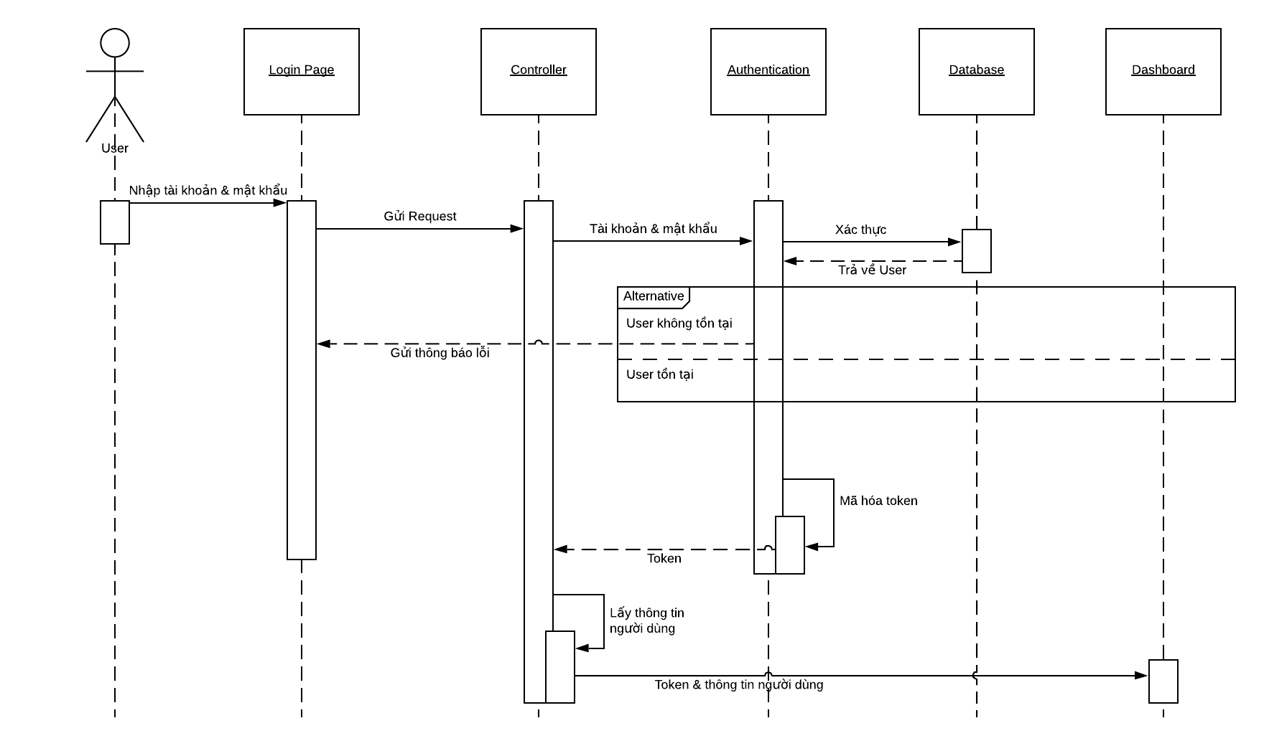

### 4.5.2 Register

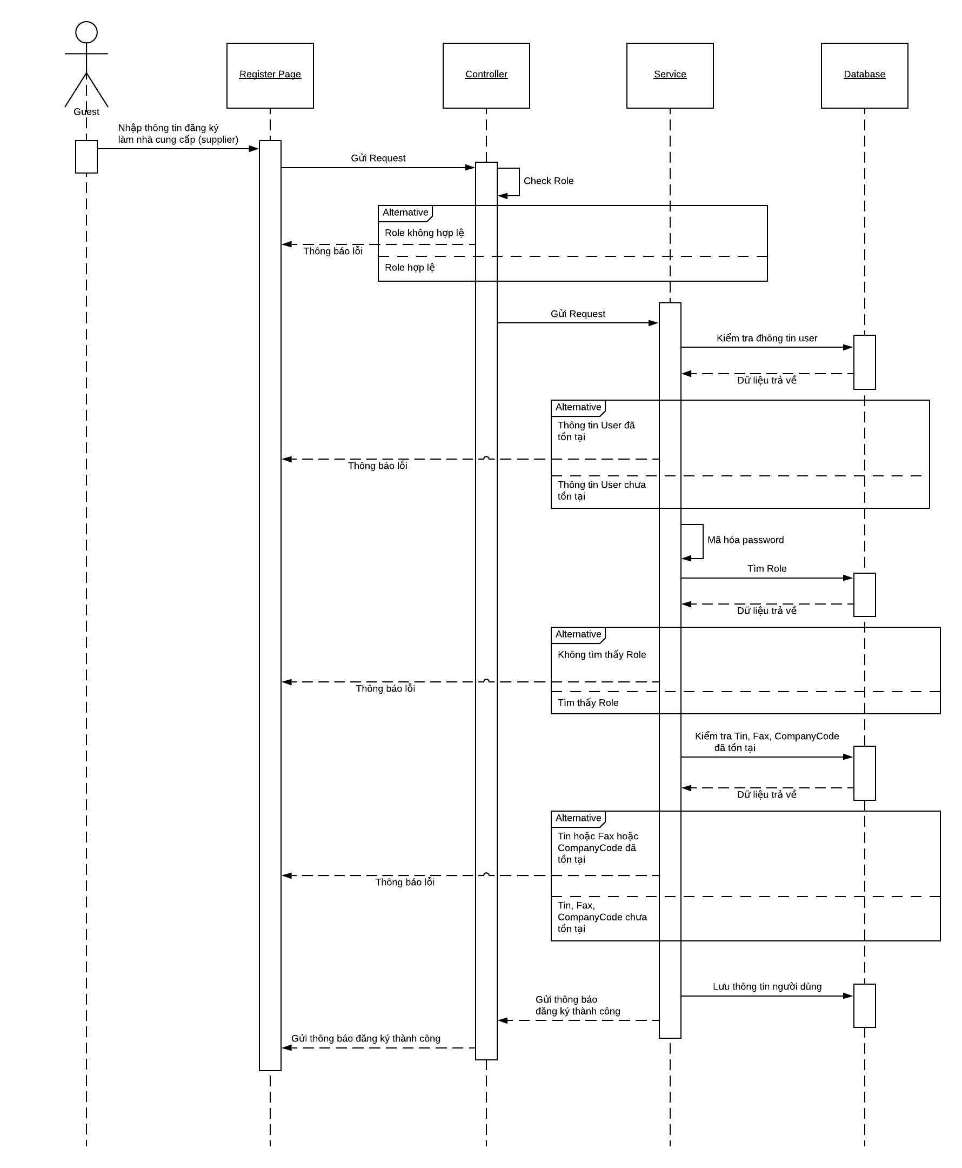

### 4.5.3 Get a list of Outbound (Lấy danh sách quản lý hàng xuất)

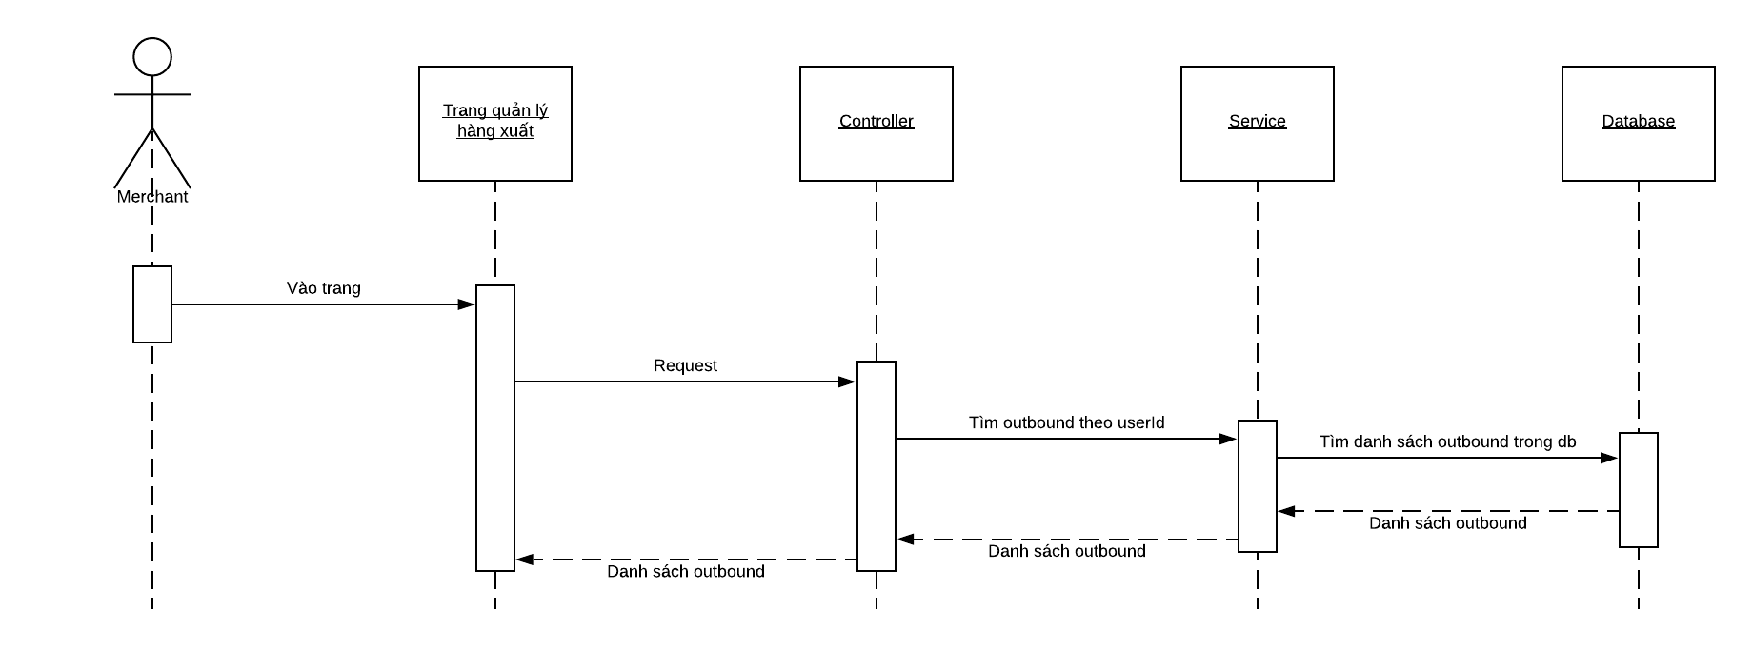

### 4.5.4 Declare outbound (Khai báo hàng xuất)

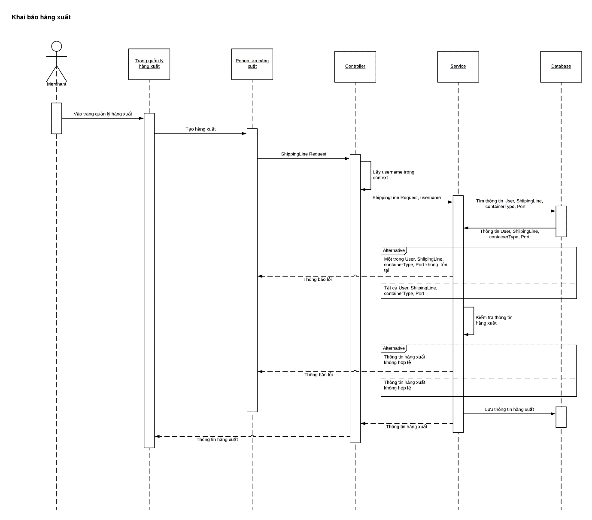

### 4.5.5 Delete outbound (Xóa hàng xuất)

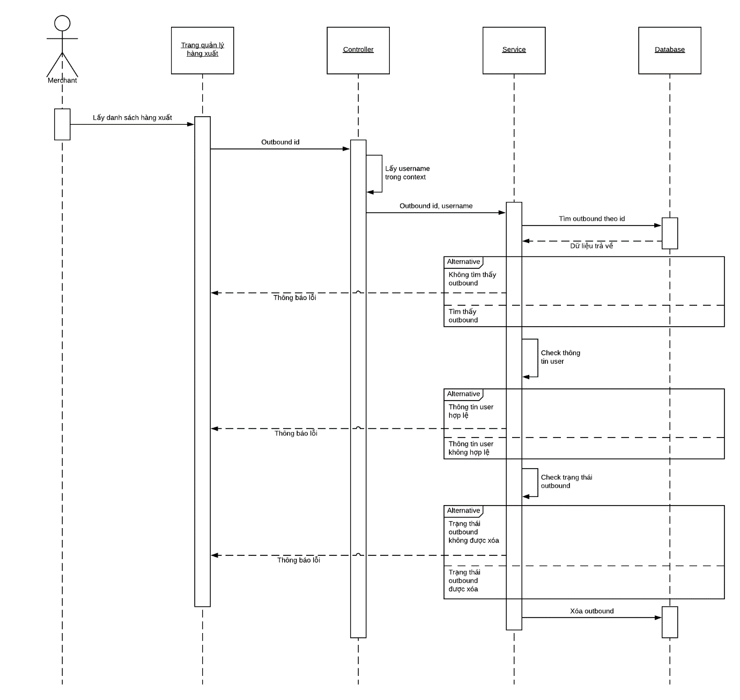

### 4.5.6 Create Bid (Tạo hồ sơ dự thầu)

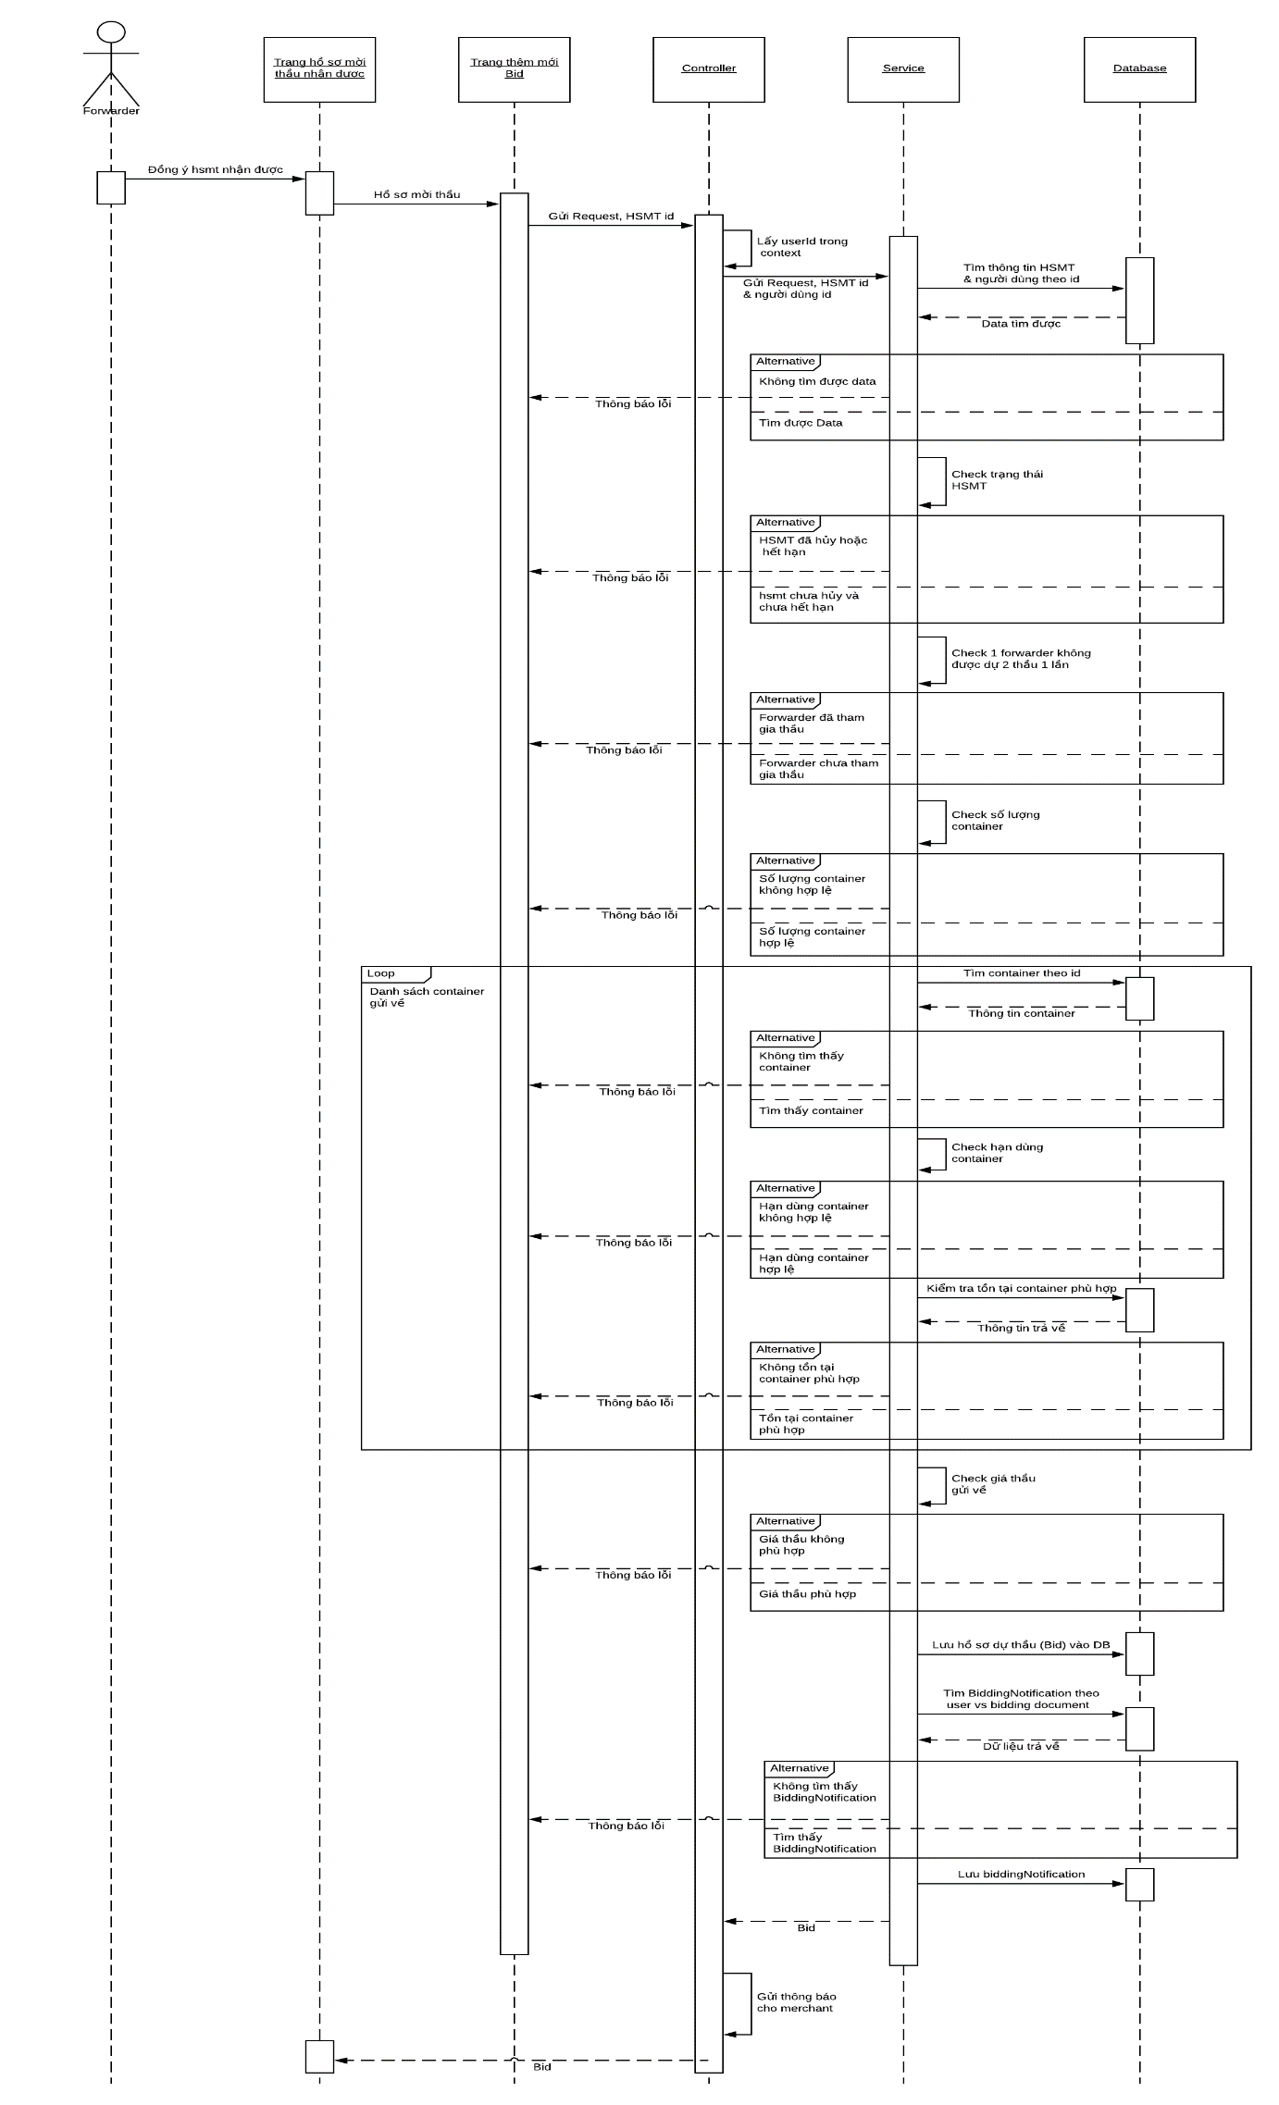

### 4.5.7 Forwarder edit Bid (Chỉnh sửa hồ sơ dự thầu)

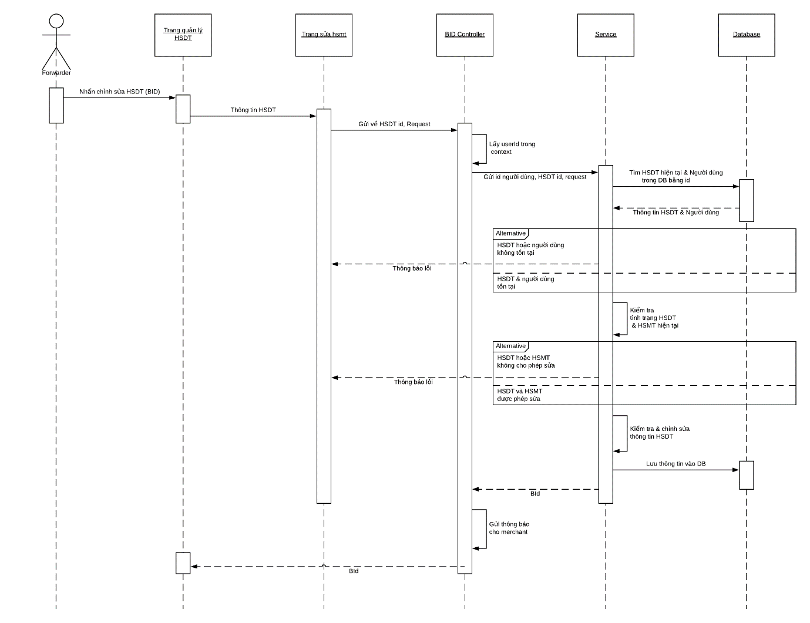

### 4.5.8 View list of Bid (Xem danh sách hồ sơ dự thầu)

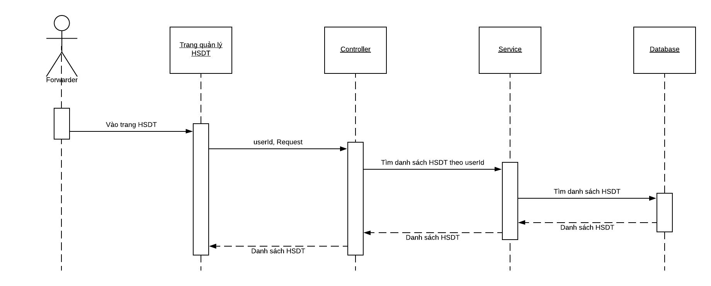

### 4.5.9 Create Bidding Document (Tạo Hồ sơ mời thầu)

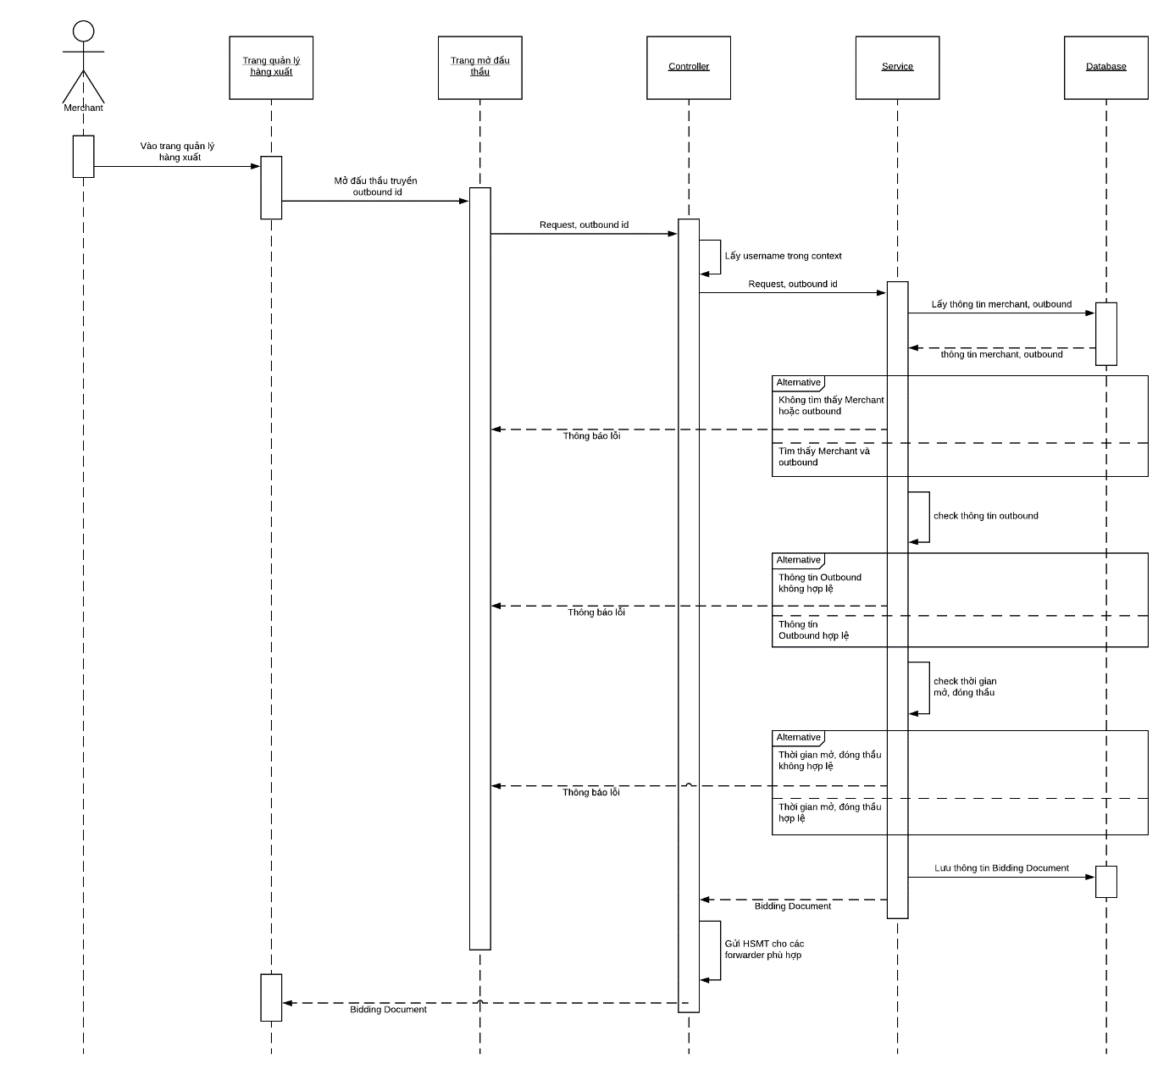

### 4.5.10 Edit Bidding Document (Hồ sơ mời thầu)

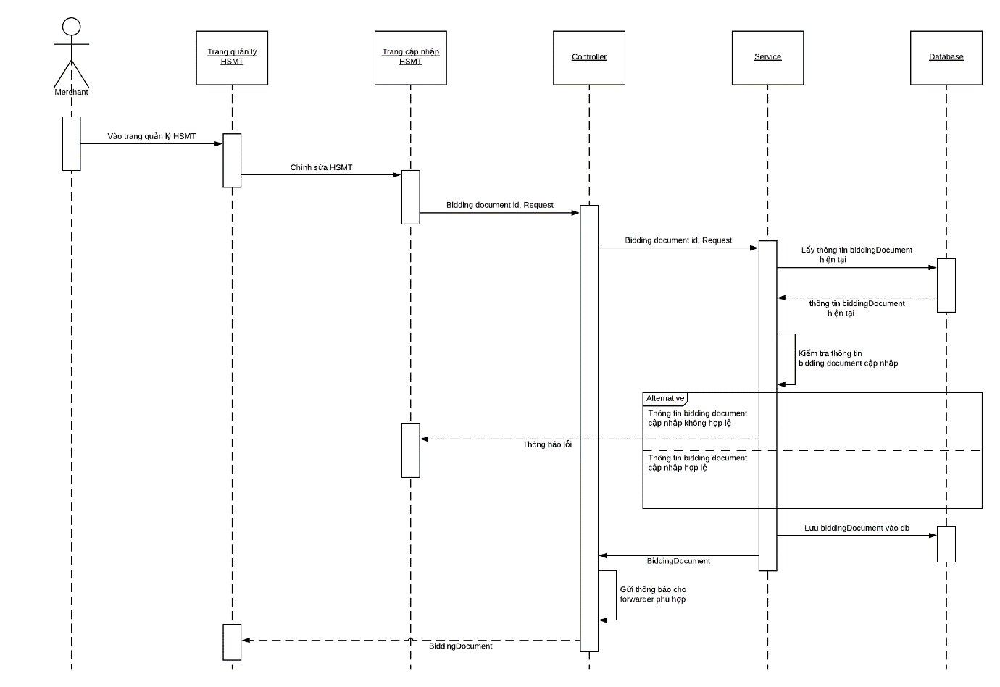

### 4.5.11 Cancel Bidding Document (Hủy thầu)

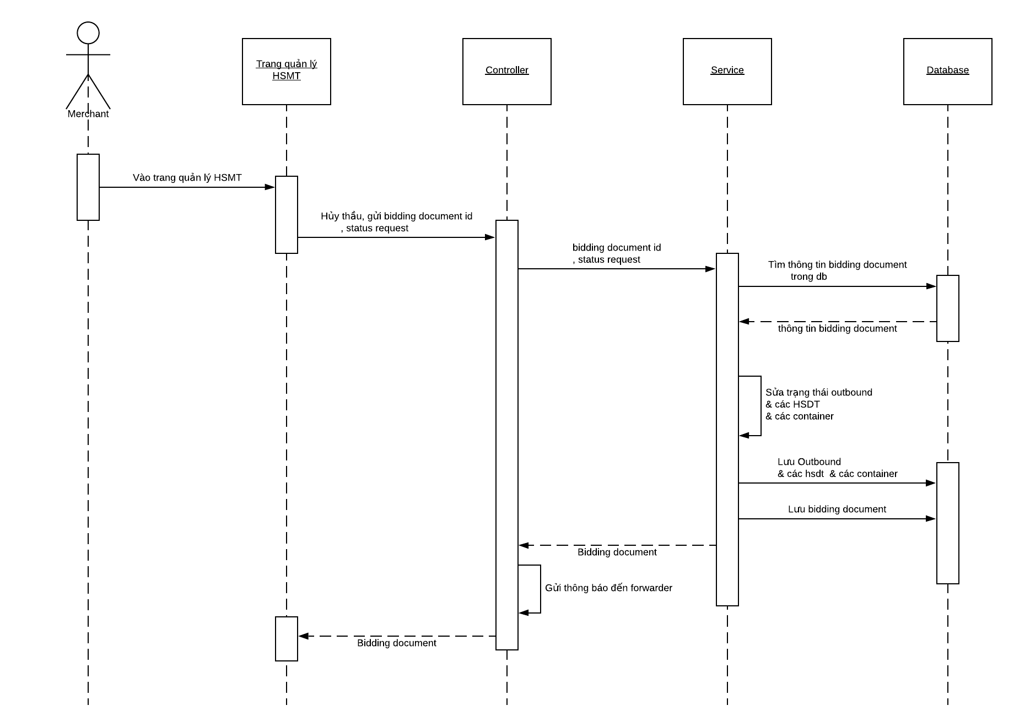

### 4.5.12 Receive Bidding Document (Nhận HSMT)

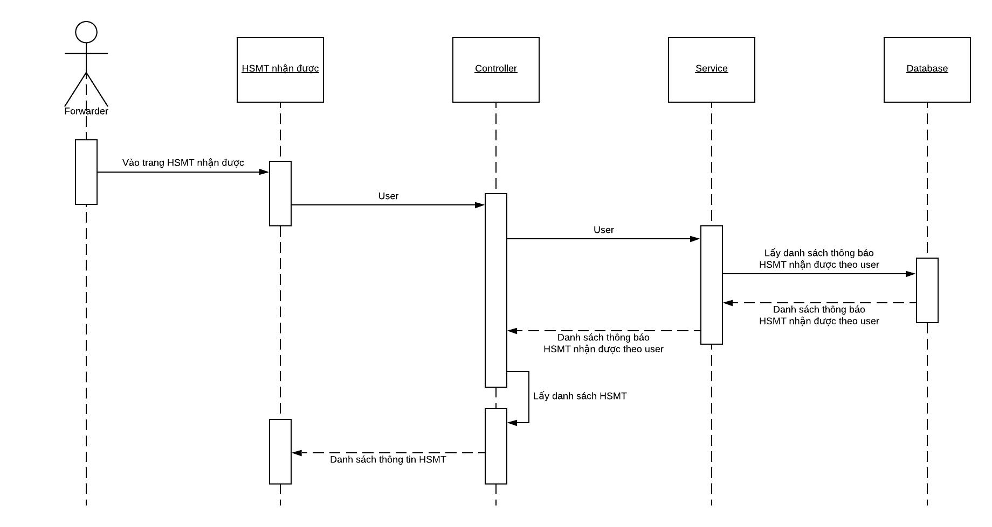

### 4.5.13 Merchant views created Bidding Document (Xem HSMT đã tạo)

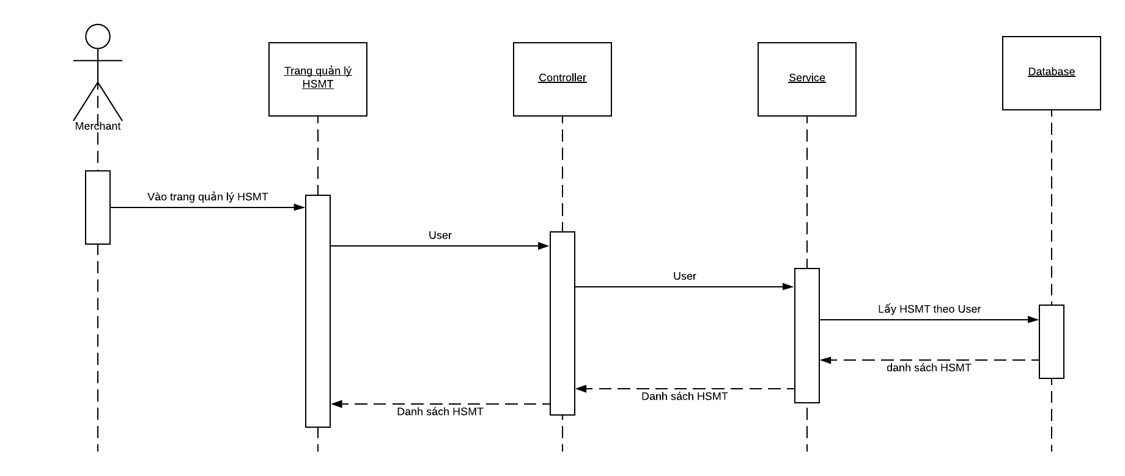

### 4.5.14 Bidding Document detail (Chi tiết HSMT)

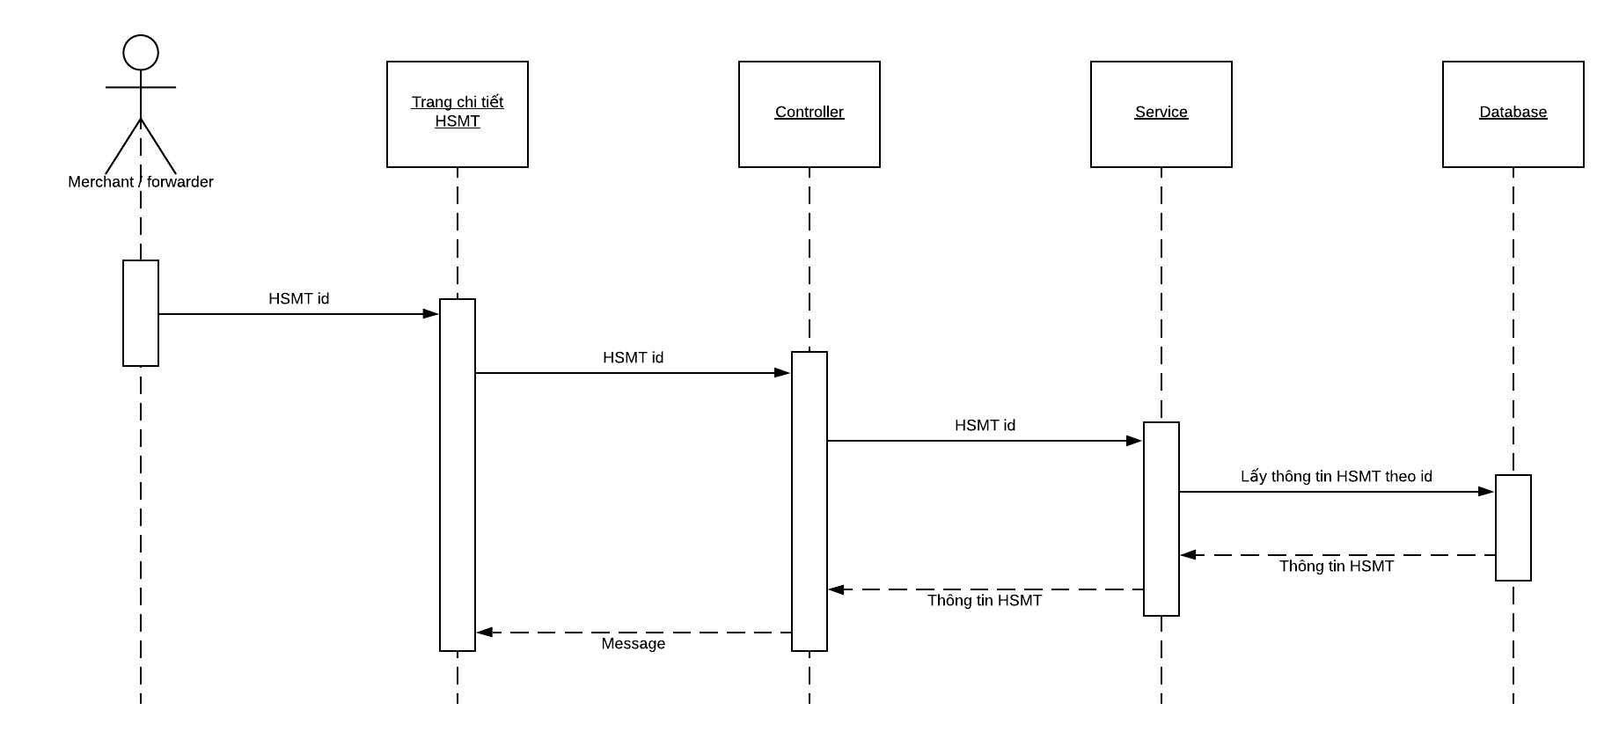

### 4.5.15 Create Combined (Tạo hàng ghép)

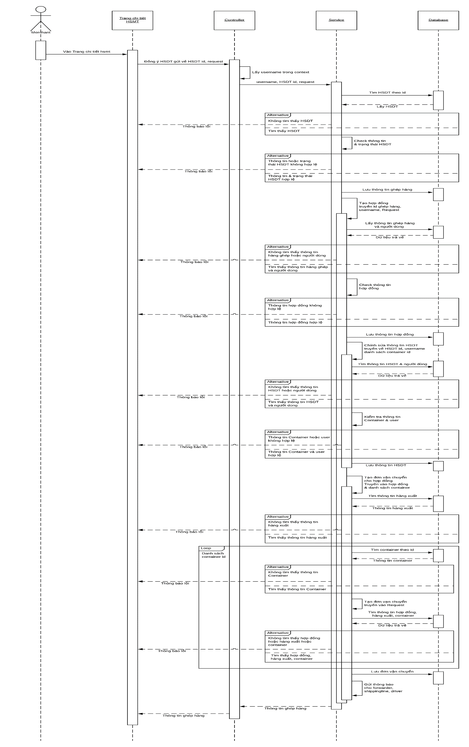

### 4.5.16 Combined Management Page (Trang quản lý hàng ghép)

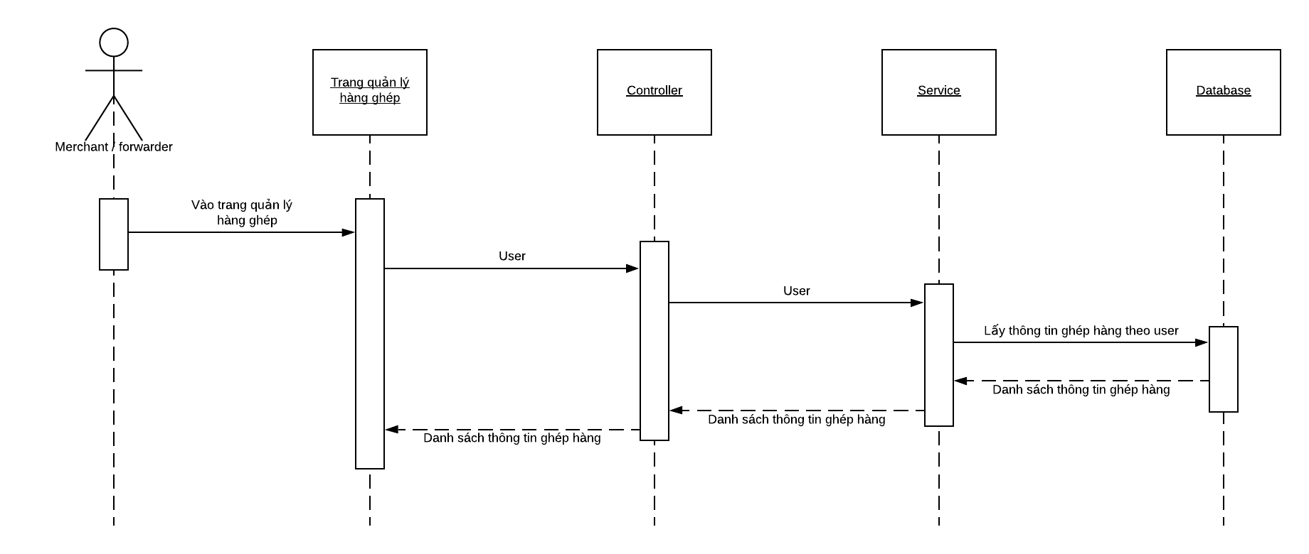

### 4.5.17 Information page of successful Bid (Trang thông tin hồ sơ trúng thầu)

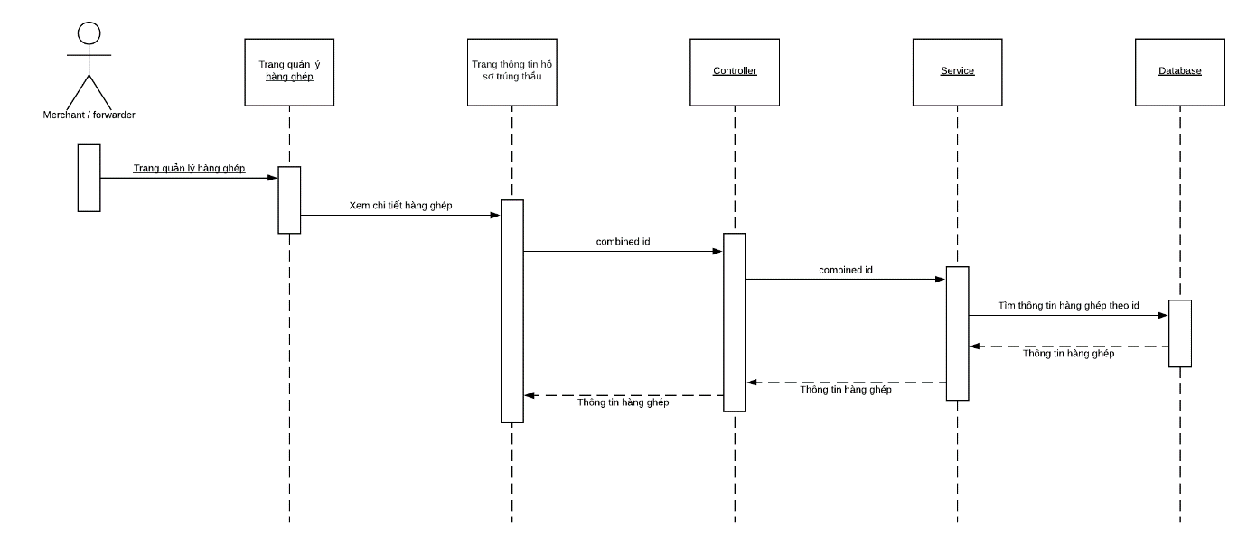

### 4.5.18 Create report (Tạo báo cáo)

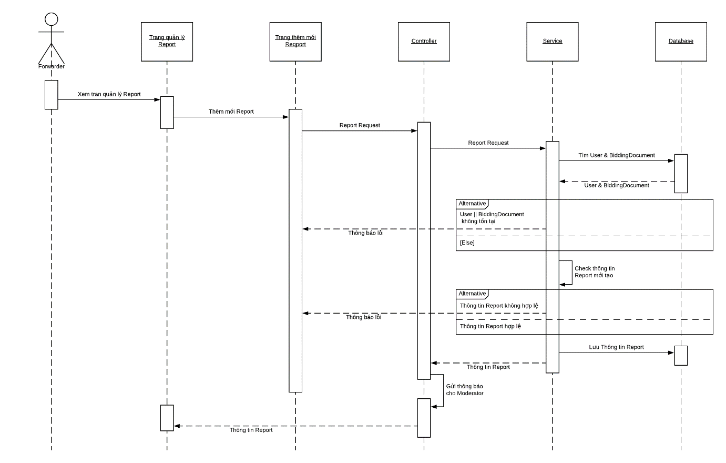

### 4.5.19 Forwarder views Report (Forwarder xem Report)

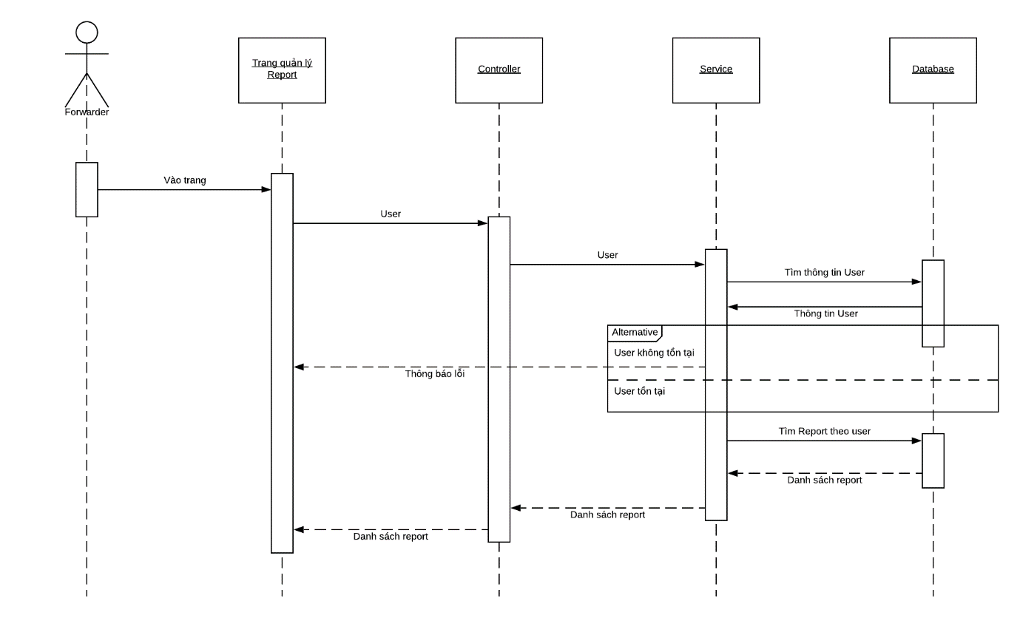

### 4.5.20 Forwarder views Report (Forwarder xem báo cáo)

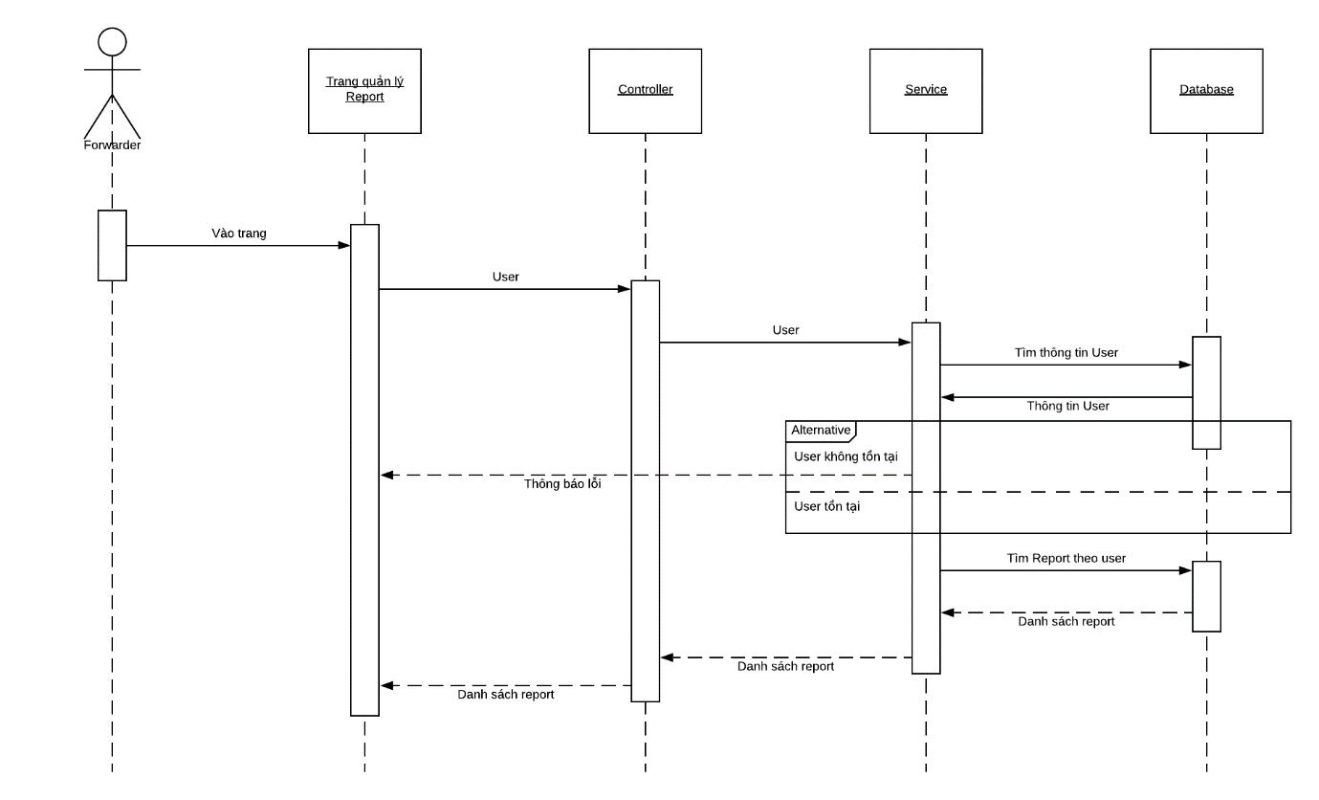

### 4.5.21 Moderator views Report (Moderator xem báo cáo)

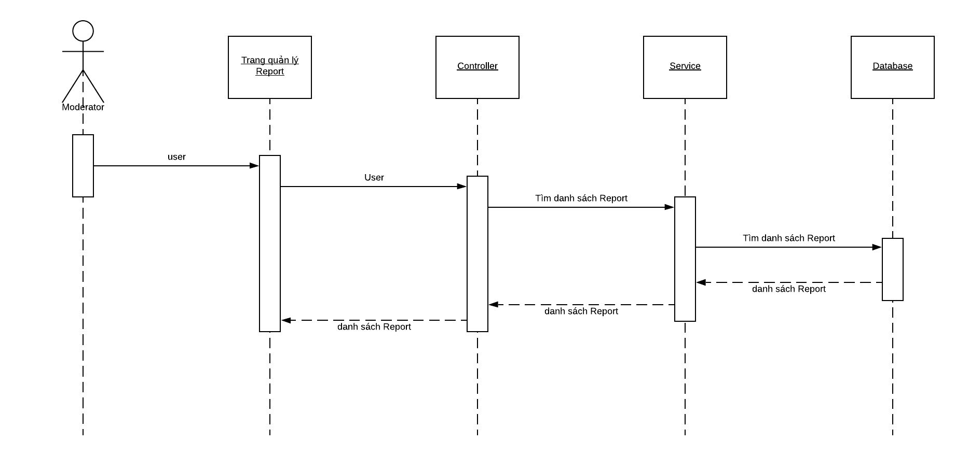

### 4.5.22 Moderator agrees/ reject Report (Moderator đồng ý/ từ chối báo cáo)

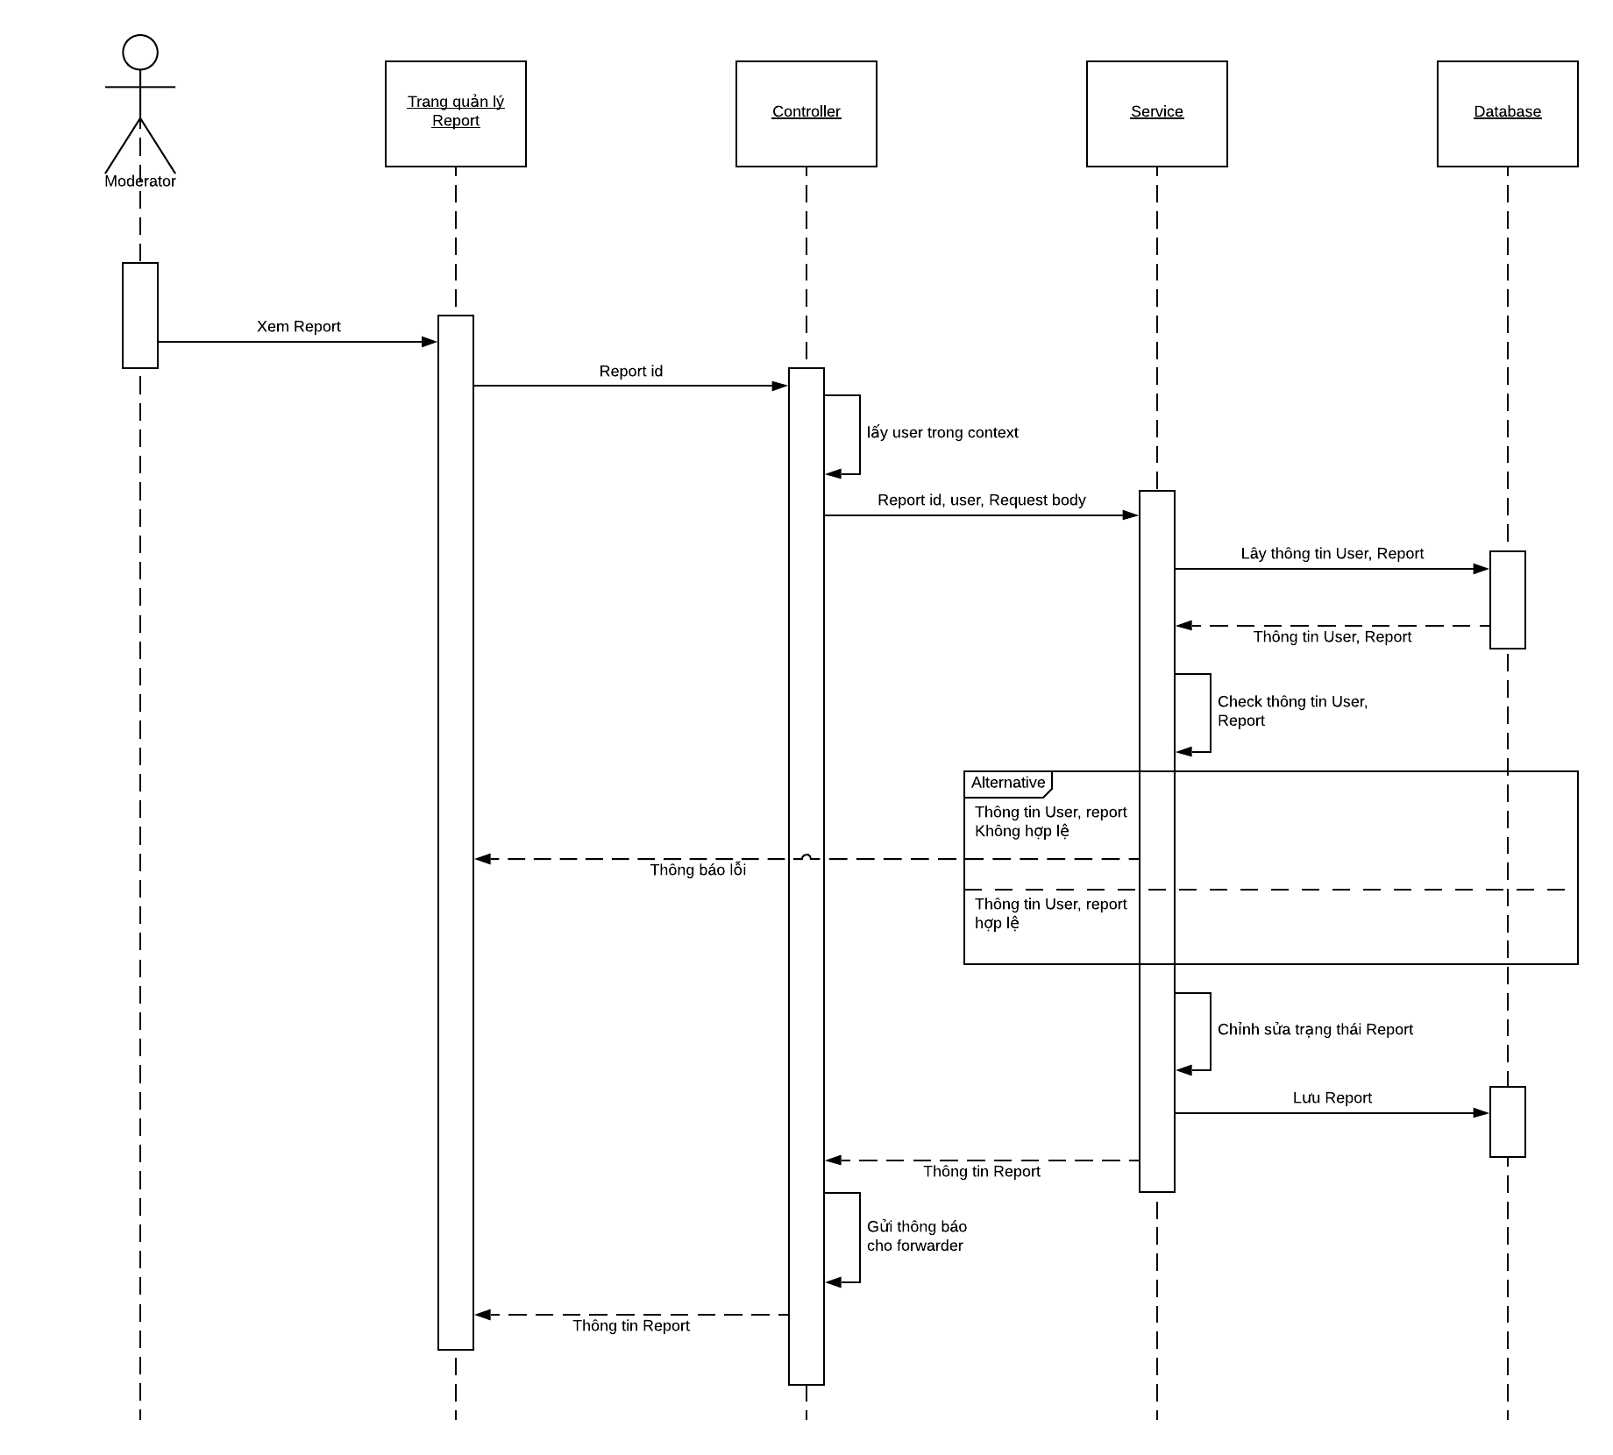

### 4.5.23 Create Feedback (Tạo feedback)

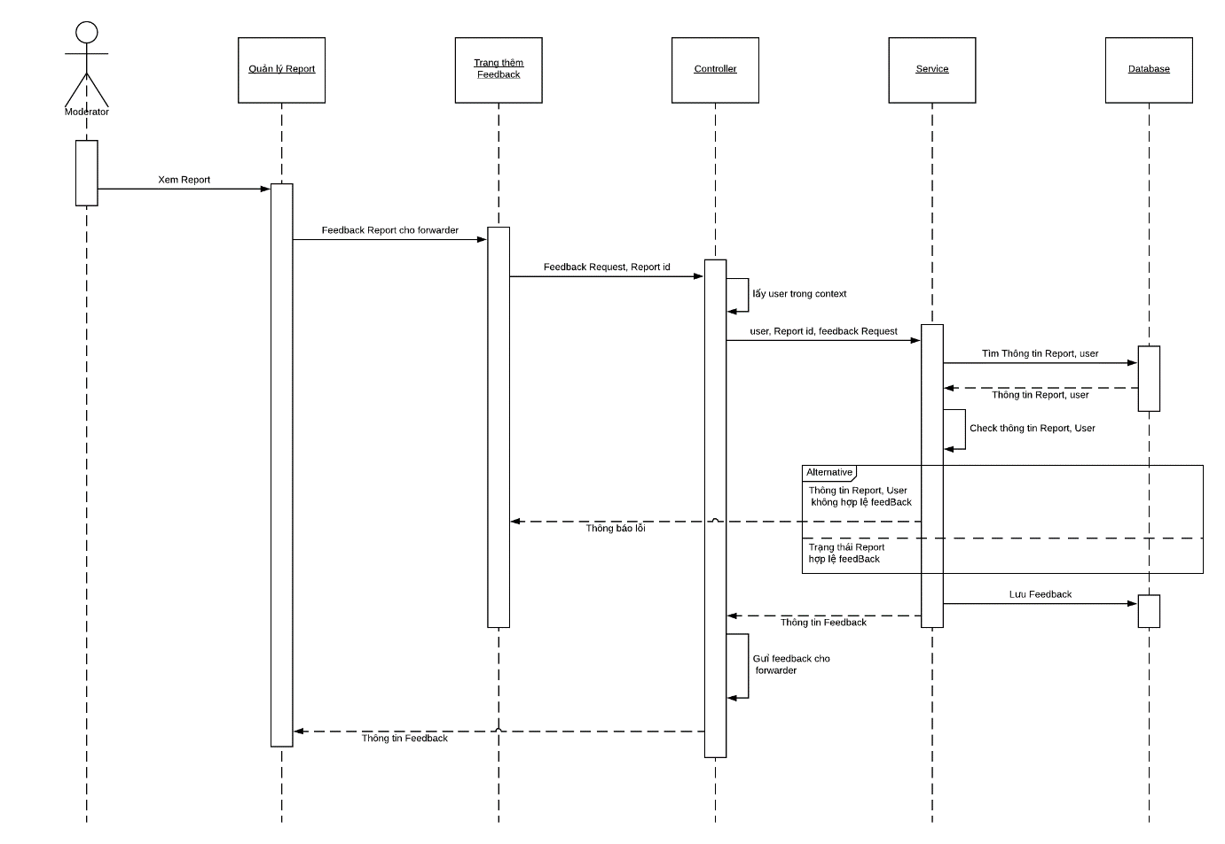

### 4.5.24 View Feedback (Xem feedback)

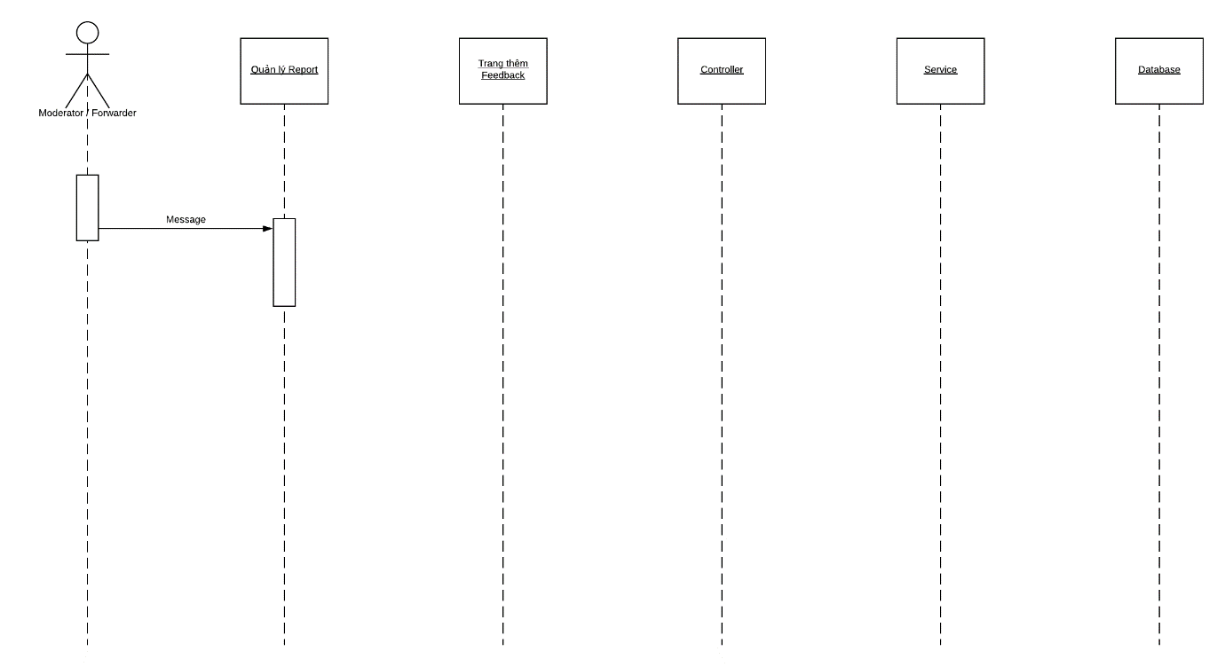

### 4.5.25 View Container Type List (Xem danh sách Container Type)

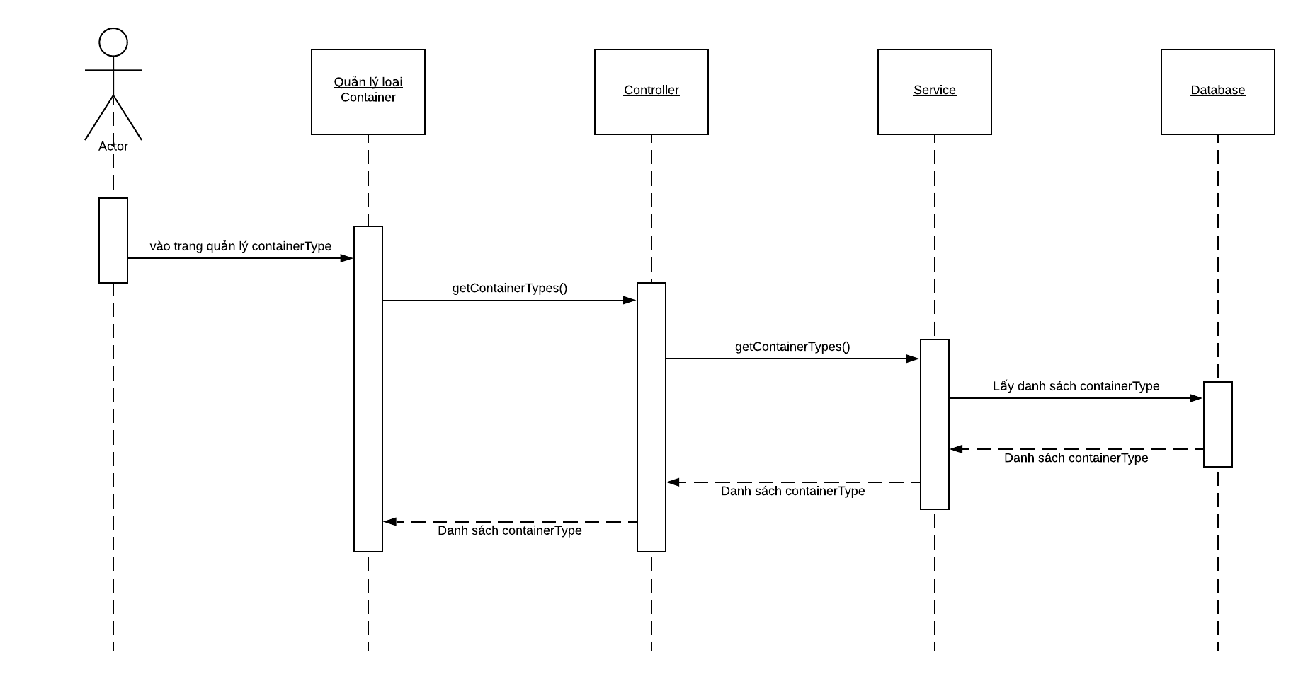

### 4.5.26 Declare Container Type (Khai báo Container Type)

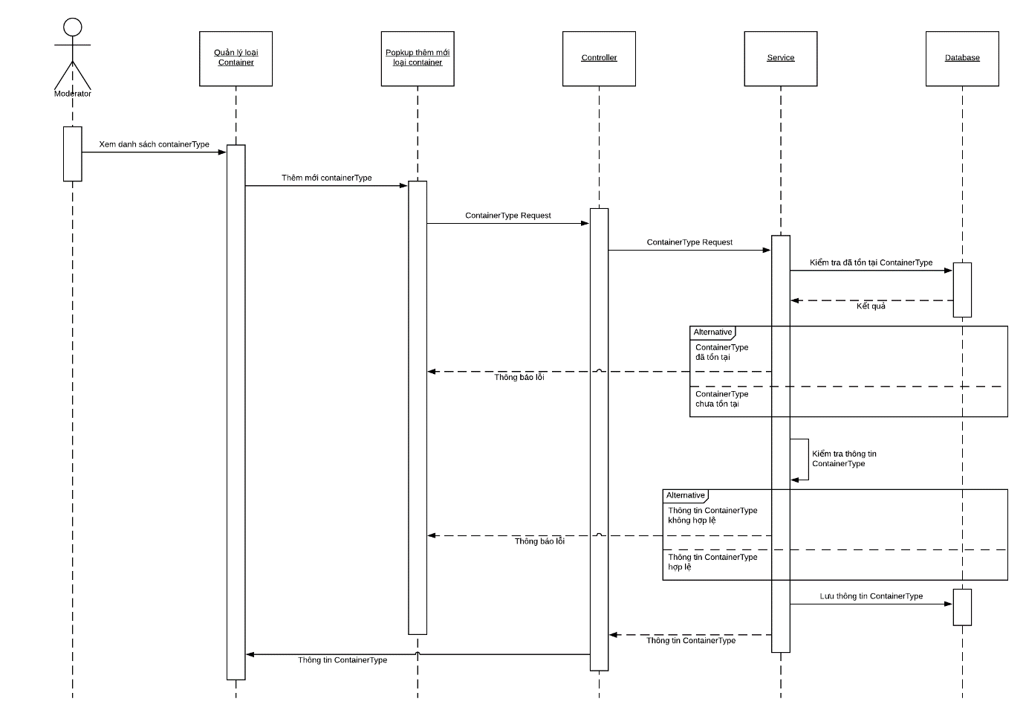

### 4.5.27 Update Container Type (Cập nhật Container Type)

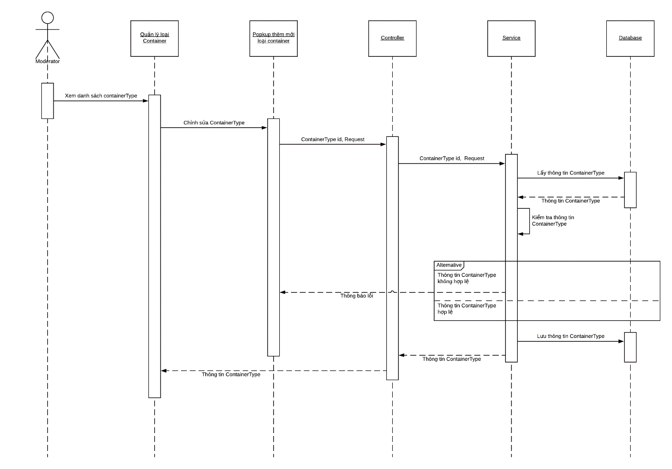

### 4.5.28 Delete Container Type (Xóa Container Type)

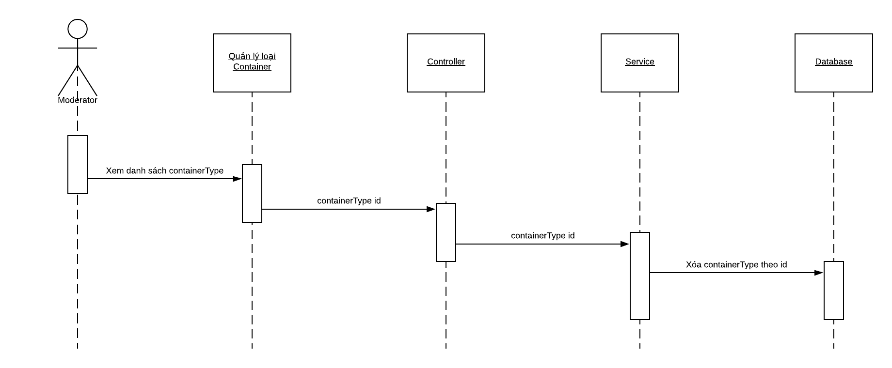

### 4.5.29 View list Port (Xem danh sách bến cảng)

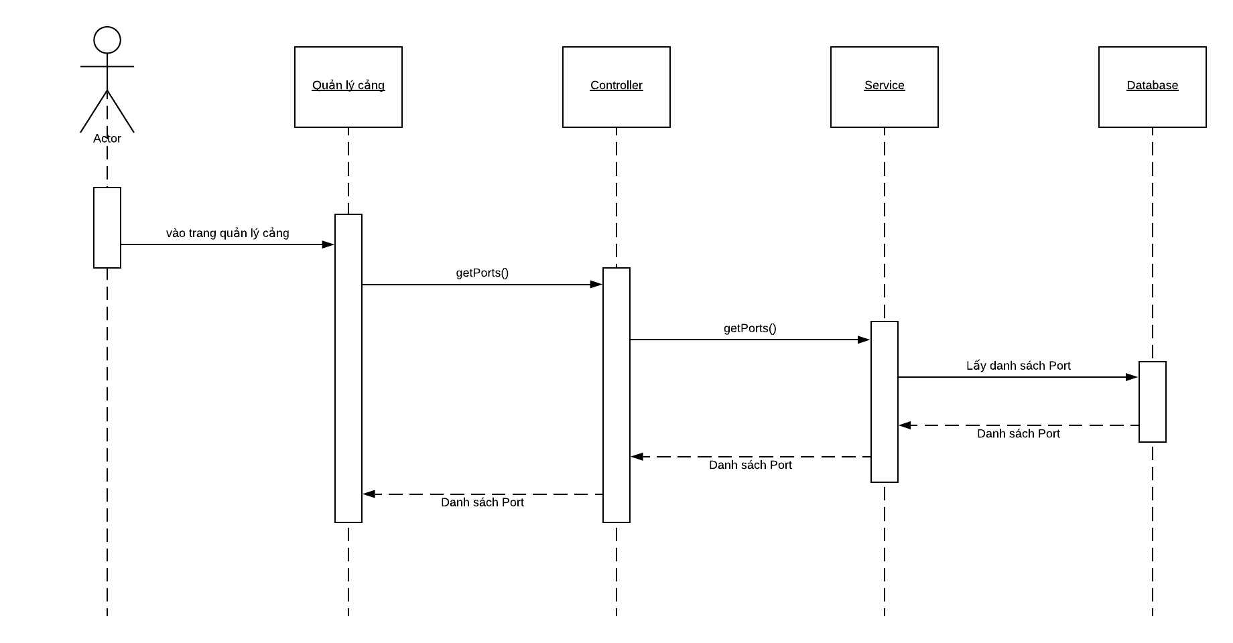

### 4.5.30 Declare Port (Khai báo bến cảng)

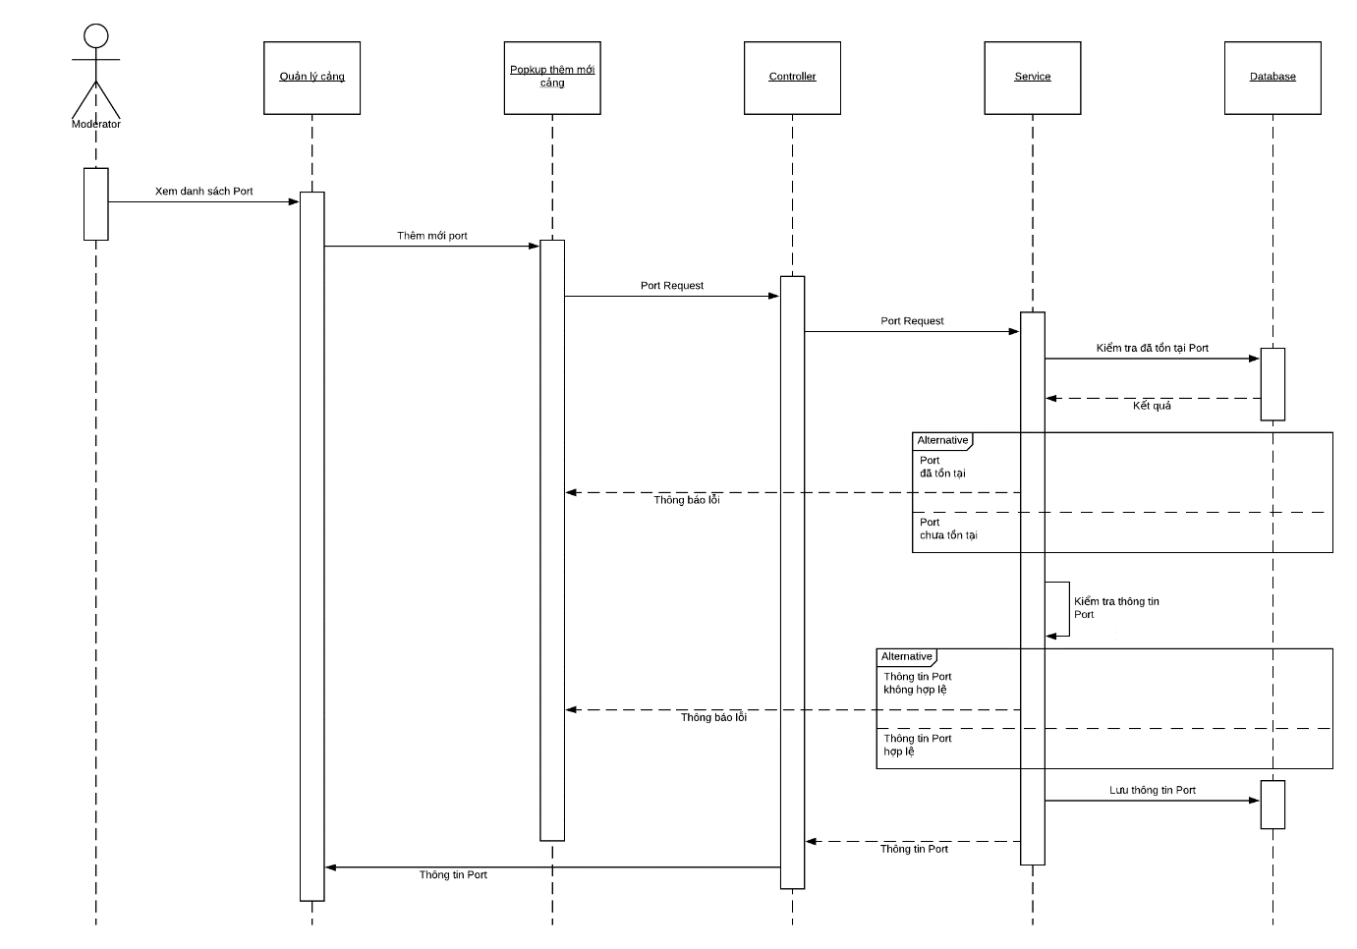

### 4.5.31 Update Port (Cập nhật bến cảng)

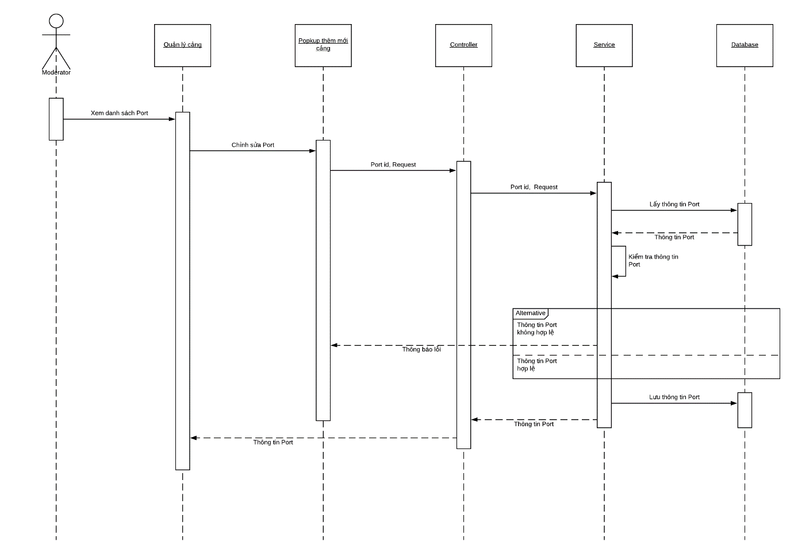

### 4.5.32 Delete Port (Xóa bến cảng)

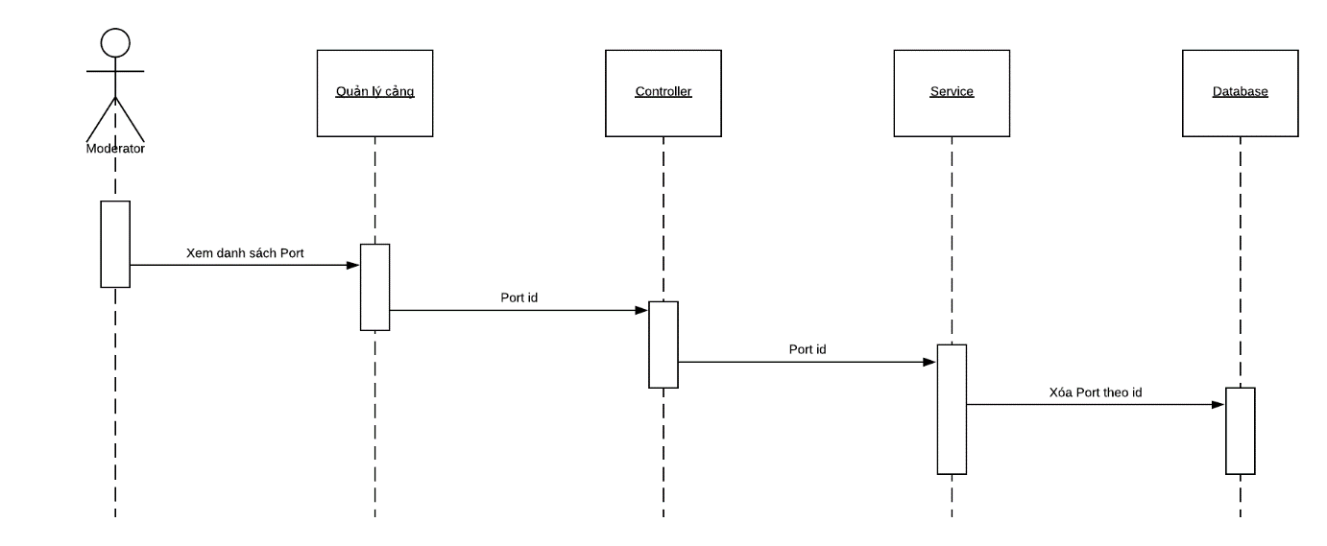

### 4.5.33 View list Shipping Line (Xem danh sách hãng tàu)

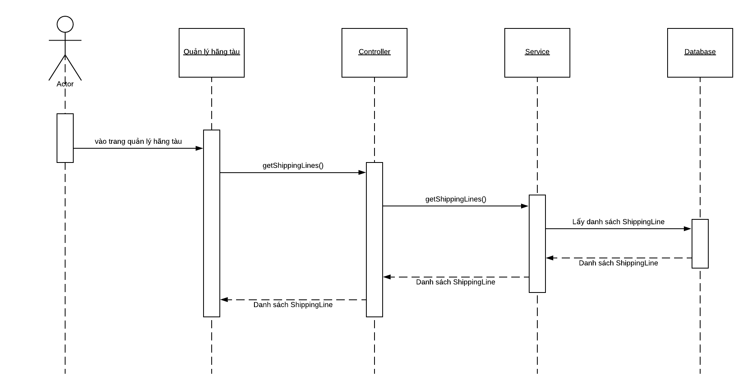

### 4.5.34 Declare Shipping Line (Khai báo hãng tàu)

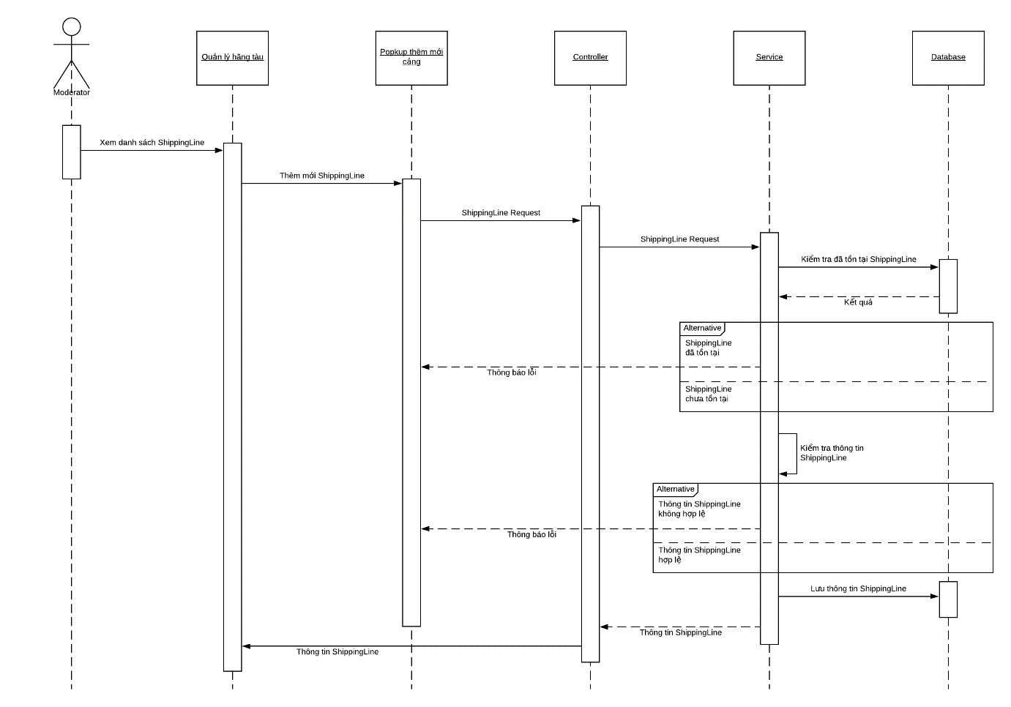

### 4.5.35 Update Shipping Line (Cập nhật hãng tàu)

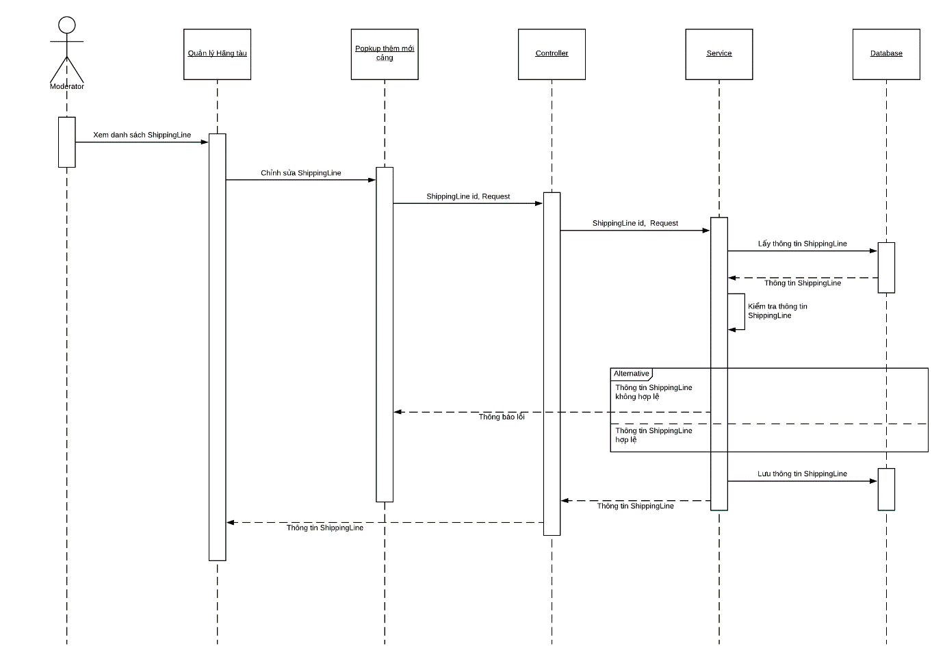

### 4.5.36 Delete Shipping Line (Xóa hãng tàu)

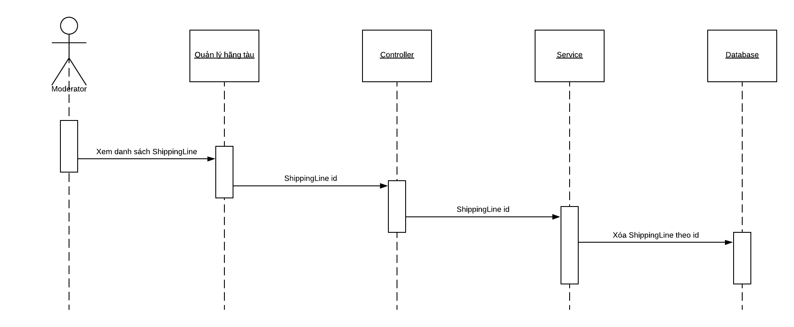

### 4.5.37 View Inbound list (Xem danh sách hàng nhập)

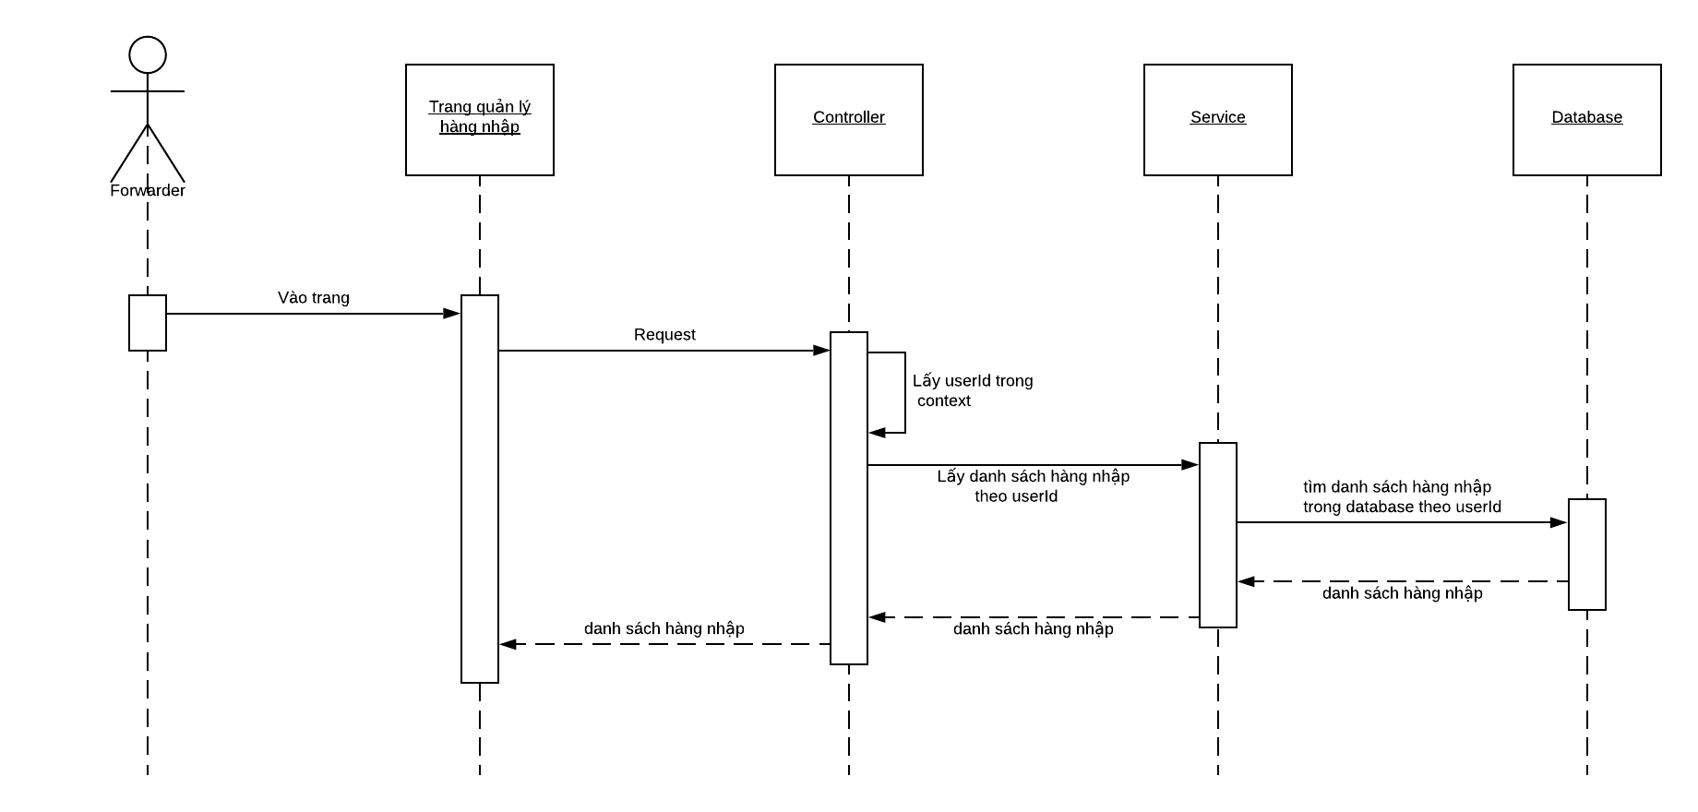

### 4.5.38 Declare Inbound (Khai báo hàng nhập)

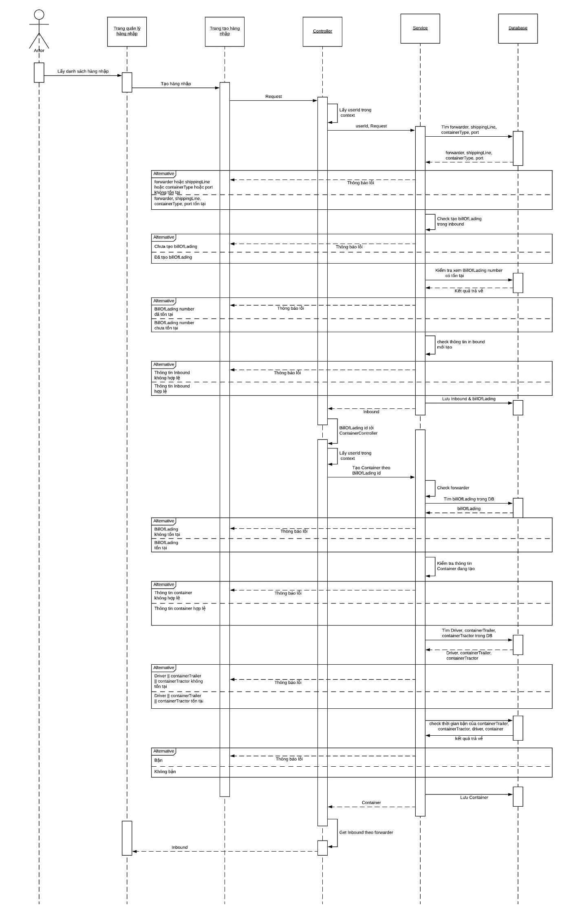

### 4.5.39 Edit Inbound (Chỉnh sửa hàng nhập)

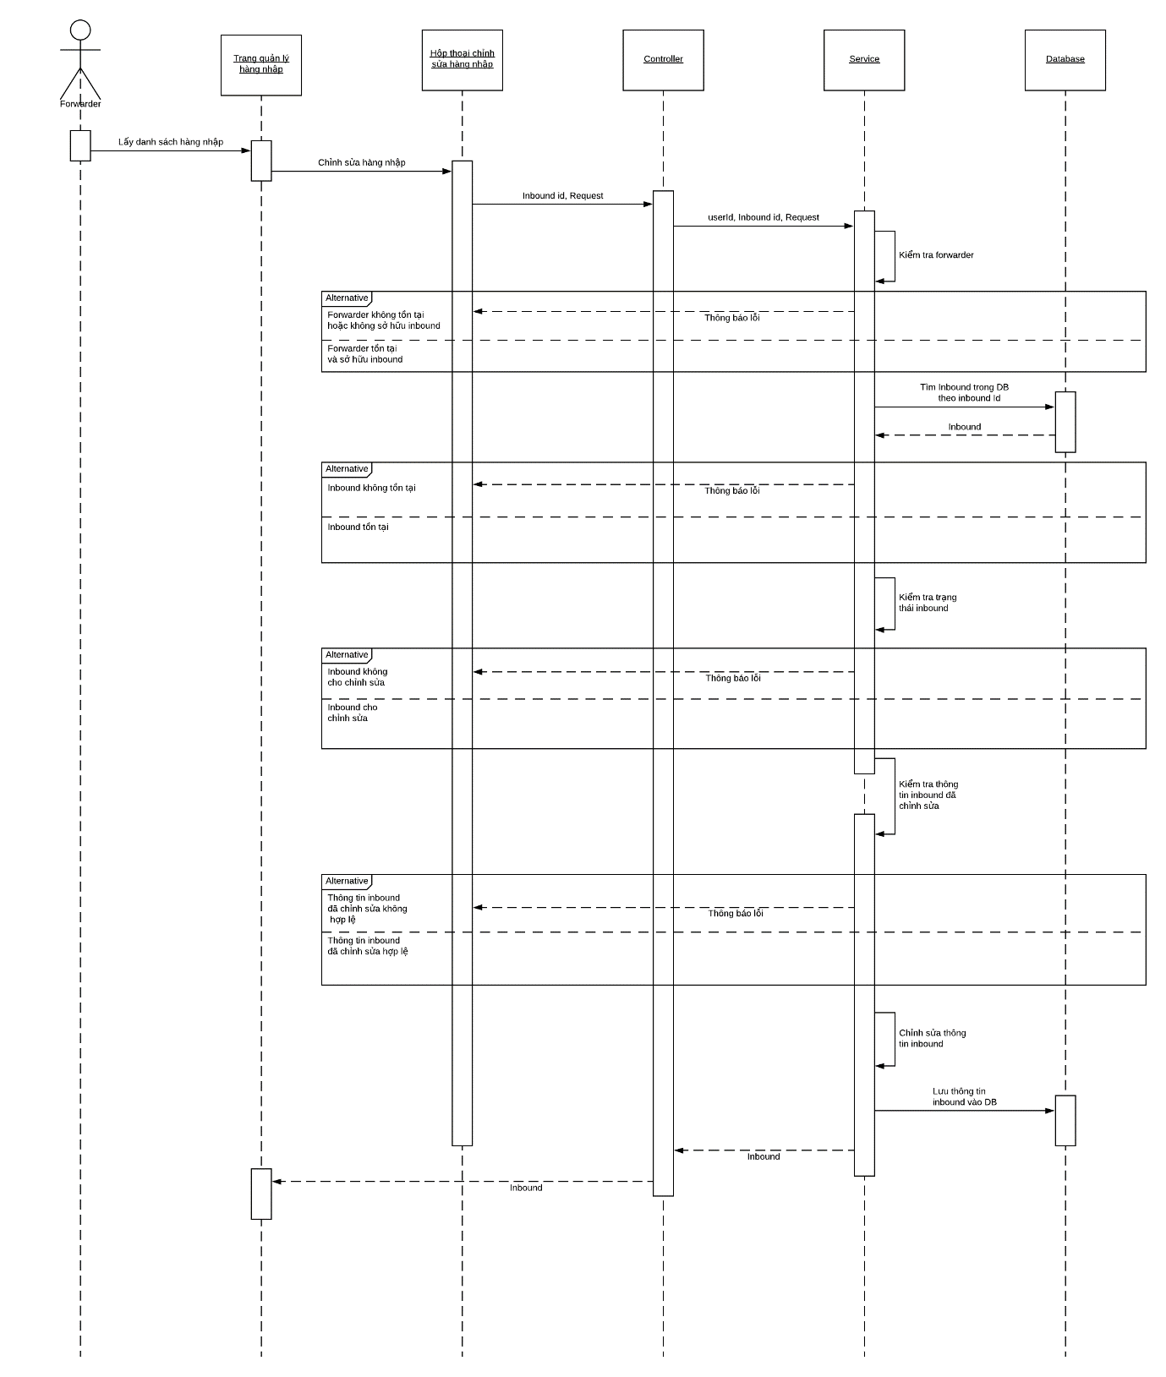

### 4.5.40 Delete Inbound (Xóa hàng nhập)

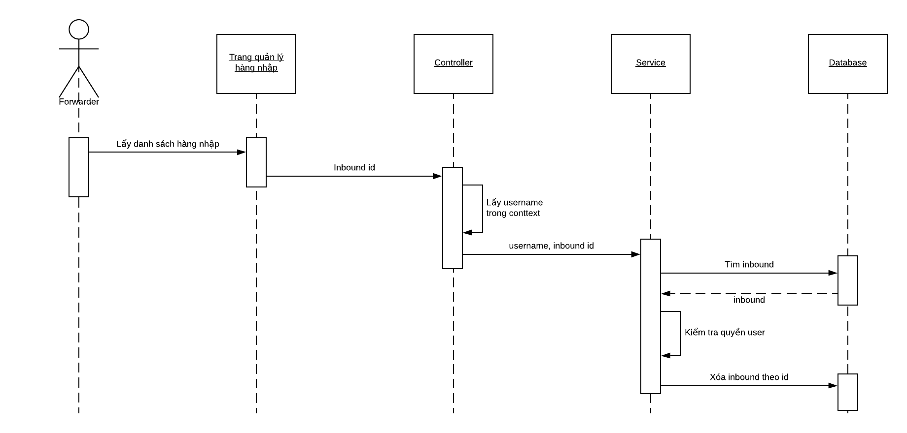

### 4.5.41 Forwarder create contract file (Forwarder tạo tài liệu hợp đồng)

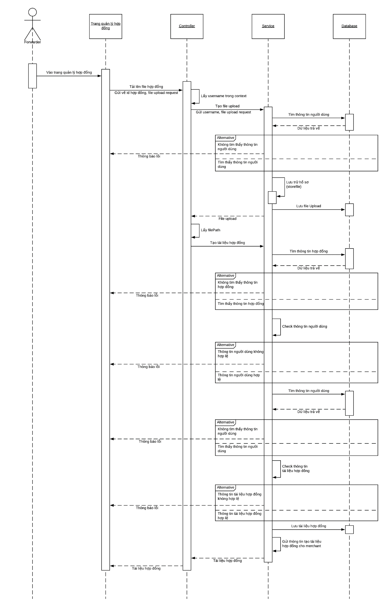

### 4.5.42 Merchant agree contract file (Merchant đồng ý tài liệu hợp đồng)

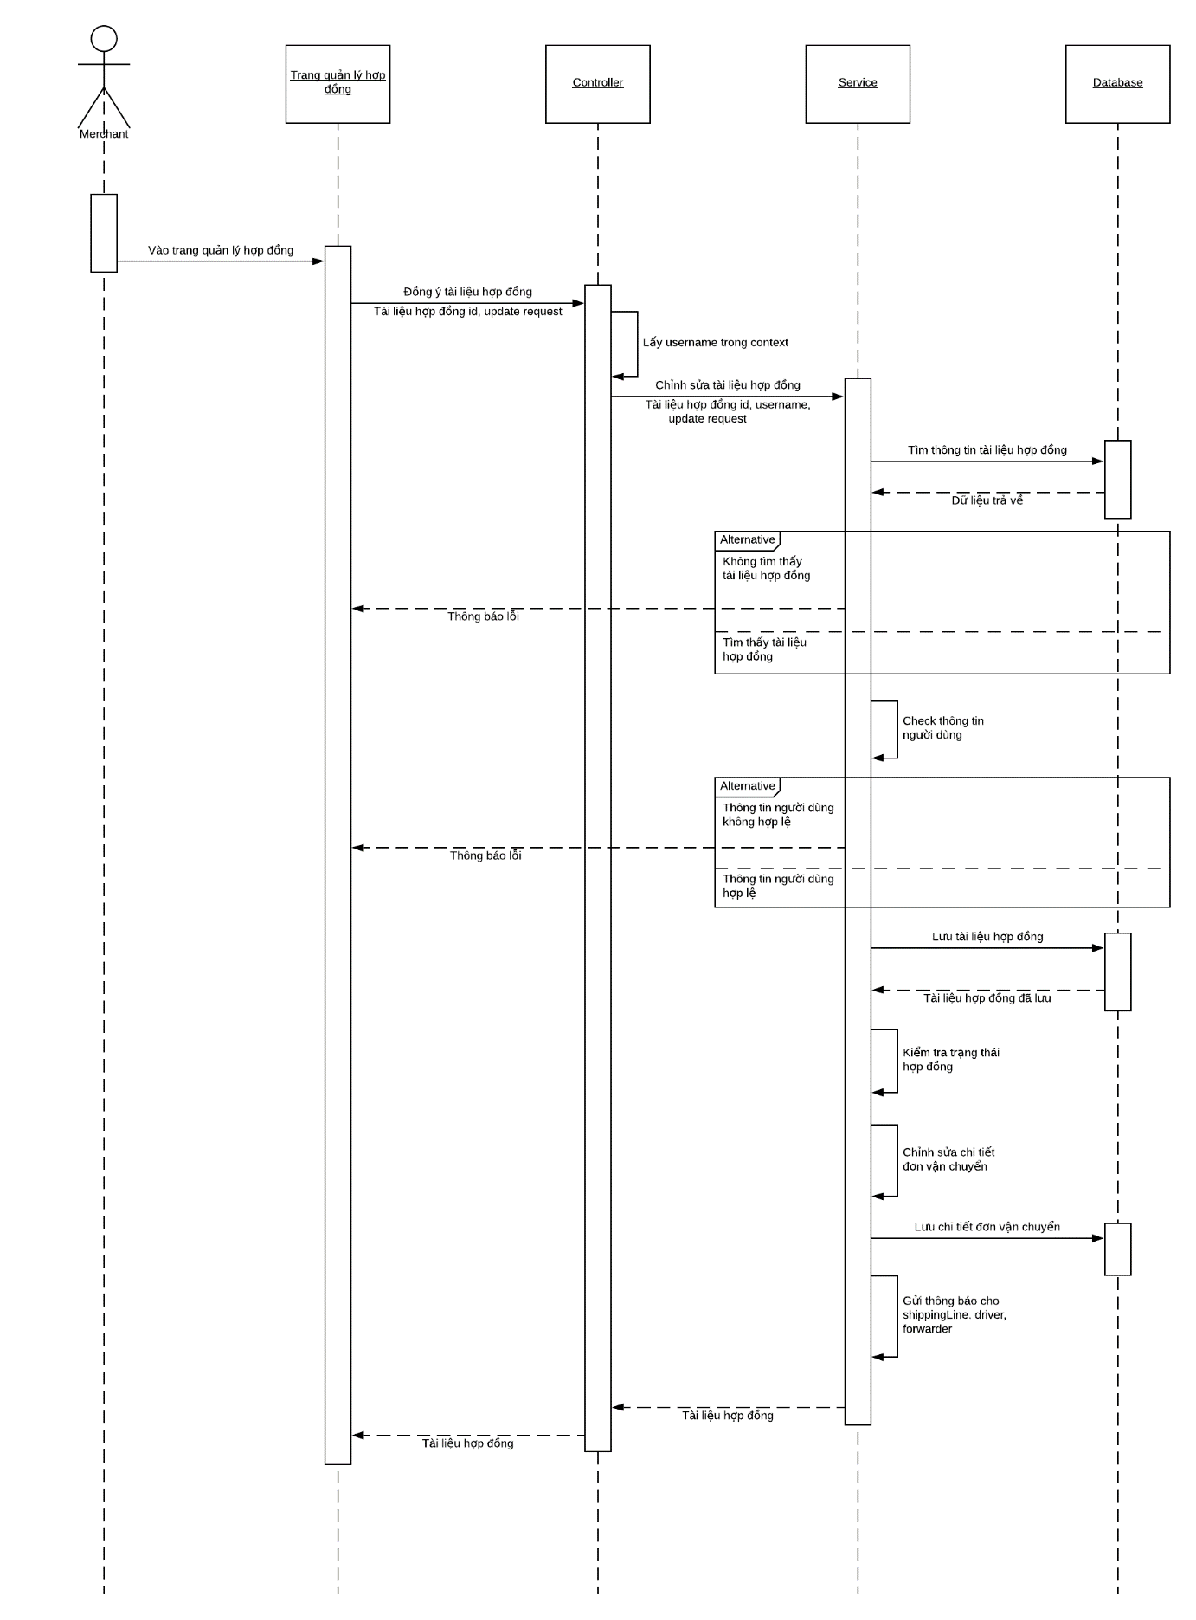

### 4.5.43 Merchant reject contract file (Merchant từ chối tài liệu hợp đồng)

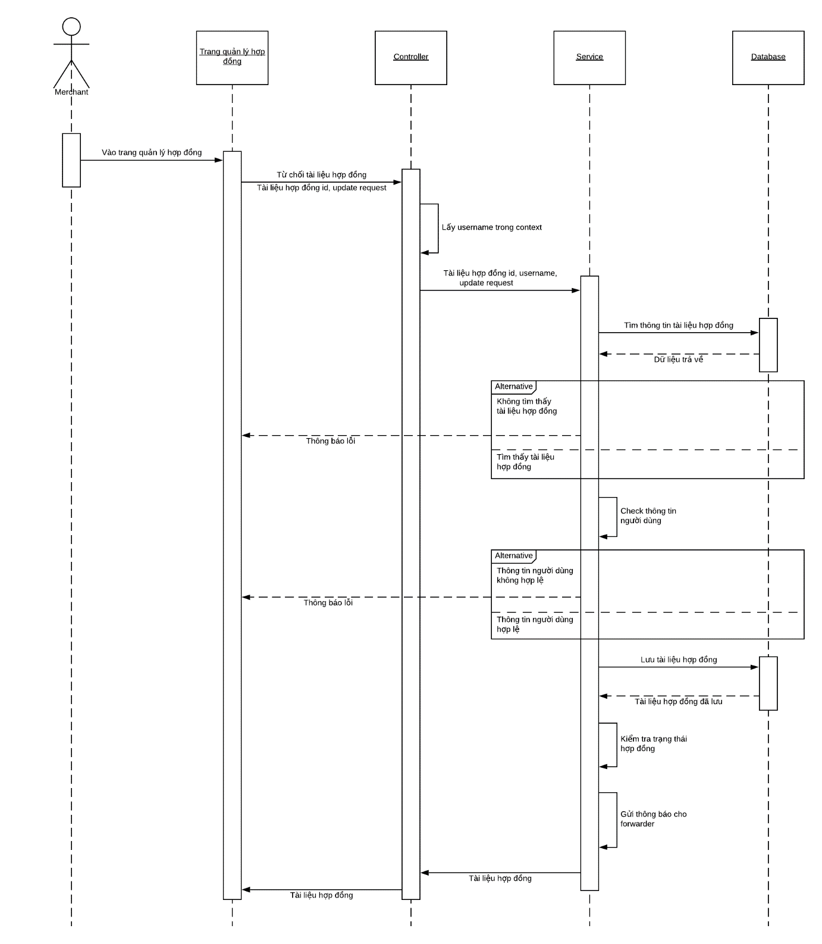

## **4.6. User Interface Design**

### 4.6.1 Description of the User Interface

4.12.1.1 Screen Images

4.12.1.1.1 Homepage when user not yet logged in

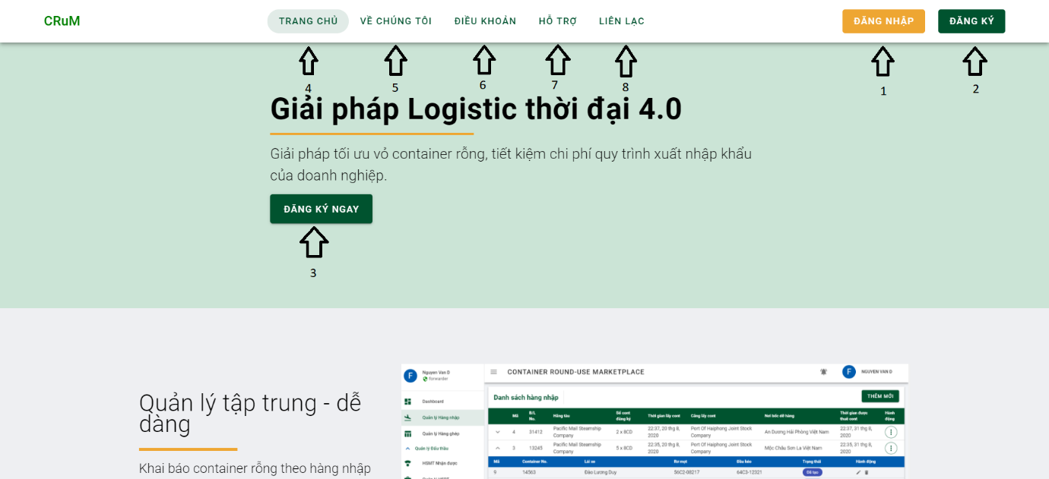

Button/ Hyperlinks

|  |  |  |  |  |
| --- | --- | --- | --- | --- |
| **No** | **Function** | **Description** | **Validation** | **Outcome** |
| 1 | Đăng nhập | Click to go to the login page | No | Navigate to login page |
| 2 | Đăng ký | Click to go to the register page | No | Navigate to register page |
| 3 | Đăng ký ngay | Click to go to the register page | No | Navigate to register page |
| 4 | Trang chủ | Homepage | No | Homepage |
| 5 | Về chúng tôi | About us | No | About us page |
| 6 | Điều khoản | Terms | No | Terms page |
| 7 | Hỗ trợ | Support | No | Support page |
| 8 | Liên lạc | Contact | No | Contact page |

4.12.1.1.2 Register

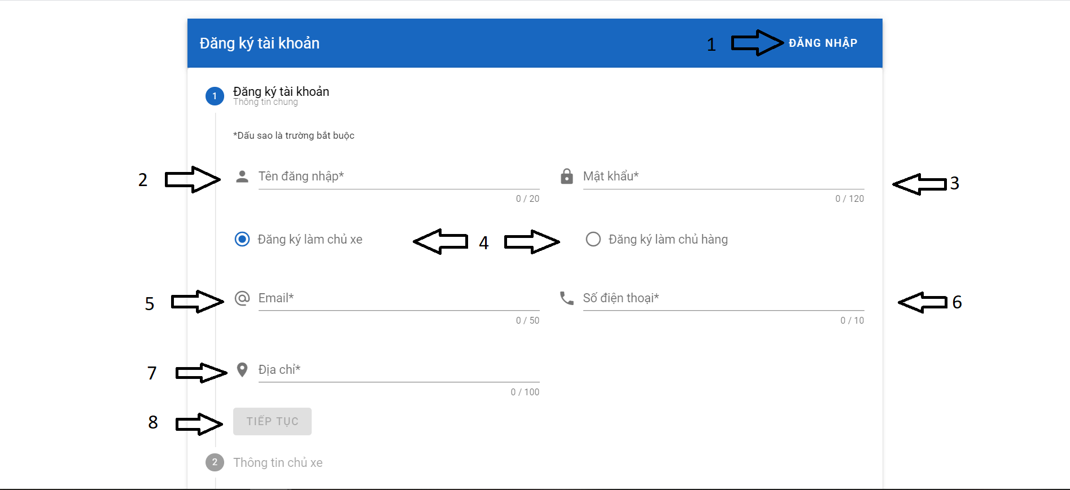

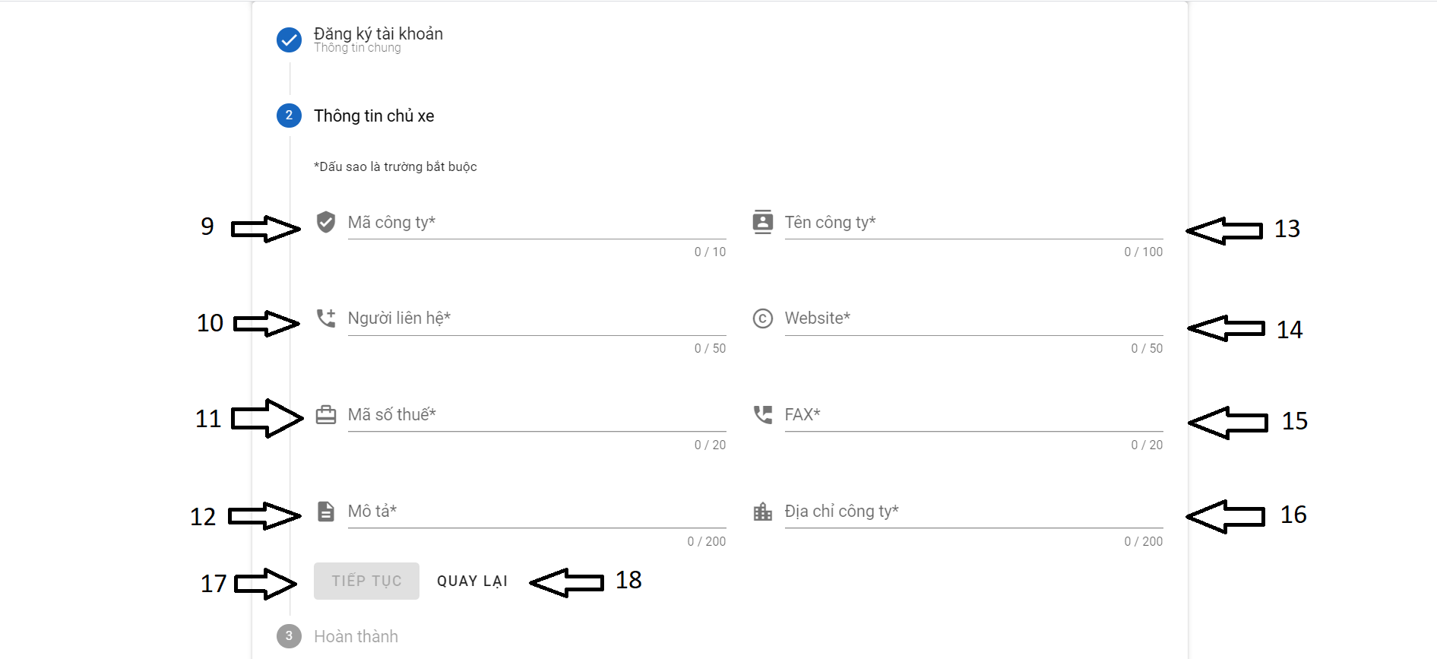

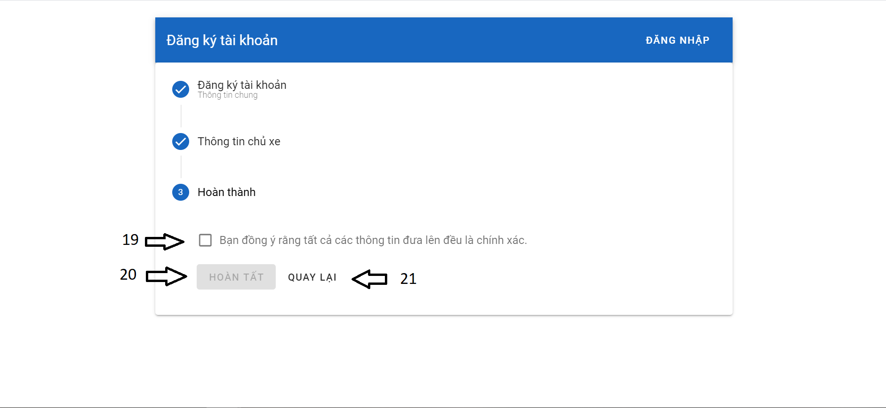

Button/ Hyperlinks

|  |  |  |  |  |
| --- | --- | --- | --- | --- |
| **No** | **Function** | **Description** | **Validation** | **Outcome** |
| 1 | Đăng nhập | Click to go to Login page | No | Navigate to Login page |
| 4 | Đăng ký làm chủ xe/ chủ hàng | Choose to become Merchant or Forwarder | No | Button is selected and title part 2 will change |
| 8 | Tiếp tục | Click to go to part 2 (Thông tin chủ xe/ chủ hàng) | Yes | Part 2 opens |
| 17 | Tiếp tục | Click to go to part 3  (Hoàn thành) | Yes | Part 3 opens |
| 18 | Quay lại | Click to go back to part 1 (Đăng ký tài khoản | No | Part 2 closes, part 1 opens |
| 19 | Checkbox Bạn đồng ý tất cả các thông tin đưa lên là chính xác | Choose to confirm that all information is correct | No | The checkbox has been checked. Button 20 is enable |
| 20 | Hoàn tất | Click to complete the registration | Yes | Registration is complete and show notification |
| 21 | Quay lại | Click to go back to part 2 (Thông tin chủ xe/ chủ hàng) | No | Part 3 closes, part 2 opens |

Fields

|  |  |  |  |  |  |  |  |
| --- | --- | --- | --- | --- | --- | --- | --- |
| **No** | **Field**  **Name** | **Description** | **Read**  **Only** | **Mandatory** | **Control**  **Type** | **Data**  **Type** | **Length** |
| 2 | Tên đăng nhập | Username | No | Yes | Text | String | 20 |
| 3 | Mật khẩu | Password | No | Yes | Password | String | 120 |
| 5 | Email | Email | No | Yes | Email | String | 50 |
| 6 | Số điện thoại | Phone number | No | Yes | Number | String | 10 |
| 7 | Địa chỉ | Address | No | Yes | Text | String | 100 |
| 9 | Mã công ty | Company code | No | Yes | Text | String | 10 |
| 10 | Người liên hệ | Contact name | No | Yes | Text | String | 50 |
| 11 | Mã số thuế | Tax identification number | No | Yes | Number | String | 20 |
| 12 | Mô tả | Description | No | Yes | Text | String | 200 |
| 13 | Tên công ty | Company Name | No | Yes | Text | String | 100 |
| 14 | Website | Website | No | Yes | Text | String | 50 |
| 15 | FAX | FAX | No | Yes | Number | String | 20 |
| 16 | Địa chỉ công ty | Company address | No | Yes | Text | String | 200 |

4.12.1.1.3 Login

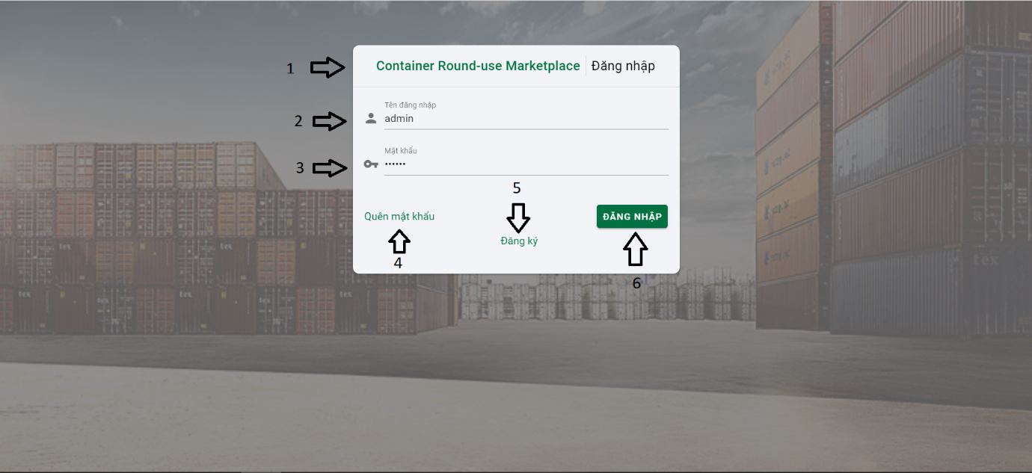

Button/ Hyperlinks

|  |  |  |  |  |
| --- | --- | --- | --- | --- |
| **No** | **Function** | **Description** | **Validation** | **Outcome** |
| 1 | Container Round-use Marketplace | Back to homepage | No | Navigate to homepage |
| 4 | Quên mật khẩu | Forgot password | No | Navigate to Forgot password page |
| 5 | Đăng ký | Register | No | Navigate to register page |
| 6 | Đăng nhập | Login | Yes | Shows successful login notification and return to home page |

Fields

|  |  |  |  |  |  |  |  |
| --- | --- | --- | --- | --- | --- | --- | --- |
| **No** | **Field**  **Name** | **Description** | **Read**  **Only** | **Mandatory** | **Control**  **Type** | **Data**  **Type** | **Length** |
| 2 | Tên đăng nhập | Username | No | Yes | Text | String | N/A |
| 3 | Mật khẩu | Password | No | Yes | Password | String | N/A |

4.12.1.1.4 Login

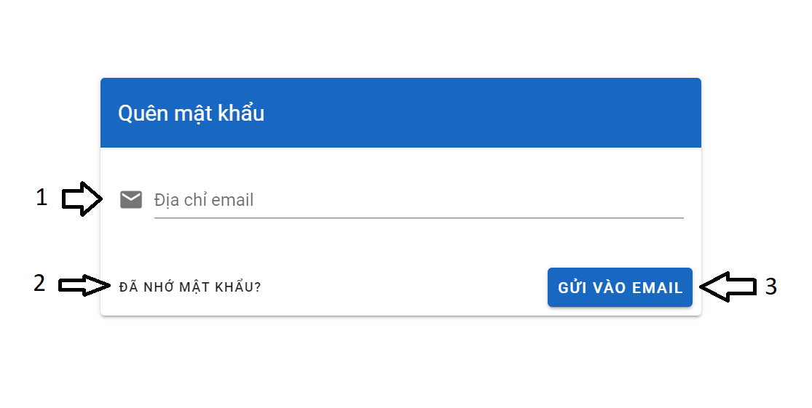

Button/ Hyperlinks

|  |  |  |  |  |
| --- | --- | --- | --- | --- |
| **No** | **Function** | **Description** | **Validation** | **Outcome** |
| 2 | Đã nhớ mật khẩu? | Remember password | No | Navigate to login page |
| 3 | Gửi vào email | Send to email | Yes | Show notification and a password reset link is sent to the email. |

Fields

|  |  |  |  |  |  |  |  |
| --- | --- | --- | --- | --- | --- | --- | --- |
| **No** | **Field**  **Name** | **Description** | **Read**  **Only** | **Mandatory** | **Control**  **Type** | **Data**  **Type** | **Length** |
| 1 | Địa chỉ email | User email | No | Yes | Text | String | N/A |

4.12.1.1.5 Change password

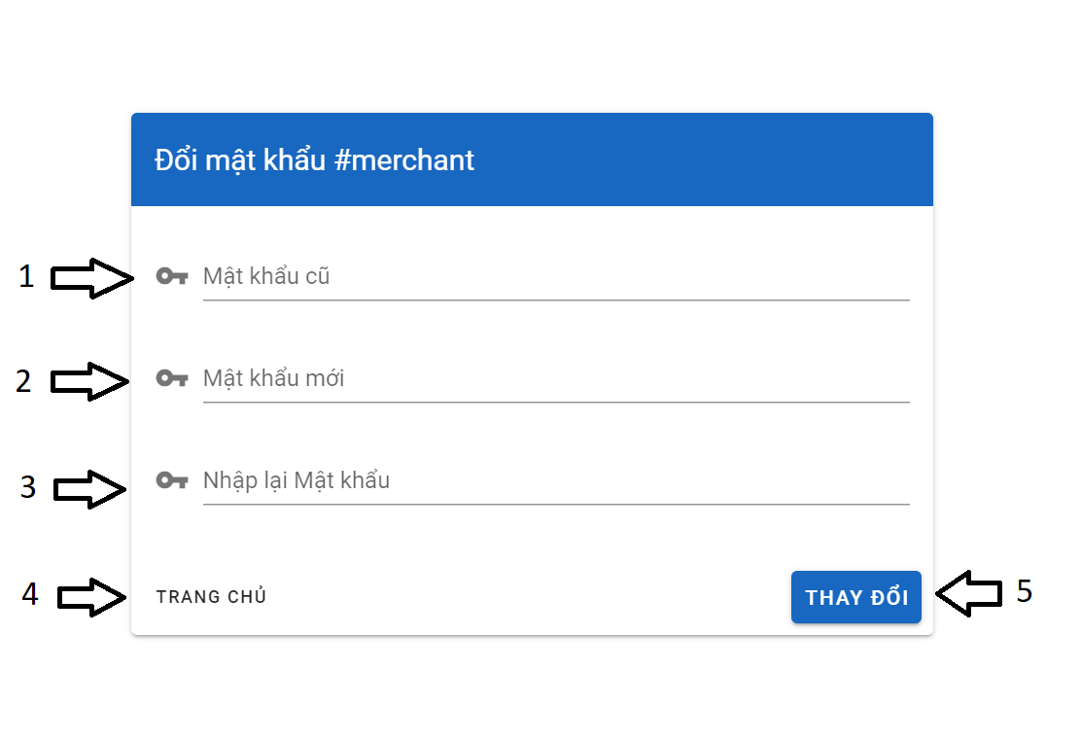

Button/ Hyperlinks

|  |  |  |  |  |
| --- | --- | --- | --- | --- |
| **No** | **Function** | **Description** | **Validation** | **Outcome** |
| 4 | Trang chủ | Homepage | No | Back to homepage |
| 5 | Thay đổi | Change password | Yes | Show notification and password changed. |

Fields

|  |  |  |  |  |  |  |  |
| --- | --- | --- | --- | --- | --- | --- | --- |
| **No** | **Field**  **Name** | **Description** | **Read**  **Only** | **Mandatory** | **Control**  **Type** | **Data**  **Type** | **Length** |
| 1 | Mật khẩu cũ | Old password | No | Yes | Password | String | N/A |
| 2 | Mật khẩu mới | New password | No | Yes | Password | String | N/A |
| 3 | Nhập lại mật khẩu | Re-enter new password | No | Yes | Password | String | N/A |

4.12.1.1.6 Dashboard

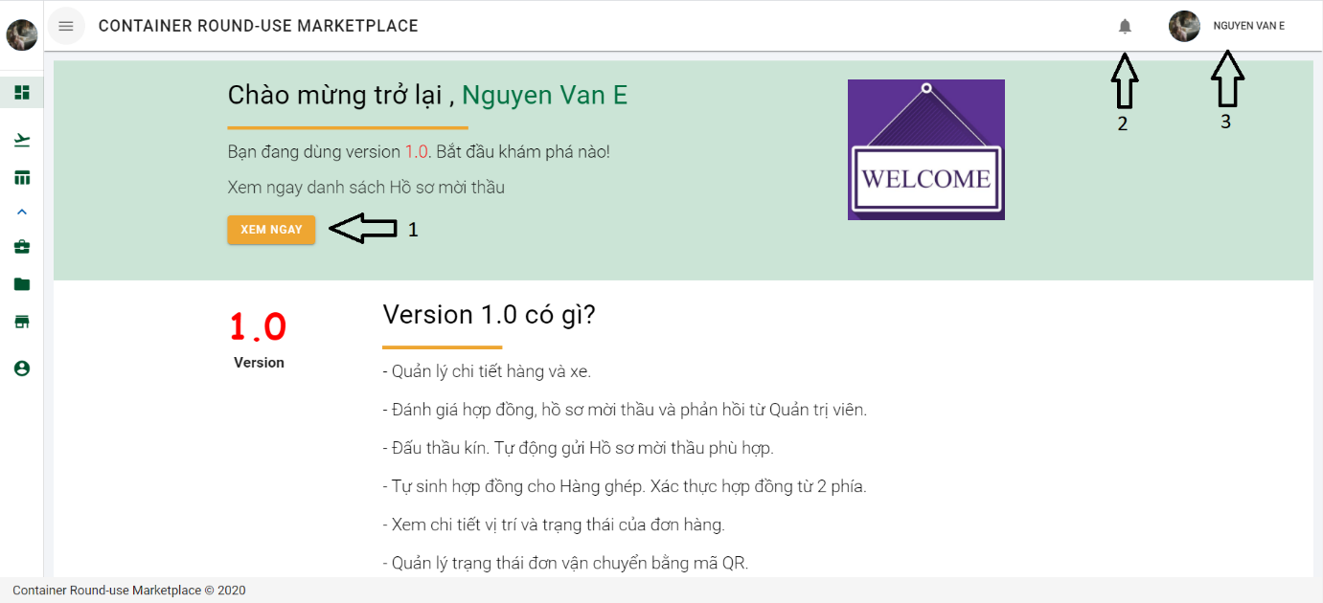

Button/ Hyperlinks

|  |  |  |  |  |
| --- | --- | --- | --- | --- |
| **No** | **Function** | **Description** | **Validation** | **Outcome** |
| 1 | Xem ngay | Bidding document | No | Navigate to list of bidding document |
| 2 | Notification | Show all bussiness notification | No | Show box notification |
| 3 | Username | Show action | No | Show list   * Trang cá nhân * Đổi mật khẩu * Đăng xuất |

4.12.1.1.7 Merchant UI

4.12.1.1.7.1 Dashboard

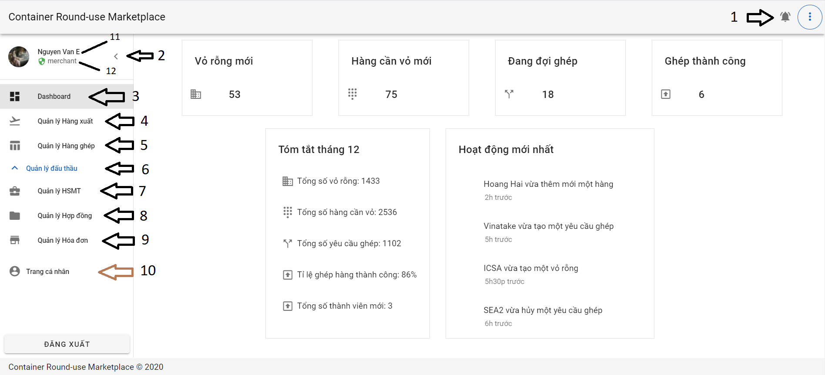

Button/ Hyperlinks

|  |  |  |  |  |
| --- | --- | --- | --- | --- |
| **No** | **Function** | **Description** | **Validation** | **Outcome** |
| 1 | Notification button | Show bussines notification | No | Show all notification |
| 2 | Collapse / expand the sidebar | Collapse / expand the sidebar | No | Side bar is Collapsed / expanded |

Fields

|  |  |  |  |  |  |  |  |
| --- | --- | --- | --- | --- | --- | --- | --- |
| **No** | **Field**  **Name** | **Description** | **Read**  **Only** | **Mandatory** | **Control**  **Type** | **Data**  **Type** | **Length** |
| 1 | Mật khẩu cũ | Old password | No | Yes | Password | String | N/A |
| 2 | Mật khẩu mới | New password | No | Yes | Password | String | N/A |
| 3 | Nhập lại mật khẩu | Re-enter new password | No | Yes | Password | String | N/A |

4.12.1.1.7.2 Outbound list

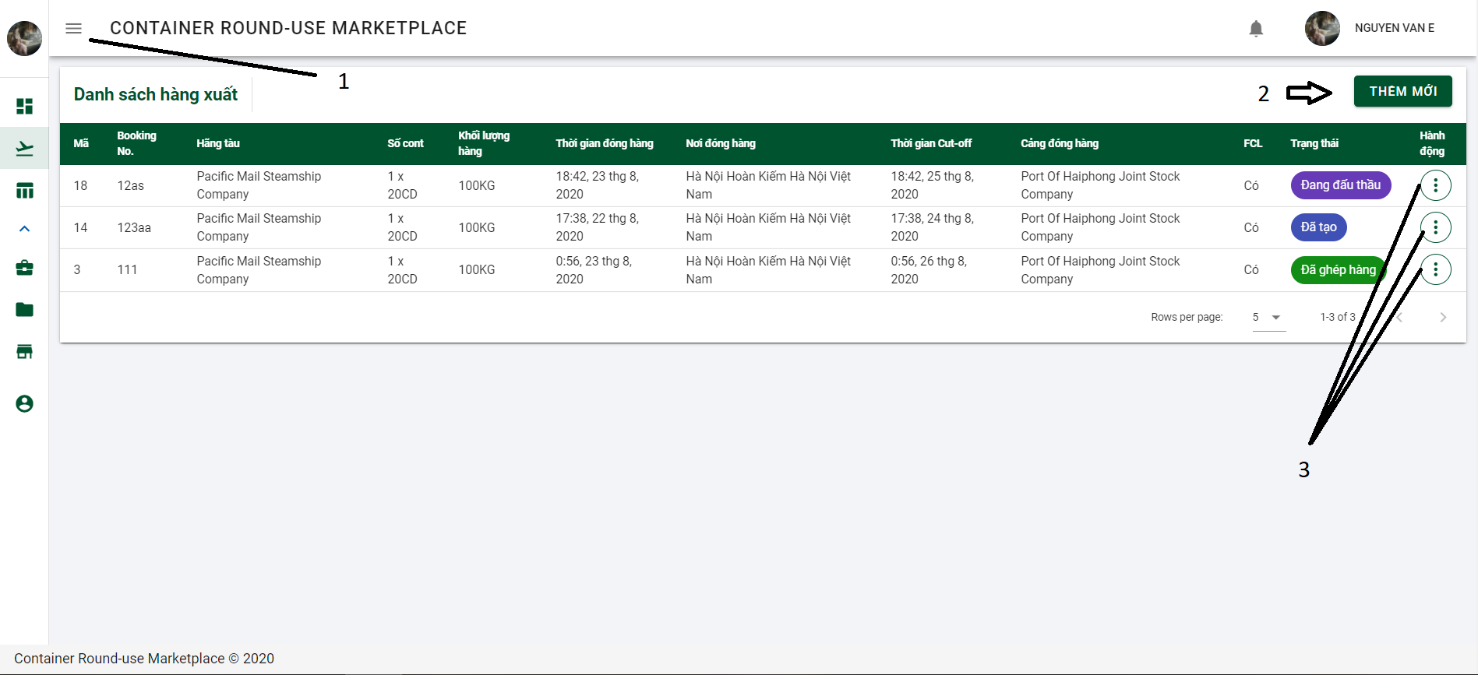

Button/ Hyperlinks

|  |  |  |  |  |
| --- | --- | --- | --- | --- |
| **No** | **Function** | **Description** | **Validation** | **Outcome** |
| 1 | Expand/ Collapse | Expland and collapse side bar | No | Sidebar explanded/collapsed |
| 2 | Thêm mới | Declare inbound | No | Navigate to Declare inbound dialog |
| 3 | 3 dots | Action | No | Selection list contained:   * Mở đấu thầu * Chỉnh sửa * Xóa bỏ |

4.12.1.1.7.3 Declare outbound page

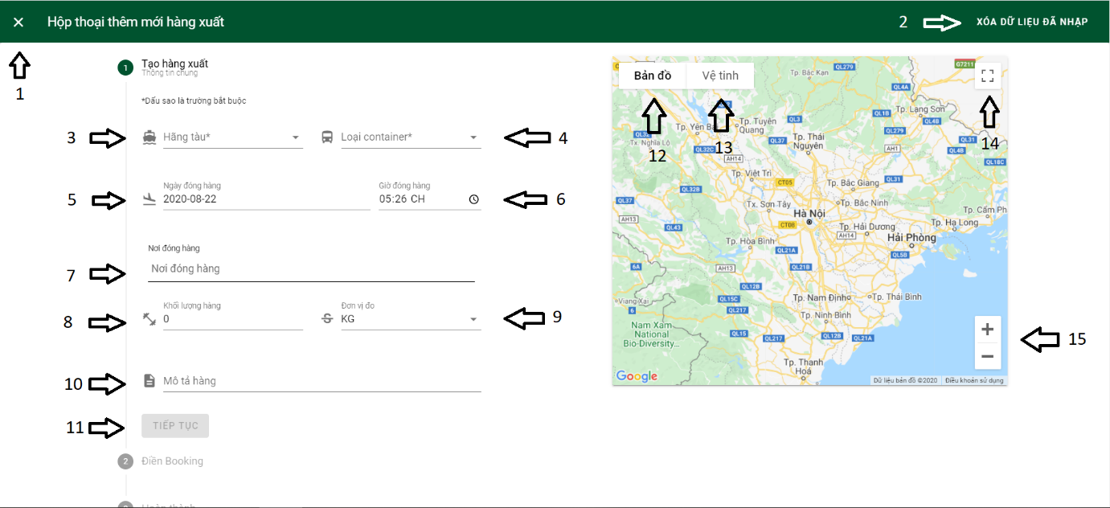

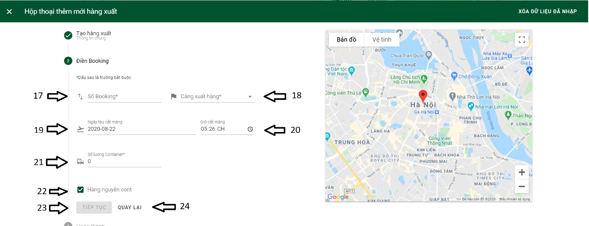

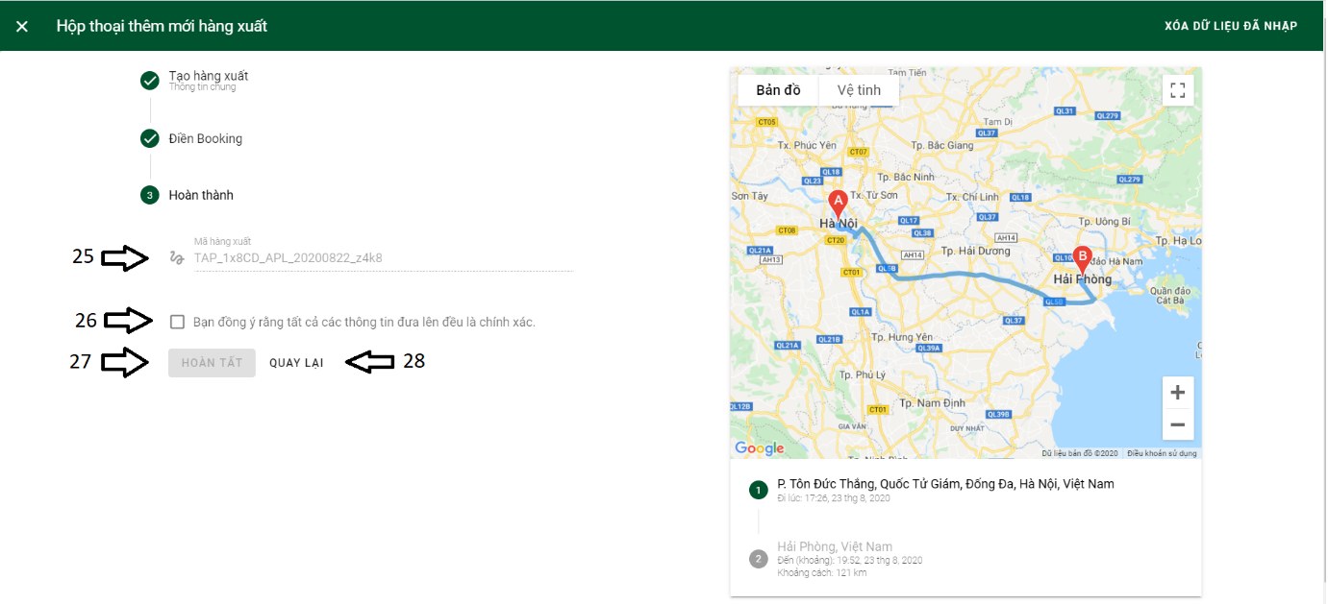

Button/ Hyperlinks

|  |  |  |  |  |
| --- | --- | --- | --- | --- |
| **No** | **Function** | **Description** | **Validation** | **Outcome** |
| 1 | Close dialog | Close declare outbound dialog | No | Close declare outbound dialog and back to outbound list. |
| 2 | Xóa dữ liệu đã nhập | Delete imported data | No | Delete all imported data |
| 3 | Hãng tàu | Shipping line | No | Show list Shipping line |
| 4 | Loại container | Container type | No | Show list Container type |
| 5 | Ngày đóng hàng | Packing time | No | Show calendar to choose packing time |
| 9 | Đơn vị đo | Unit of measurement | No | Show list unit |
| 11 | Tiếp tục | Continue | Yes | Open part 2 |
| 12 | Map | Normal map | No | Normal map mode |
| 13 | Satellite map | Satellite map | No | Satellite map mode |
| 14 | Full screen | Full screen map | No | Open full screen map |
| 15 | Zoom in/ Zoom out | Zoom in/ Zoom out map | No | Zoom map |
| 18 | Cảng xuất hàng | Port of loading | No | Show list port of loading |
| 19 | Ngày tàu cắt máng | Cut off time | No | Open calendar to choose cut off time |
| 22 | Checkbox Hàng nguyên cont | Check box full container load | No | Choose option full container load |
| 23 | Tiếp tục | Continue | Yes | Open part 3 |
| 24 | Quay lại | Back | No | Back to part 1 |
| 26 | Check box | Agree that the information posted is correct | No | Choose to Agree that the information posted is correct |
| 27 | Hoàn tất | Complete | Yes | Declare outbound |
| 28 | Quay lại | Back | No | Back to part 2 |

Fields

|  |  |  |  |  |  |  |  |
| --- | --- | --- | --- | --- | --- | --- | --- |
| **No** | **Field**  **Name** | **Description** | **Read**  **Only** | **Mandatory** | **Control**  **Type** | **Data**  **Type** | **Length** |
| 7 | Nơi đóng hàng | Packing station | No | Yes | Text | String | N/A |
| 8 | Khối lượng hàng | Gross weight | No | No | Number | Long | N/A |
| 10 | Mô tả hàng | Outbound description | No | No | Text | String | N/A |
| 17 | Số booking | Booking number | No | Yes | Text | String | N/A |
| 21 | Số lượng container | Container quantity | No | Yes | Number | Int | N/A |
| 25 | Mã hàng xuất | Outbound code | Yes | Yes | Text | String | N/A |

4.12.1.1.7.4 Combined list page

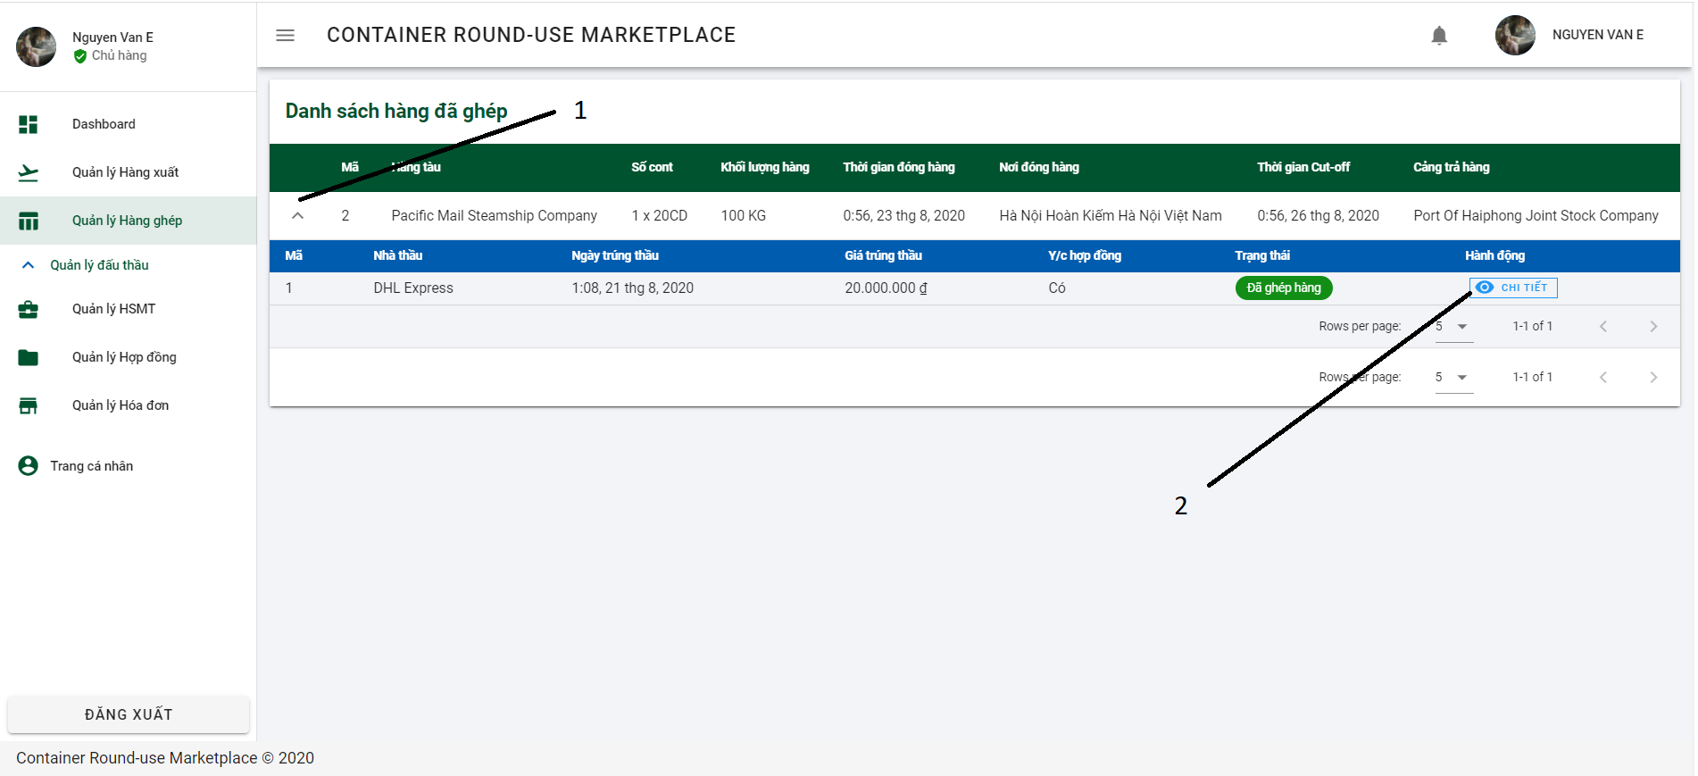

Button/ Hyperlinks

|  |  |  |  |  |
| --- | --- | --- | --- | --- |
| **No** | **Function** | **Description** | **Validation** | **Outcome** |
| 1 | Expand | Expand combined information | No | Expand combined |
| 2 | Chi tiết | Detail | No | Navigate to combined detail |

4.12.1.1.7.4 Add new Bidding document dialog

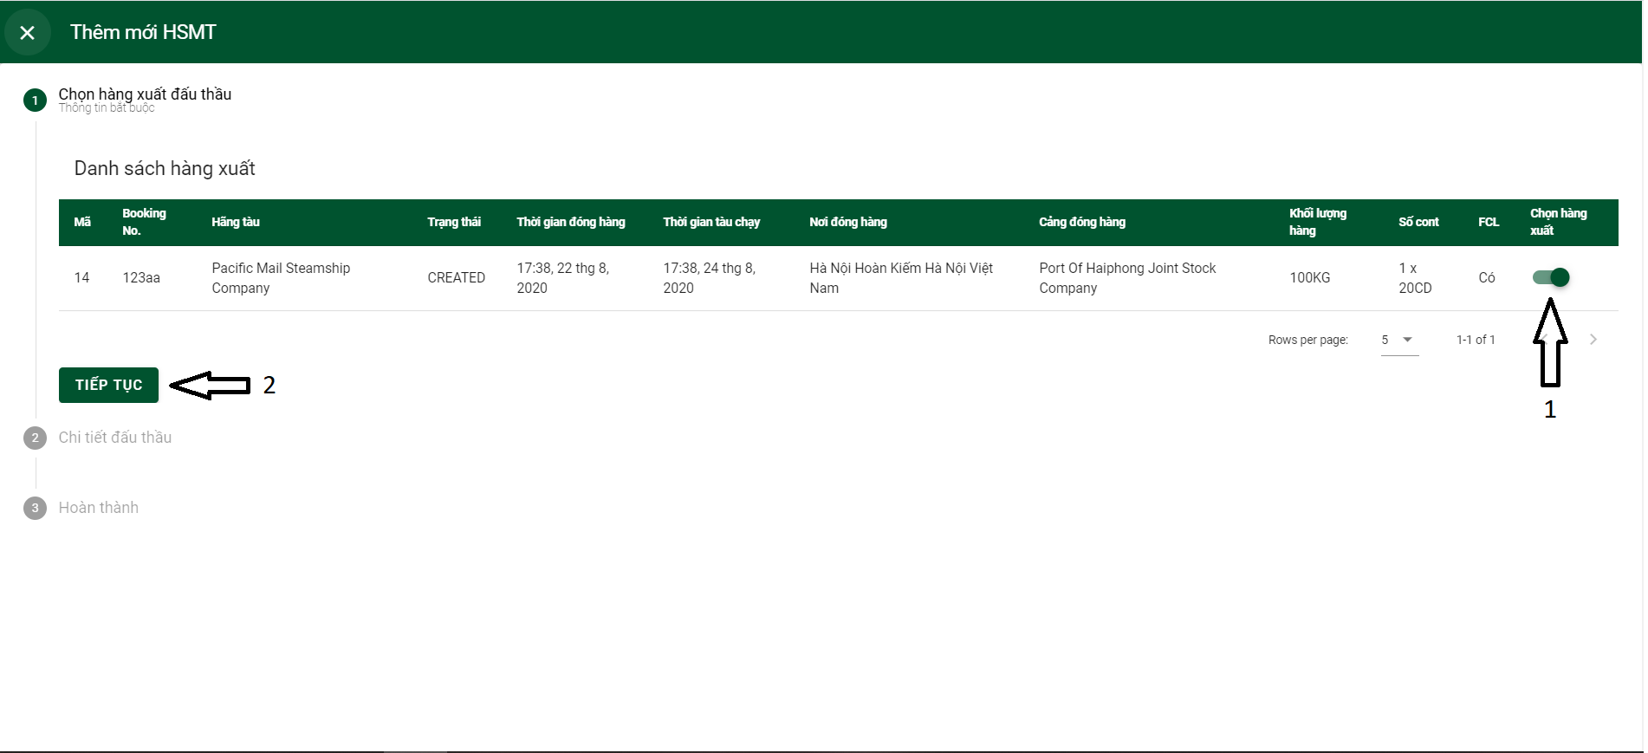

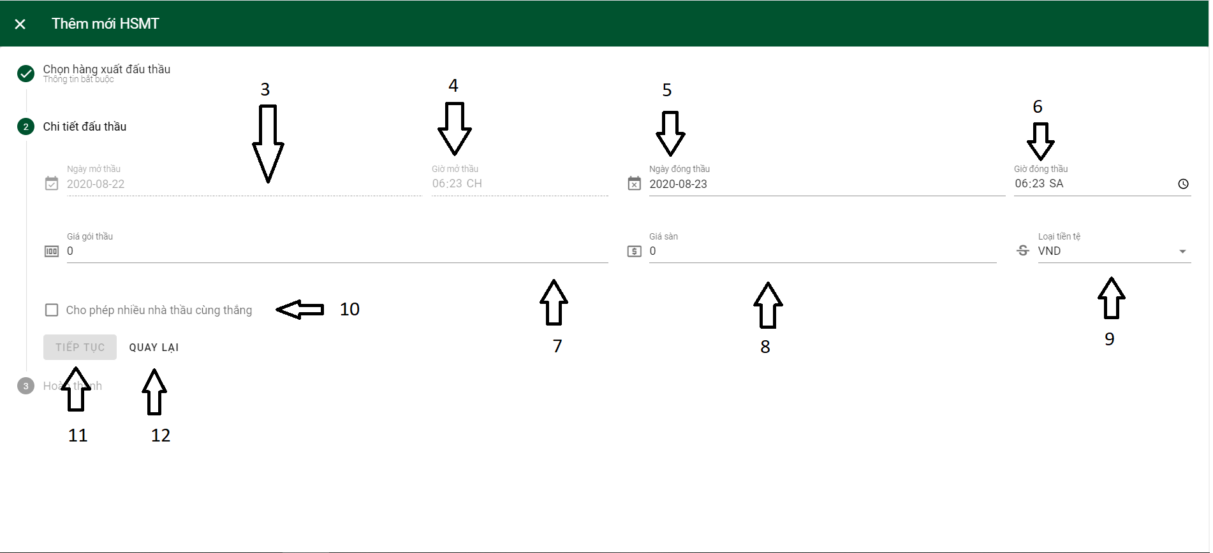

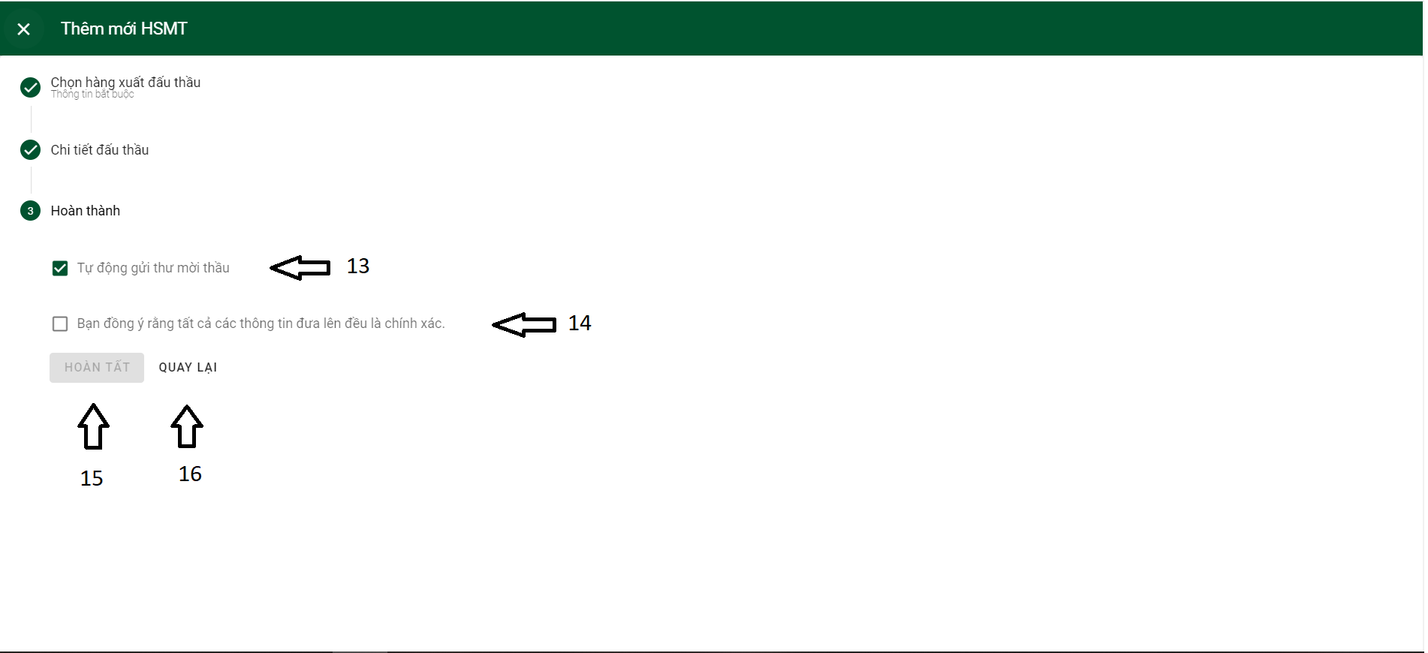

Button/ Hyperlinks

|  |  |  |  |  |
| --- | --- | --- | --- | --- |
| **No** | **Function** | **Description** | **Validation** | **Outcome** |
| 1 | Toggle button | Choose outbound | No | Outbound choosed |
| 2 | Tiếp tục | Continue | No | Open part 2 |
| 3 | Open bidding date | Start bidding date | Yes | Disable. Default current date |
| 5 | Close bidding date | End bidding date | No | Open calendar to choose date |
| 9 | Loại tiền tệ | Currency | No | Selection list   * VND * USD |
| 10 | Checkbox | Choose Many bid win | No | Allow many bid win |
| 11 | Tiếp tục | Continue | Yes | Open part 3 |
| 12 | Quay lại | Back | No | Back to part 1 |

Fields

|  |  |  |  |  |  |  |  |
| --- | --- | --- | --- | --- | --- | --- | --- |
| **No** | **Field**  **Name** | **Description** | **Read**  **Only** | **Mandatory** | **Control**  **Type** | **Data**  **Type** | **Length** |
| 4 | Open bidding time | Start bidding time | Yes | Yes | Time | DateTime | N/A |
| 6 | Close bidding time | End bidding time | No | Yes | Time | DateTime | N/A |
| 7 | Giá gói thầu | Bid Package price | No | Yes | number | Double | N/A |
| 8 | Giá sàn | Floor price | No | No | number | Double | N/A |

4.12.1.1.7.4 Combined detail page

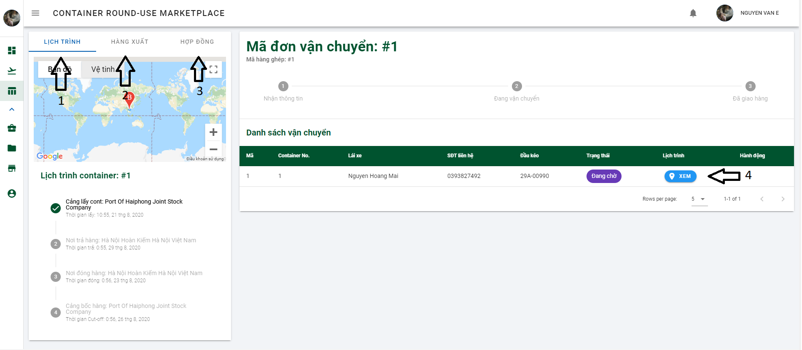

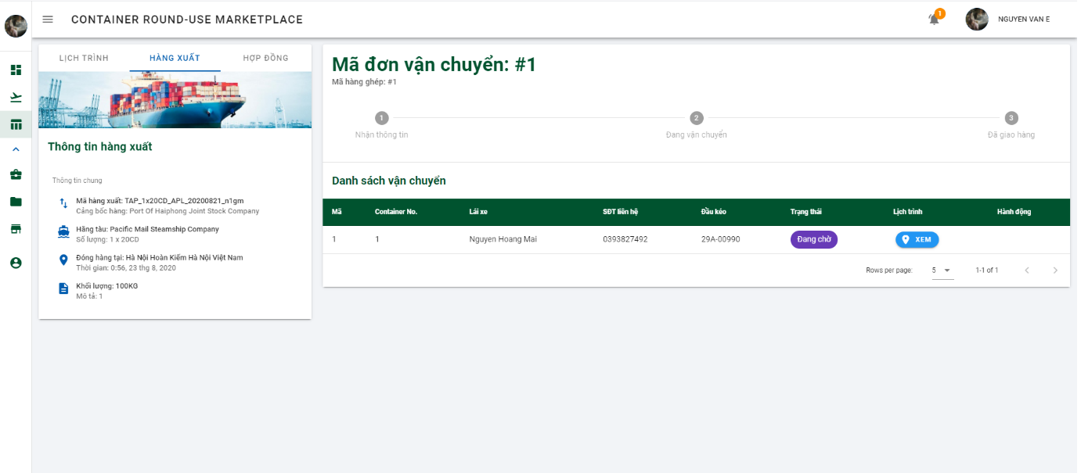

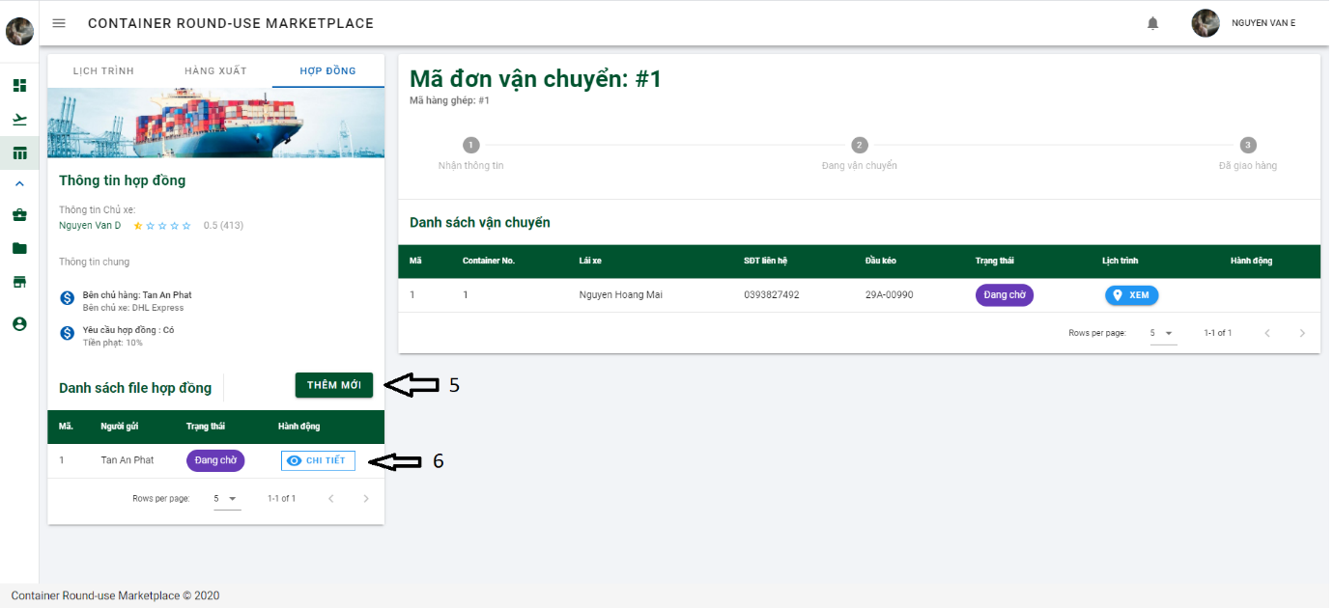

Button/ Hyperlinks

|  |  |  |  |  |
| --- | --- | --- | --- | --- |
| **No** | **Function** | **Description** | **Validation** | **Outcome** |
| 1 | Lịch trình | Tracking container | No | Tracking container location |
| 2 | Hàng xuất | Outbound information | No | Outbound all information |
| 3 | Hợp đồng | Contract | No | Contract information |
| 4 | Xem | Show container schedule | No | Show container schedule |
| 5 | Thêm mới | Add new contract file | No | Show dialog attach file |
| 6 | Chi tiết | Contract file detail | No | Show dialog to see detail file |

4.12.1.1.7.5 Contract list page and declare invoice

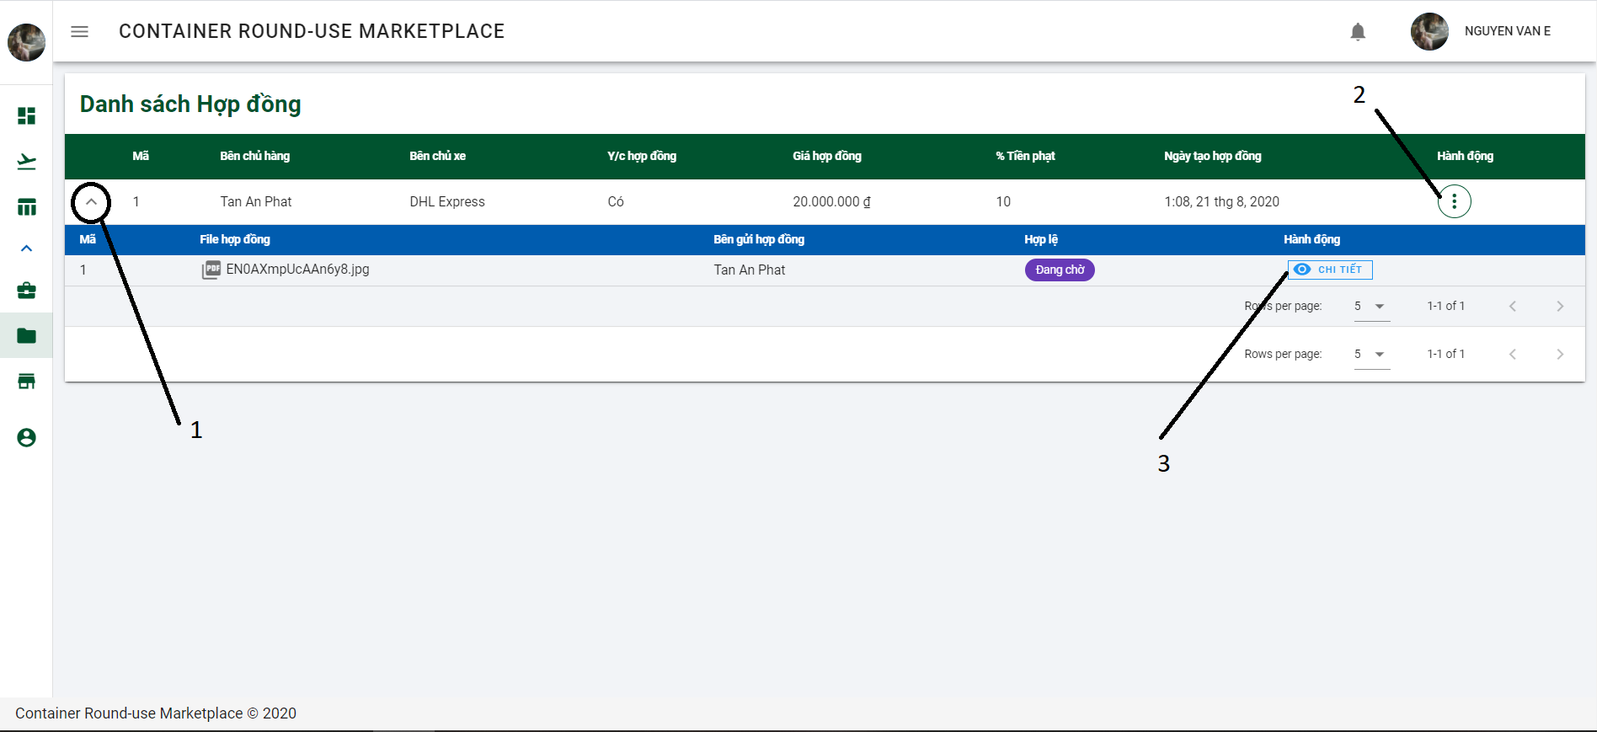

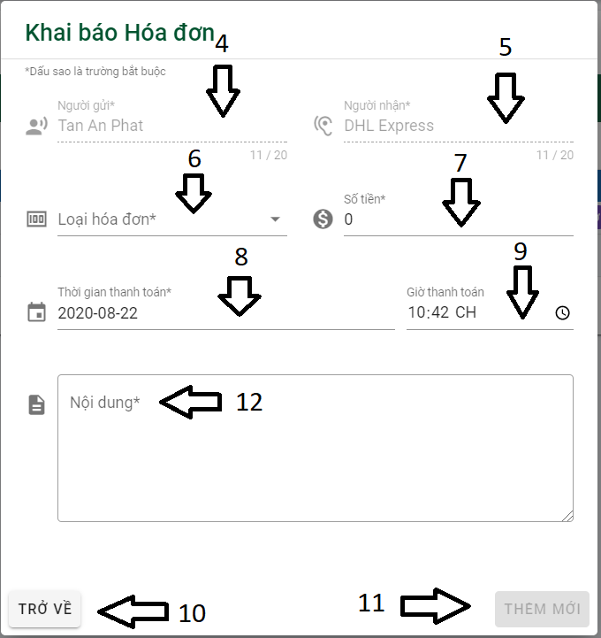

Button/ Hyperlinks

|  |  |  |  |  |
| --- | --- | --- | --- | --- |
| **No** | **Function** | **Description** | **Validation** | **Outcome** |
| 1 | Expand | Expand contract information | No | Expand contract |
| 2 | Selection list | Show action option | No | Selection list contained:   * Tạo hóa đơn * Chỉnh sửa |
| 3 | Chi tiết | Contract file detail | No | Show contract file detail |
| 6 | Selection list invoice type | Invoice type | No | Selection list contained:   * Fines * Payment |
| 8 | Thời gian thanh toán | Payment date | No | Show calendar to choose Payment date |
| 10 | Trở về | Back | No | Back to contract list |
| 11 | Thêm mới | Add | Yes | Add contract |

Fields

|  |  |  |  |  |  |  |  |
| --- | --- | --- | --- | --- | --- | --- | --- |
| **No** | **Field**  **Name** | **Description** | **Read**  **Only** | **Mandatory** | **Control**  **Type** | **Data**  **Type** | **Length** |
| 4 | Người gửi | Invoice creator | Yes | Yes | Text | String | N/A |
| 5 | Người nhận | Receiver | Yes | Yes | Text | String | N/A |
| 7 | Số tiền | Amount | No | Yes | number | Double | N/A |
| 9 | Giờ thanh toán | Payment time | No | Yes | Time | DateTime | N/A |
| 12 | Nội dung | Content | No | Yes | Text | String | N/A |

4.12.1.1.7.6 List of invoice page

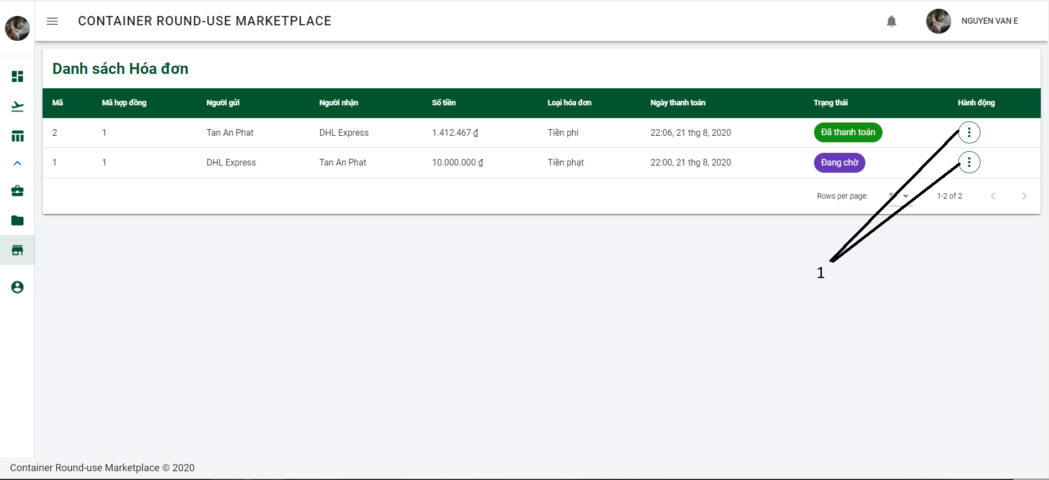

Button/ Hyperlinks

|  |  |  |  |  |
| --- | --- | --- | --- | --- |
| **No** | **Function** | **Description** | **Validation** | **Outcome** |
| 1 | Selection list | Show action option | No | Selection list contained:   * Xem chi tiết * Chấp nhận thanh toán |

4.12.1.1.7.7 User information page

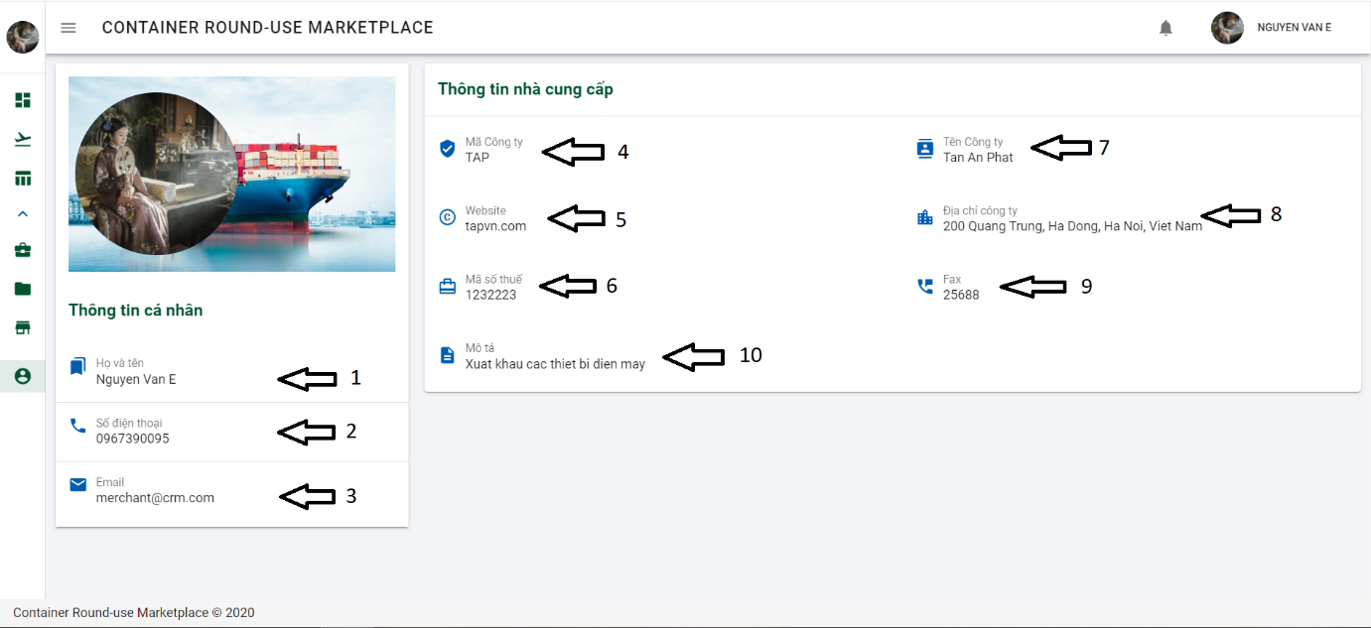

Fields

|  |  |  |  |  |  |  |  |
| --- | --- | --- | --- | --- | --- | --- | --- |
| **No** | **Field**  **Name** | **Description** | **Read**  **Only** | **Mandatory** | **Control**  **Type** | **Data**  **Type** | **Length** |
| 1 | Họ và tên | Fullname | Yes | Yes | Text | String | N/A |
| 2 | Số điện thoại | Phone number | Yes | Yes | Text | String | N/A |
| 3 | Email | Email | Yes | Yes | Text | String | N/A |
| 4 | Mã công ty | Company code | Yes | Yes | Text | String | N/A |
| 5 | Website | Content | Yes | Yes | Text | String | N/A |
| 6 | Mã số thuế | Tax identification number | Yes | Yes | Text | String | N/A |
| 7 | Tên Công ty | companyName | Yes | Yes | Text | String | N/A |
| 8 | Địa chỉ công ty | Company address | Yes | Yes | Text | String | N/A |
| 9 | Fax | Fax number | Yes | Yes | Text | String | N/A |
| 10 | Mô tả | Description | Yes | Yes | Text | String |  |

4.12.1.1.7 Forwarder UI

4.12.1.1.7.1 Inbound list page

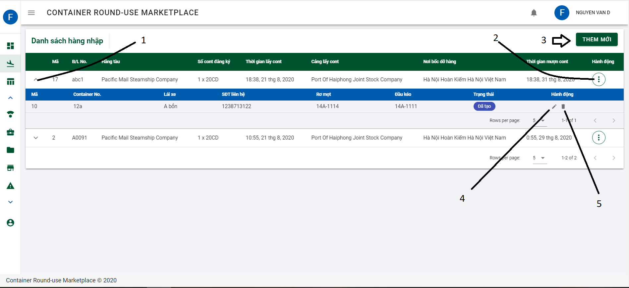

Button/ Hyperlinks

|  |  |  |  |  |
| --- | --- | --- | --- | --- |
| **No** | **Function** | **Description** | **Validation** | **Outcome** |
| 1 | Expand | Expand inbound infomation | No | Show container info |
| 2 | Action | Selection | No | Show list contained   * Tìm thầu * Chỉnh sửa * Xóa bỏ * Khai báo Container |
| 3 | Thêm mới | Add new inbound | No | Navigate to dialog declare inbound |
| 4 | Edit | Edit container | No | Show dialog edit container |
| 5 | Delete | Delete container | No | Show dialog delete container |

4.12.1.1.7.1 Inbound list page

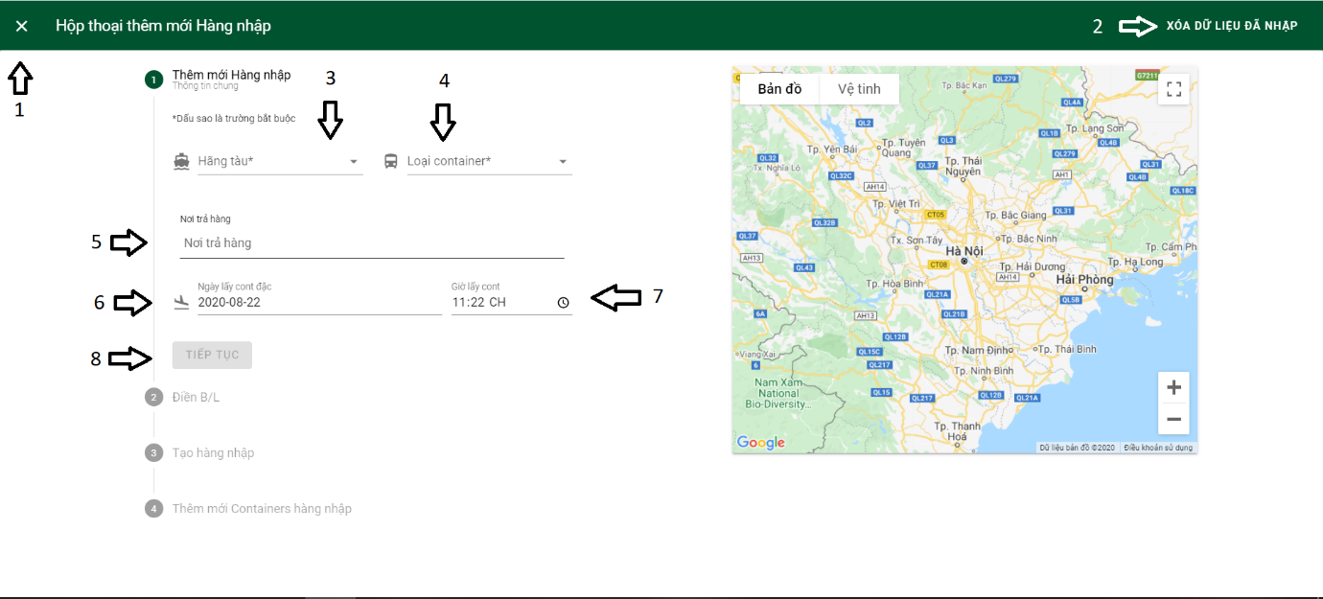

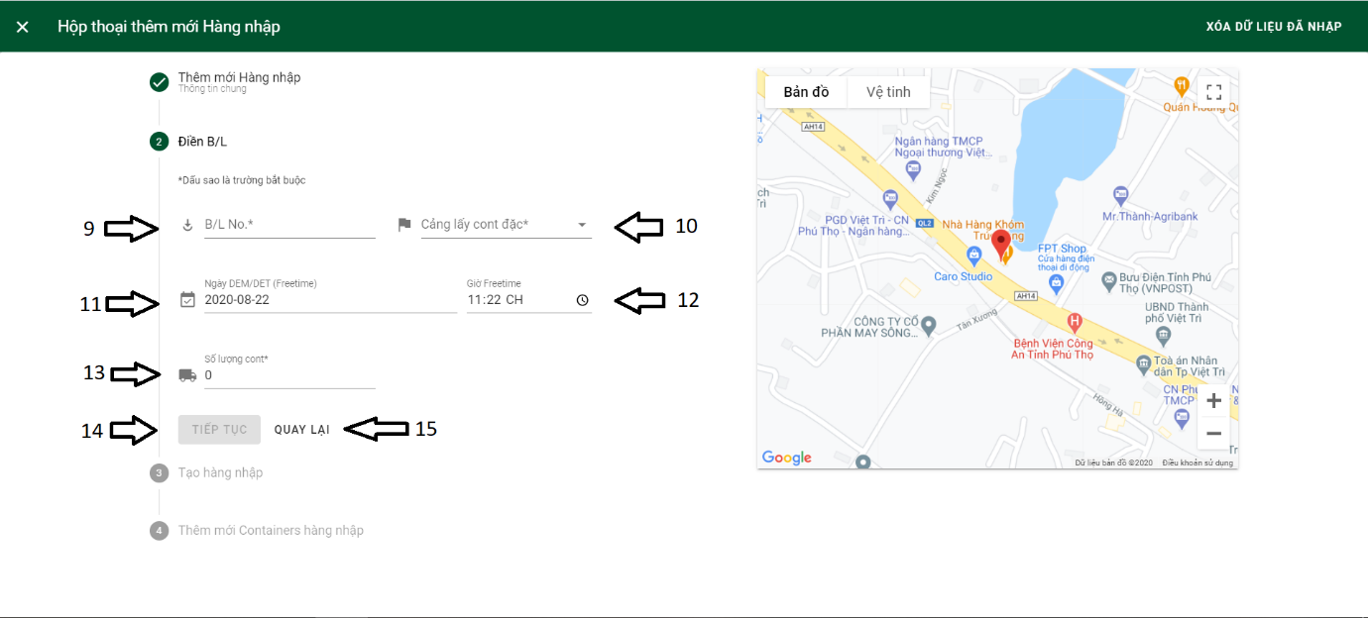

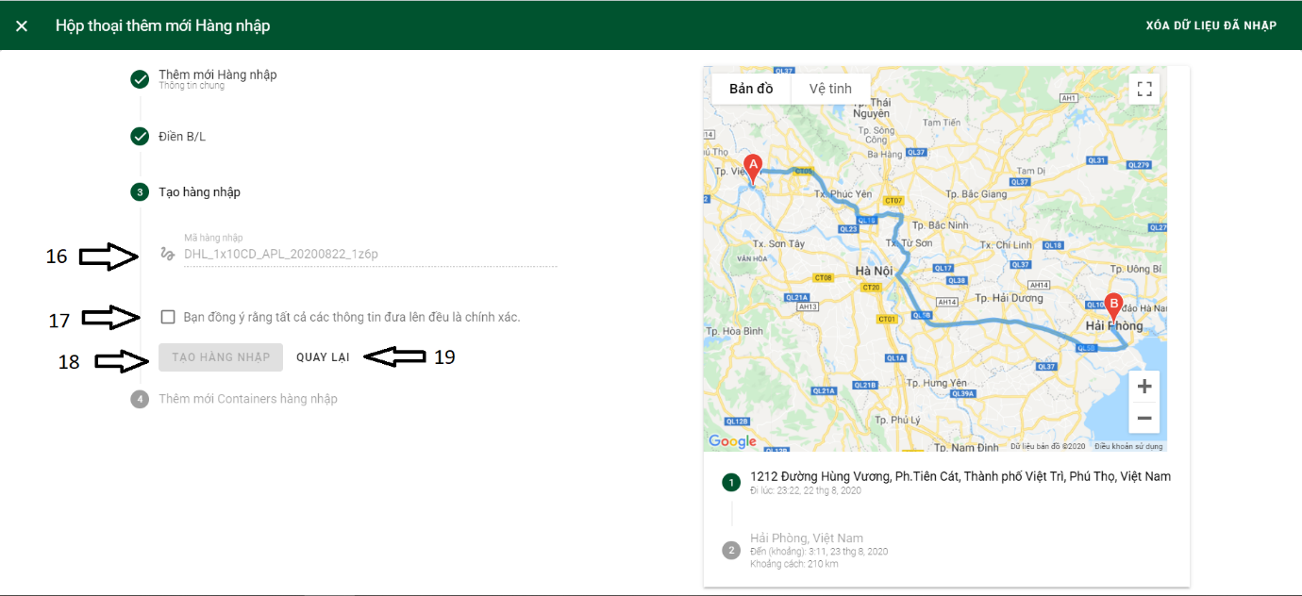

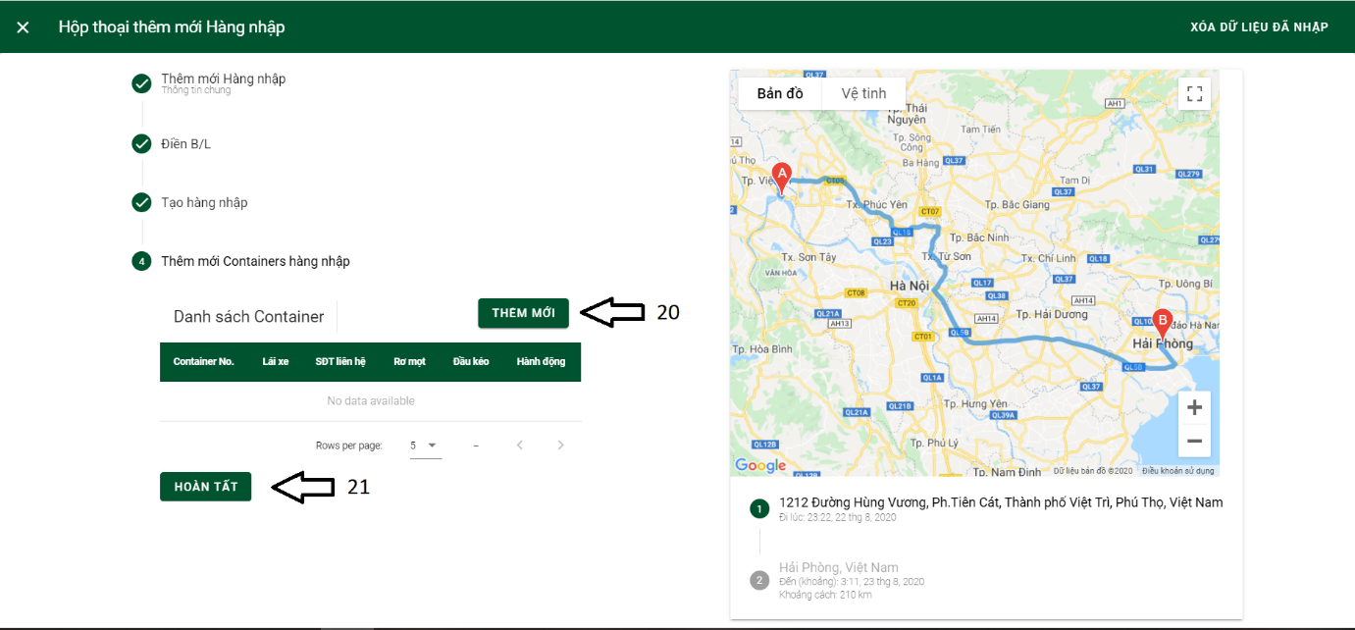

Button/ Hyperlinks

|  |  |  |  |  |
| --- | --- | --- | --- | --- |
| **No** | **Function** | **Description** | **Validation** | **Outcome** |
| 1 | Close | Close dialog Declare inbound | No | Dialog declare inbound is closed |
| 2 | Xóa dữ liệu đã nhập | Delete all imported data | No | All imported data is deleted |
| 8 | Tiếp tục | Continue | Yes | Open part 2 |
| 14 | Tiếp tục | Continue | Yes | Open part 3 |
| 15 | Quay lại | Back | No | Go back to part 1 |
| 17 | Checkbox | Choose Many bid win | No | Allow many bid win |
| 18 | Tiếp tục | Continue | Yes | Open part 3 |
| 19 | Quay lại | Back | No | Back to part 2 |
| 20 | Thêm mới | Add new container | No | Open dialog declare container |
| 21 | Hoàn tất | Complete | Yes | New inbound is declared |

Fields

|  |  |  |  |  |  |  |  |
| --- | --- | --- | --- | --- | --- | --- | --- |
| **No** | **Field**  **Name** | **Description** | **Read**  **Only** | **Mandatory** | **Control**  **Type** | **Data**  **Type** | **Length** |
| 3 | Hãng tàu | Shipping line | No | Yes | Selection list | String | N/A |
| 4 | Loại container | Container type | No | Yes | Selection list | String | N/A |
| 5 | Nơi trả hàng | Return station | No | Yes | Text | String | N/A |
| 6 | Ngày lấy cont đặc | Pickup date | No | Default current date | Text | DateTime | N/A |
| 7 | Giờ lấy cont | Pickup time | No | Default current time | Time | DateTime | N/A |
| 9 | B/L No. | Bill of lading number | No | Yes | Text | String | N/A |
| 10 | Cảng lấy cont đặc | Pickup port | No | Yes | Selection list | String | N/A |
| 11 | Ngày DEM/DET | Container freetime | No | Yes | Text | DateTime | N/A |
| 12 | Giờ freetime | Container freetime | No | Yes | Time | DateTime | N/A |
| 13 | Số lượng cont | Container quantity | No | Yes | Number | Int | N/A |
| 16 | Mã hàng nhập | Inbound code | Yes | Yes | Text | String | N/A |

4.12.1.1.7.2 Combined detail page

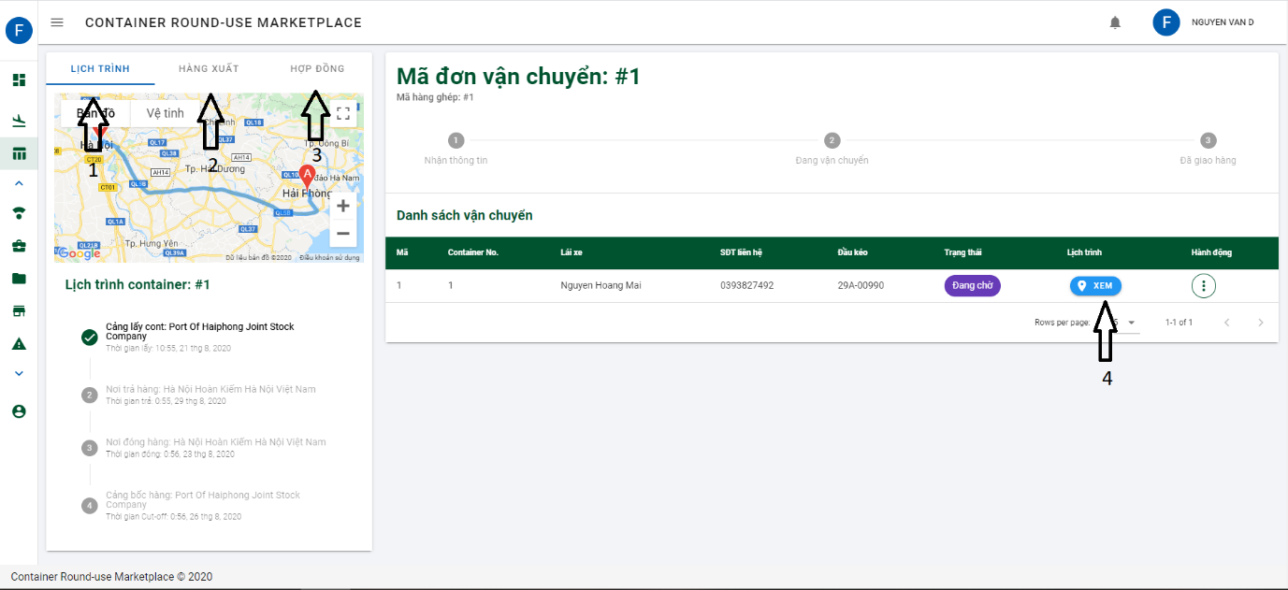

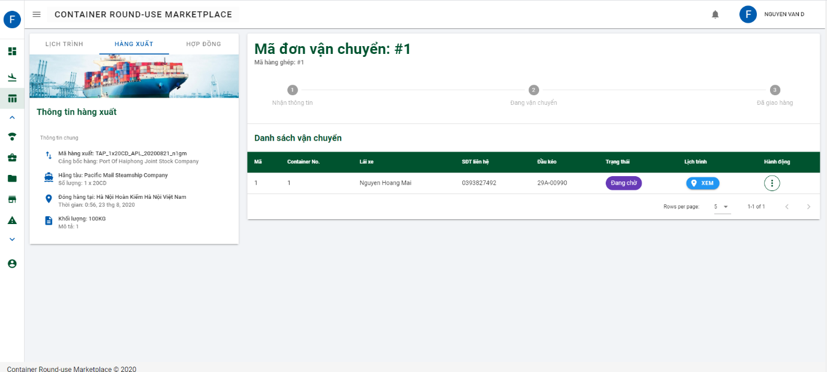

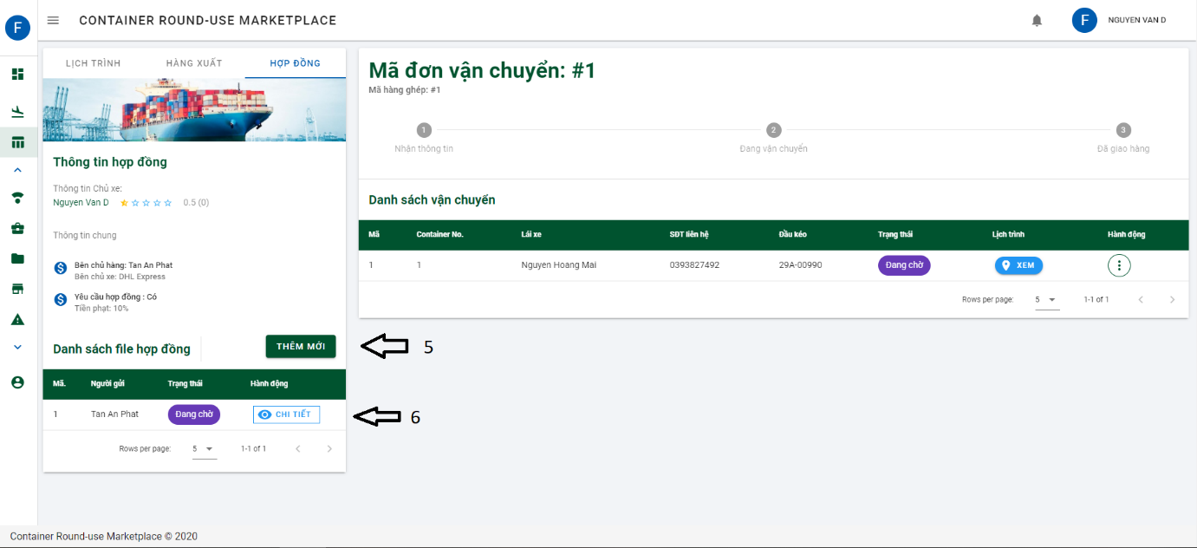

Button/ Hyperlinks

|  |  |  |  |  |
| --- | --- | --- | --- | --- |
| **No** | **Function** | **Description** | **Validation** | **Outcome** |
| 1 | Lịch trình | Tracking container | No | Tracking container location |
| 2 | Hàng xuất | Outbound information | No | Outbound all information |
| 3 | Hợp đồng | Contract | No | Contract information |
| 4 | Xem | Show container schedule | No | Show container schedule |
| 5 | Thêm mới | Add new contract file | No | Show dialog attach file |
| 6 | Chi tiết | Contract file detail | No | Show dialog to see detail file |

4.12.1.1.7.3 Received bidding document page

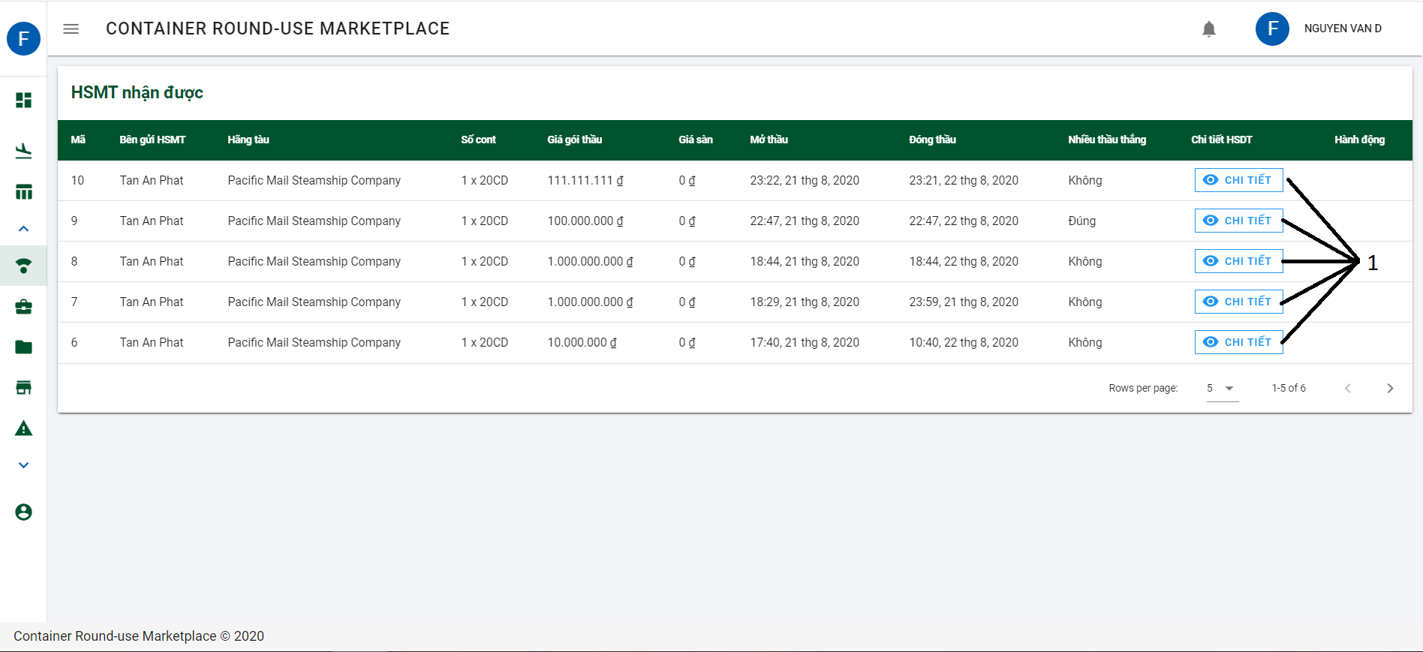

Button/ Hyperlinks

|  |  |  |  |  |
| --- | --- | --- | --- | --- |
| **No** | **Function** | **Description** | **Validation** | **Outcome** |
| 1 | Chi tiết | Bidding document detail | No | Navigate to bidding document detail |

4.12.1.1.7.4 Detail bidding document page

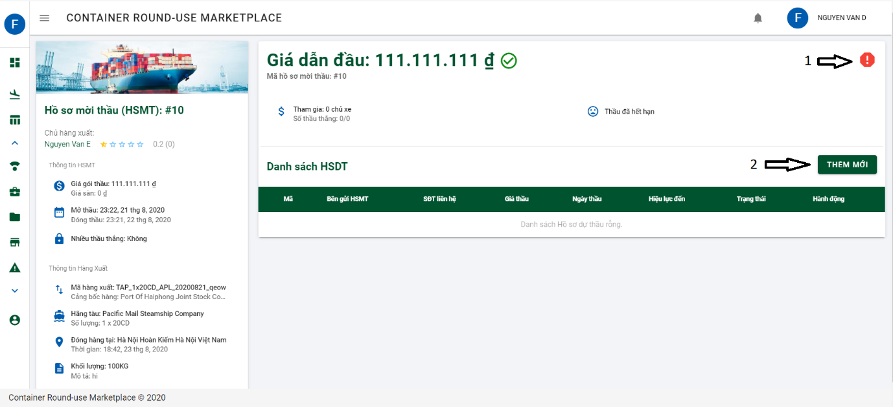

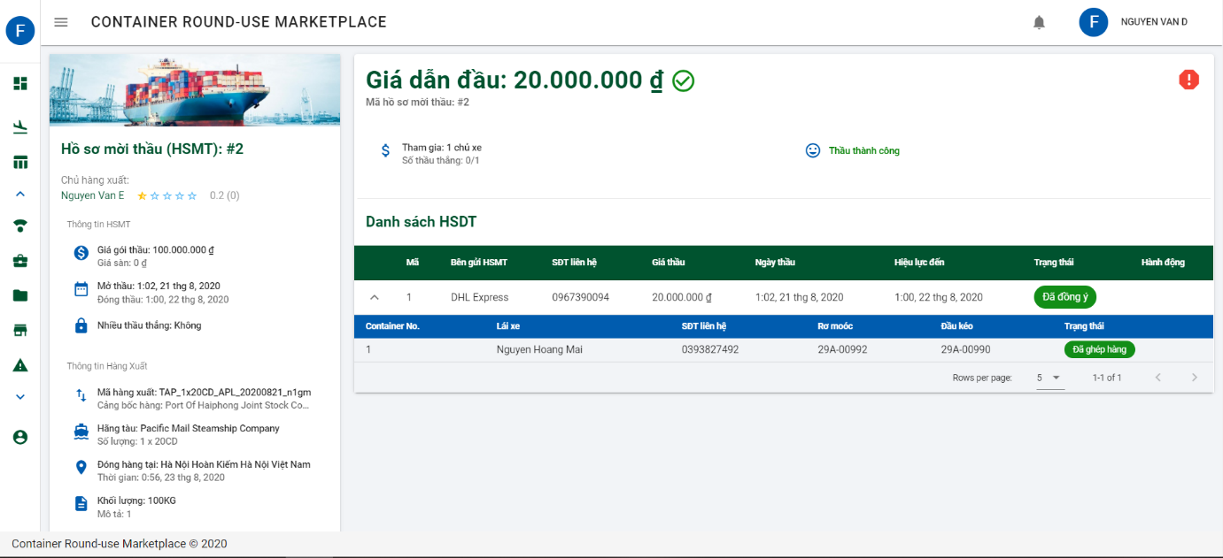

Button/ Hyperlinks

|  |  |  |  |  |
| --- | --- | --- | --- | --- |
| **No** | **Function** | **Description** | **Validation** | **Outcome** |
| 1 | Report | Create report | No | Open dialog add new report |
| 2 | Thêm mới | Declare bid | No | Declare bid |

4.12.1.1.7.5 List of bid page

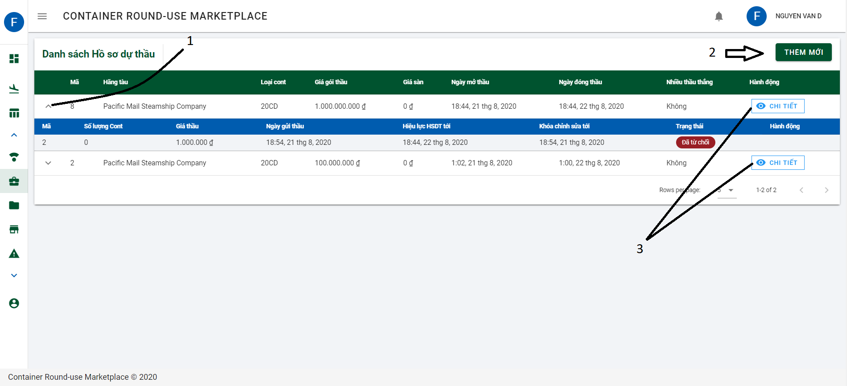

Button/ Hyperlinks

|  |  |  |  |  |
| --- | --- | --- | --- | --- |
| **No** | **Function** | **Description** | **Validation** | **Outcome** |
| 1 | Expand | Expand bid information | No | Expand combined contained container detail |
| 2 | Thêm mới | Declare bid | No | Declare bid |
| 3 | Chi tiết | Detail bid | No | Navigate to detail bid page. |

4.12.1.1.7.6 List of contract

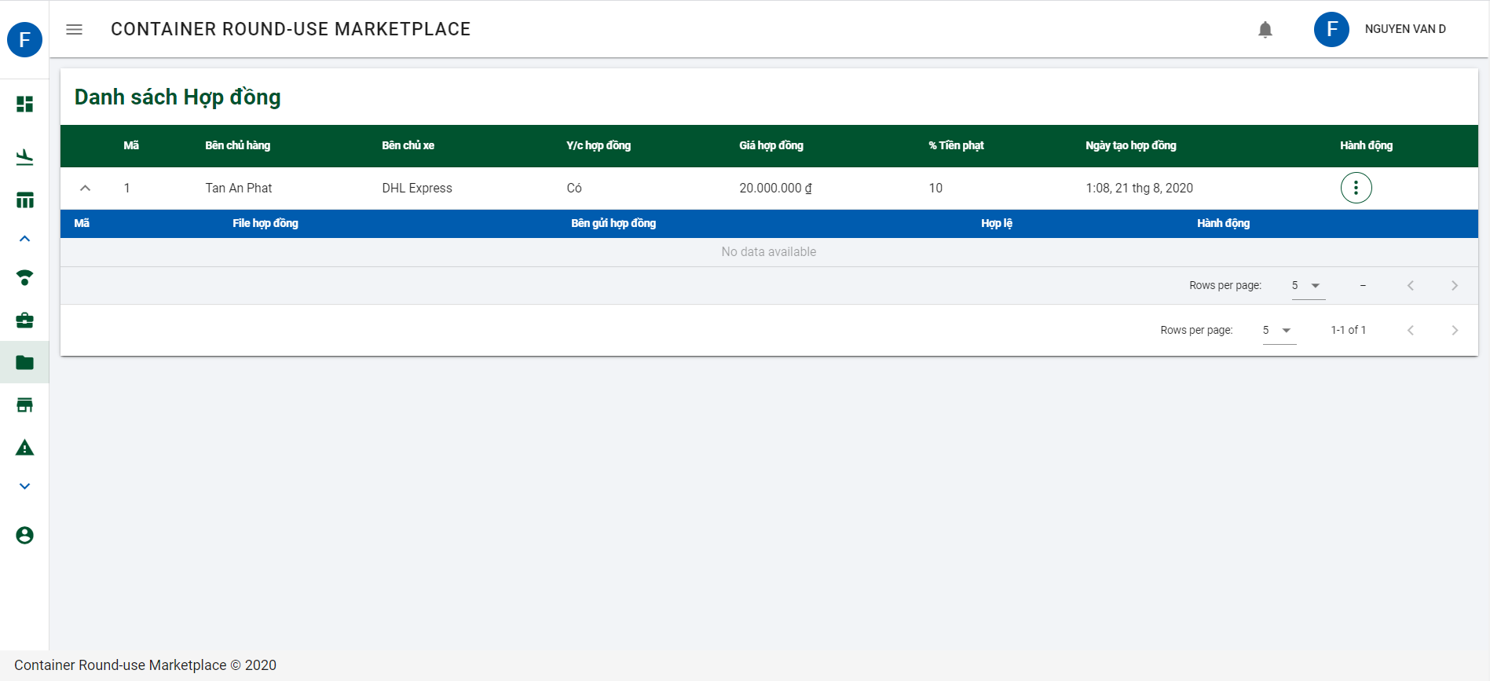

Similar to4.12.1.1.7.5 Contract list page and declare invoice

4.12.1.1.7.7 List of Invoice page

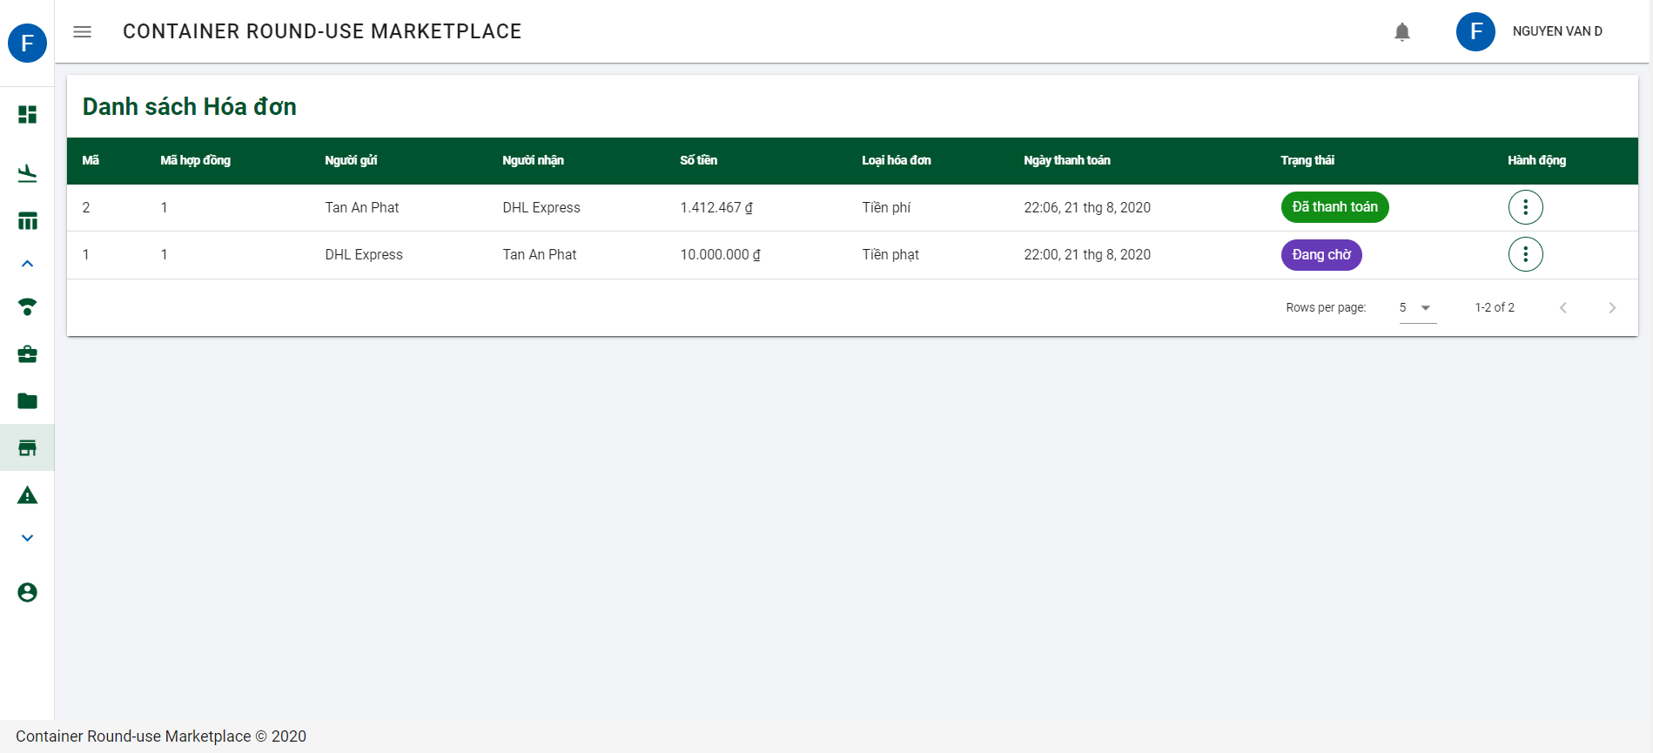

Similar to 4.12.1.1.7.6 List of invoice page

4.12.1.1.7.7 List of report page

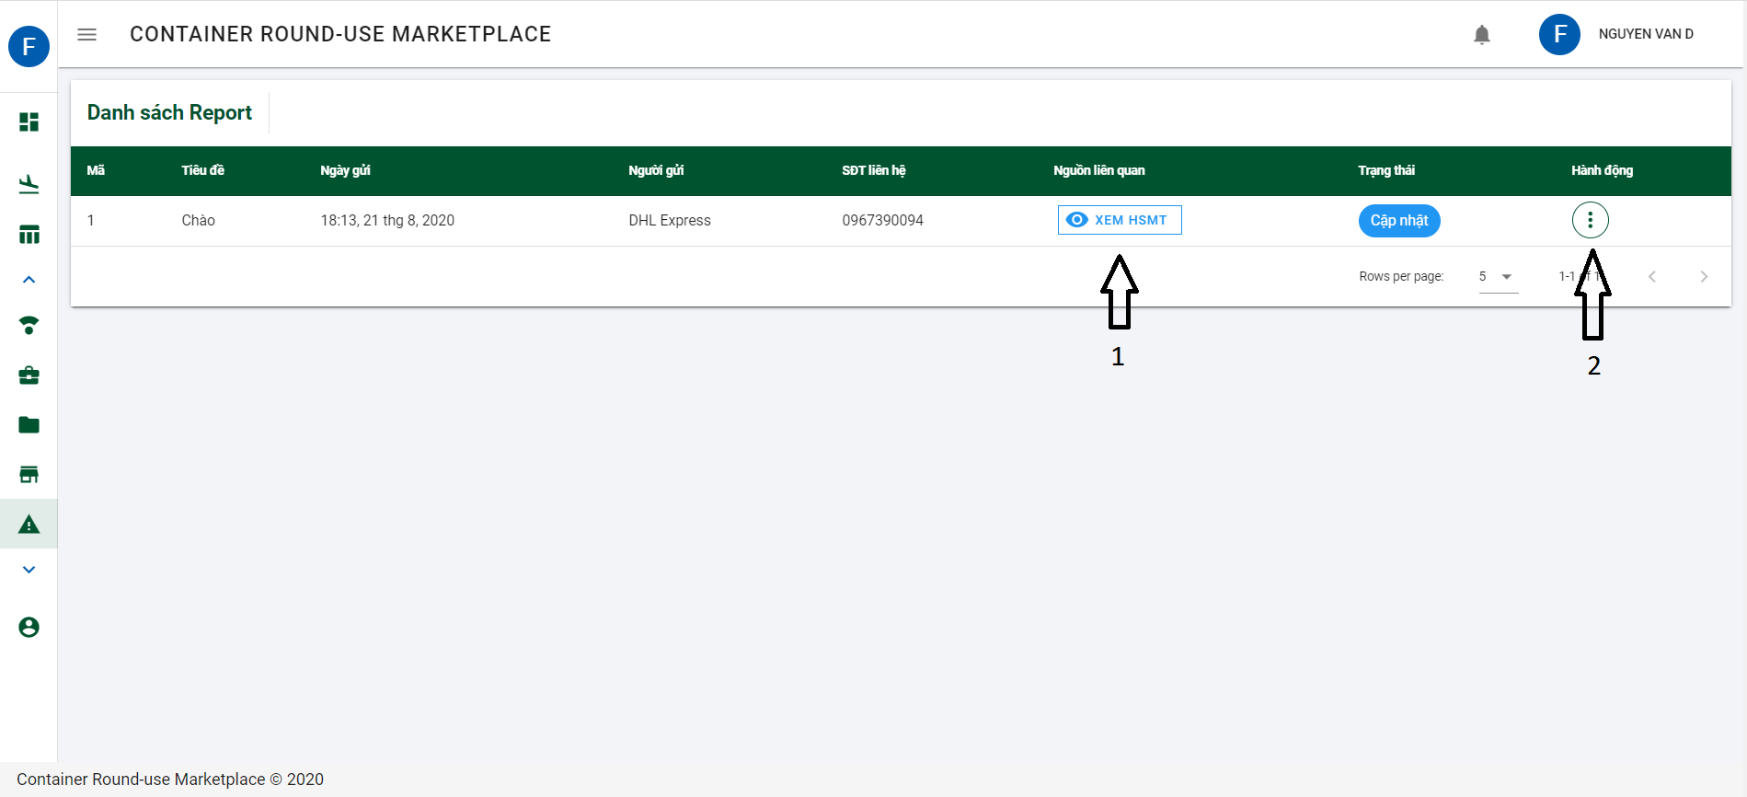

Button/ Hyperlinks

|  |  |  |  |  |
| --- | --- | --- | --- | --- |
| **No** | **Function** | **Description** | **Validation** | **Outcome** |
| 1 | Xem HSMT | Detail bidding documment | No | Navigate to detail bidding document page |
| 2 | Action | Show action | No | Show action contained:   * Xem chi tiết * Chỉnh sửa * Xóa bỏ |

4.12.1.1.7.8 List of driver and add new driver

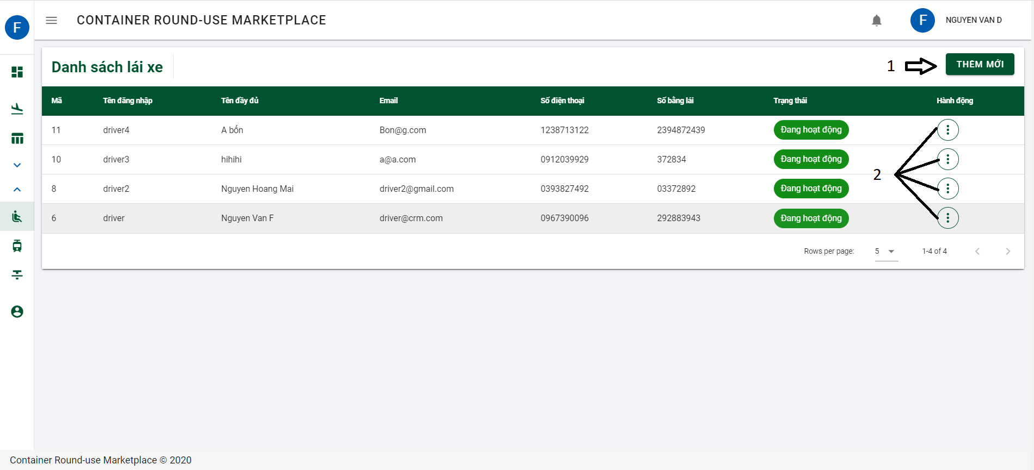

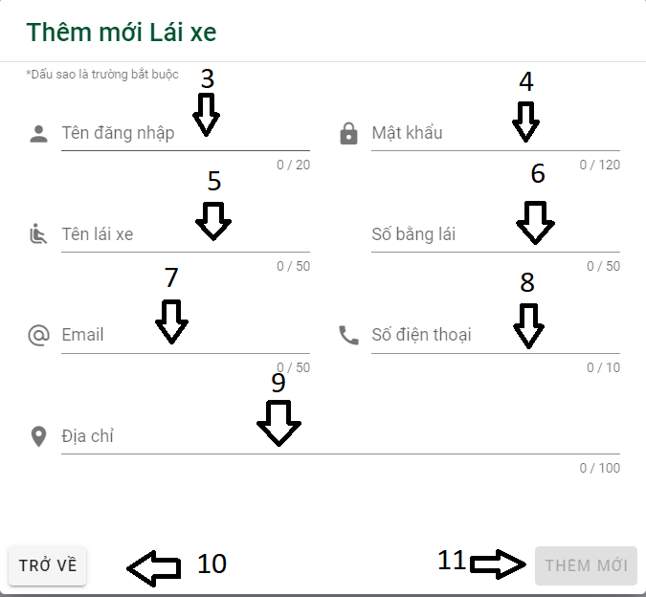

Button/ Hyperlinks

|  |  |  |  |  |
| --- | --- | --- | --- | --- |
| **No** | **Function** | **Description** | **Validation** | **Outcome** |
| 1 | Thêm mới | Add new driver | No | Open dialog add new driver |
| 2 | Action | Show action | No | Show action contained:   * Chỉnh sửa * Xóa bỏ |
| 10 | Trở về | Back | No | Close dialog and come back to list of driver |
| 11 | Thêm mới | Add new driver | Yes | Add new driver |

Fields

|  |  |  |  |  |  |  |  |
| --- | --- | --- | --- | --- | --- | --- | --- |
| **No** | **Field**  **Name** | **Description** | **Read**  **Only** | **Mandatory** | **Control**  **Type** | **Data**  **Type** | **Length** |
| 3 | Tên đăng nhập | Username | No | Yes | Text | String | 20 |
| 4 | Mật khẩu | Password | No | Yes | Password | String | 120 |
| 5 | Tên lái xe | Driver name | No | Yes | Text | String | 50 |
| 6 | Số bắng lái | Driver license number | No | Yes | Text | String | 50 |
| 7 | Email | Email | No | Yes | Email | String | 50 |
| 8 | Số điện thoại | Phone number | No | Yes | Phone | String | 10 |
| 9 | Địa chỉ | Address | No | Yes | Text | String | 100 |

4.12.1.1.7.9 List of tractor and add new tractor

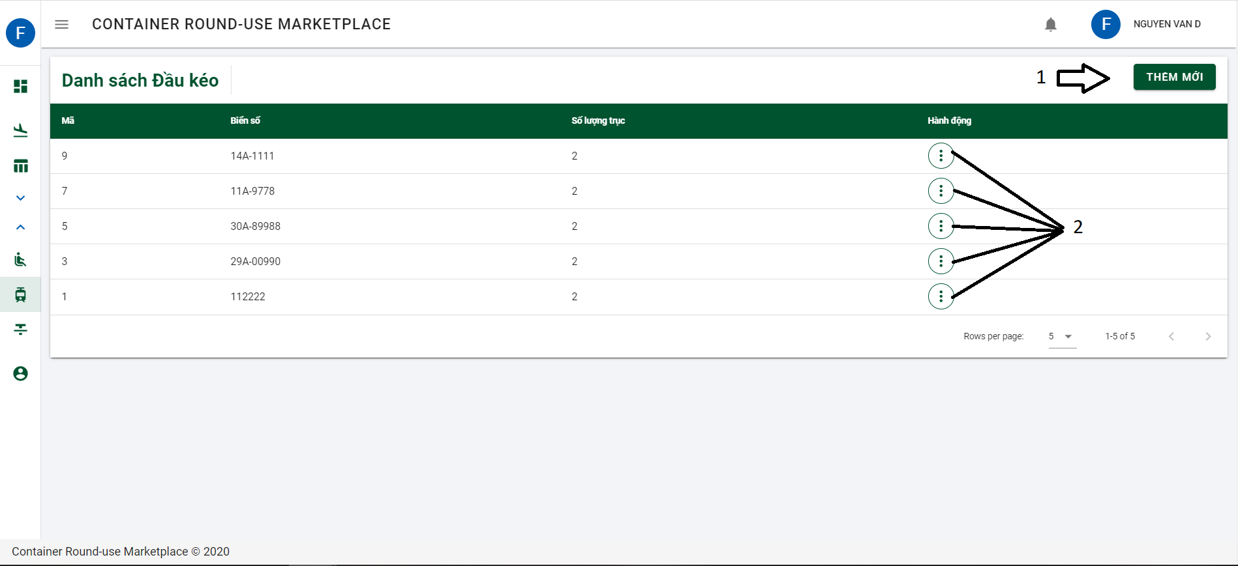

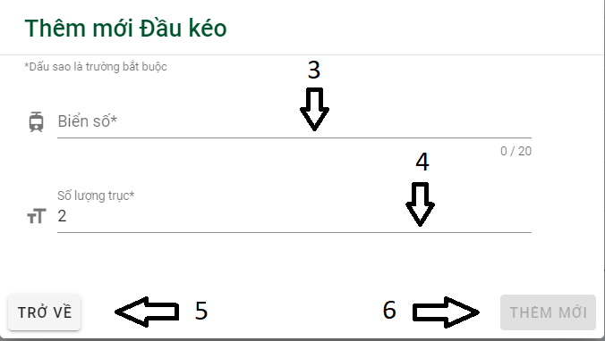

Button/ Hyperlinks

|  |  |  |  |  |
| --- | --- | --- | --- | --- |
| **No** | **Function** | **Description** | **Validation** | **Outcome** |
| 1 | Thêm mới | Add new tractor | No | Open dialog add new tractor |
| 2 | Action | Show action | No | Show action contained:   * Chỉnh sửa * Xóa bỏ |
| 5 | Trở về | Back | No | Close dialog and come back to list of tractor |
| 6 | Thêm mới | Add new tractor | Yes | Add new tractor |

Fields

|  |  |  |  |  |  |  |  |
| --- | --- | --- | --- | --- | --- | --- | --- |
| **No** | **Field**  **Name** | **Description** | **Read**  **Only** | **Mandatory** | **Control**  **Type** | **Data**  **Type** | **Length** |
| 3 | Biển số | License plate | No | Yes | Text | String | 20 |
| 4 | Số lượng trục | Number of axles | No | Yes | Number | Int | N/A |

4.12.1.1.7.10 List of Semi trailer and add new Semi trailer

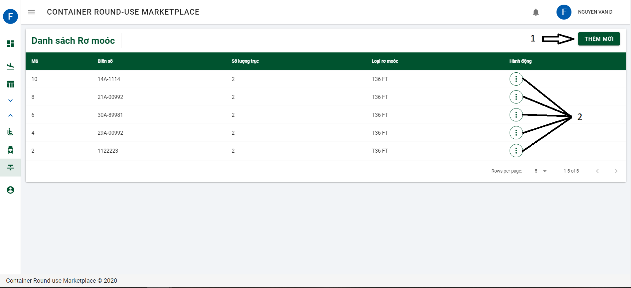

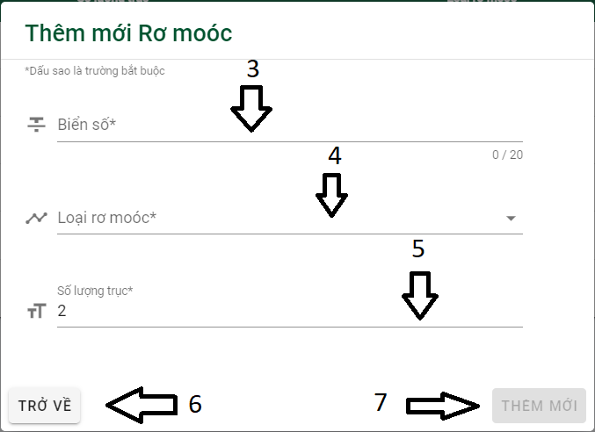

Button/ Hyperlinks

|  |  |  |  |  |
| --- | --- | --- | --- | --- |
| **No** | **Function** | **Description** | **Validation** | **Outcome** |
| 1 | Thêm mới | Add new semi trailer | No | Open dialog add new semi trailer |
| 2 | Action | Show action | No | Show action contained:   * Chỉnh sửa * Xóa bỏ |
| 6 | Trở về | Back | No | Close dialog and come back to list of tractor |
| 7 | Thêm mới | Add new semi trailer | Yes | Add new semi trailer |

Fields

|  |  |  |  |  |  |  |  |
| --- | --- | --- | --- | --- | --- | --- | --- |
| **No** | **Field**  **Name** | **Description** | **Read**  **Only** | **Mandatory** | **Control**  **Type** | **Data**  **Type** | **Length** |
| 3 | Biển số | License plate | No | Yes | Text | String | 20 |
| 4 | Loại rơ moóc | Semi trailer typr | No | Yes | Selection list | String | N/A |
| 5 | Số lượng trục | Number of axles | No | Yes | Number | Int | N/A |

4.12.1.1.8 Admin UI

4.12.1.1.8.1 List of admin/ moperator and Add new admin/ moderator

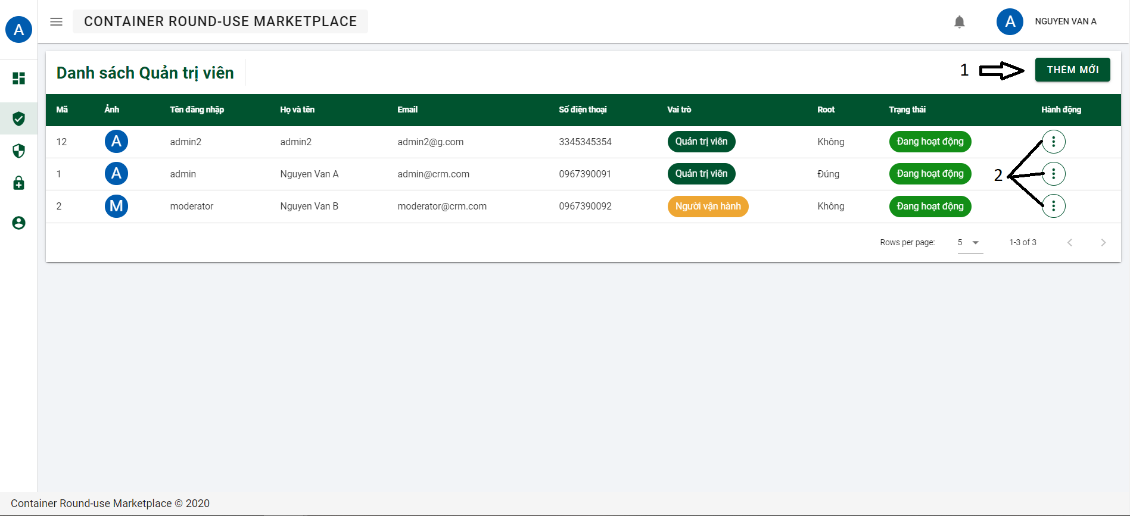

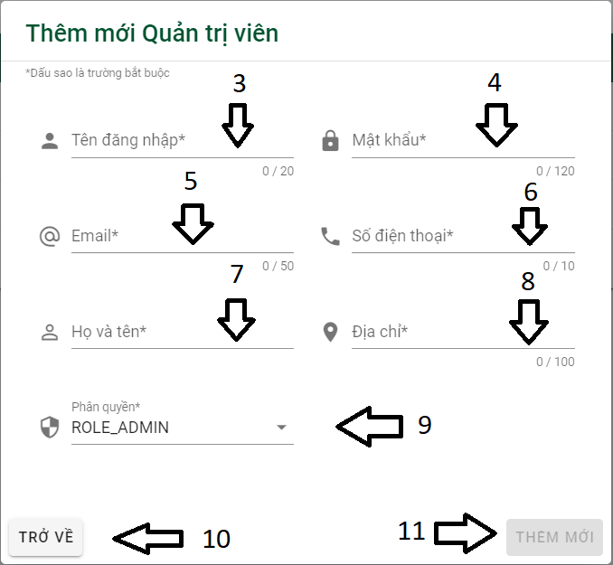

Button/ Hyperlinks

|  |  |  |  |  |
| --- | --- | --- | --- | --- |
| **No** | **Function** | **Description** | **Validation** | **Outcome** |
| 1 | Thêm mới | Add new admin/ moderator | No | Open dialog add new admin/ moderator |
| 2 | Action | Show action | No | Show action contained:   * Chỉnh sửa * Xóa bỏ |
| 10 | Trở về | Back | No | Close dialog and come back to list of admin/ moderator |
| 11 | Thêm mới | Add new admin/ moderator | Yes | Add new admin/ moderator |

Fields

|  |  |  |  |  |  |  |  |
| --- | --- | --- | --- | --- | --- | --- | --- |
| **No** | **Field**  **Name** | **Description** | **Read**  **Only** | **Mandatory** | **Control**  **Type** | **Data**  **Type** | **Length** |
| 3 | Tên đăng nhập | Username | No | Yes | Text | String | 20 |
| 4 | Mật khẩu | Password | No | Yes | Password | String | 120 |
| 5 | Email | Email | No | Yes | Email | String | 50 |
| 6 | Số điện thoại | Phone number | No | Yes | Phone | String | 10 |
| 7 | Họ và tên | Fullname | No | Yes | Text | String | N/A |
| 8 | Địa chỉ | Address | No | Yes | Text | String | 100 |
| 9 | Phân quyền | Role | No | Yes | Selection list | String | N/A |

4.12.1.1.8.2 List of Role and Add new role

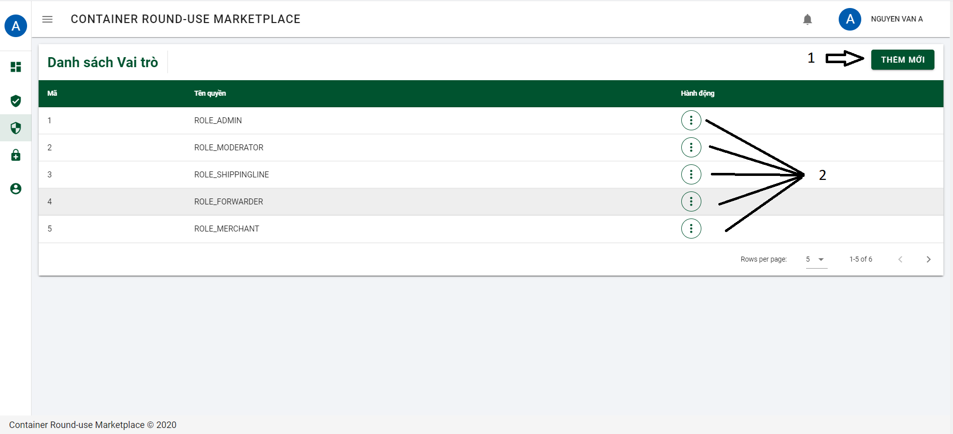

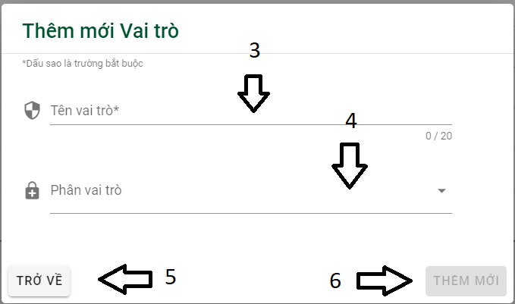

Button/ Hyperlinks

|  |  |  |  |  |
| --- | --- | --- | --- | --- |
| **No** | **Function** | **Description** | **Validation** | **Outcome** |
| 1 | Thêm mới | Add new role | No | Open dialog add new role |
| 2 | Action | Show action | No | Show action contained:   * Chỉnh sửa * Xóa bỏ |
| 5 | Trở về | Back | No | Close dialog and come back to list of role |
| 6 | Thêm mới | Add new role | Yes | Add new role |

Fields

|  |  |  |  |  |  |  |  |
| --- | --- | --- | --- | --- | --- | --- | --- |
| **No** | **Field**  **Name** | **Description** | **Read**  **Only** | **Mandatory** | **Control**  **Type** | **Data**  **Type** | **Length** |
| 3 | Tên vai trò | Role name | No | Yes | Text | String | 20 |
| 4 | Phân vai trò | Permission | No | Yes | Selection list | String | N/A |

4.12.1.1.8.3 List of permission and add new permission

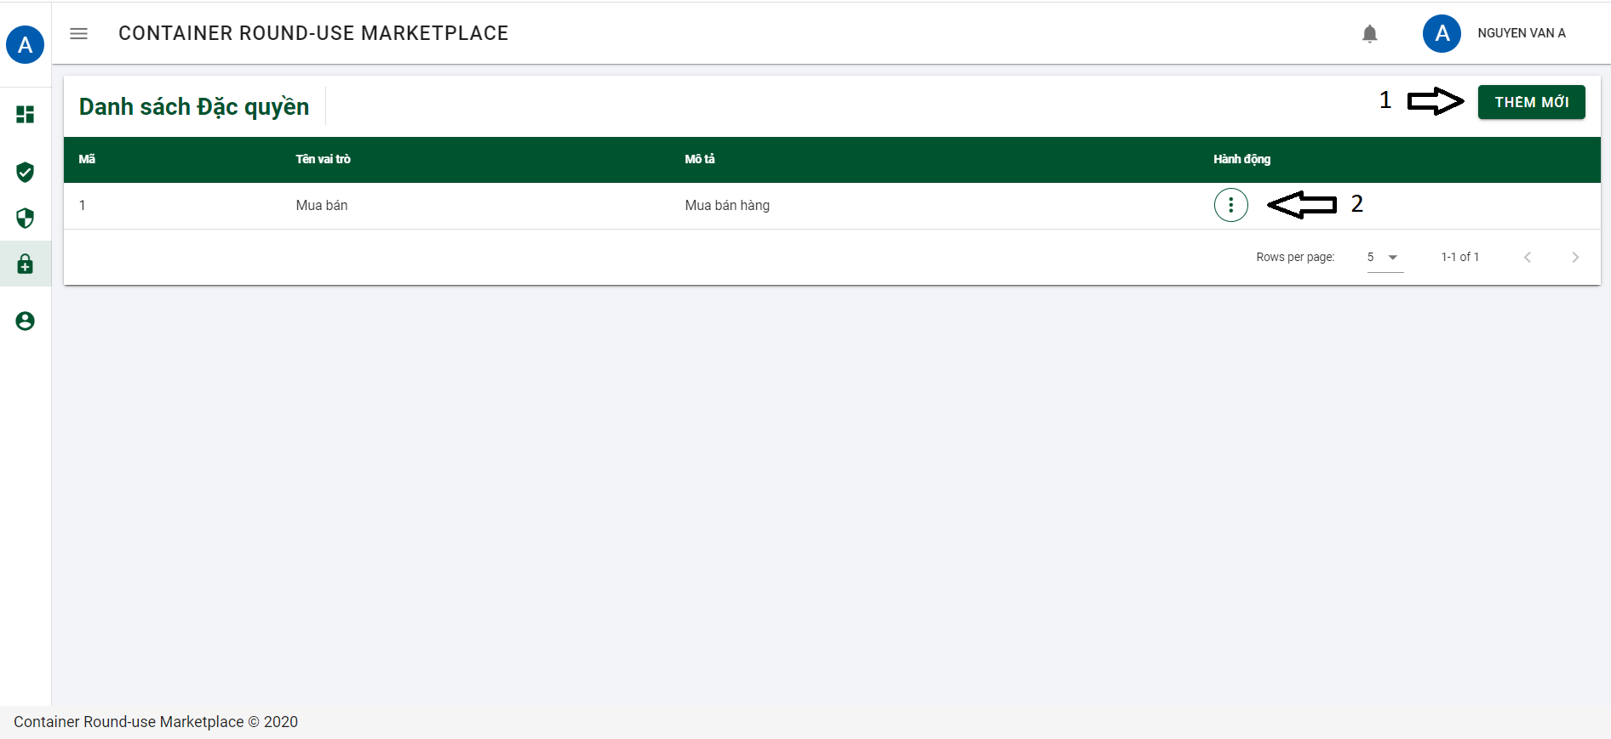

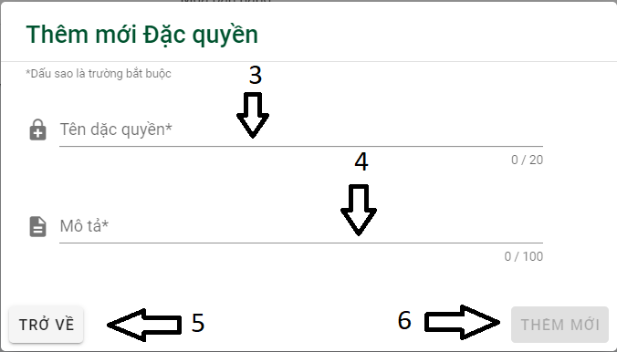

Button/ Hyperlinks

|  |  |  |  |  |
| --- | --- | --- | --- | --- |
| **No** | **Function** | **Description** | **Validation** | **Outcome** |
| 1 | Thêm mới | Add new permission | No | Open dialog add new permission |
| 2 | Action | Show action | No | Show action contained:   * Chỉnh sửa * Xóa bỏ |
| 5 | Trở về | Back | No | Close dialog and come back to list of permission |
| 6 | Thêm mới | Add new permission | Yes | Add new permission |

Fields

|  |  |  |  |  |  |  |  |
| --- | --- | --- | --- | --- | --- | --- | --- |
| **No** | **Field**  **Name** | **Description** | **Read**  **Only** | **Mandatory** | **Control**  **Type** | **Data**  **Type** | **Length** |
| 3 | Tên vai trò | Role name | No | Yes | Text | String | 20 |
| 4 | Phân vai trò | Permission | No | Yes | Selection list | String | N/A |

4.12.1.1.9 Moderator UI

4.12.1.1.9.1 List of registration form

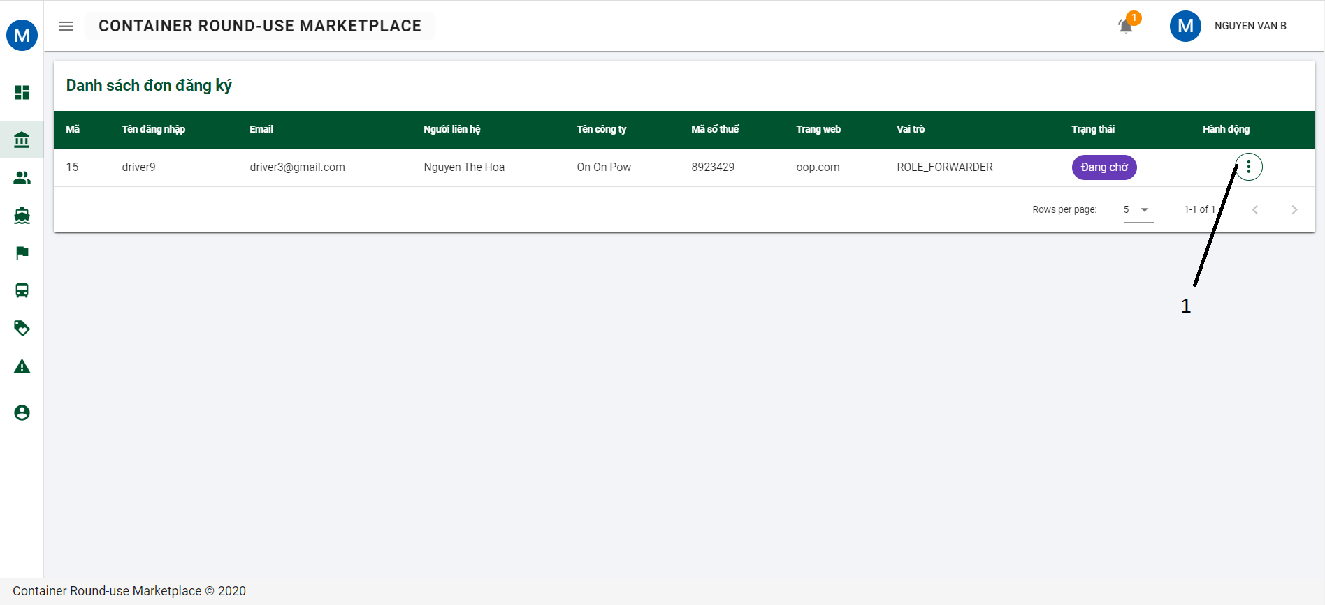

Button/ Hyperlinks

|  |  |  |  |  |
| --- | --- | --- | --- | --- |
| **No** | **Function** | **Description** | **Validation** | **Outcome** |
| 1 | Action | Show action | No | Show action contained:   * Xem chi tiết * Đồng ý đơn * Từ chối đơn |

4.12.1.1.9.2 List of supplier

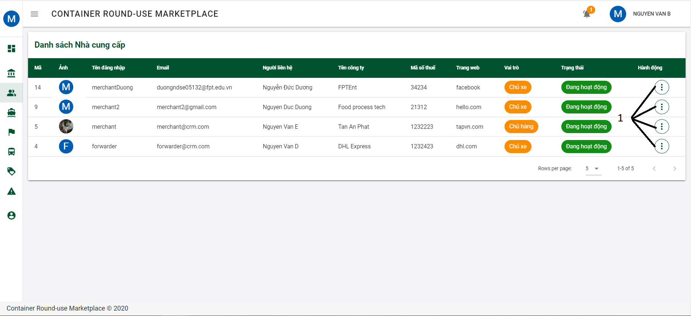

Button/ Hyperlinks

|  |  |  |  |  |
| --- | --- | --- | --- | --- |
| **No** | **Function** | **Description** | **Validation** | **Outcome** |
| 1 | Action | Show action | No | Show action contained:   * Xem chi tiết * Khóa tài khoản |

4.12.1.1.9.3 List of shipping line and add new shipping line

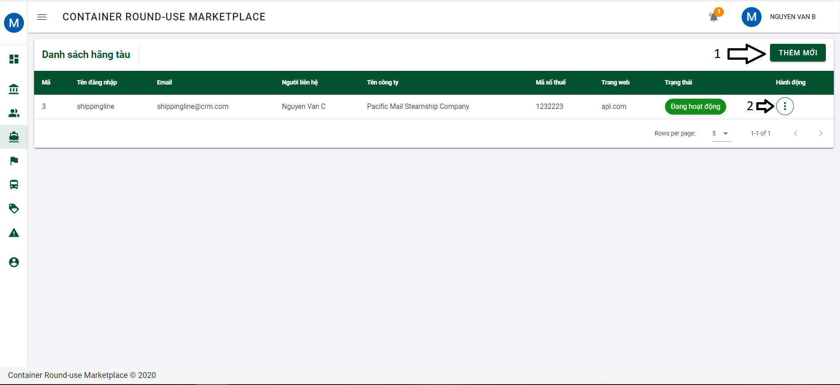

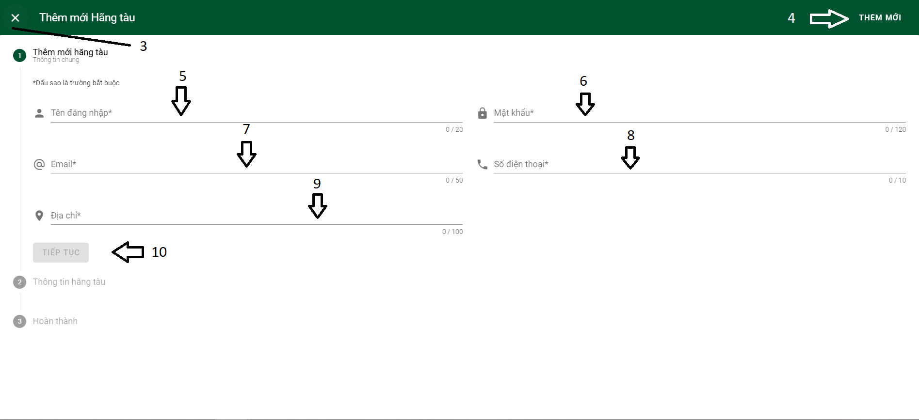

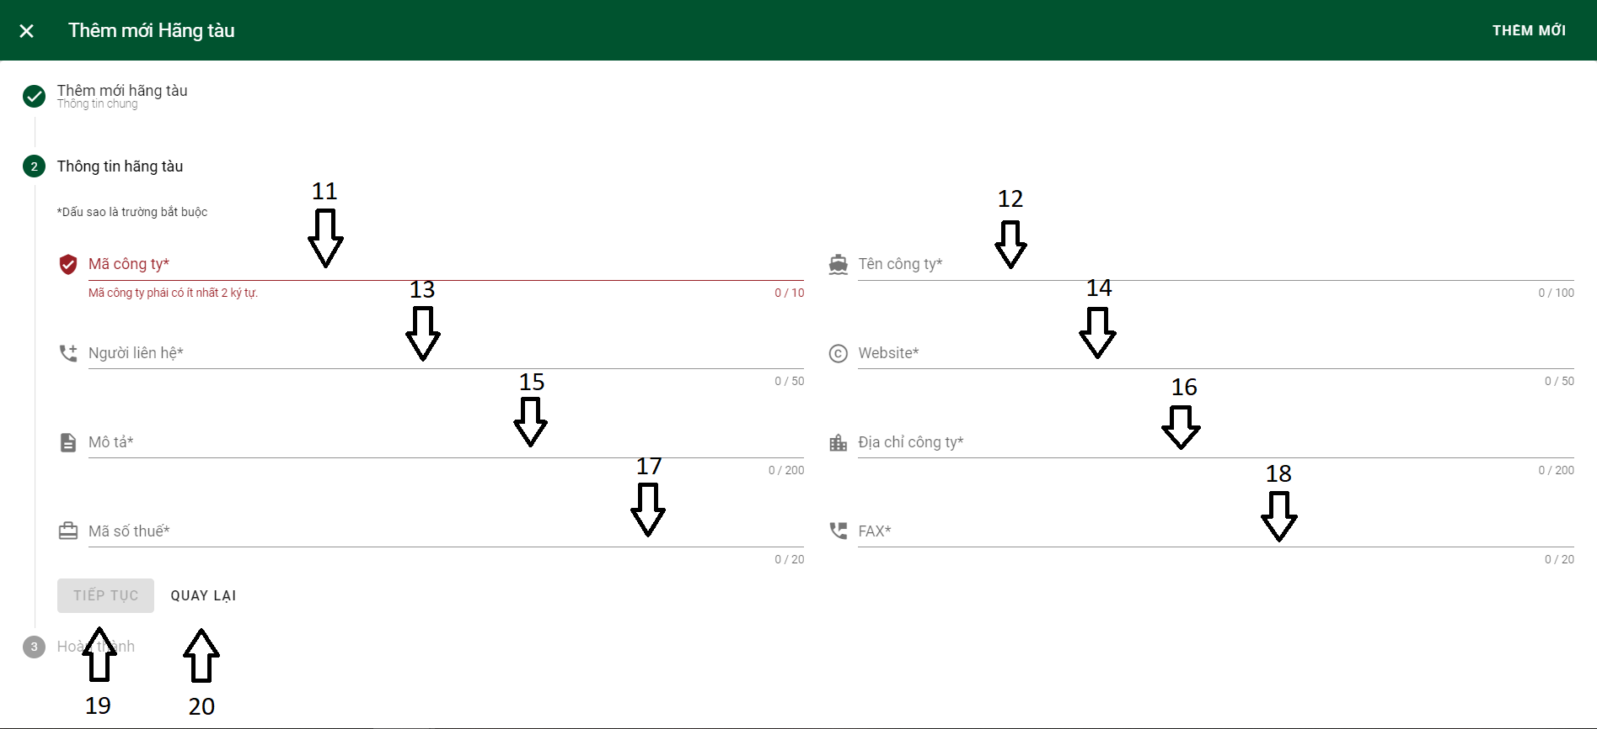

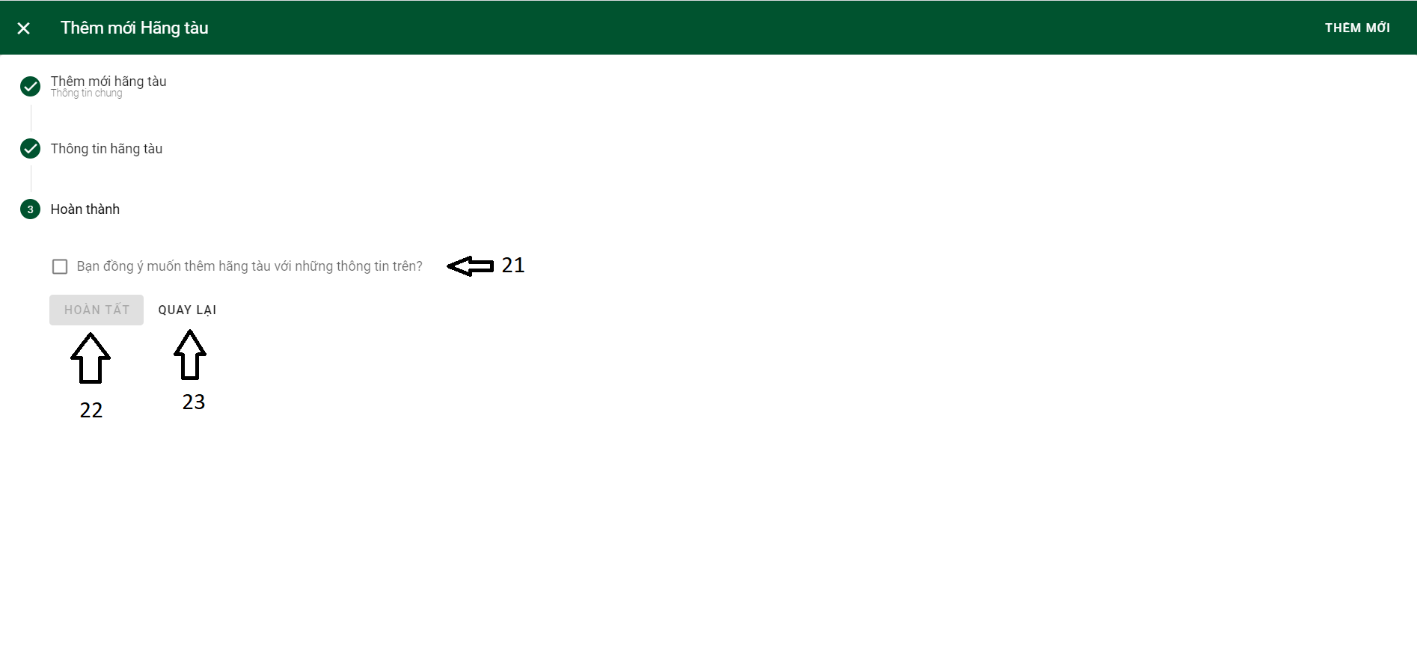

Button/ Hyperlinks

|  |  |  |  |  |
| --- | --- | --- | --- | --- |
| **No** | **Function** | **Description** | **Validation** | **Outcome** |
| 1 | Thêm mới | Add new permission | No | Open dialog add new permission |
| 2 | Action | Show action | No | Show action contained:   * Chỉnh sửa * Xóa bỏ |
| 3 | Close | Close dialog | No | Dialog is closed |
| 4 | Thêm mới | Add new permission | Yes | Add new permission |
| 10 | Tiếp tục | Continue | Yes | Open part 2 |
| 19 | Tiếp tục | Continue | Yes | Open part 3 |
| 20 | Quay lại | Back | No | Back to part 1 |
| 21 | Checkbox | Confirm information | No | Checked |
| 22 | Hoàn tất | Complete | Yes | Add new permision |
| 23 | Quay lại | Back | No | Back to part 2 |

Fields

|  |  |  |  |  |  |  |  |
| --- | --- | --- | --- | --- | --- | --- | --- |
| **No** | **Field**  **Name** | **Description** | **Read**  **Only** | **Mandatory** | **Control**  **Type** | **Data**  **Type** | **Length** |
| 5 | Tên đăng nhập | Username | No | Yes | Text | String | N/A |
| 6 | Mật khẩu | Password | No | Yes | Password | String | N/A |
| 7 | Email | Email | No | Yes | Email | String | N/A |
| 8 | Số điện thoại | Phone number | No | Yes | Phone | String | N/A |
| 9 | Địa chỉ | Address | No | Yes | Text | String | N/A |
| 11 | Mã công ty | Company code | No | Yes | Text | String | N/A |
| 12 | Tên công ty | Company name | No | Yes | Text | String | N/A |
| 13 | Người liên hệ | Contact name | No | Yes | Text | String | N/A |
| 14 | Website | Website | No | Yes | Website | String | N/A |
| 15 | Mô tả | Description | No | Yes | Text | String | N/A |
| 16 | Địa chỉ công ty | Company addres | No | Yes | Text | String | N/A |
| 17 | Mã số thuế | Tax code | No | Yes | Text | String | N/A |
| 18 | FAX | Fax | No | Yes | Text | String | N/A |

4.12.1.1.9.4 List of port and add new port

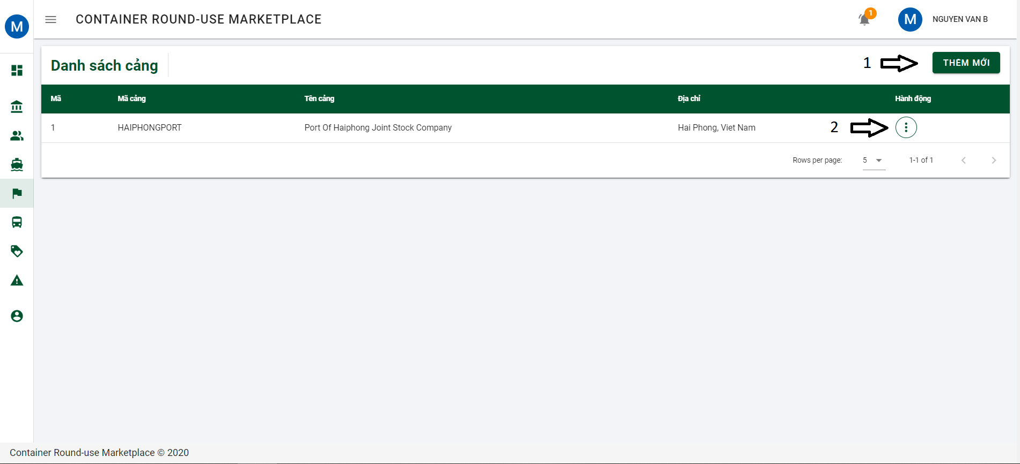

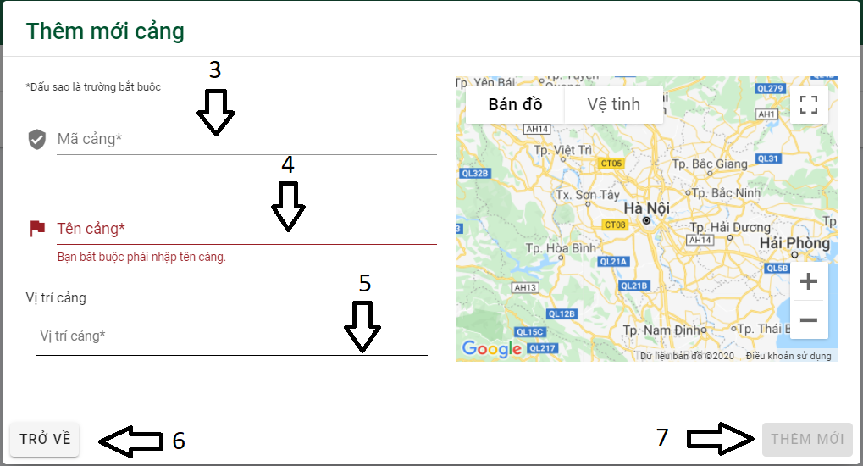

Button/ Hyperlinks

|  |  |  |  |  |
| --- | --- | --- | --- | --- |
| **No** | **Function** | **Description** | **Validation** | **Outcome** |
| 1 | Thêm mới | Add new port | No | Open dialog add new port |
| 2 | Action | Show action | No | Show action contained:   * Chỉnh sửa * Xóa bỏ |
| 6 | Trở về | Back | No | Close dialog and come back to list of port |
| 7 | Thêm mới | Add new port | Yes | Add new role |

Fields

|  |  |  |  |  |  |  |  |
| --- | --- | --- | --- | --- | --- | --- | --- |
| **No** | **Field**  **Name** | **Description** | **Read**  **Only** | **Mandatory** | **Control**  **Type** | **Data**  **Type** | **Length** |
| 3 | Mã cảng | PortCode | No | Yes | Text | String | N/A |
| 4 | Tên cảng | Port name | No | Yes | Text | String | N/A |
| 5 | Vị trí cảng | Port Address | No | Yes | Text | String | N/A |

4.12.1.1.9.5 List of container type and add new container type

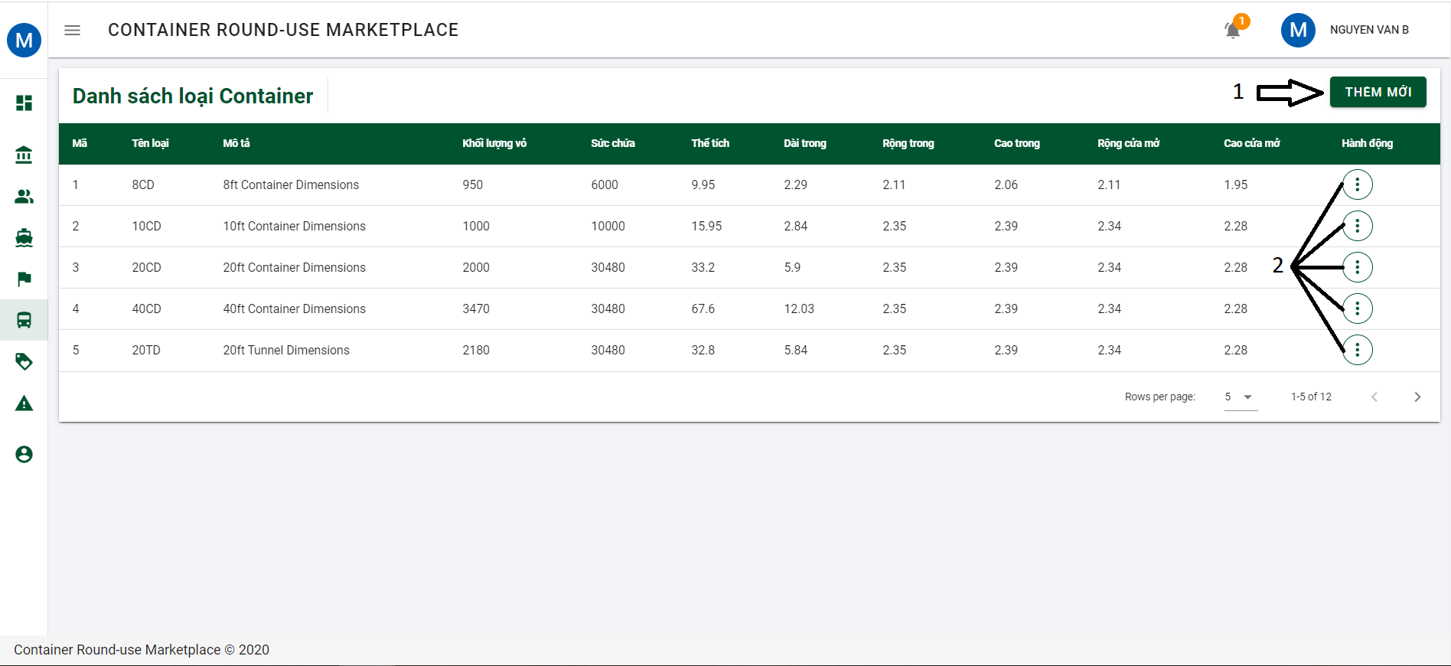

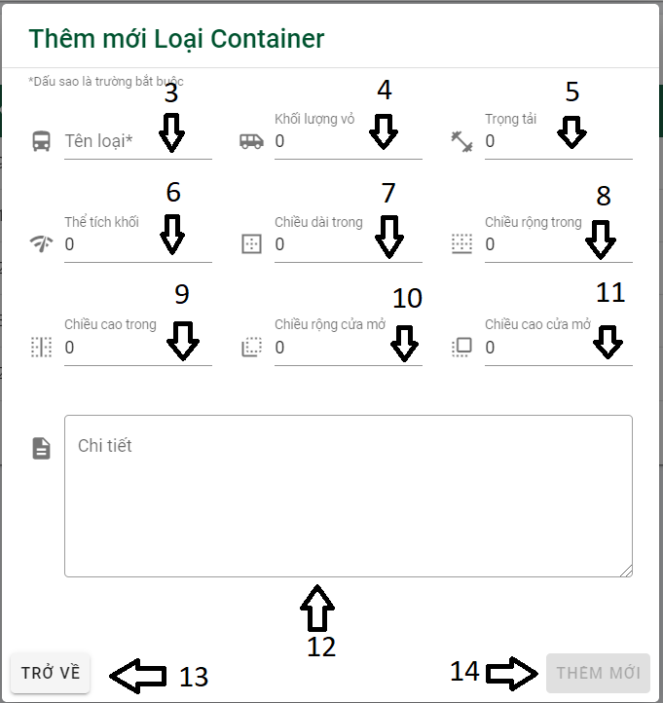

Button/ Hyperlinks

|  |  |  |  |  |
| --- | --- | --- | --- | --- |
| **No** | **Function** | **Description** | **Validation** | **Outcome** |
| 1 | Thêm mới | Add new container type | No | Open dialog add new container type |
| 2 | Action | Show action | No | Show action contained:   * Chỉnh sửa * Xóa bỏ |
| 13 | Trở về | Back | No | Close dialog and come back to list of container type |
| 14 | Thêm mới | Add new container type | Yes | Add new container type |

Fields

|  |  |  |  |  |  |  |  |
| --- | --- | --- | --- | --- | --- | --- | --- |
| **No** | **Field**  **Name** | **Description** | **Read**  **Only** | **Mandatory** | **Control**  **Type** | **Data**  **Type** | **Length** |
| 3 | Tên loại | Type name | No | Yes | Text | String | N/A |
| 4 | Khối lượng vỏ | Tare Weight | No | No | Text | String | N/A |
| 5 | Trọng tải | Gross Weight | No | No | Text | String | N/A |
| 6 | Thể tích khối | Cubic Capacity | No | No | Text | String | N/A |
| 7 | Chiều dài trong | Internal Length | No | No | Text | String | N/A |
| 8 | Chiều rộng trong | Internal width | No | No | Text | String | N/A |
| 9 | Chiều cao trong | Internal height | No | No | Text | String | N/A |
| 10 | Chiều rộng cửa mở | Door opening width | No | No | Text | String | N/A |
| 11 | Chiều cao cửa mở | Door opening height | No | No | Text | String | N/A |
| 12 | Chi tiết | Detail | No | No | Text | String | N/A |

4.12.1.1.9.6 List of discount code and add new discount code

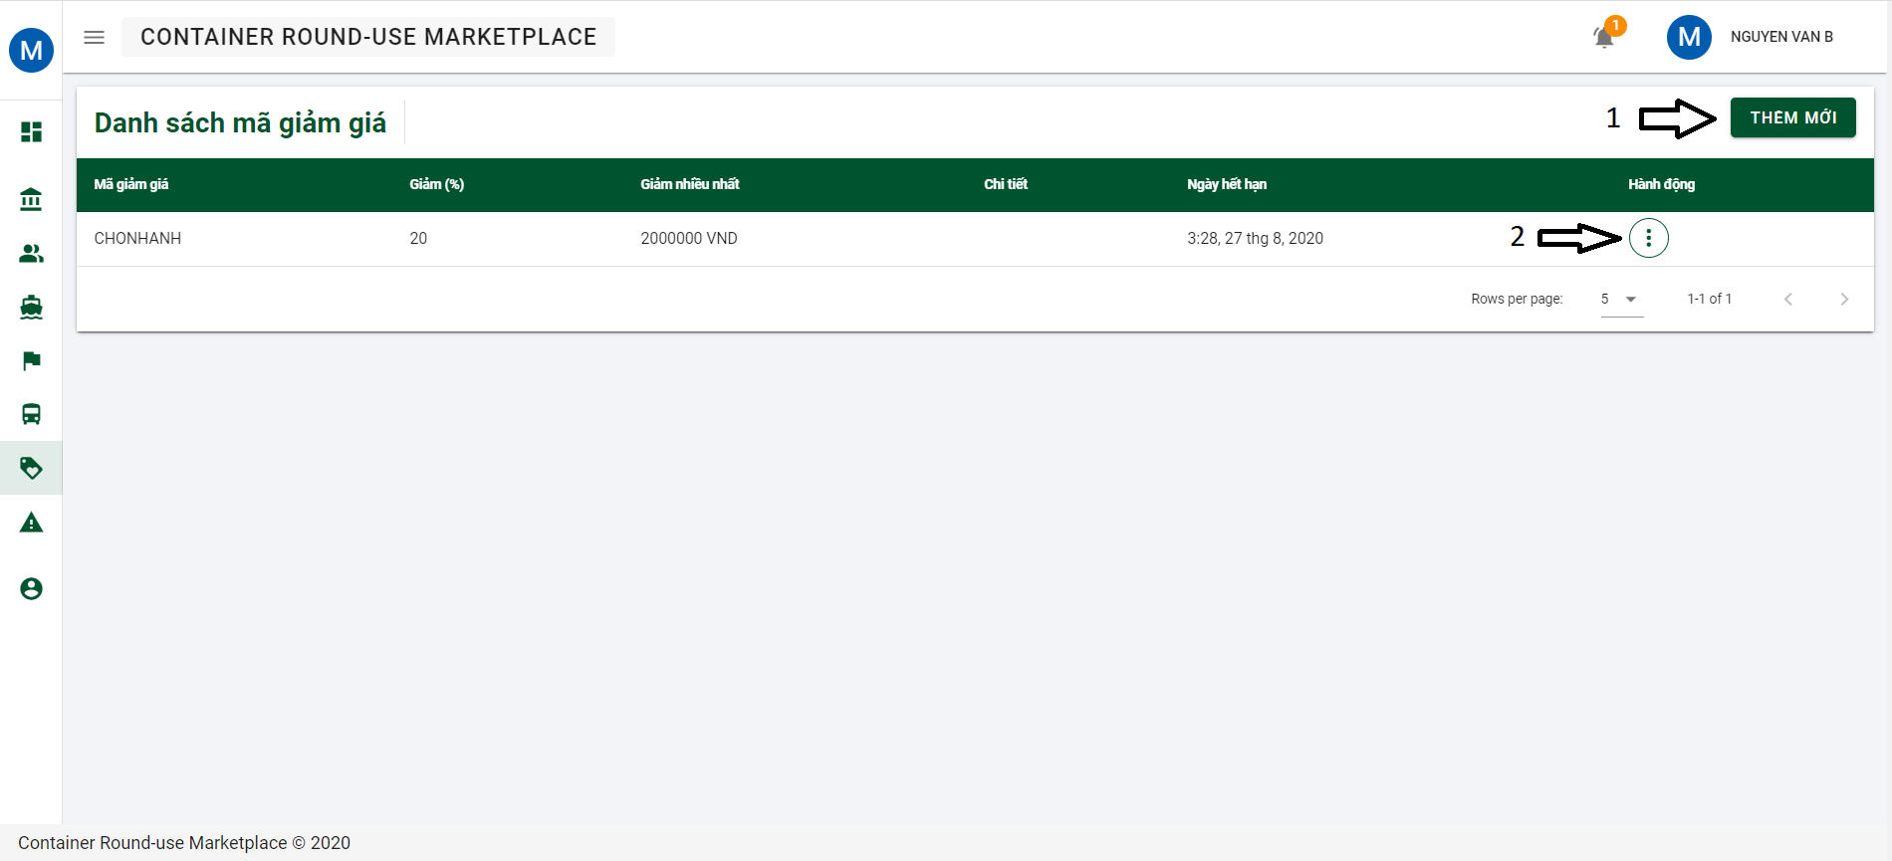

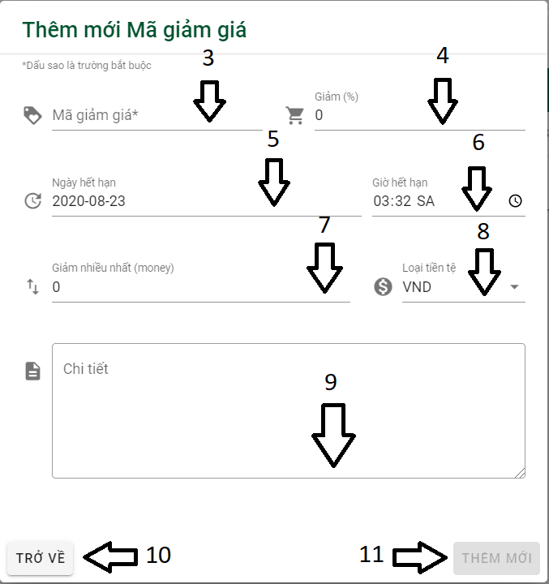

Button/ Hyperlinks

|  |  |  |  |  |
| --- | --- | --- | --- | --- |
| **No** | **Function** | **Description** | **Validation** | **Outcome** |
| 1 | Thêm mới | Add new discount code | No | Open dialog add new discount code |
| 2 | Action | Show action | No | Show action contained:   * Chỉnh sửa * Xóa bỏ |
| 10 | Trở về | Back | No | Close dialog and come back to list of discount code |
| 11 | Thêm mới | Add new discount code | Yes | Add new discount code |

Fields

|  |  |  |  |  |  |  |  |
| --- | --- | --- | --- | --- | --- | --- | --- |
| **No** | **Field**  **Name** | **Description** | **Read**  **Only** | **Mandatory** | **Control**  **Type** | **Data**  **Type** | **Length** |
| 3 | Mã giảm giá | Discount code | No | Yes | Text | String | N/A |
| 4 | Giảm (%) | % discount | No | No | Text | Double | N/A |
| 5 | Ngày hết hạn | Expiration date | No | No | Text | Datetime | N/A |
| 6 | Giờ hết hạn | Expiration date | No | No | Time | Datetime | N/A |
| 7 | Giảm nhiều nhất | Maximum discount amount | No | No | Text | Float | N/A |
| 8 | Loại tiền tệ | Currency unit | No | No | Text | String | N/A |
| 9 | Chi tiết | Detail | No | No | Text | String | N/A |

## **4.7. Database Design or Data Structures**

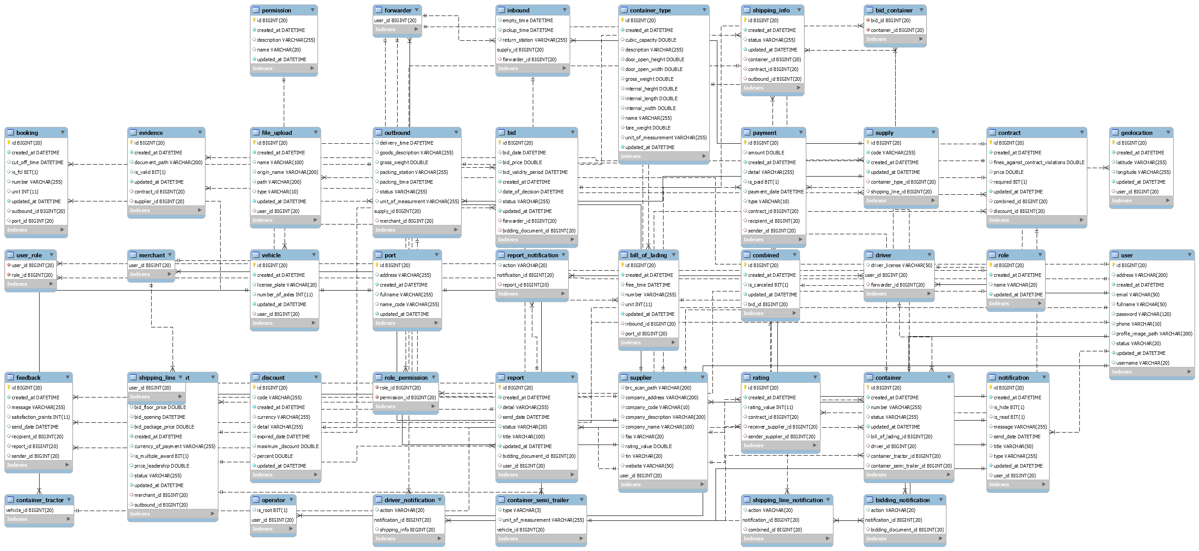

# **5. Software Test Documentation**

## **5.1. Introduction**

### 5.1.1 Purpose

This chapter provides details related to the system's test including the scope of testing, test plan, test case and test report. Through testing, system defects can be discovered and fixed, then help to build better software quality. Using the contents of this chapter, developers and testers can work together to ensure that the system is thoroughly tested and performs functions as intended.

## 5.1.2 Scope of testing

5.1.2.1 States of testing

The testing process is divided into 2 phases: Unit testing and Intergration testing.

|  |  |
| --- | --- |
| **States of testing** | **Description** |
| Unit test | Unit Tests are performed to guarantee that individual units of source code work well. Unit tests are basically utilized to test complicated algorithms and automatically test vital functions |
| Intergration test | Putting integration tests of all modules into the application is performed by CRuM tester to check if the combined units were working as expected. |
| System test | System testing is performed to monitor and evaluate the behavior of a completely integrated software product or software system, based on predefined specification and functional requirements. |

Table 5.1 Scope of testing

5.1.2.2 Types of testing

The following types of testing are performed:

* Function testing:
  + Unit test
  + Intergration test
  + System test

5.1.2.3 Range of testing

All features described in the System Requirement Specification are tested.

## **5.2. Test Plan**

### 5.2.1 Testing tools and Enviroment

5.2.1.1 Testing tools

|  |  |
| --- | --- |
| **Tool** | **Purpose** |
| Junit5 | Use to view app, bug loggin, etc.. |
| Excel | Use to manage test cases and manage bugs |
| Google Chrome | View app, bug loggin, debug |
| Eclipse v4.15.0 | Use to view app, bug loggin, etc.. |
| Android Device | View app, bug login |

Table 5.2 Testing tools

5.2.1.1 Testing enviroment

|  |  |  |
| --- | --- | --- |
| **Type of testing** | **Software** | **Hardware** |
| Unit test | Junit | Asus  Window 10  Intel core i7  RAM 8G  1T Disk Space |
| Intergration test | Junit | Asus  Window 10  Intel core i7  RAM 8G  1T Disk Space |
| System test | Google Chrome | Asus  Window 10  Intel core i7  RAM 8G  1T Disk Space  Android |

Table 5.3 Testing enviroment

## 5.2.2 Resources and Responsibilities

|  |  |  |
| --- | --- | --- |
| **ID** | **Resource** | **Responsibilities** |
| 1 | Test Leader | • Review test cases and test report.  • Review overall quality of the project. |
| 2 | Tester | Preforming the actual system testing  • Create test plan  • Creat test cases  • Perform tests  • Write test reports  • Log bugs |
| 3 | Developer | Create and perform Unit Tests.  • Fix bugs. |

Table 5.4 Resources and Responsibilities

### 5.2.3 Test Strategy

5.2.3.1 Test model

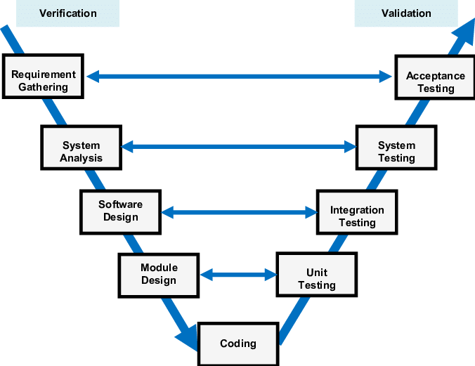

Figure 5.1 Test model

More information: <https://en.wikipedia.org/wiki/V-Model_(software_development)>

5.2.3.2 Test types

The following types of testing are performed:

* + GUI (Graphical user interface) testing
    - Test whether the interface is displayed correctly or not.
    - Test you can perform the intended functionality of the application using the GUI.
    - Test that the error messages are displayed correctly.
    - Test the font used in the system is readable.
    - Test the colors of the fonts and warning messages.
    - Test if the images are clear or not.
    - Test that the images are properly aligned.
  + Regression testing
    - Regresstion test ensures that the bugs are fixed.
    - Regression testing ensures bugs fixing does not affect other parts of the system
  + Functional testing
    - Tests whether or not functions of the system work as intended on the CRuM system.
    - Functional testing is a type of black-box testing and as such, internal structure is rarely considered.

5.2.3.3 State of testing

|  |  |  |  |
| --- | --- | --- | --- |
| **Test Type** | **States of testing** | | |
| **Unit Test** | **Integration Test** | **System Test** |
| Unit test | ✓ |  |  |
| GUI testing |  | ✓ | ✓ |
| Functional testing |  | ✓ | ✓ |

Table 5.5 States of testing

5.2.3.4 Test schedule

Table below are the Test Schedule for CRuM Project. That consist of two round:

|  |  |  |  |  |
| --- | --- | --- | --- | --- |
| **Test Schedule** | **Round 1** | | **Round 2** | |
| **Start Date** | **End Date** | **Start Date** | **End Date** |
| Unit Test | 22/07 | 22/08 |  |  |
| Intergration test | 10/08 | 25/08 | 26/08 | 02/09 |
| System test |  |  |  |  |

5.2.3.5 Deliverable

|  |  |  |
| --- | --- | --- |
| **Deliverables** | **Responsibilities** | **Completion date** |
| Test plan | Test Leader | 3-4-2020 |
| Test cases | Testers | 15-4-2020 |
| Test case review | Testers + Test Learder | 26-4-2020 |
| Test data( Data Set) | Testers | 30-4-2020 |
| Defect report | All members | 1-5-2020 |
| Final test report | Test Leader | 2-5-2020 |

## **5.3.** **Test Approach**

### 5.3.1 Unit test with Eclipse

Unit tests are done by the developers in order to test individual units, and approved by the test leader. CRuM uses Junit5 to execute unit test. CRuM embrace this feature in order to gain the following advantages:

* Reduce the level of bugs in production code
* Save development time
* Easier to change and refactor code
* Unit Tests are a form of documentation

### 5.3.2 Intergration and System test

Integration and system tests are done by testers to ensure that combined units work correctly and that the system as a whole function as intended. Each test case is tested using Google Chrome, Android Devices.

GUI testing is also done during this process to ensure that elements load and function correctly, text is readable, and the app interface looks good in various devices sizes.

Test case details are described in the file: **Report5_System Test Case.xlsx**

## **5.4.** **Test Report**

### 5.4.1 Unit test

### 5.4.2 Intergration test

### 5.4.3 System test

# **6. Software User’s Manual**

## **6.1. Installation Guide**

## **6.2. User’s Guide**

### 6.2.1 General function

6.2.1.1 Register

Step 1: At the home page, click on “ĐĂNG KÝ” or “ĐĂNG KÝ NGAY” to navigate to registration page.

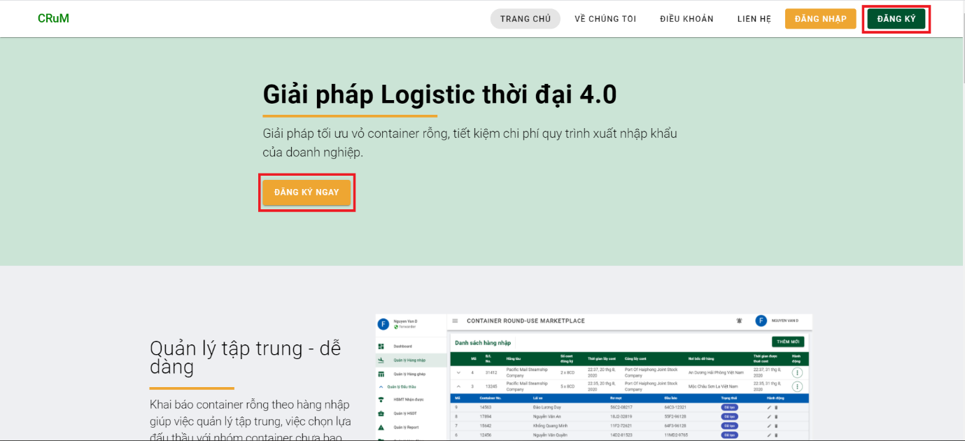

Step 2: After entering the registration page, please fill in all required information. Choose “Đăng ký làm chủ xe” to become a forwarder, “Đăng ký làm chủ hàng” to become a merchant. After you fill in all the information, please press the continue button to go to the next section.

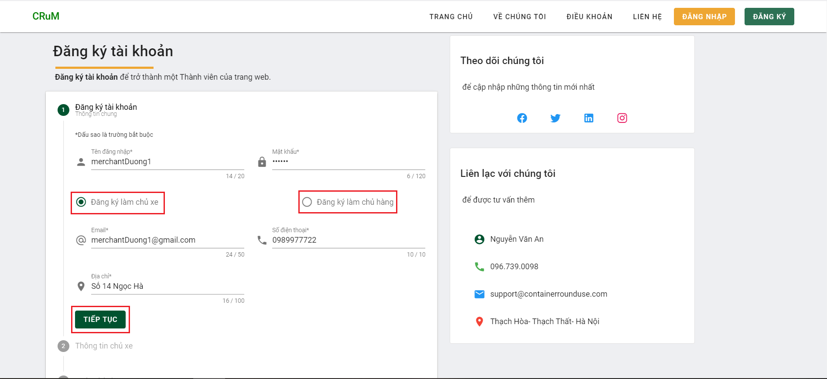

Step 3: Part 2 is opens, user continues to fill in the required information and clicks “TIẾP TỤC” to go to the last section. User can go back to part 1 to edit the information entered by clicking button “QUAY LẠI”.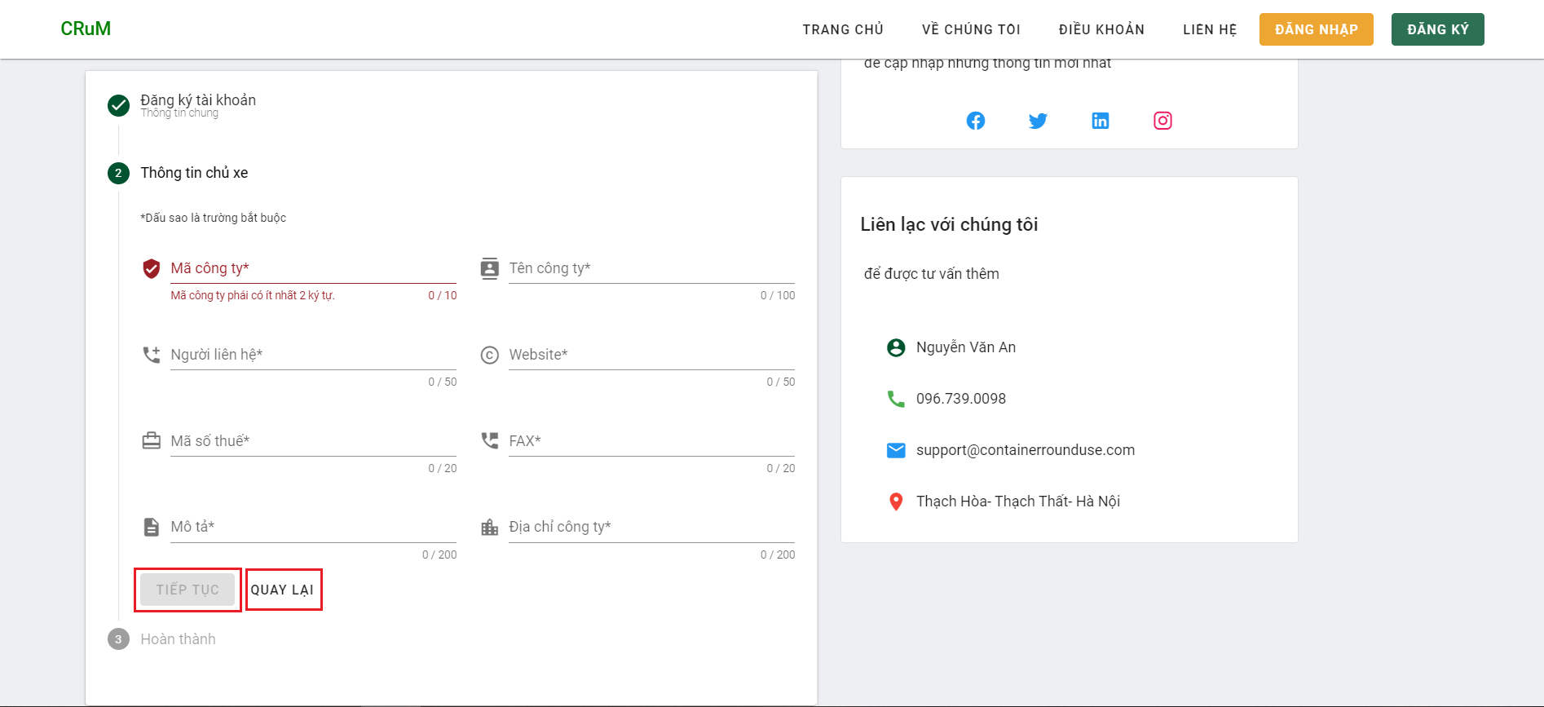

Step 4: User checks the checkbox to confirm that all information entered is correct, then press the "HOÀN TẤT" button to complete the registration process. Then wait for Moderator to approve your application.

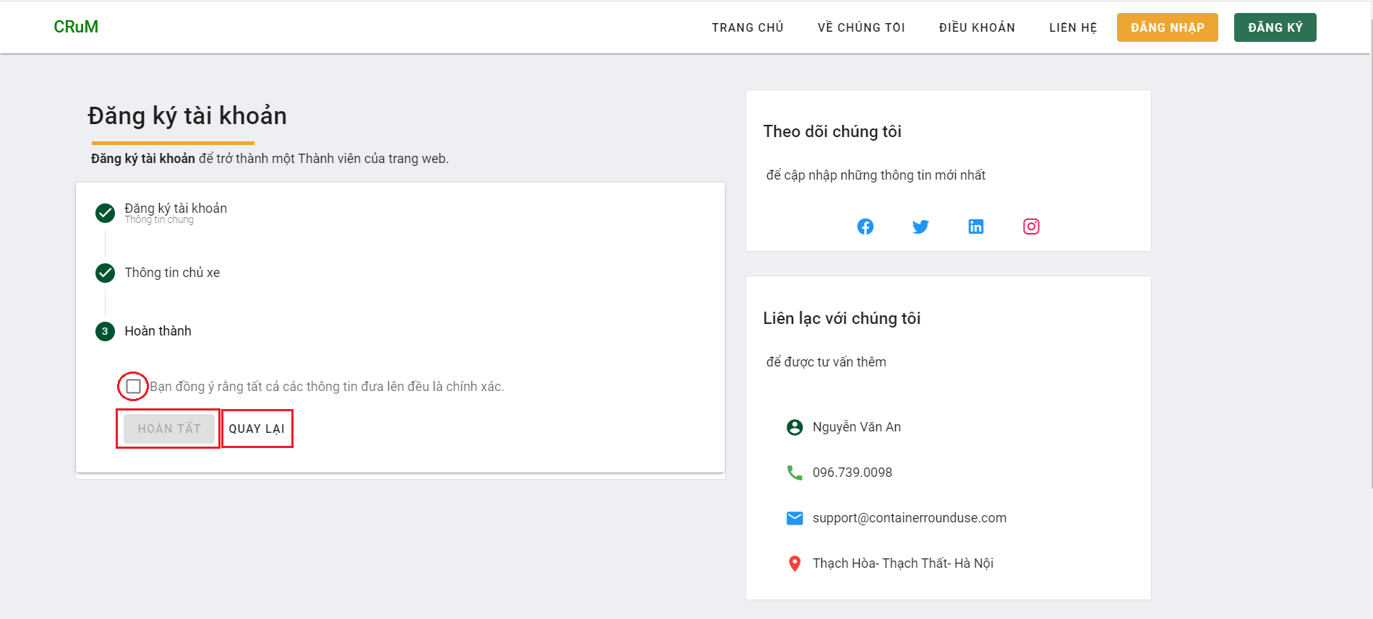

6.2.1.2 Login

Step 1: At the home page, click on “ĐĂNG NHẬP” to open login dialog.

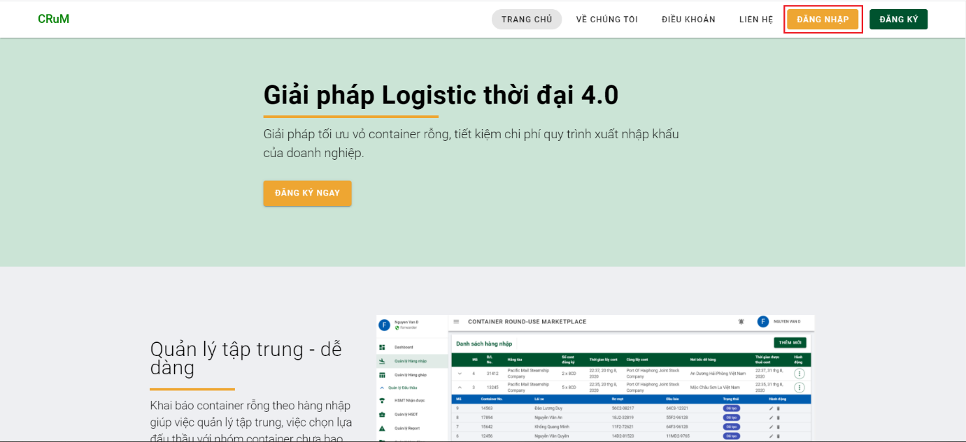

Step 2: Enter username and password then click button “ĐĂNG NHẬP”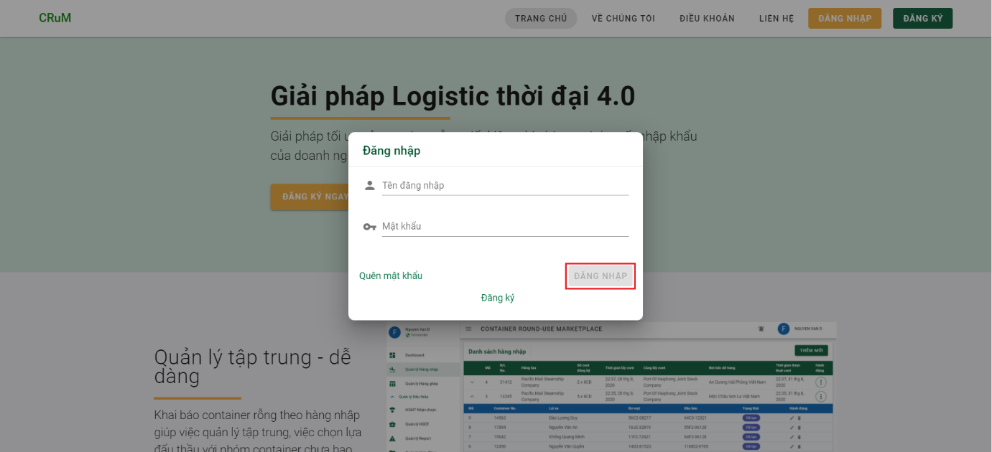

6.2.1.3 Forgot password and reset password

Step 1: At the home page, click on “ĐĂNG NHẬP” to open login dialog.



Step 2: Login dialog is open. Click on “QUÊN MẬT KHẨU” to navigate to forgot password page.

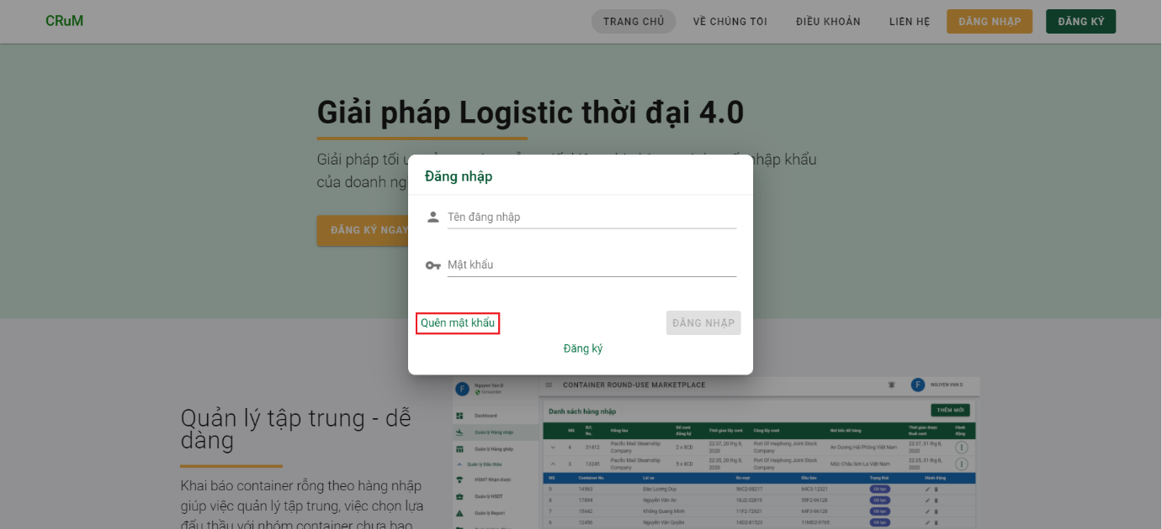

Step 3: Enter email used to register your account and click “GỬI VÀO EMAIL”. Then you will receive an email containing a password reset link. Click on that link and you will go to step 4.

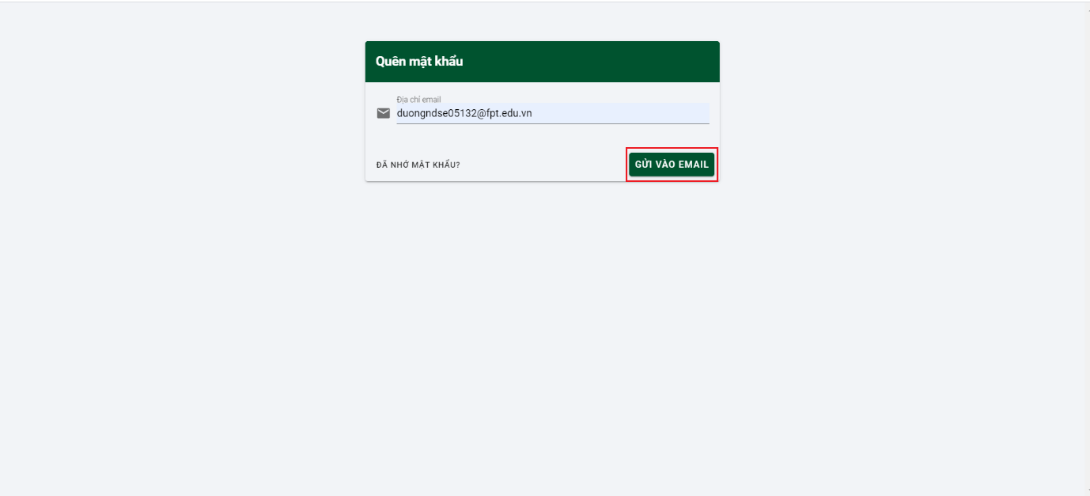 Step 4: Enter your new password and click button “THAY ĐỔI”.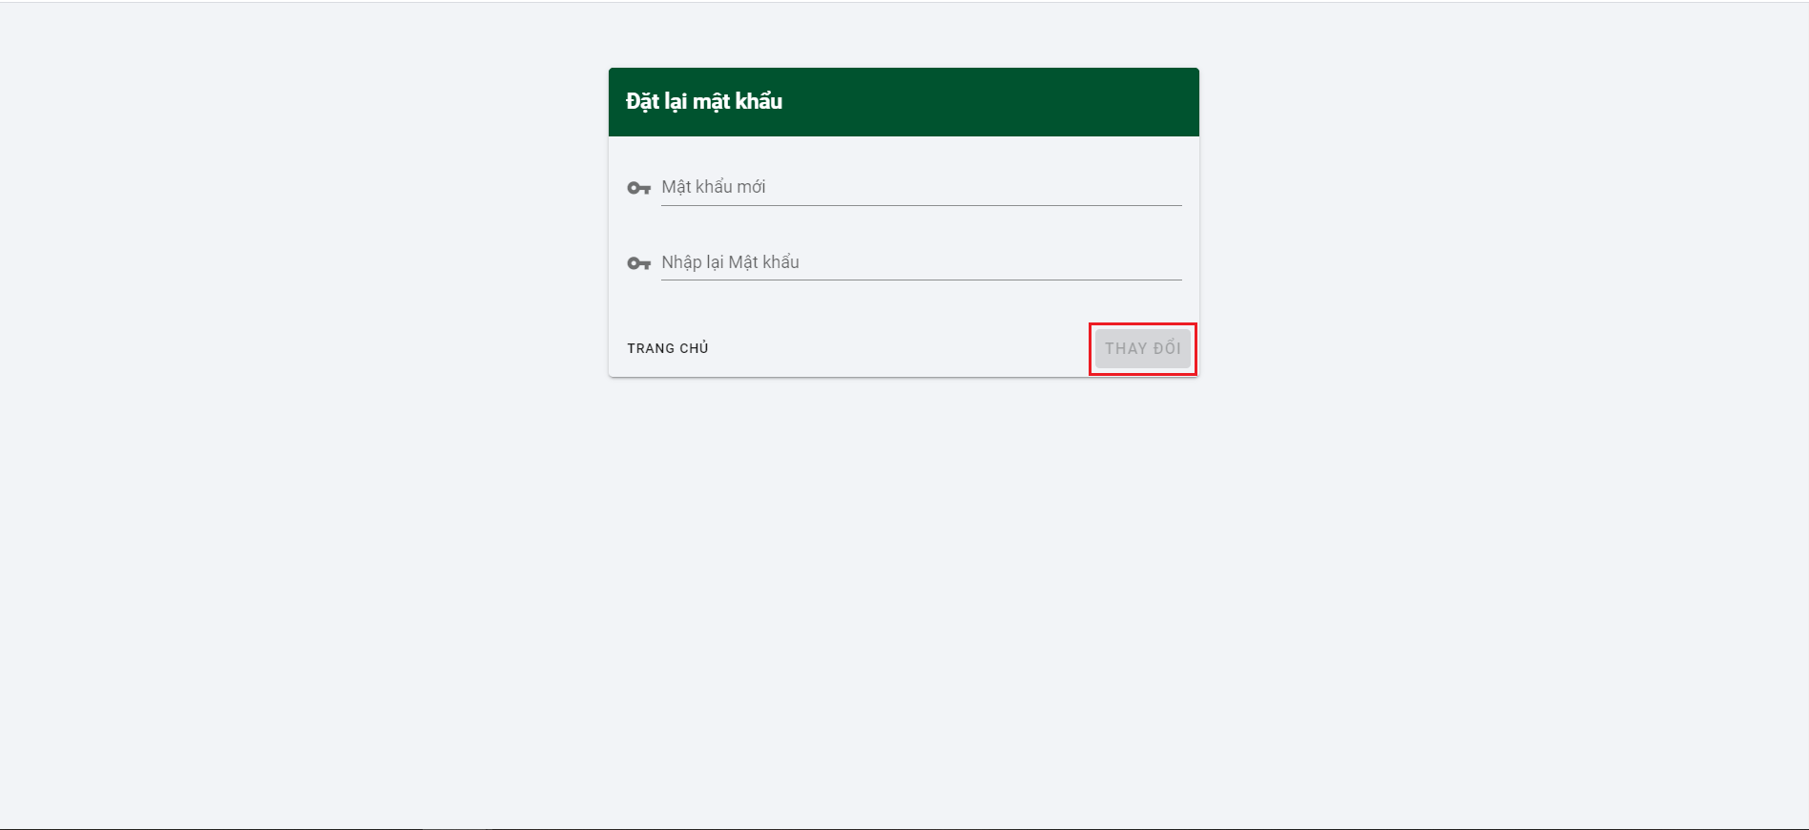

6.2.1.4 Change password

Step 1: After login to system. Click on username on the right conner of page.

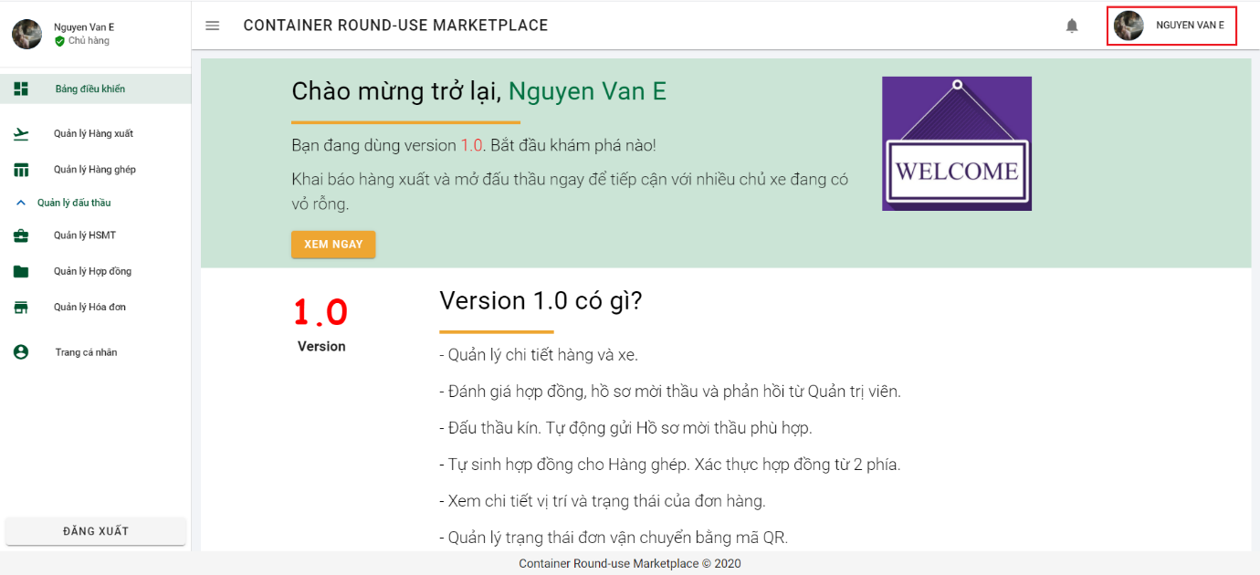

Step 2: Click on “Đổi mật khẩu” to navigate to change password page.

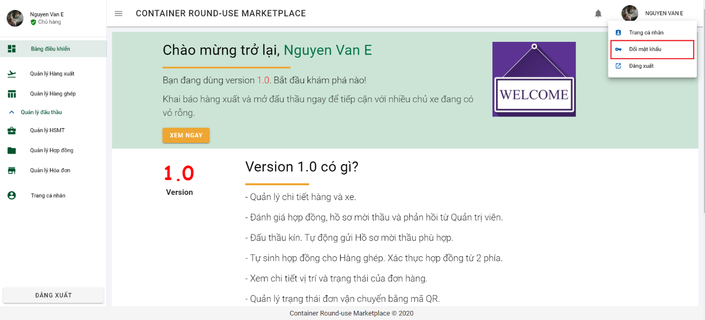

Step 3: Input your old password, new password and re-enter your new password than click button “THAY ĐỔI”.

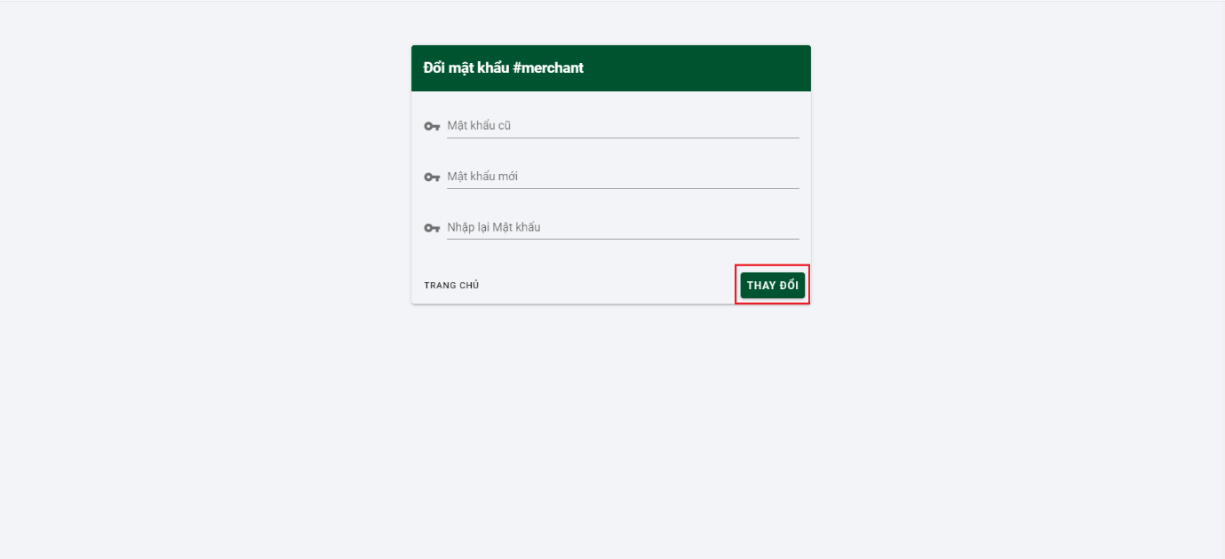

## 6.2.2 Merchant function

6.2.2.1 Declare outbound

Step 1: Click on “Quản lý hàng xuất” from side bar to navigate to list of outbound page.

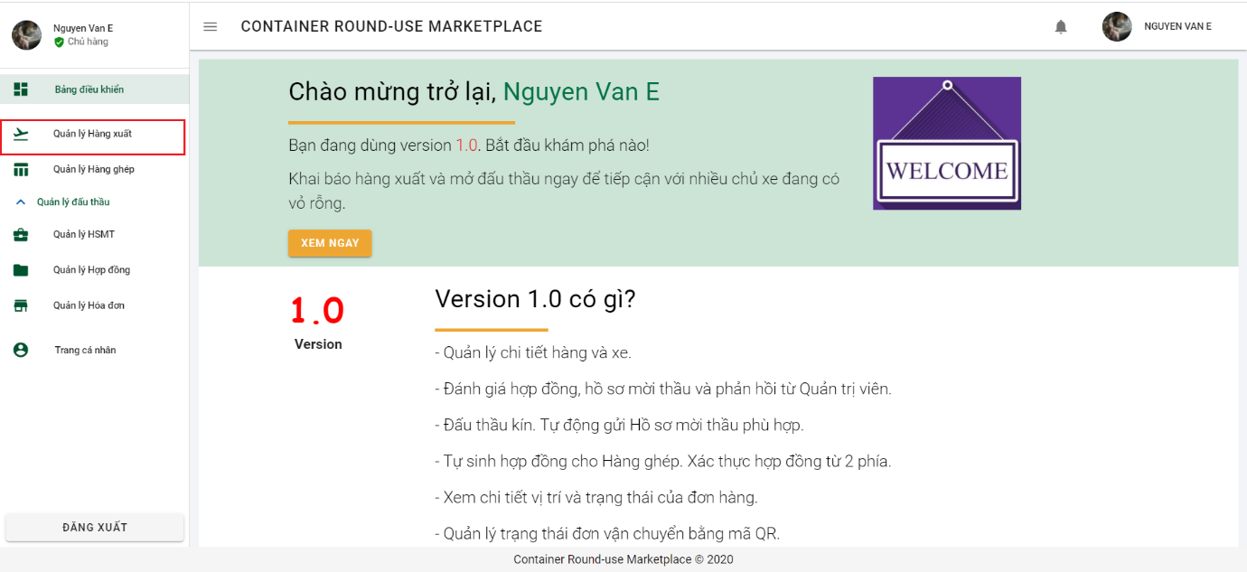

Step 2: Click on button “THÊM MỚI” to open dialog declare outbound.

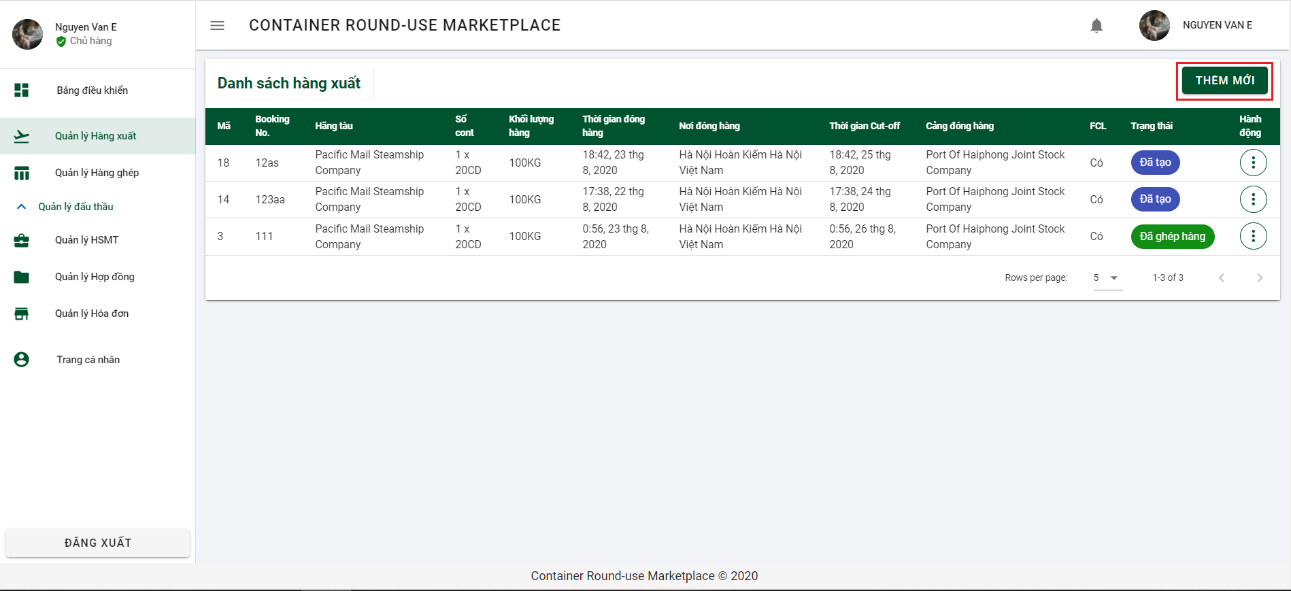

Step 3: Enter all require information and click on button “TIẾP TỤC” to go to next section.

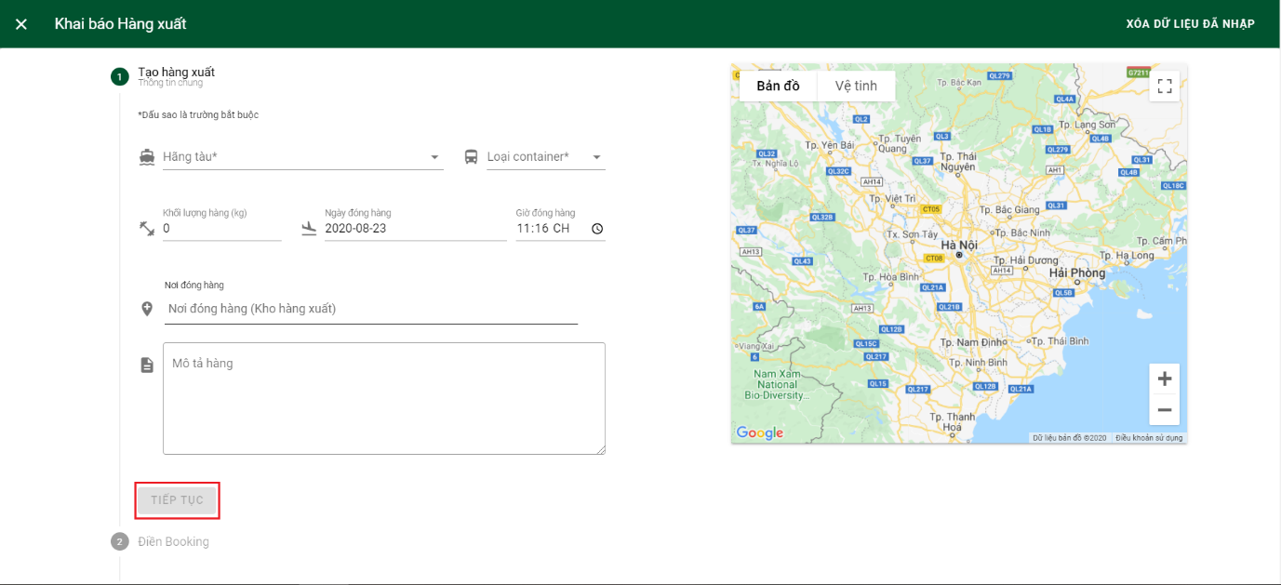

Step 4: Continue to fill in the required information in part 2 and click button “TIẾP TỤC” to go to last step. Check box “Hàng nguyên cont” is default checked to choose full container load and button “QUAY LẠI” to go back to section 1.

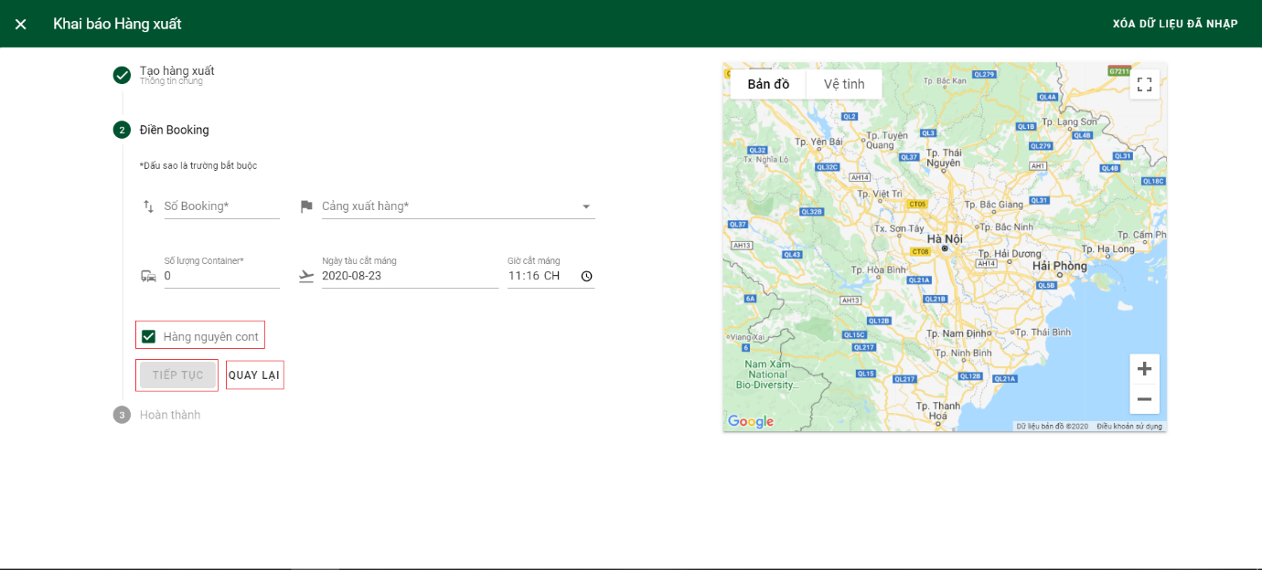

Step 5: Merchant checks the checkbox to confirm all the inputted information is real and clicks button “HOÀN TẤT” to complete declare outbound. Button “QUAY LẠI” to go back to section 2.

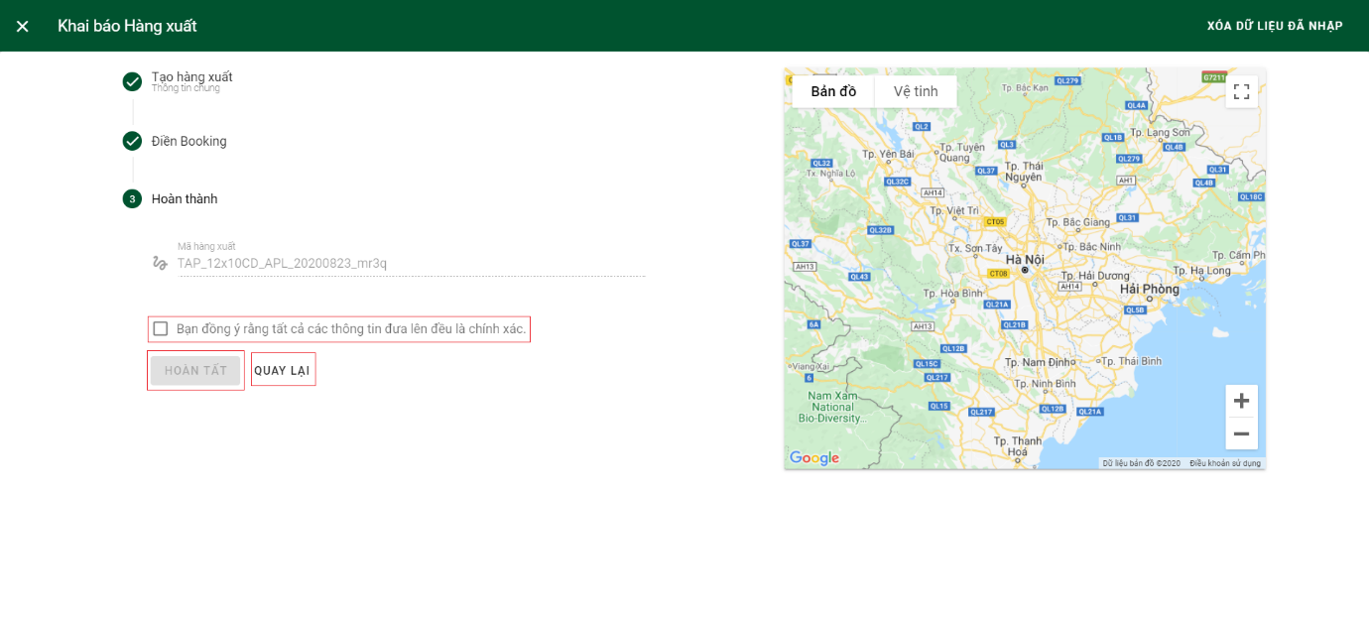

6.2.2.2 Open bidding.

Step 1: Click on “Quản lý hàng xuất” from side bar to navigate to list of outbound page.



Step 2: Click on 3 dots of outbound you want to open bidding

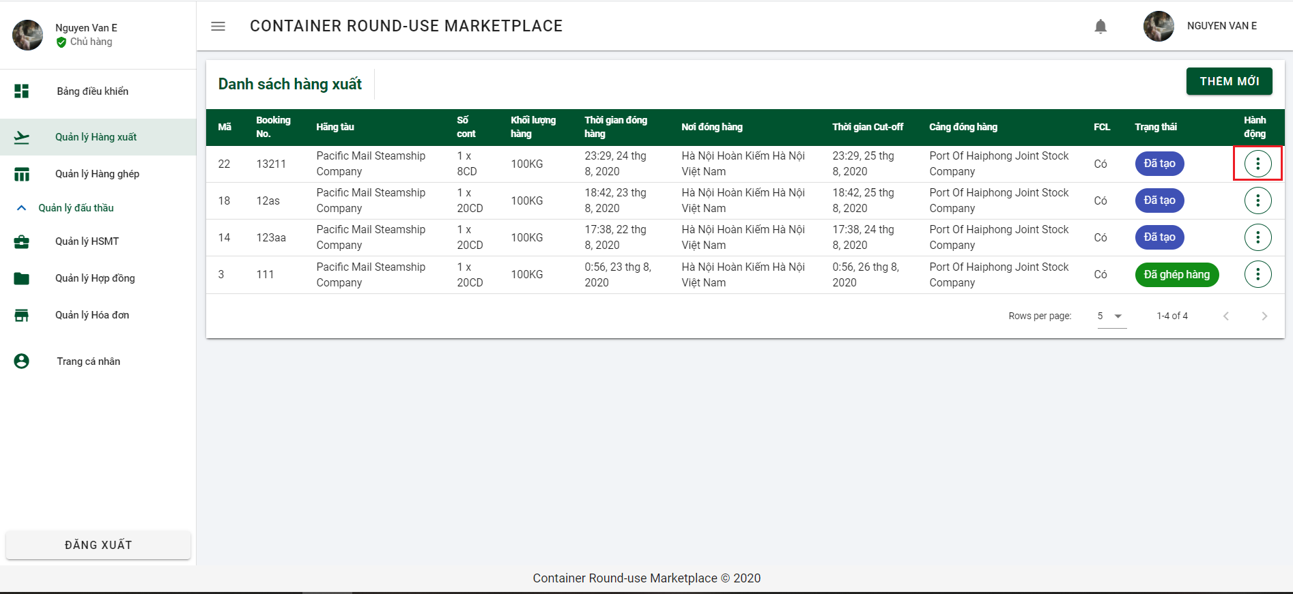

Step 3: Click on “Mở đấu thầu” to open open bidding dialog.

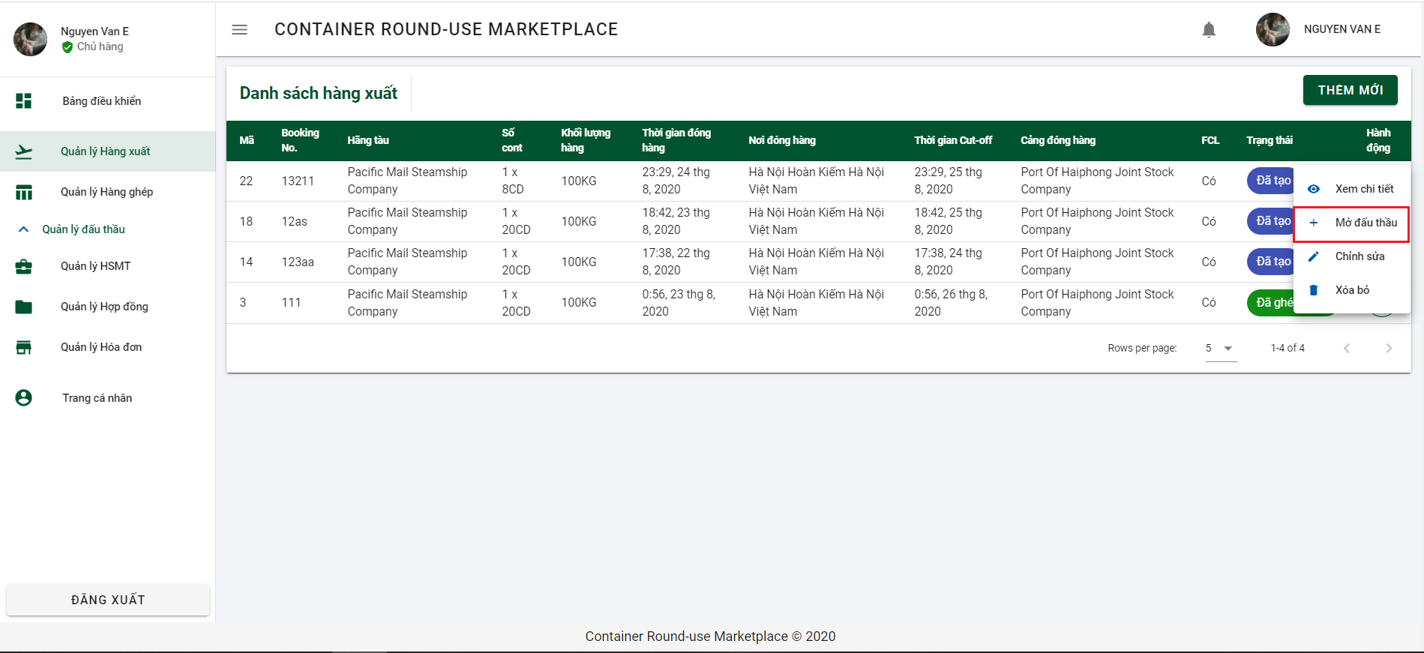

Step 4: The toggle button is show you are choosing this outbound to bidding. Click on button “TIẾP TỤC” to go to the next section.

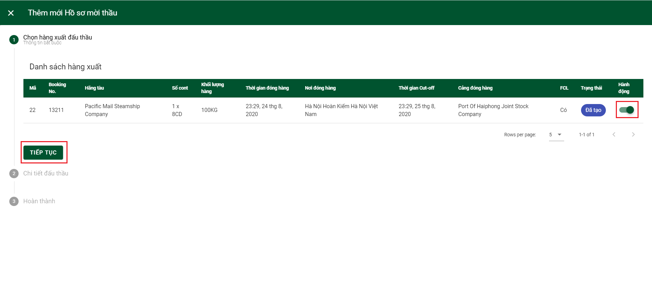

Step 5: Fill in all information. “Giá sàn” is mean floor price is optional. Check the check box to choose option “Many bid win” and click “TIẾP TỤC” to go to next section.

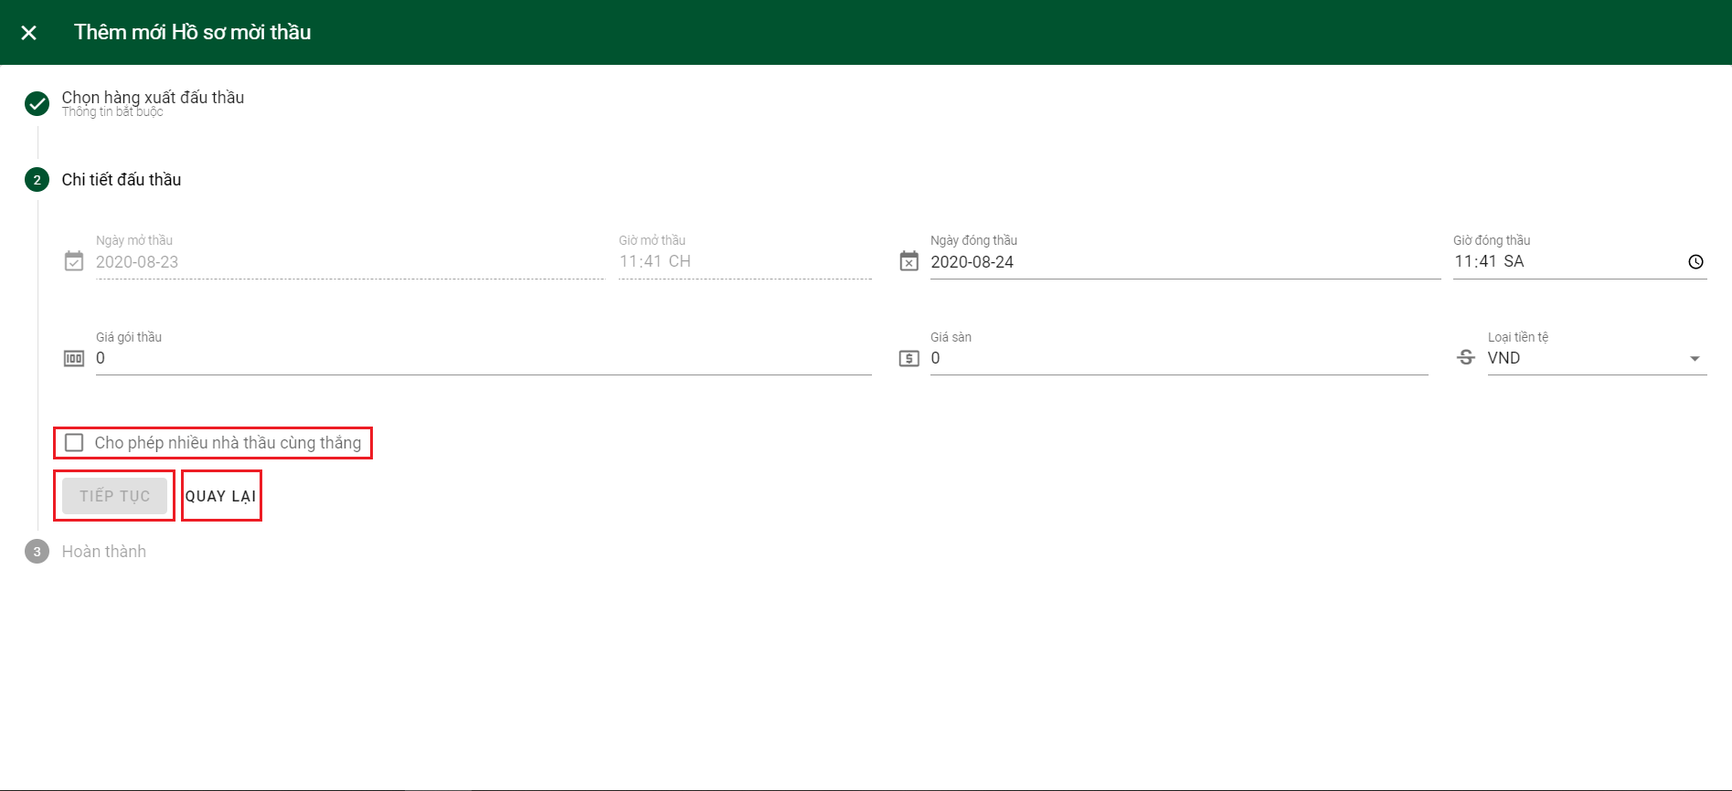

Step 6: The first checkbox is default checked to auto send invitation to bid. Check the second checkbox to agree that all inputted information is correct and click “HOÀN TẤT” to complete declare bidding document.

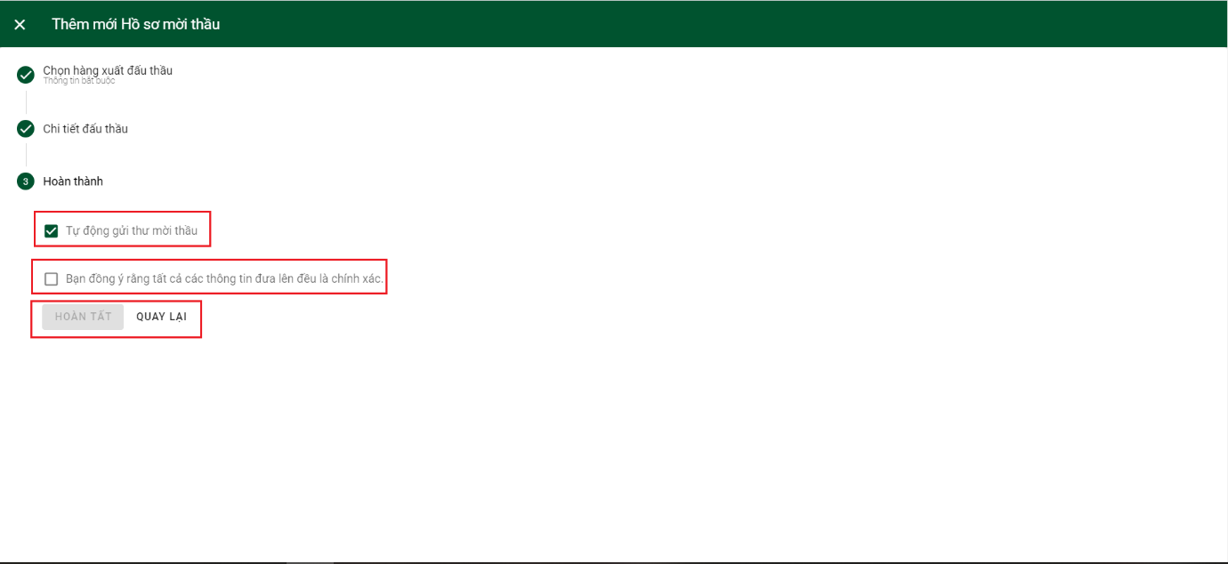

6.2.2.3 Create combined

Step 1: Click on “Quản lý HSMT” on sidebar and then click on 3 dots of outbound you want to create combined.

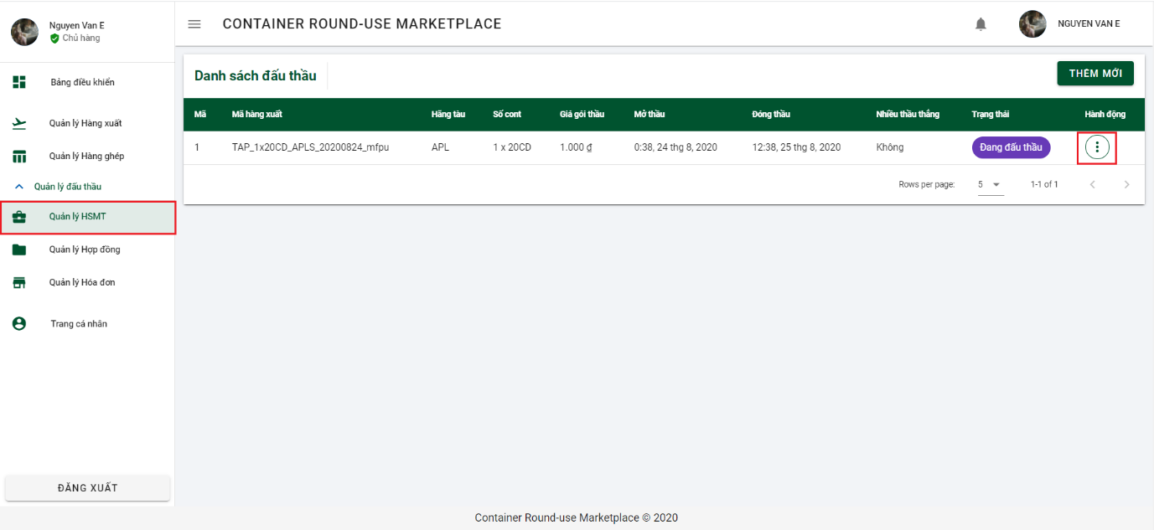

Step 2: Click on “Xem chi tiết” to navigate to Bidding Document detail page.

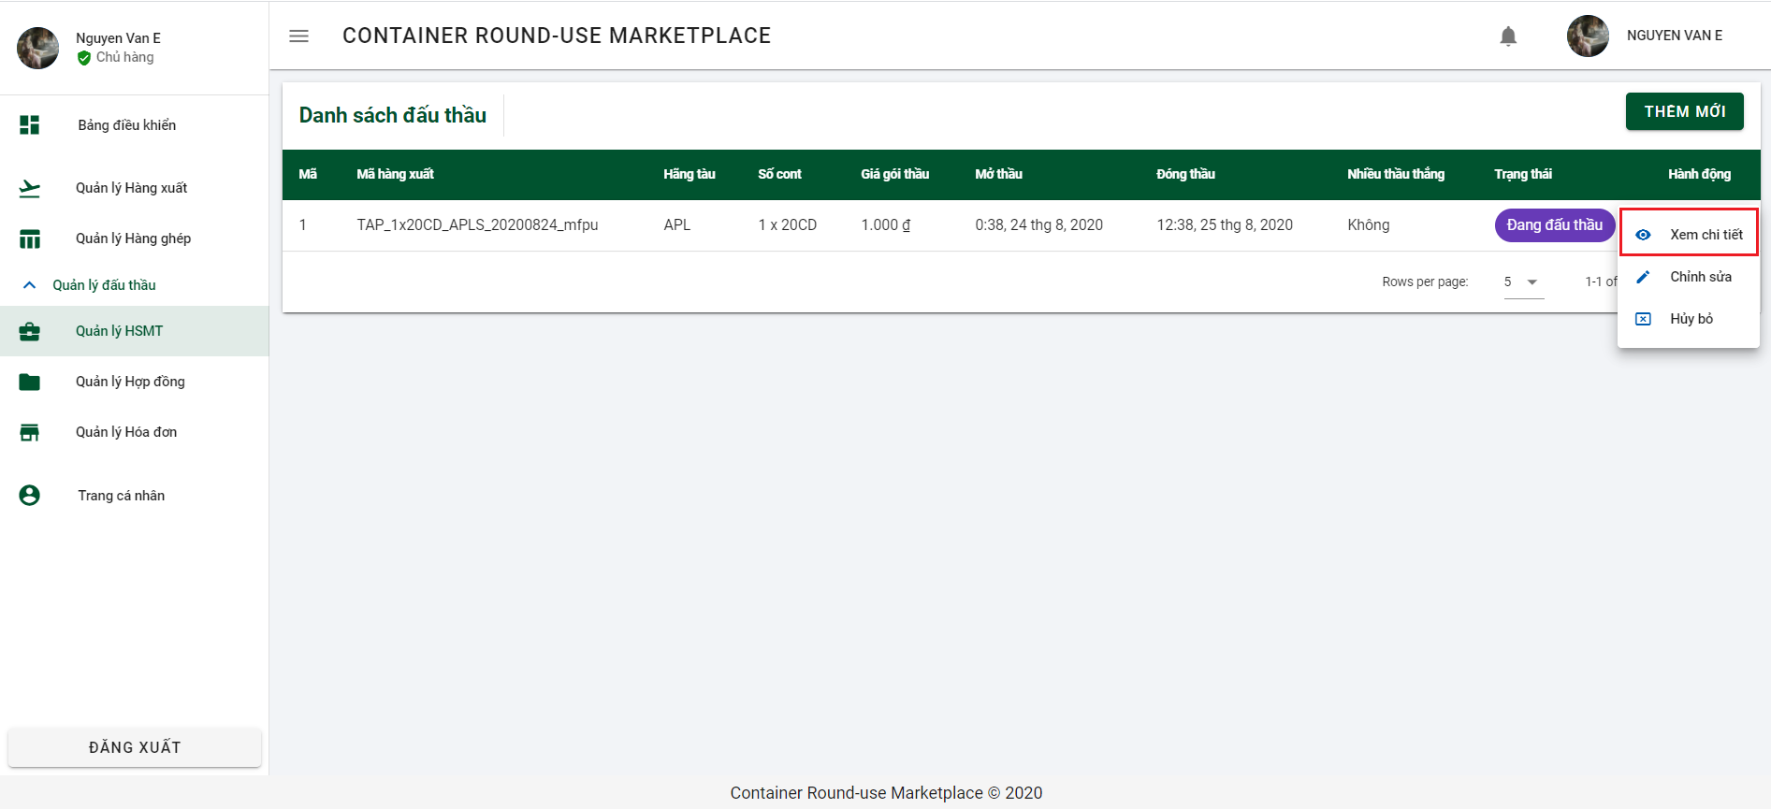

Step 3: Click on “ĐỒNG Ý” to agree combine with forwarder and open create combined dialog

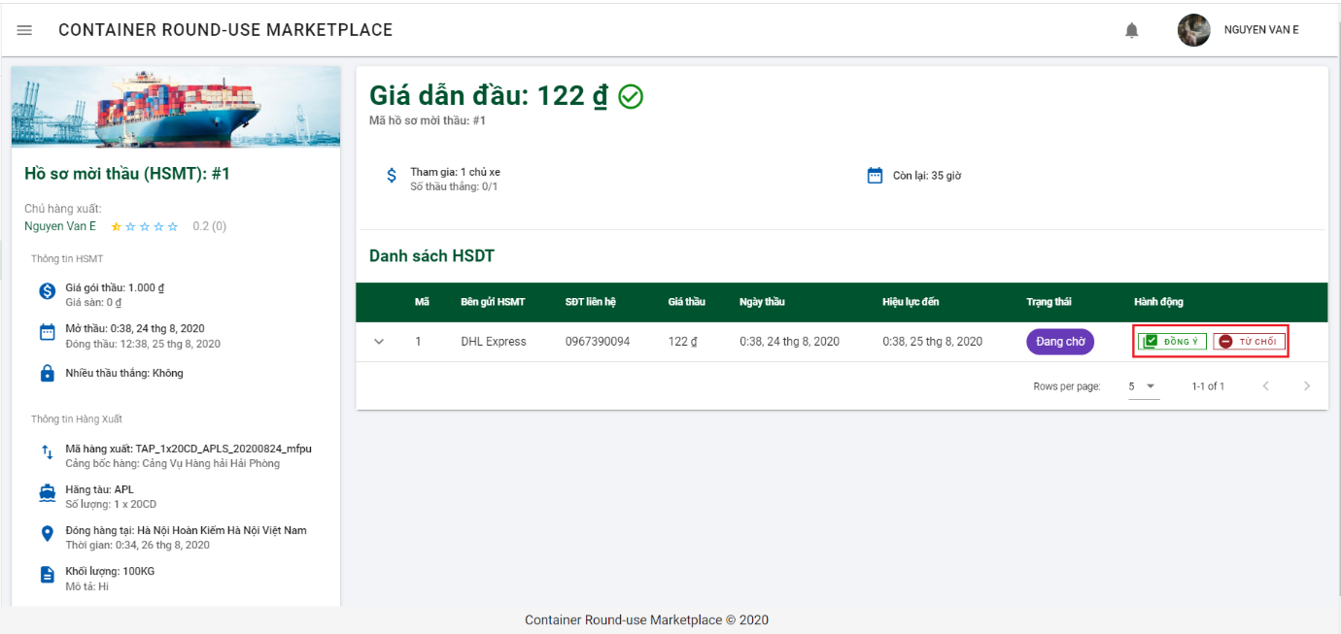

Step 4: Check on check box if you need contract

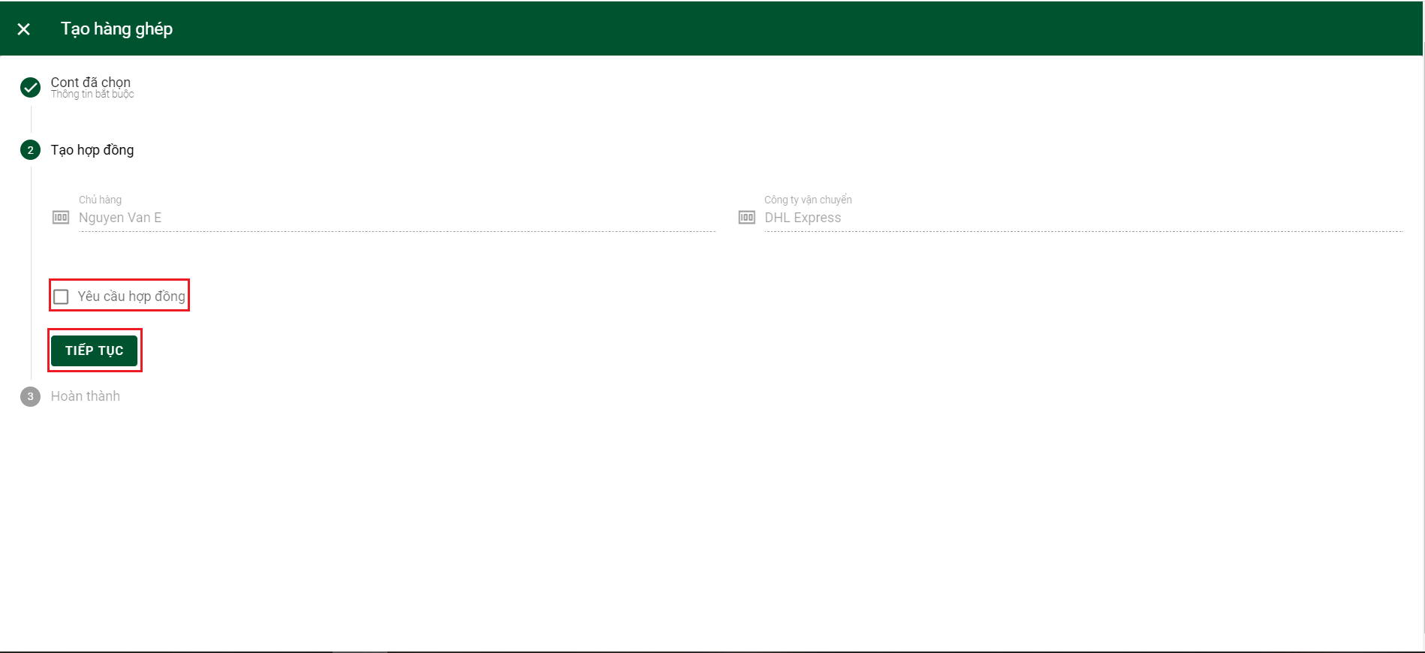

Step 5: After checking the checkbox, “% tiền phạt” will be showed and you have to put 5 fines and click button “TIẾP TỤC” to go no next portion.

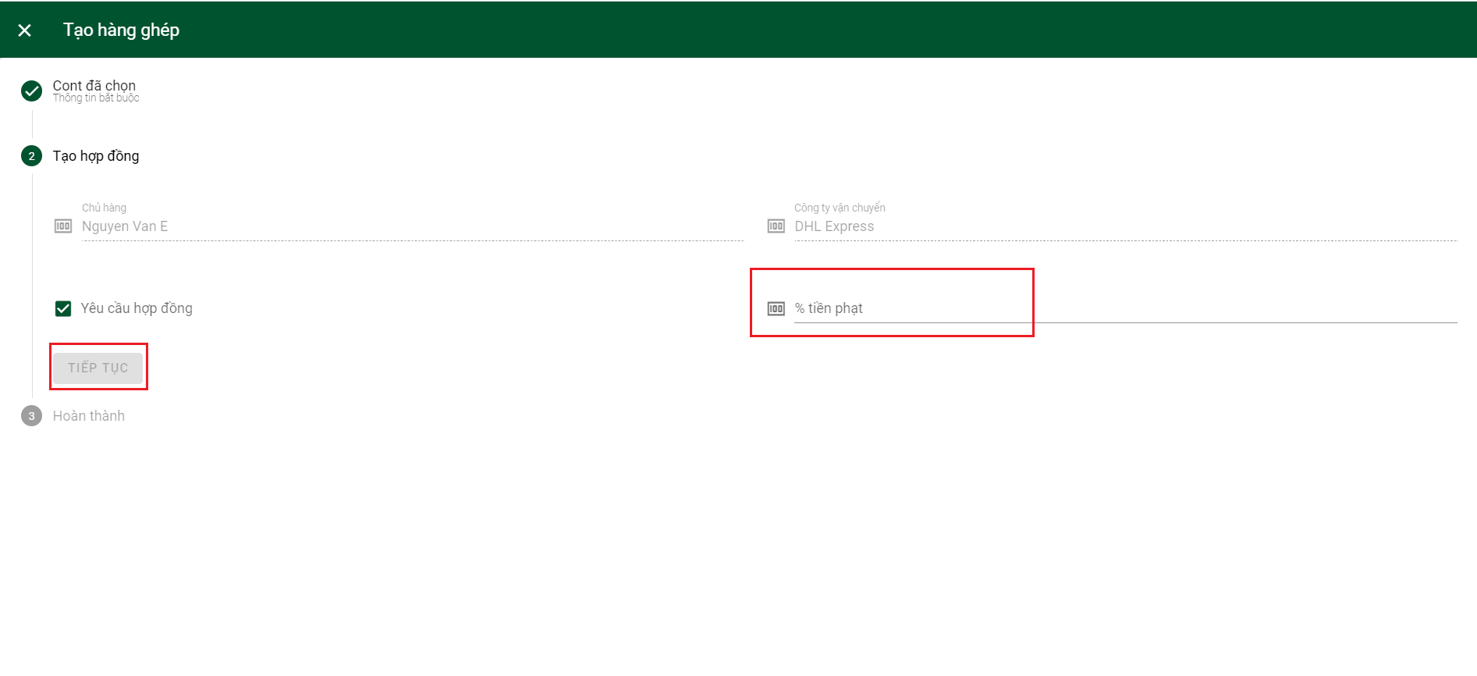

Step 6: Check on checkbox to agree all inputted information is correct. And then click “HOÀN TẤT” to complete create combined.

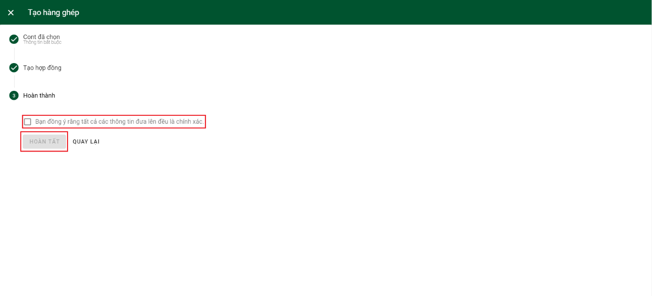

6.2.2.4 Declare invoice

Step 1: Click on “Quản lý hợp đồng” on side bar and then click on 3 dots on contract you want to declare invoice.

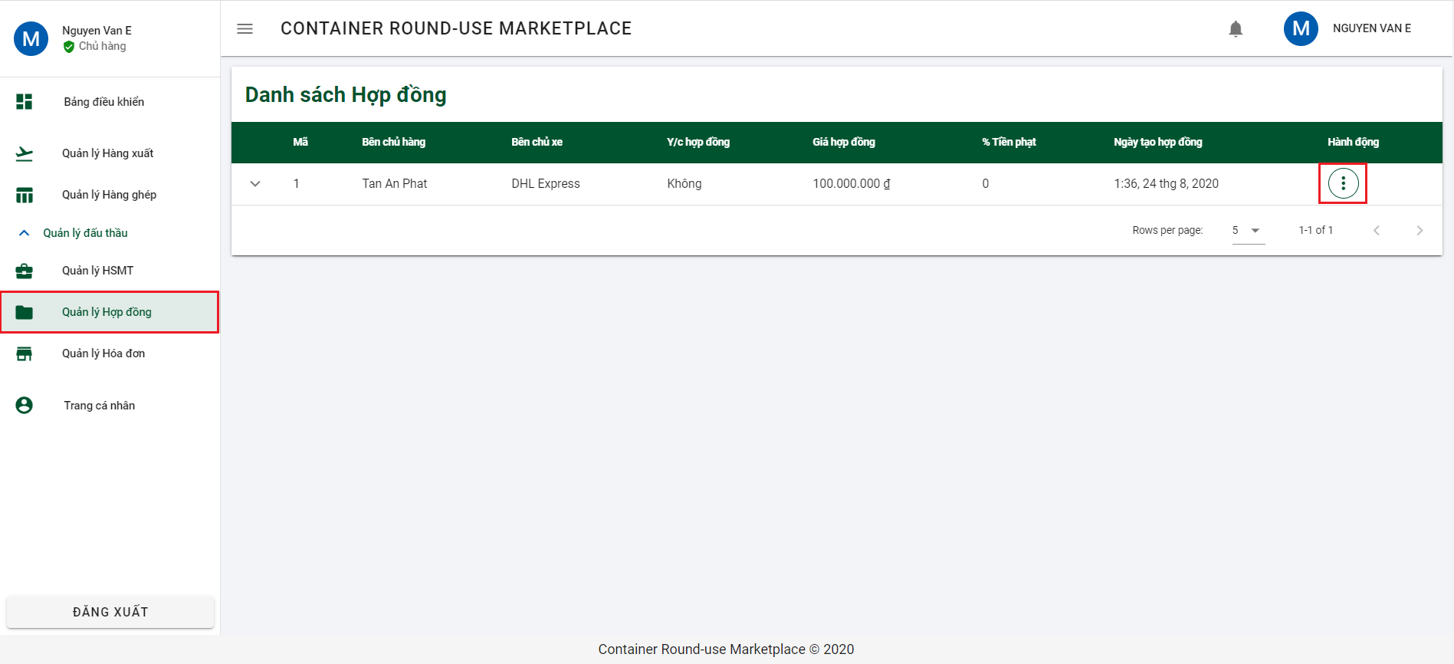

Step 2: Click on “Tạo hóa đơn” to open dialog Declare invoice.

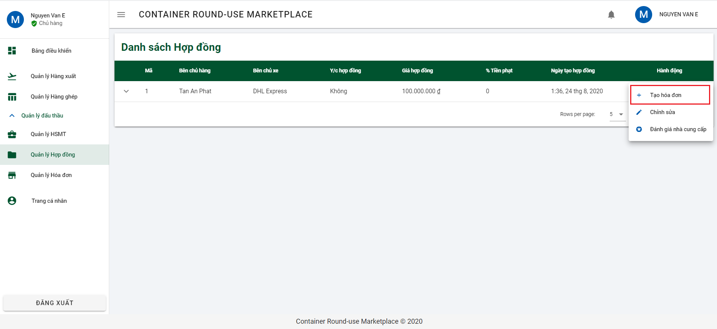

Step 3: Input all required information and click button “THÊM MỚI” to declare invoice.

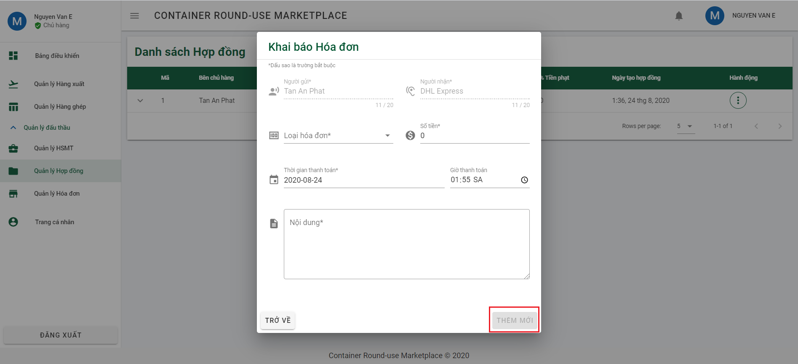

6.2.2.5 Rating supplier

Step 1: Click on “Quản lý hợp đồng” on side bar and then click on 3 dots on contract you want to declare invoice.



Step 2: Click on “Đánh giá nhà cung cấp” to open dialog Rating supplier

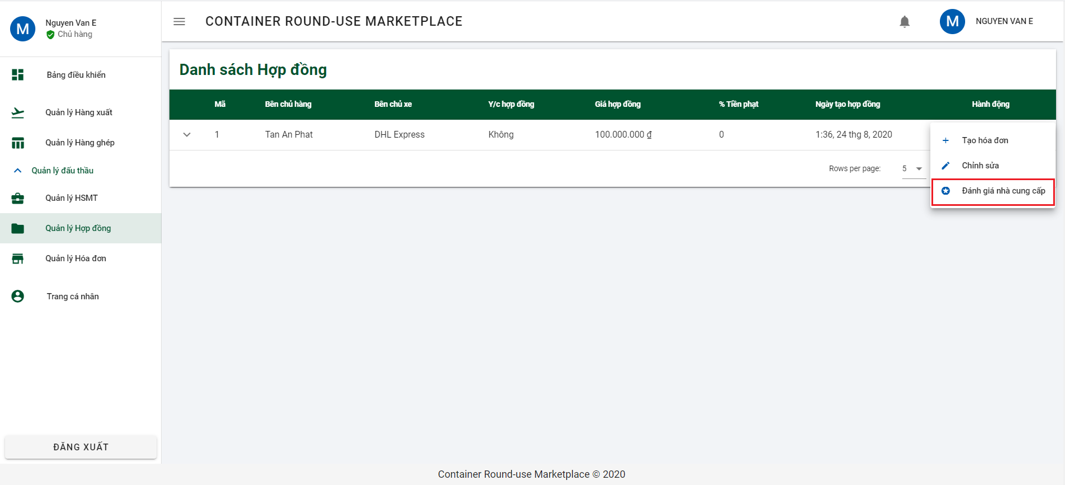

Step 3: Rate by choosing the corresponding number of stars and click button “ĐÁNH GIÁ” to rate supplier.

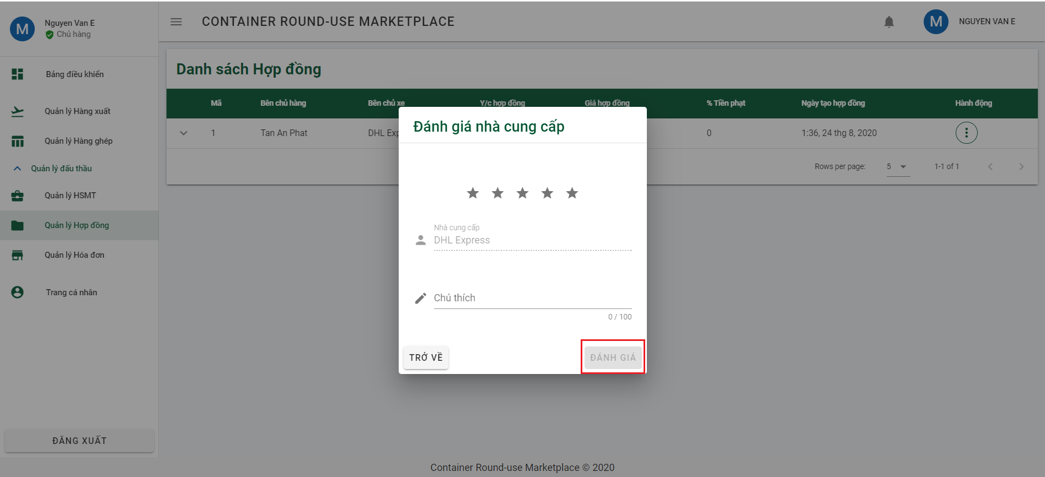

6.2.2.6 Confirm Invoice

Step 1: Click on “Quản lý hóa đơn” on side bar and then click on 3 dots on invoice you want to confirm.

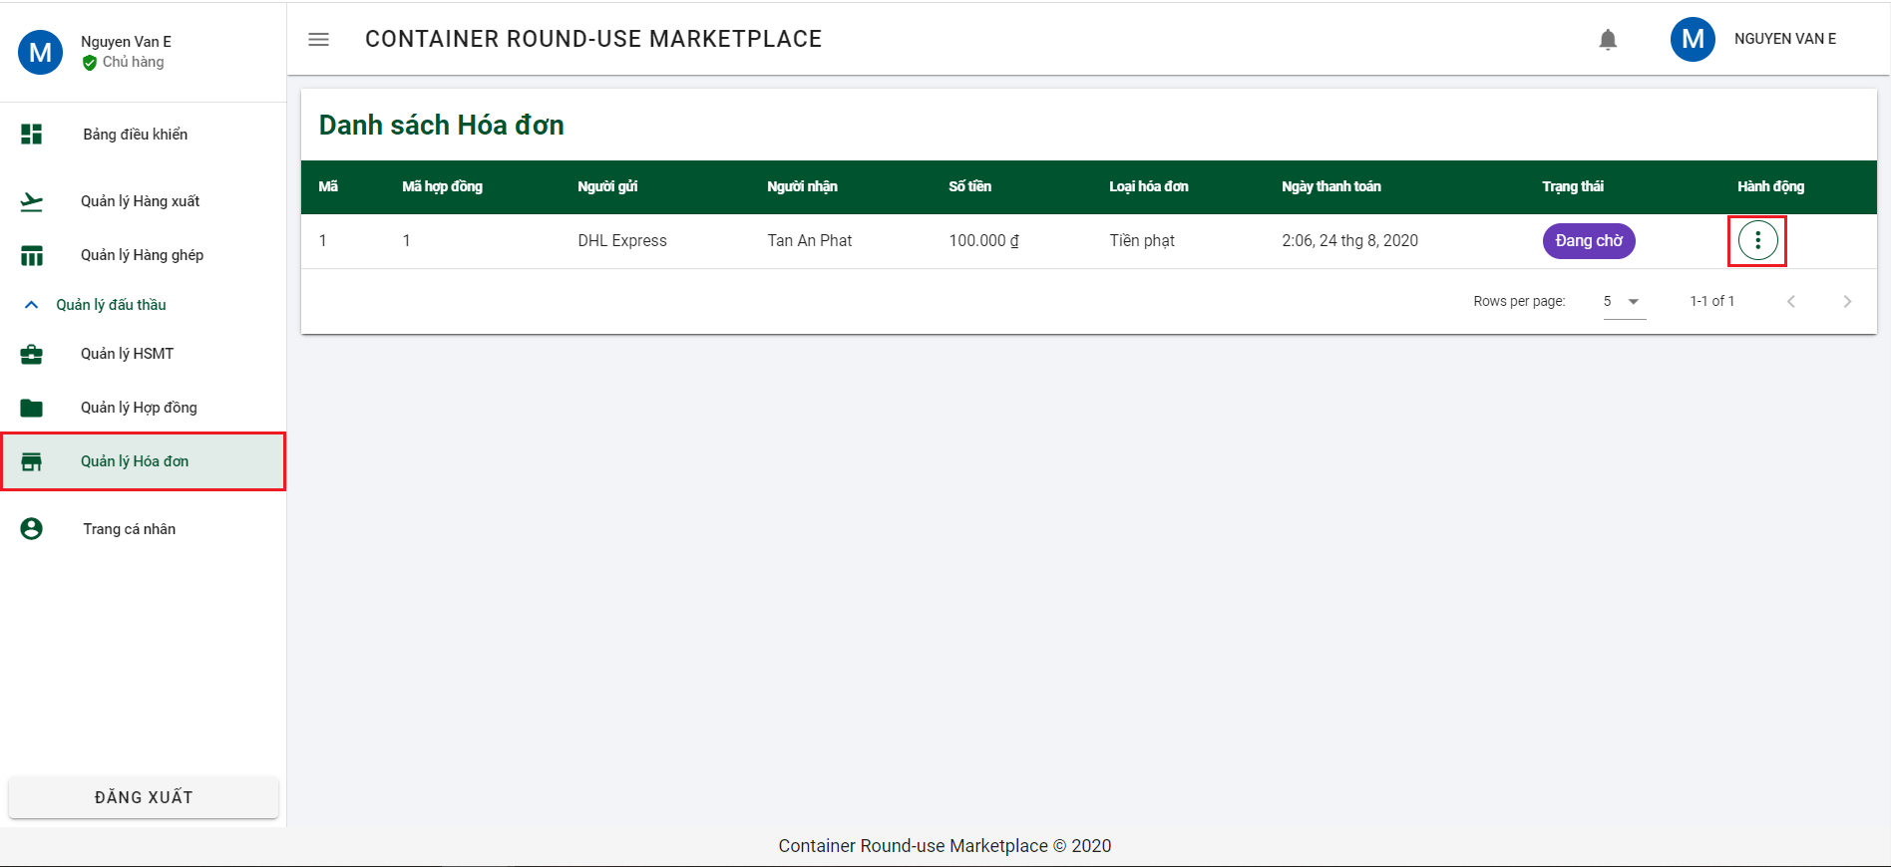

Step 2: Click on “Xác nhận thanh toán” to open dialog confirm invoice.

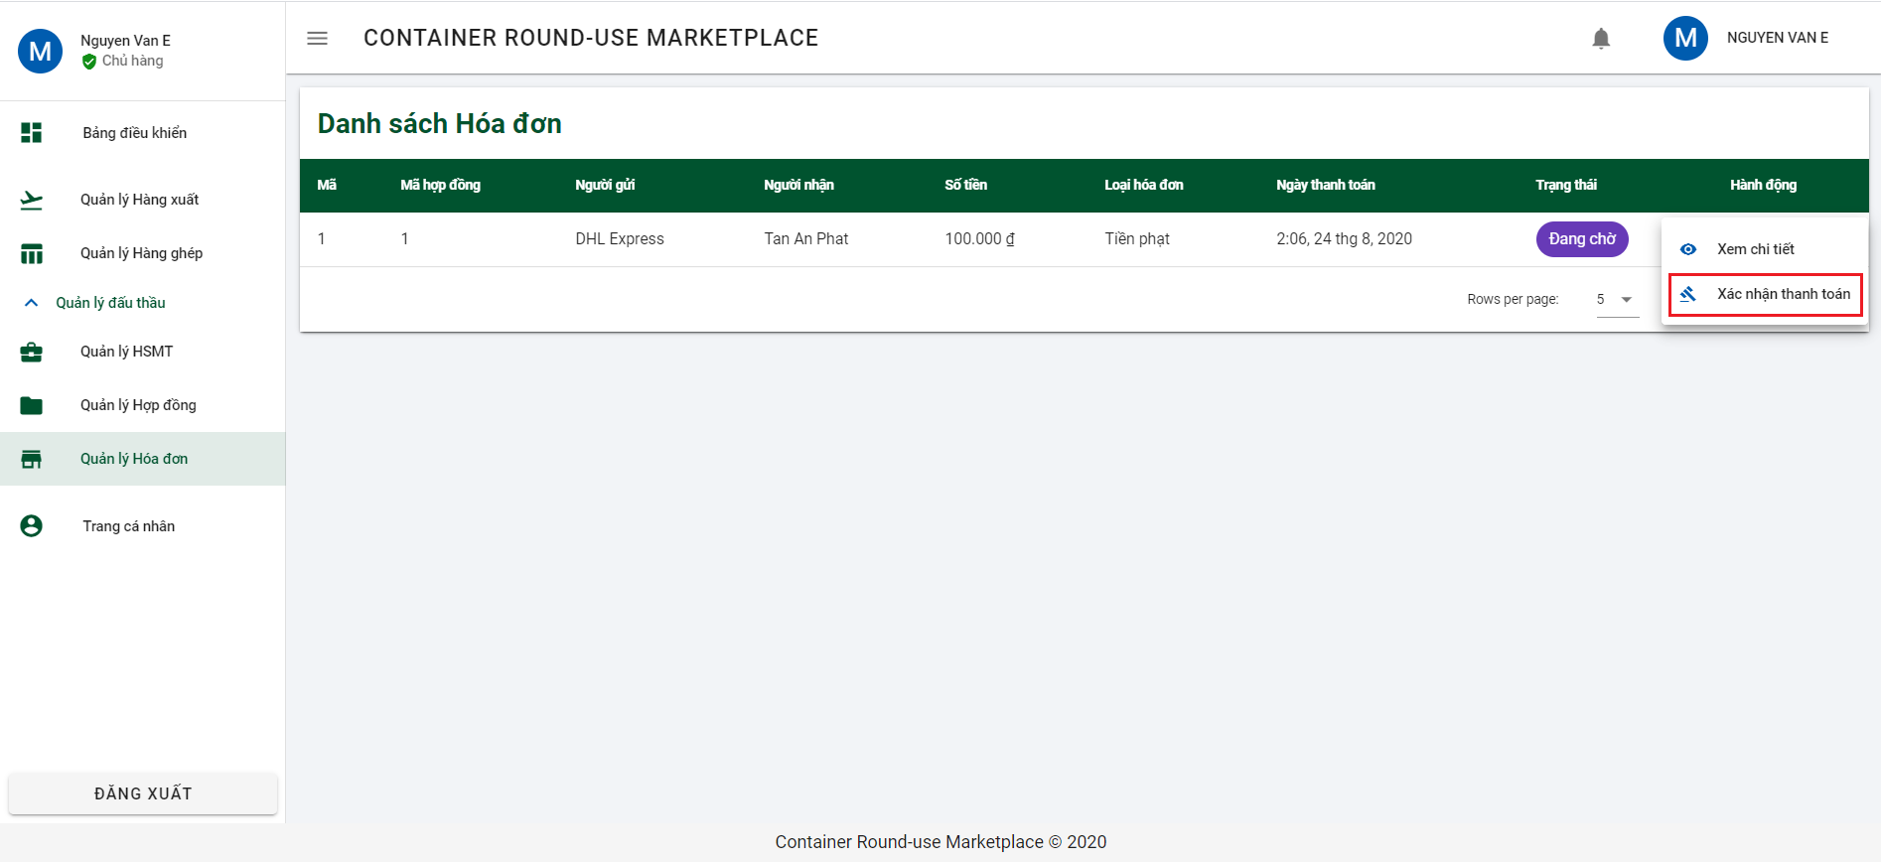

Step 3: Click on button “XÁC NHẬN” to confirm invoice.

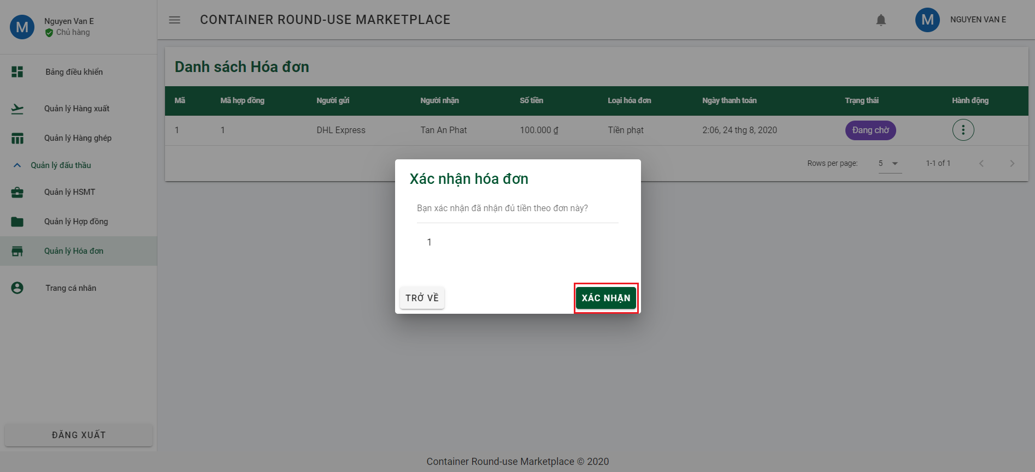

### 6.2.3 Forwarder function

6.2.3.1 Declare outbound

Step 1: Click on “Quản lý hàng nhập” on side bar and then click on button “THÊM MỚI” to open Declare outbound dialog.

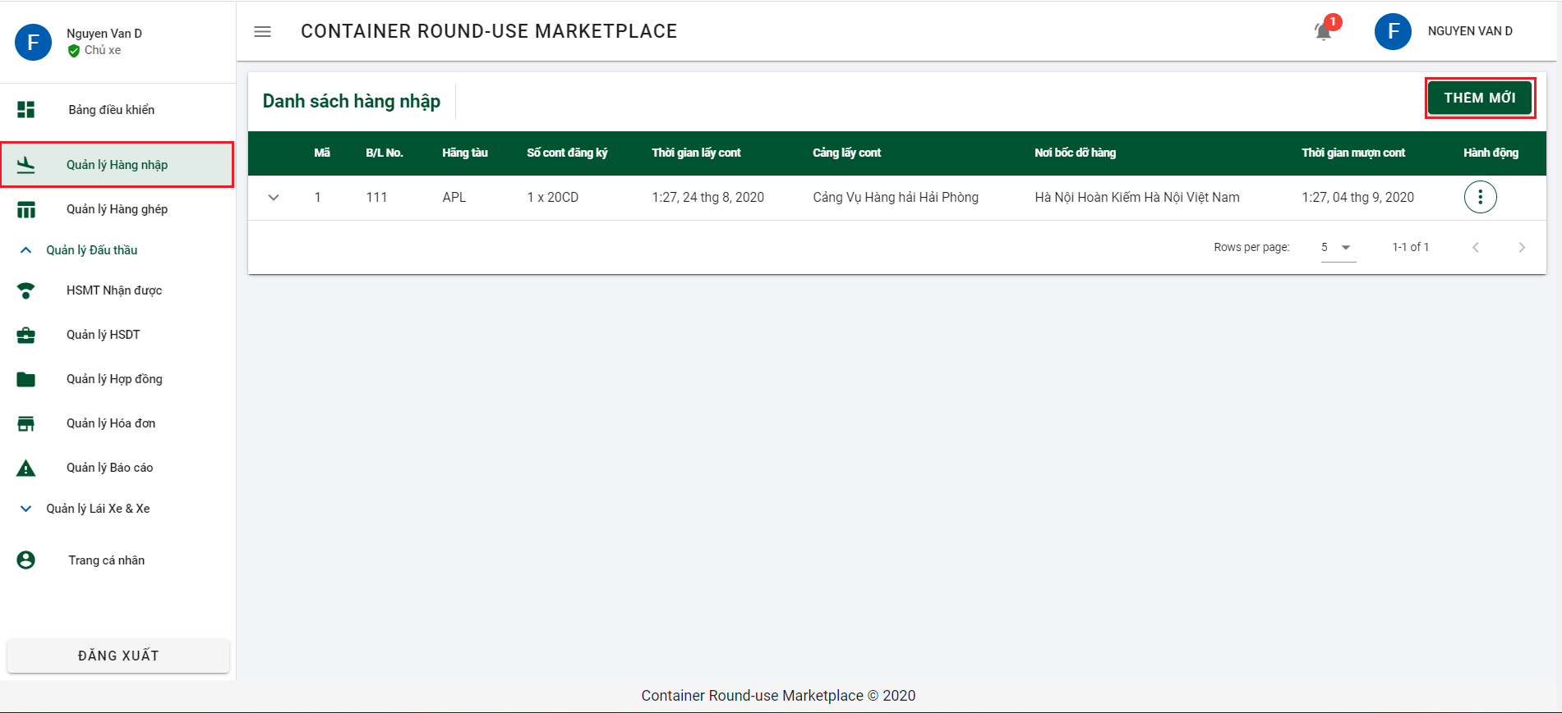

Step 2: Input all require information of part 1: “Thêm mới hàng nhập” and click on button “TIẾP TỤC” to go to the next section.

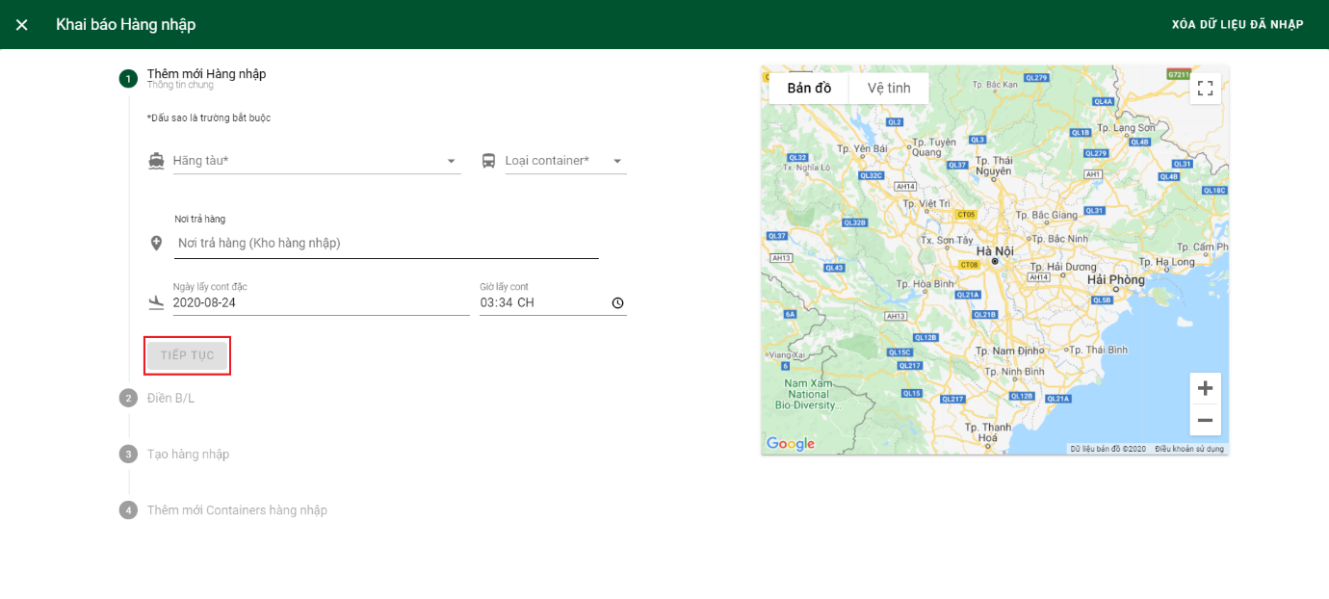

Step 3: Input all required information of part 2 and then click on button “TIẾP TỤC” to go the step 4.

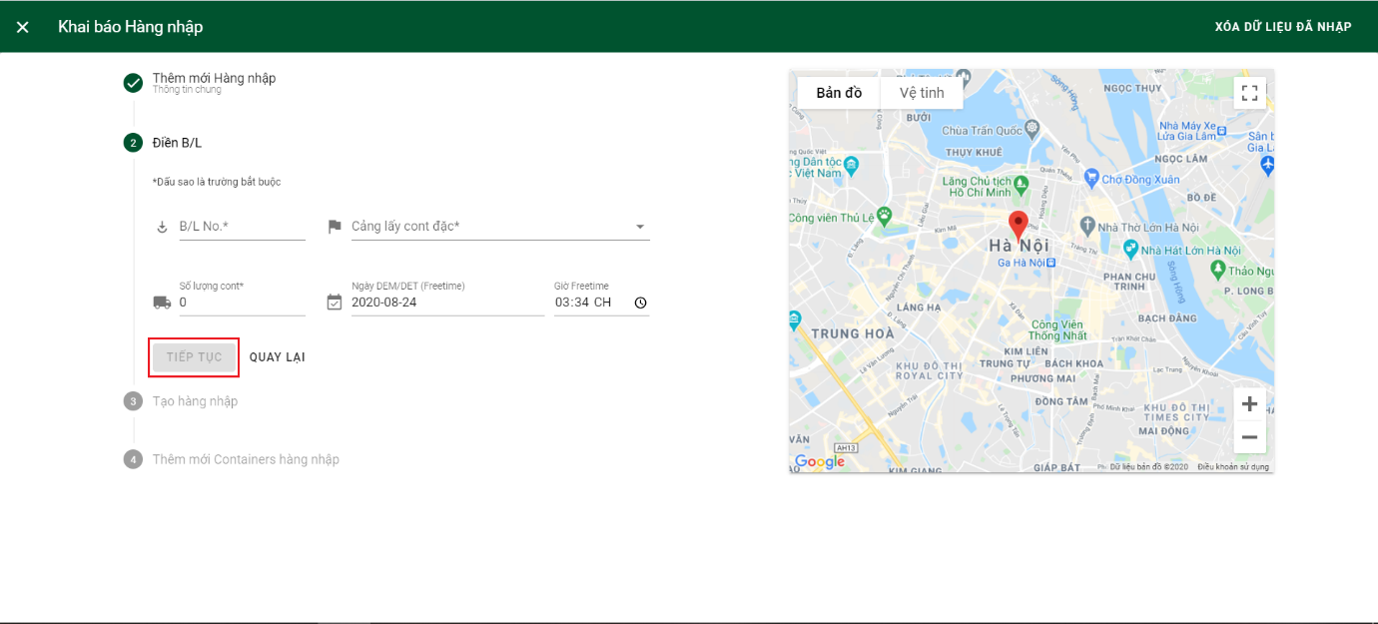

Step 4: Checking the checkbox to confirm that all your inputted information is correct and click “TẠO HÀNG NHẬP” to declare outbound and go to the last section.

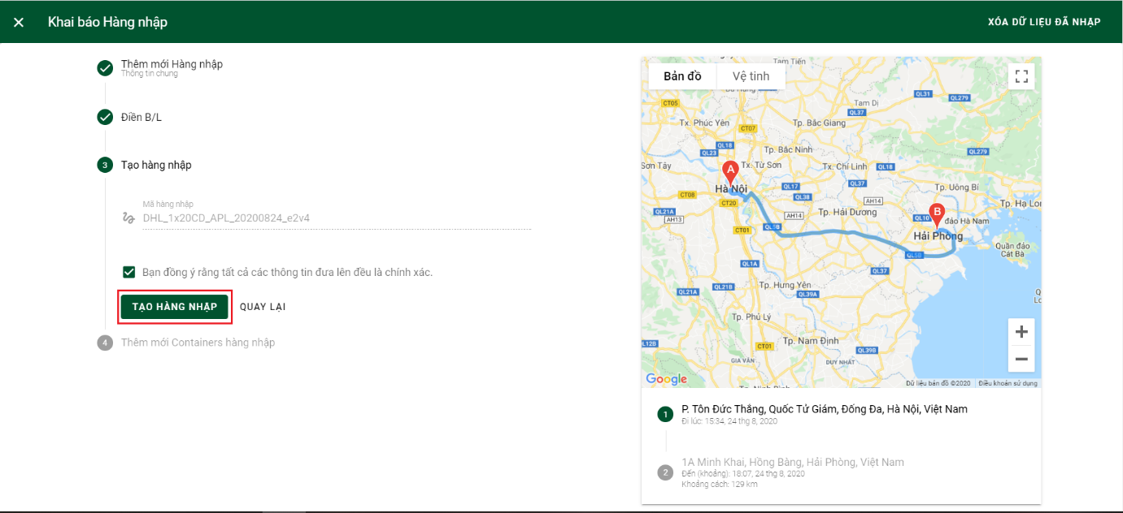

Step 5: Click on button “THÊM MỚI” to add new container.

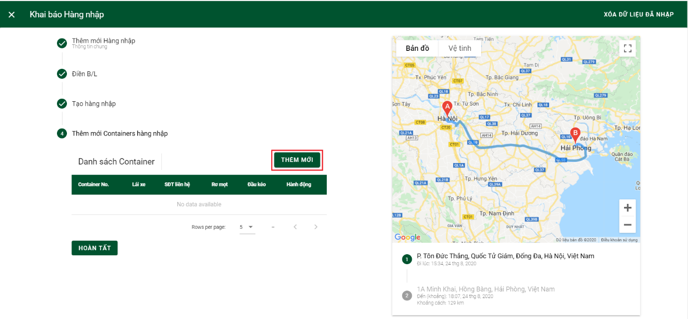

Step 6: Input all container information and click button “THÊM MỚI” to add container, then click on button “HOÀN TẤT” to complete declare inbound.

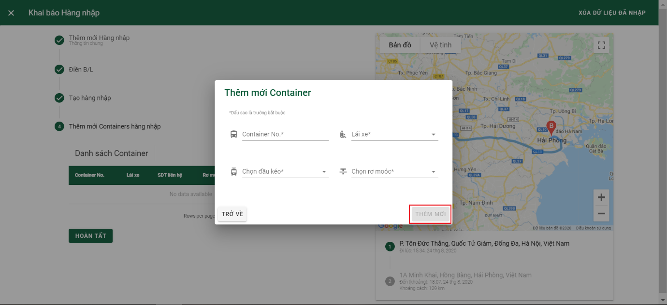

6.2.3.2 Sending bid

Step 1: Click on “Quản lý hàng nhập” on side bar and then click 3 dots of inbound you want to send bid.

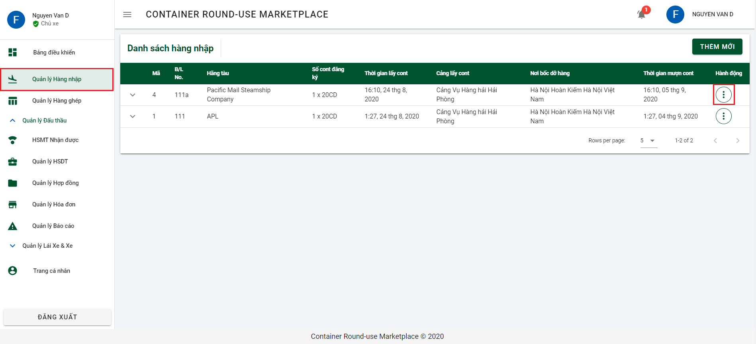

Step 2: Click on tìm thầu to open add new bid dialog.

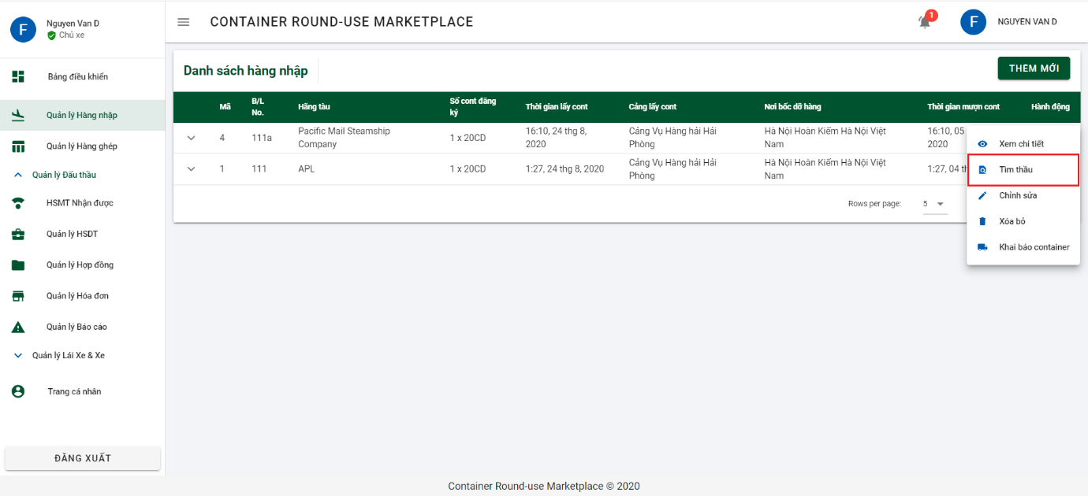

Step 3: Choose bidding document you want to send bid by checking the check box and then click on button “TIẾP TỤC” to go to the next section.

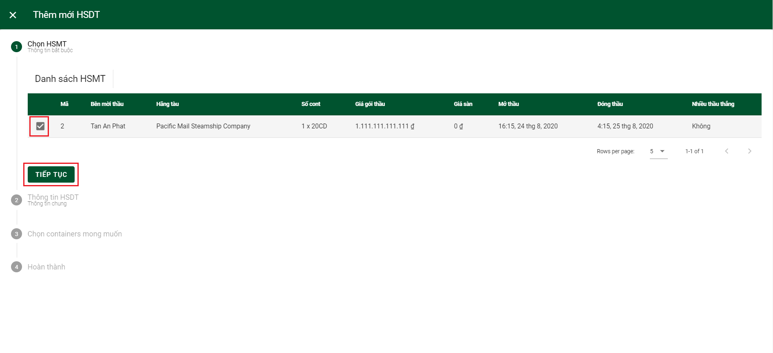

Step 4: Forwarder inputs bid price and click “TIẾP TỤC” to go to next step.

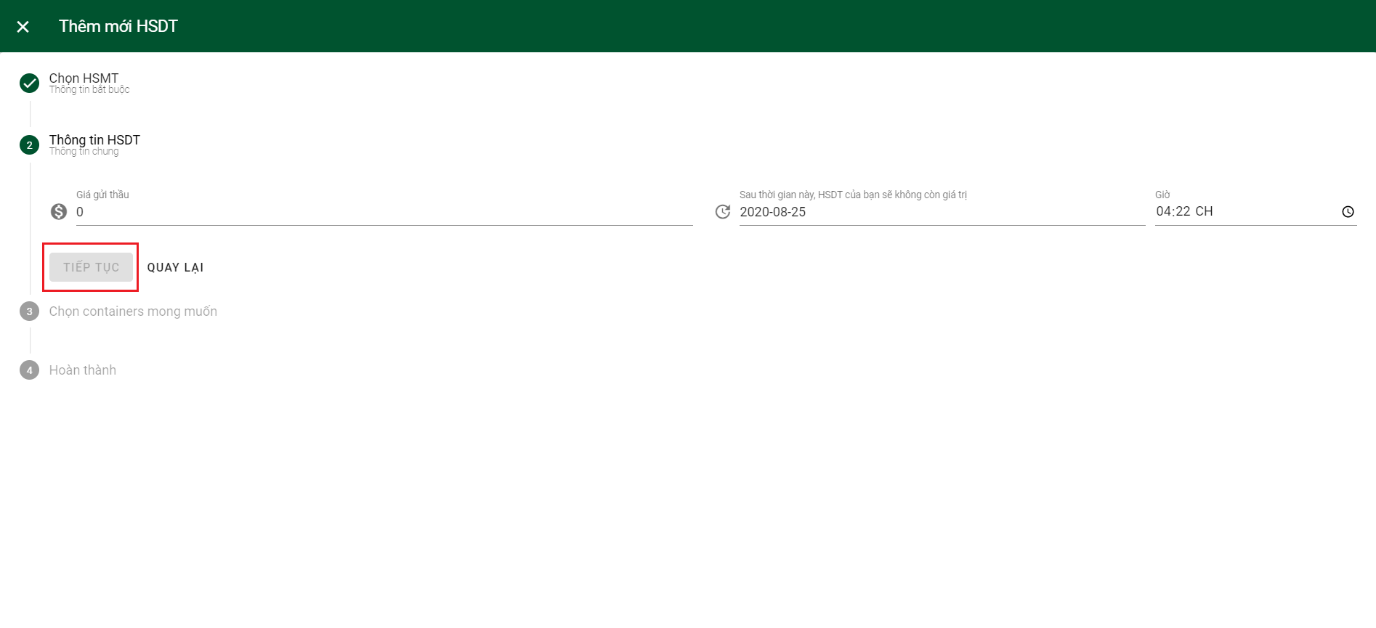

Step 5: Click on inbound forwarder wants to bid to expand container list and choose suitable container by checking the checkbox. And then click on button “TIẾP TỤC” to go to the last step

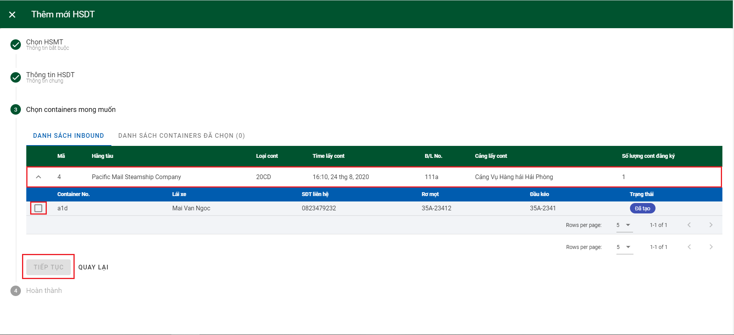

Step 6: Checking the checkbox to confirm that all your inputted information is correct and click “HOÀN TẤT” to sending bid.

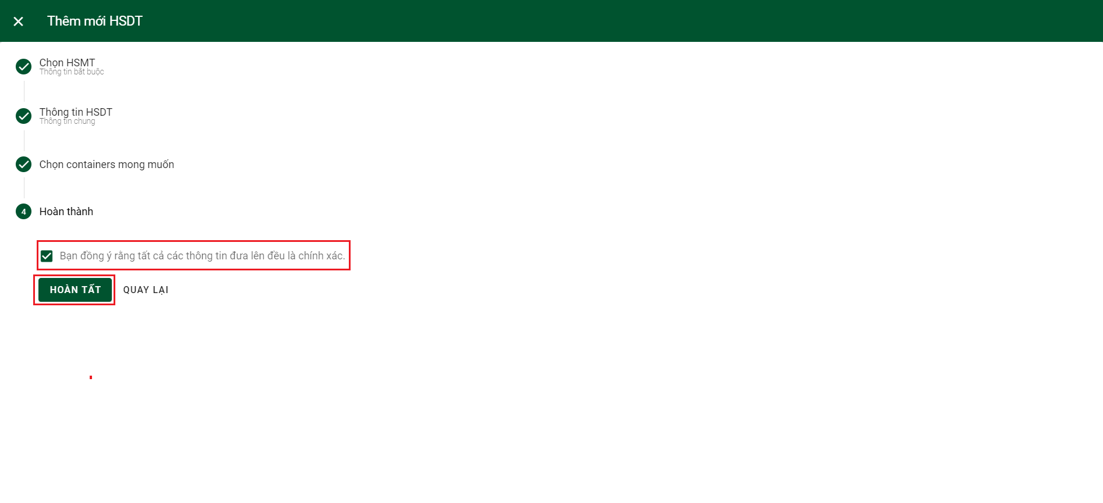

6.2.3.3 Update shipping status

Step 1: Click on “Quản lý hàng ghép” from side bar and then click on combined you want to update shipping status.

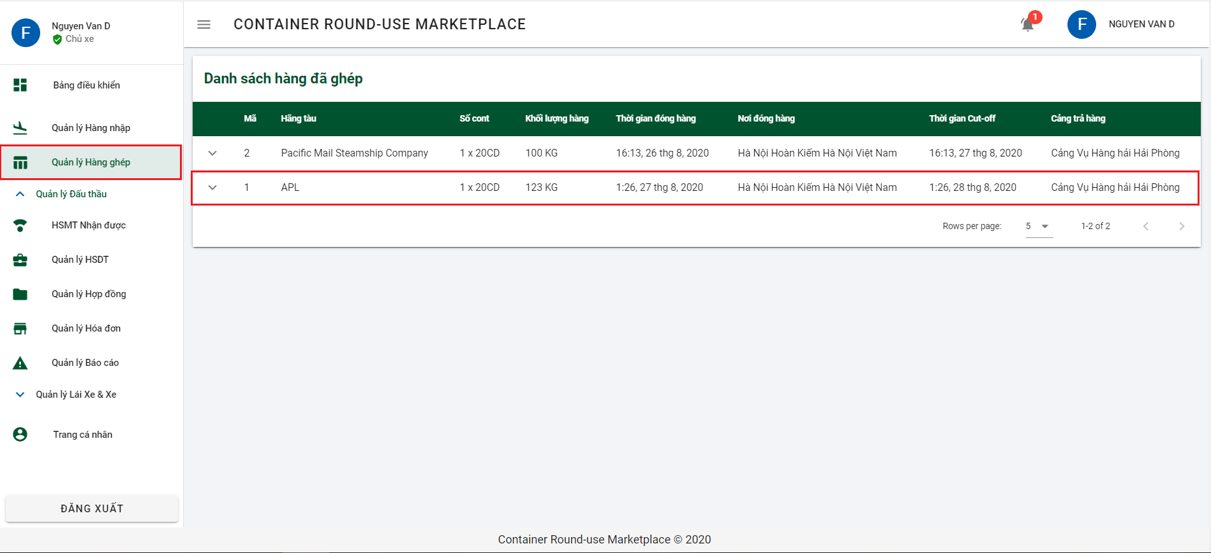

Step 2: Click on “CHI TIẾT” to navigate to combined detail.

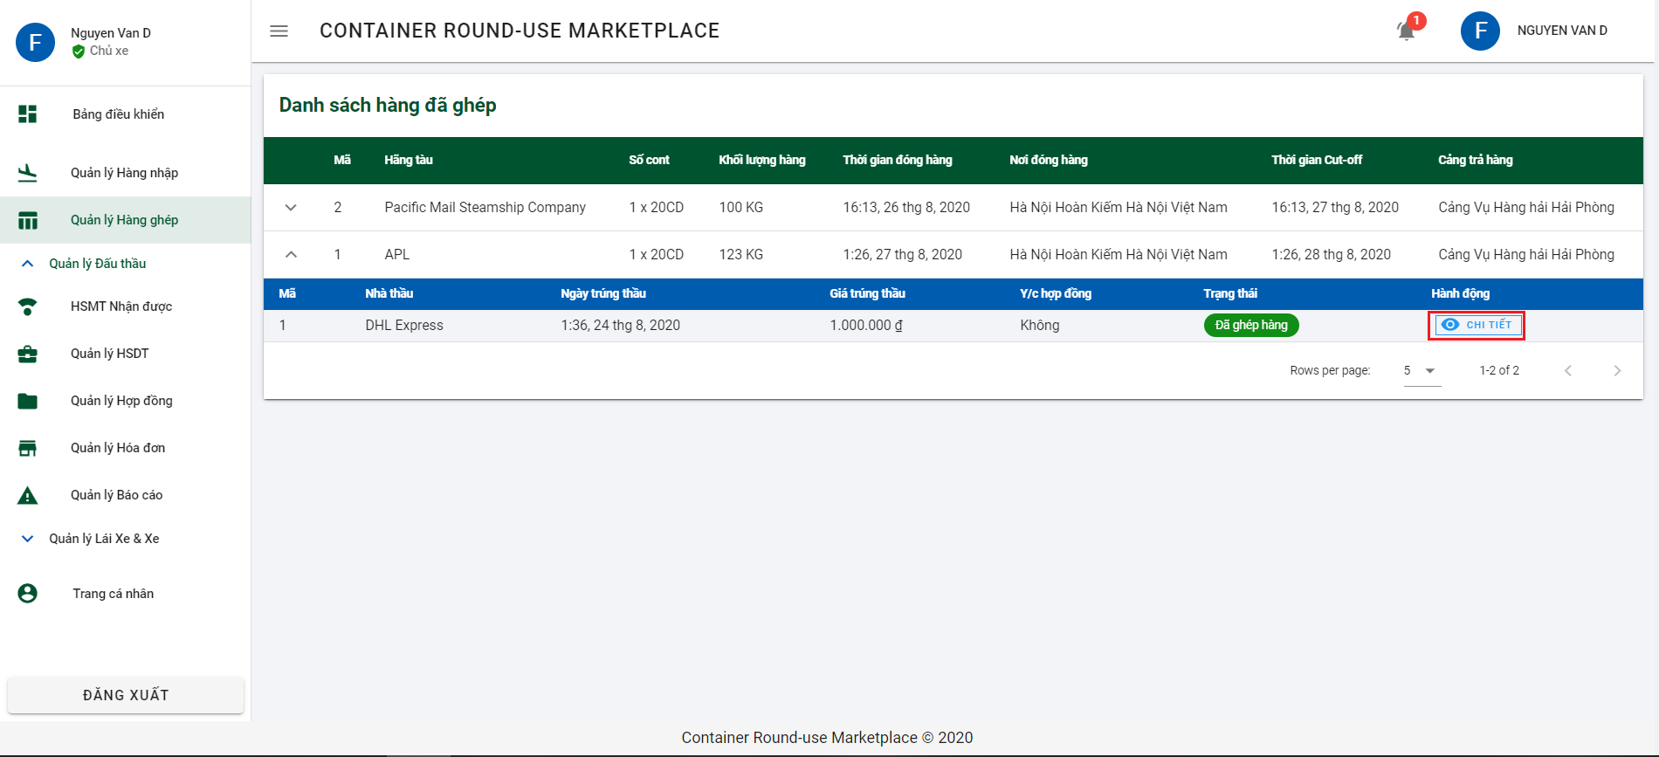

Step 3: Click on 3 dots of container you want to update shipping status.

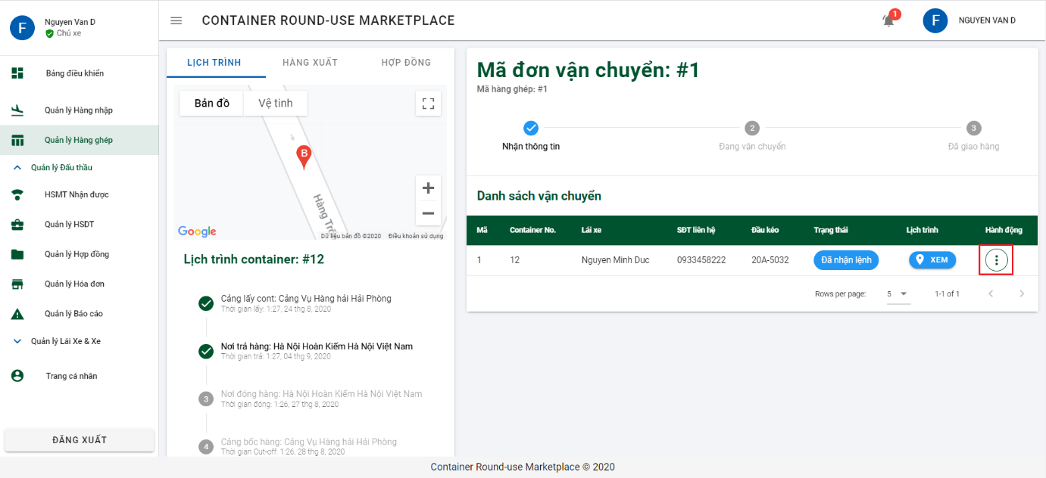

Step 4: Click on “Cập nhật trạng thái” to open update dialog.

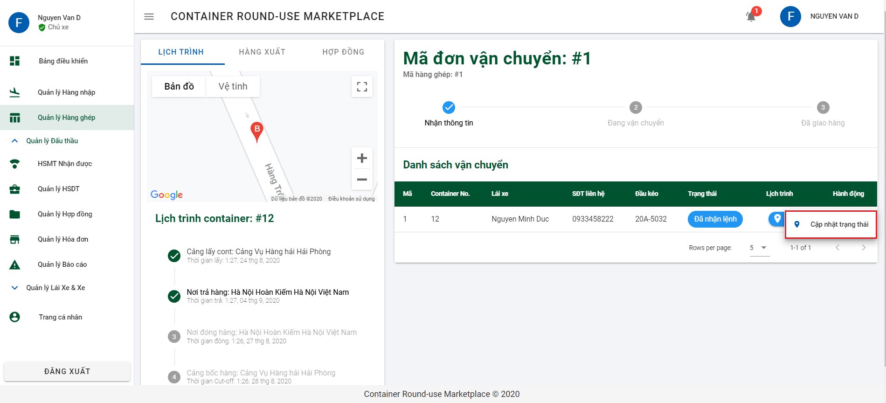

Step 5: Choose the right status on “Trạng thái đơn vị vận chuyển” and click on button “CẬP NHẬT TRẠNG THÁI” to update status.

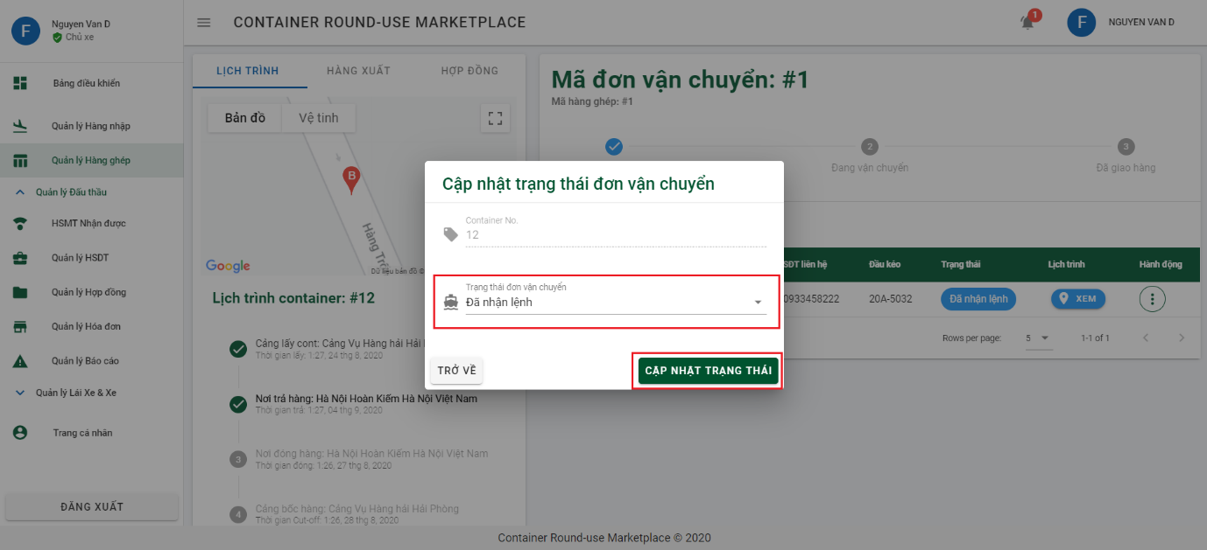

6.2.3.4 Declare invoice

Step 1: Click on “Quản lý hợp đồng” on side bar and then click on 3 dots on contract you want to declare invoice.

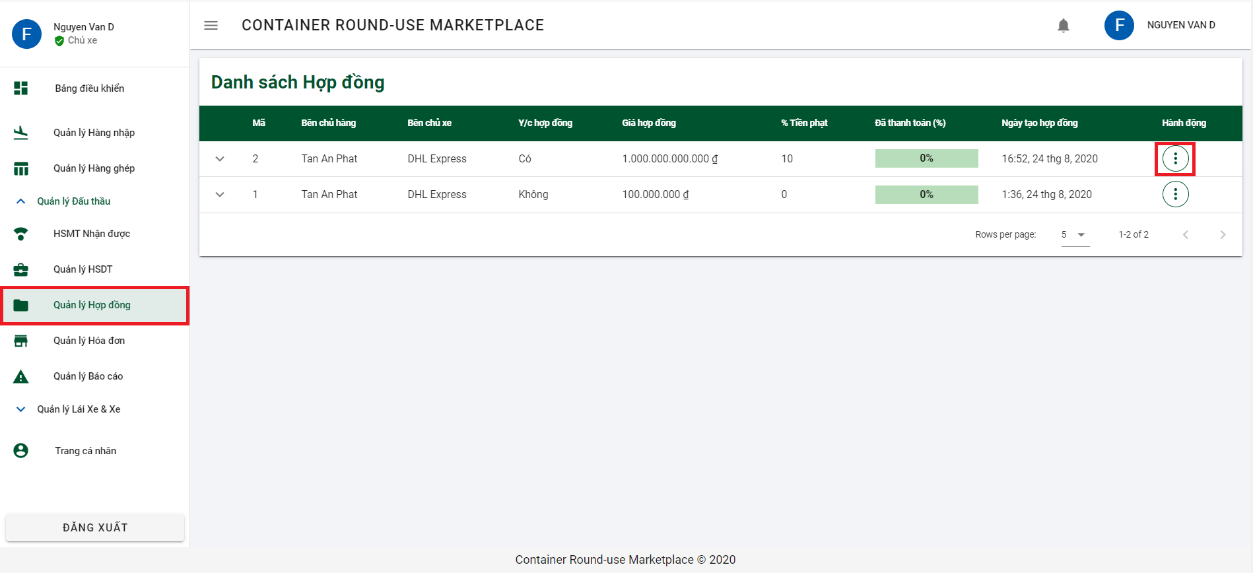

Step 2: Click on “Tạo hóa đơn” to open dialog Declare invoice.

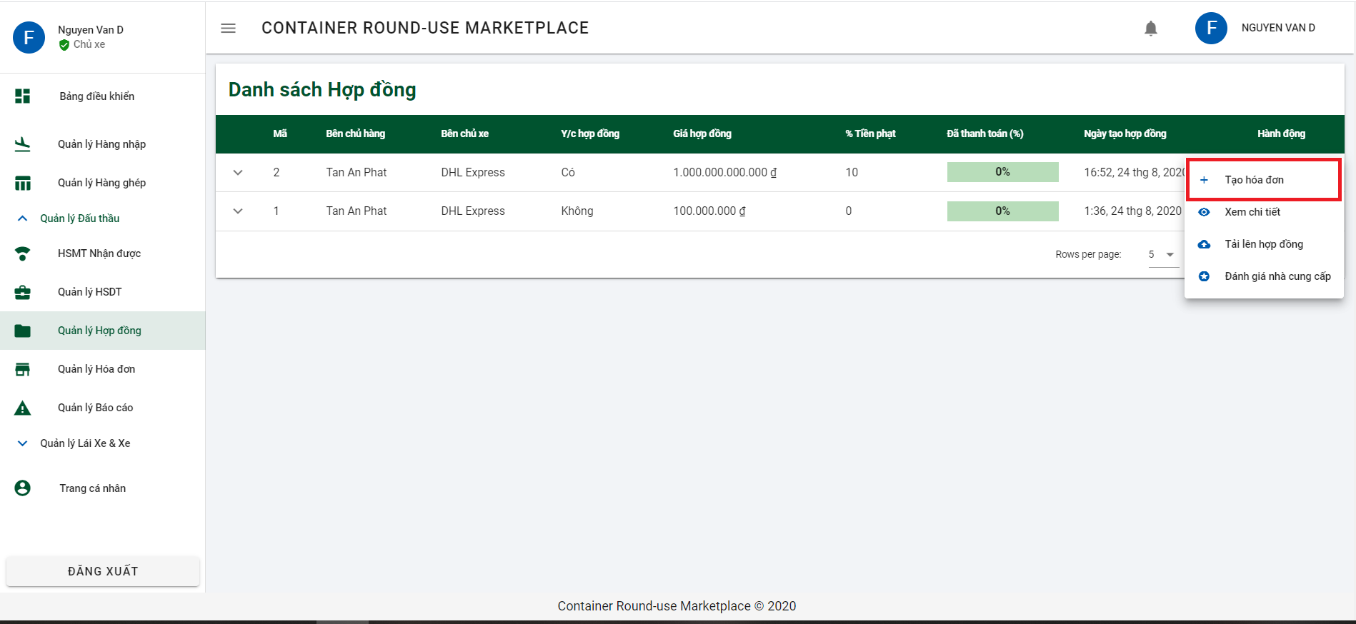

Step 3: Input all required information and click button “THÊM MỚI” to declare invoice.

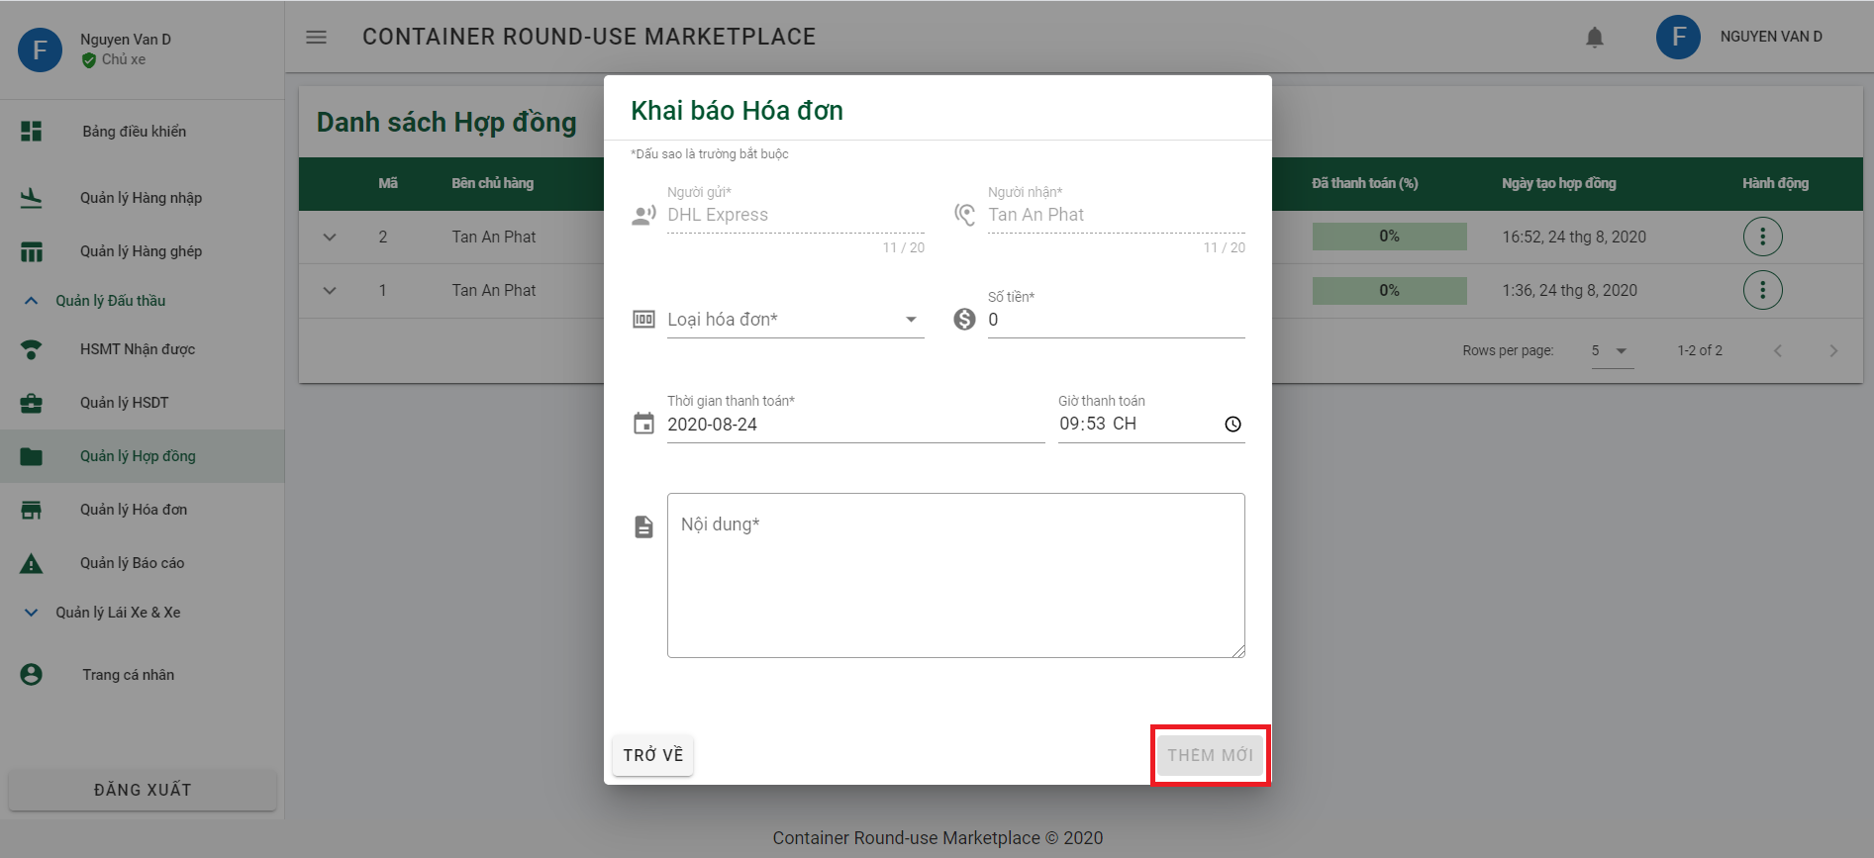

6.2.3.5 Upload file contract

Step 1: Click on “Quản lý hợp đồng” on side bar and then click on 3 dots on contract you want to declare invoice.



Step 2: Click on “Tải lên hợp đồng” to open dialog upload contract file.

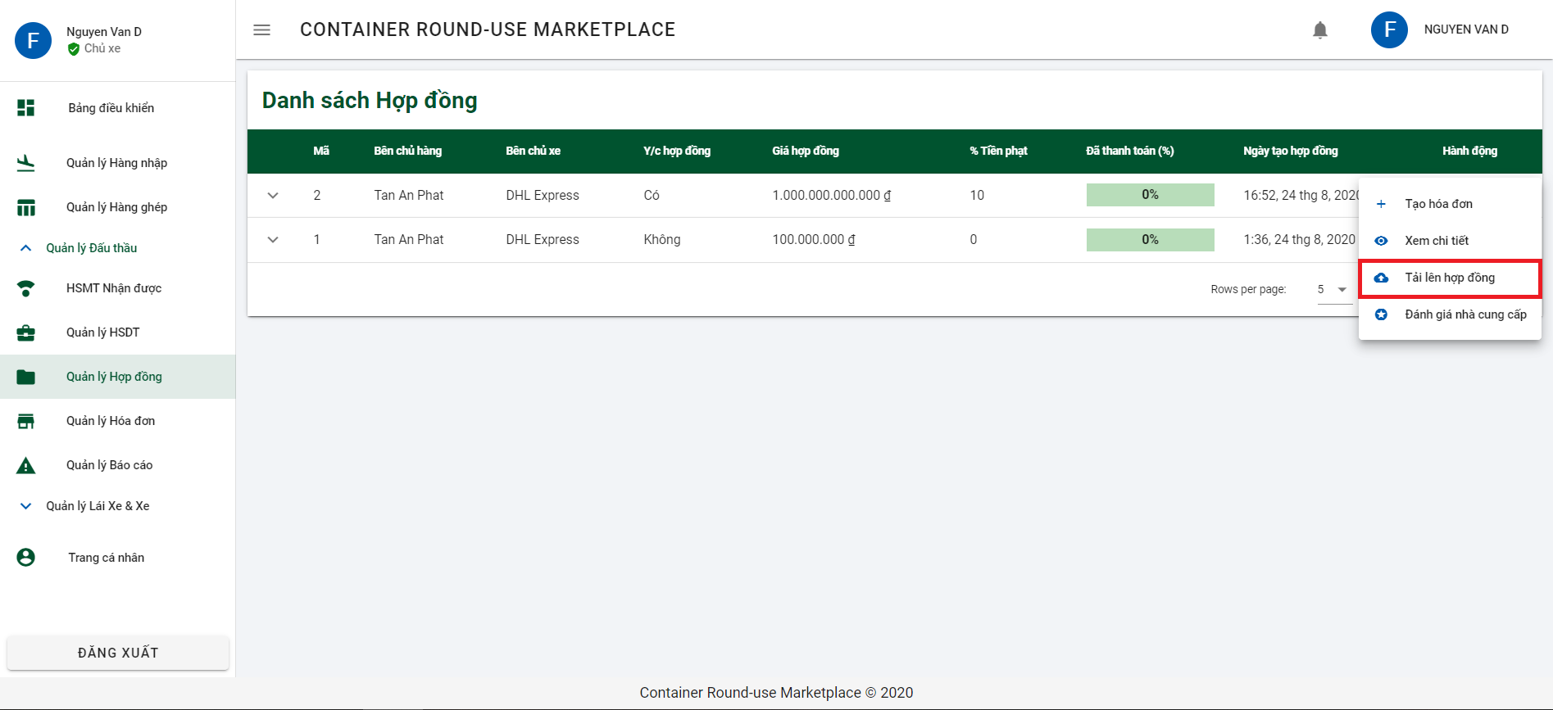

Step 3: Click on field “Hợp đồng” to upload contract file and then click on button “GỬI HỢP ĐỒNG” to send contract file.

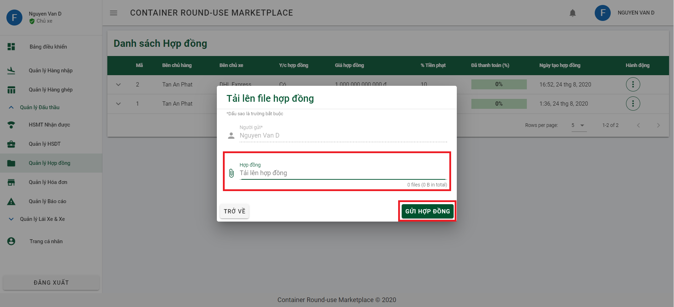

6.2.3.6 Rate supplier

Step 1: Click on “Quản lý hợp đồng” on side bar and then click on 3 dots on contract you want to declare invoice.



Step 2: Click on “Đánh giá nhà cung cấp” to open dialog Rating supplier.

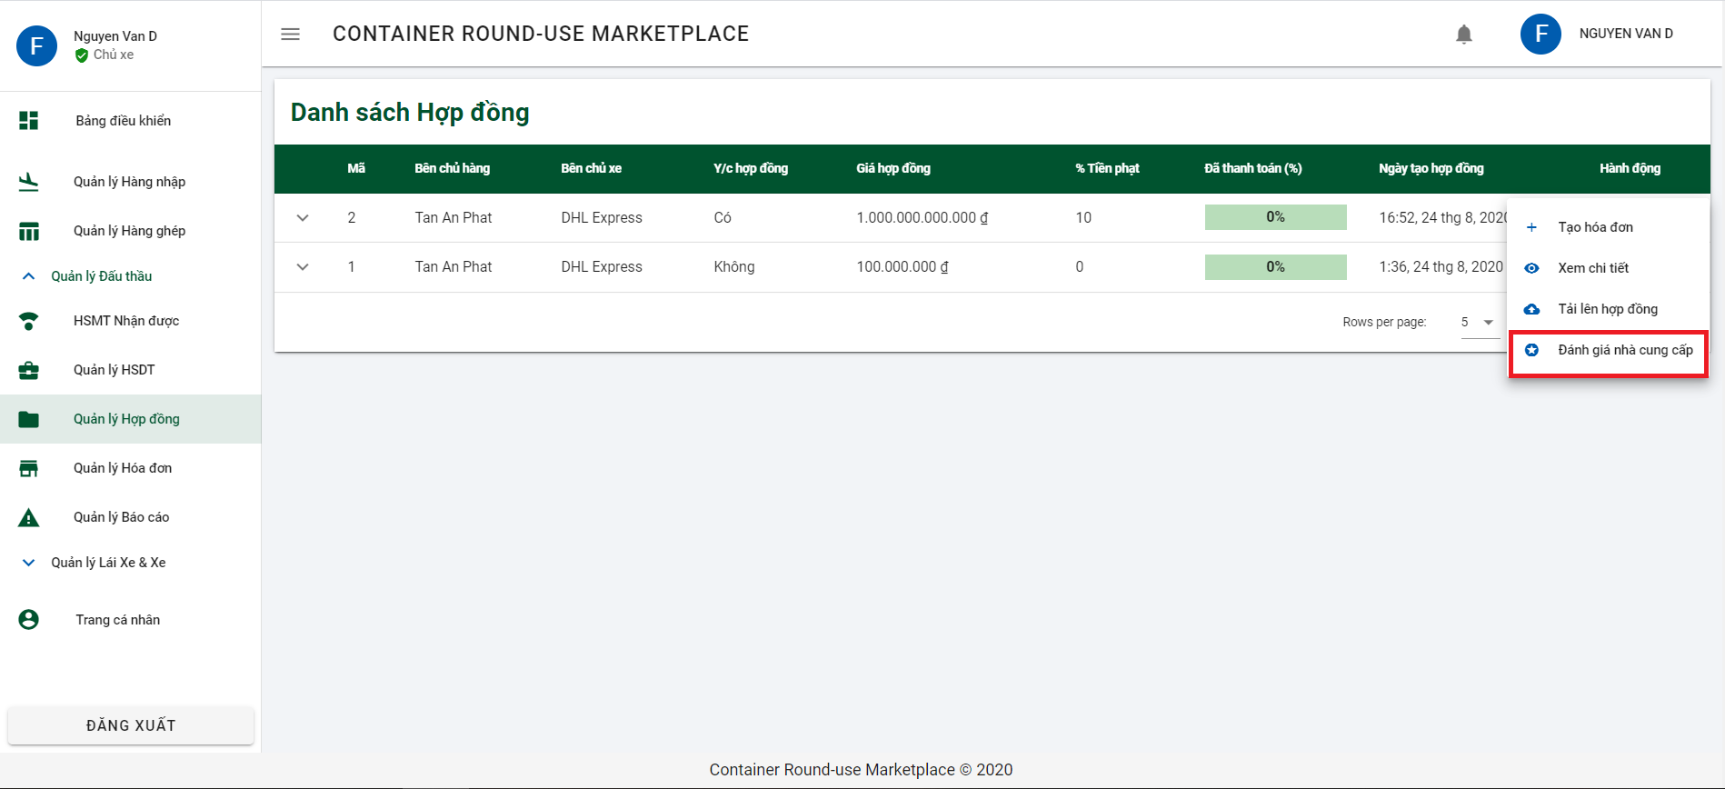

Step 3: Rate by choosing the corresponding number of stars and click button “ĐÁNH GIÁ” to rate supplier.

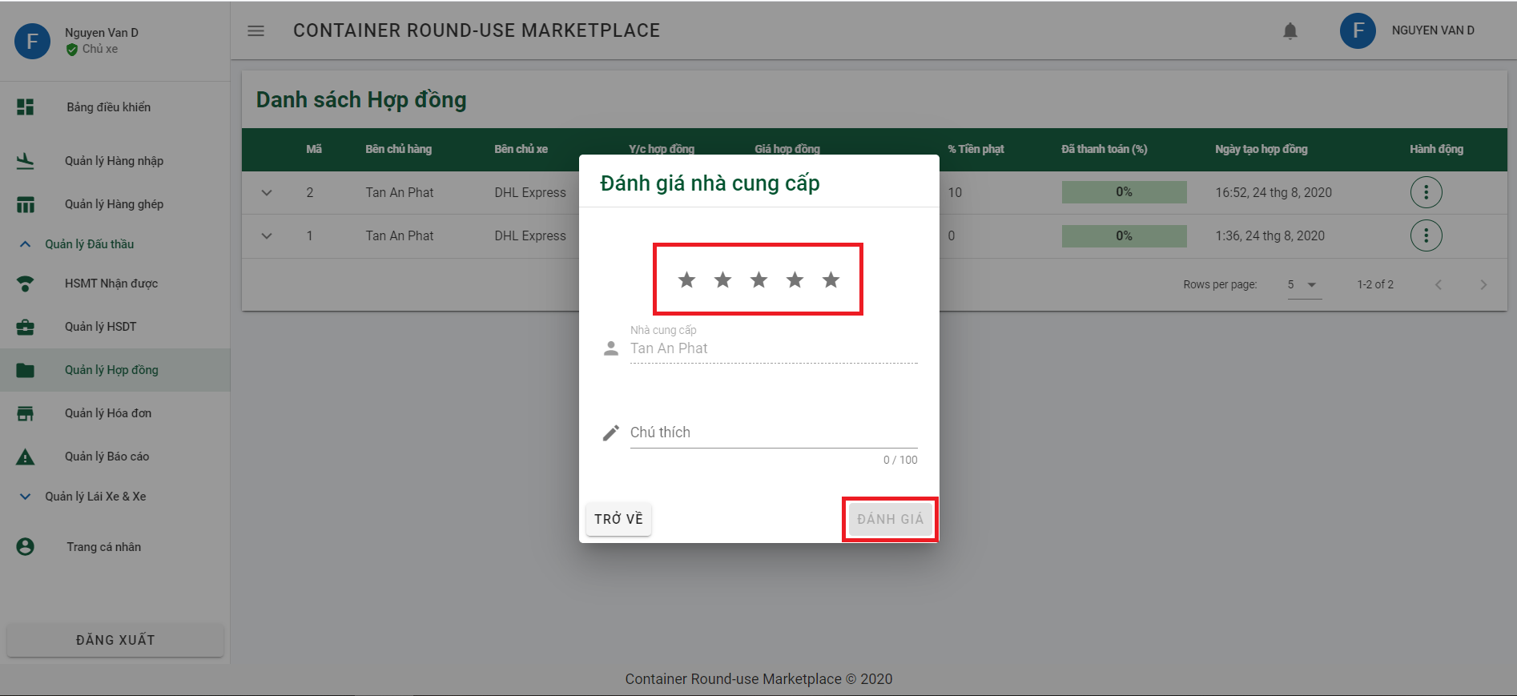

6.2.3.7 Add new Driver

Step 1: Click on “Quản lý Lái Xe & Xe” and then “Quản lý lái xe”. And click on button “THÊM MỚI” to open add driver dialog.

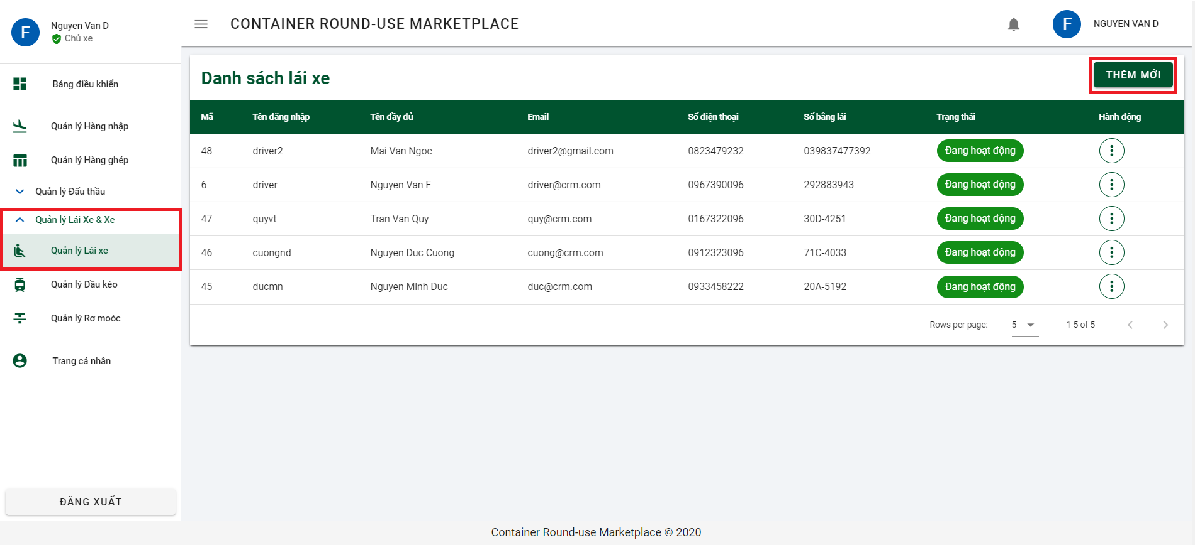

Step 2: Input all required information and click on button “THÊM MỚI” to add new driver.

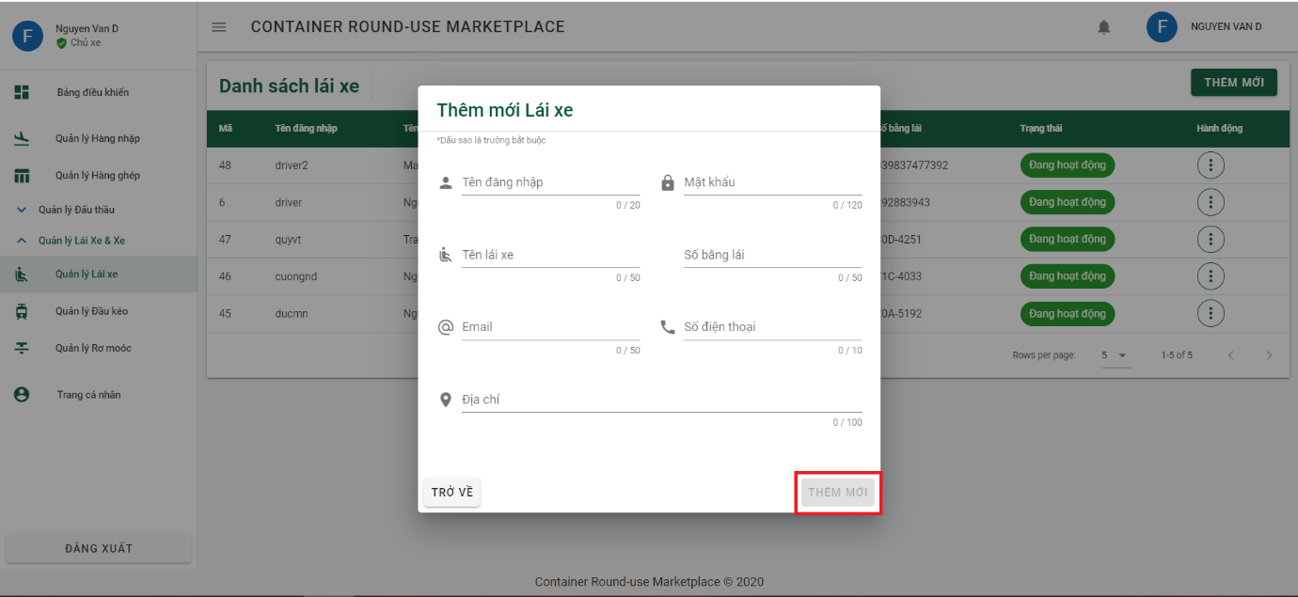

6.2.3.8 Add new Tractor

Step 1: Click on “Quản lý Đầu kéo” from sidebar and click on button “THÊM MỚI” to open dialog add new tractor.

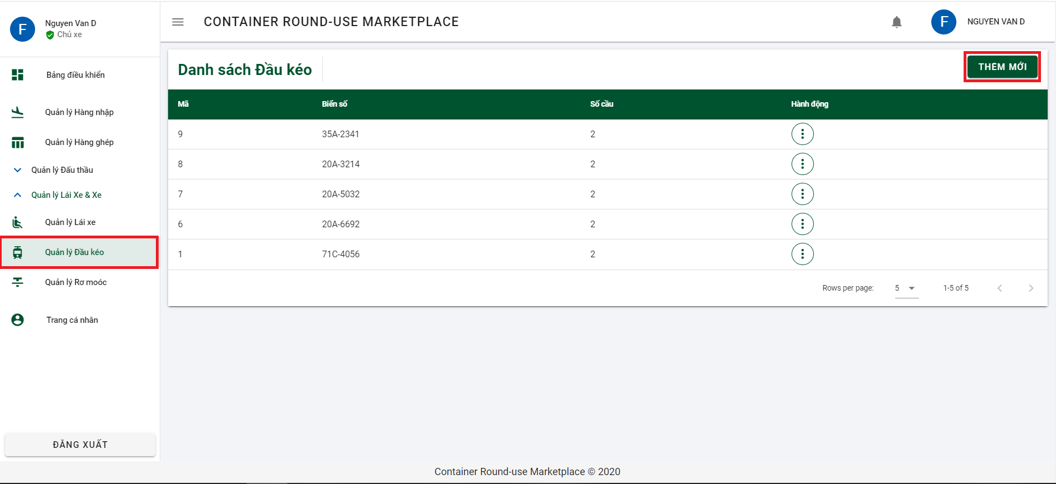

Step 2: Input all requirement information and click button “THÊM MỚI” to add new tractor.

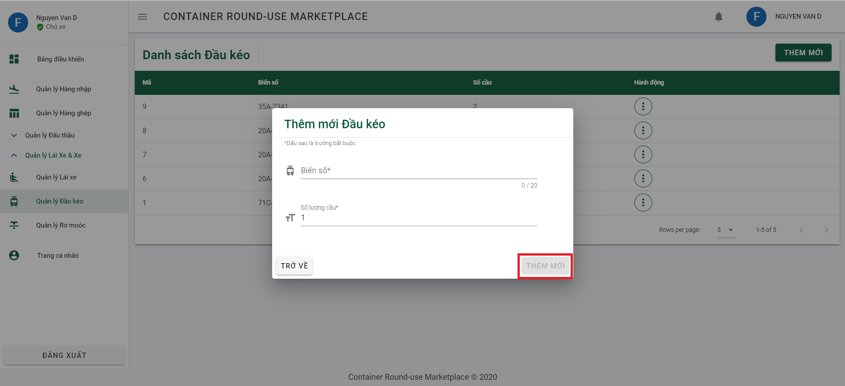

6.2.3.8 Add new Tractor

Step 1: Click on “Quản lý Rơ Moóc” from sidebar and click on button “THÊM MỚI” to open dialog add new Semi trailer.

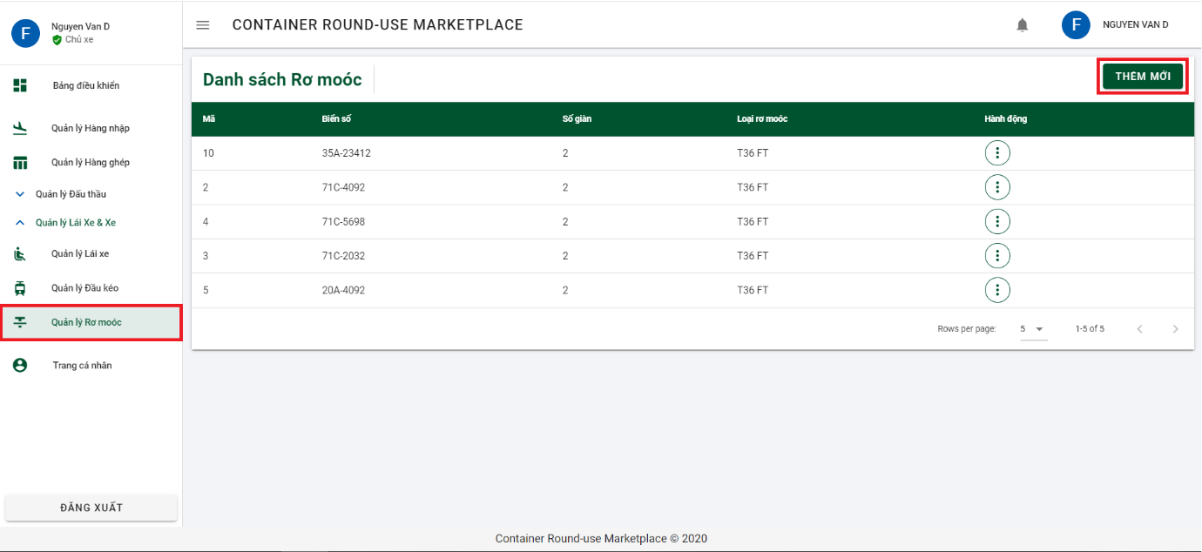

Step 2: Input all requirement information and click button “THÊM MỚI” to add new semi trailer.

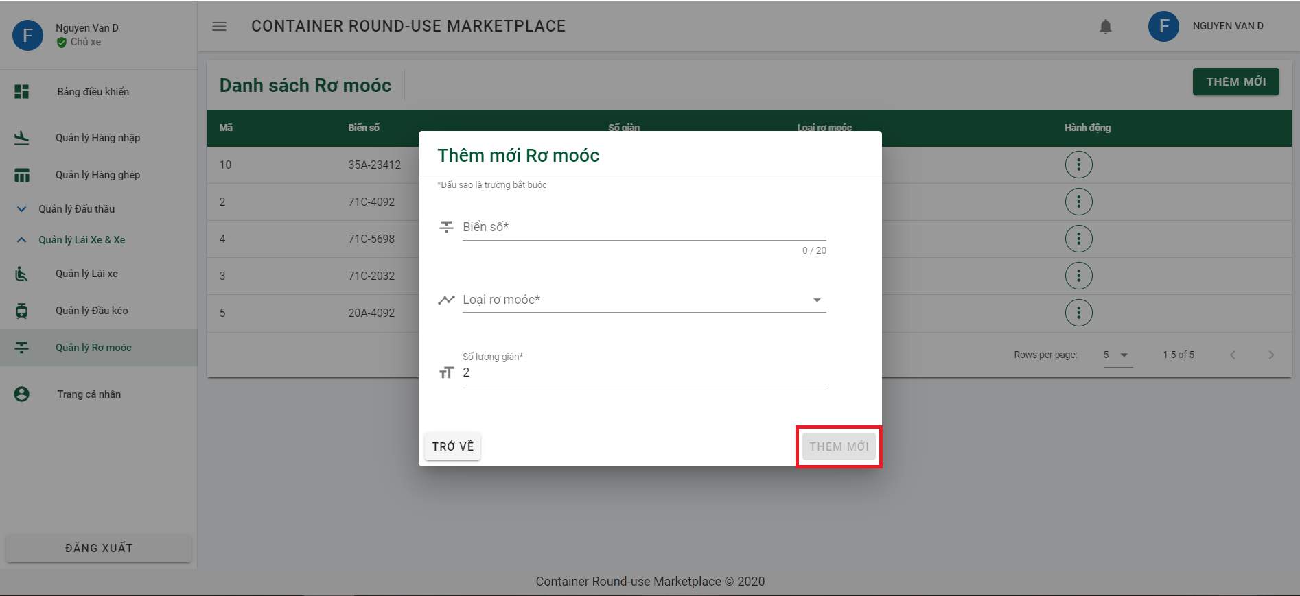

### 6.2.4 Admin function

6.2.4.1 Add new Admin/ Moderator

Step 1: Click on “Quản lý Quản trị viên” from sidebar and click on button “THÊM MỚI” to open dialog add new admin or moderator.

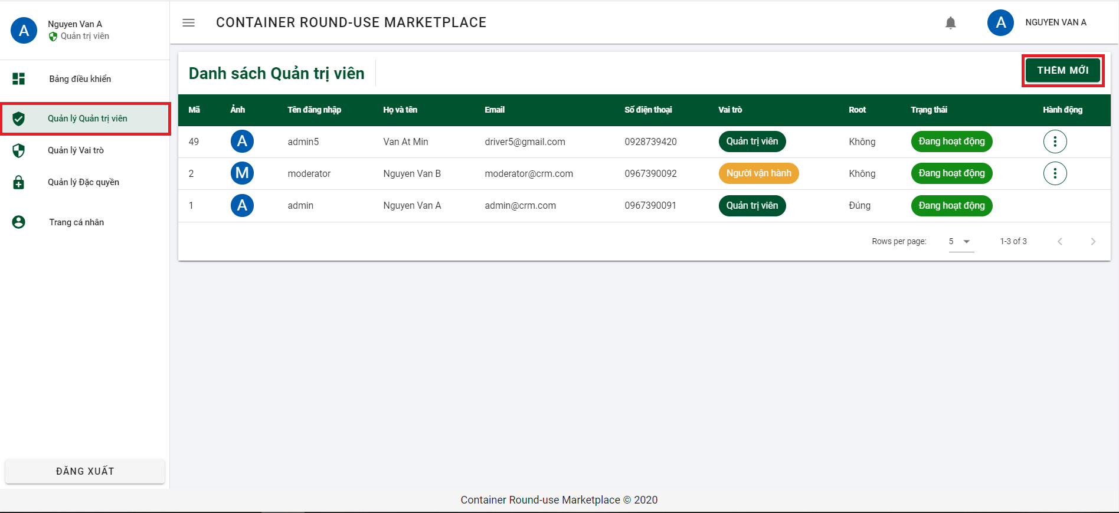

Step 2: Input all requirement information, choose role to added and click button “THÊM MỚI” to add new admin or moderator

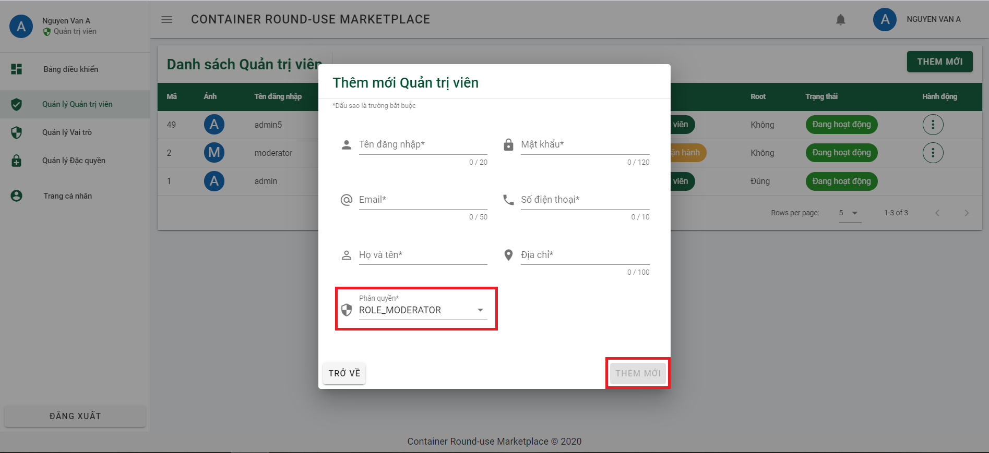

6.2.4.2 Add new Role

Step 1: Click on “Quản lý Vai trò” from sidebar and click on button “THÊM MỚI” to open dialog add new role.

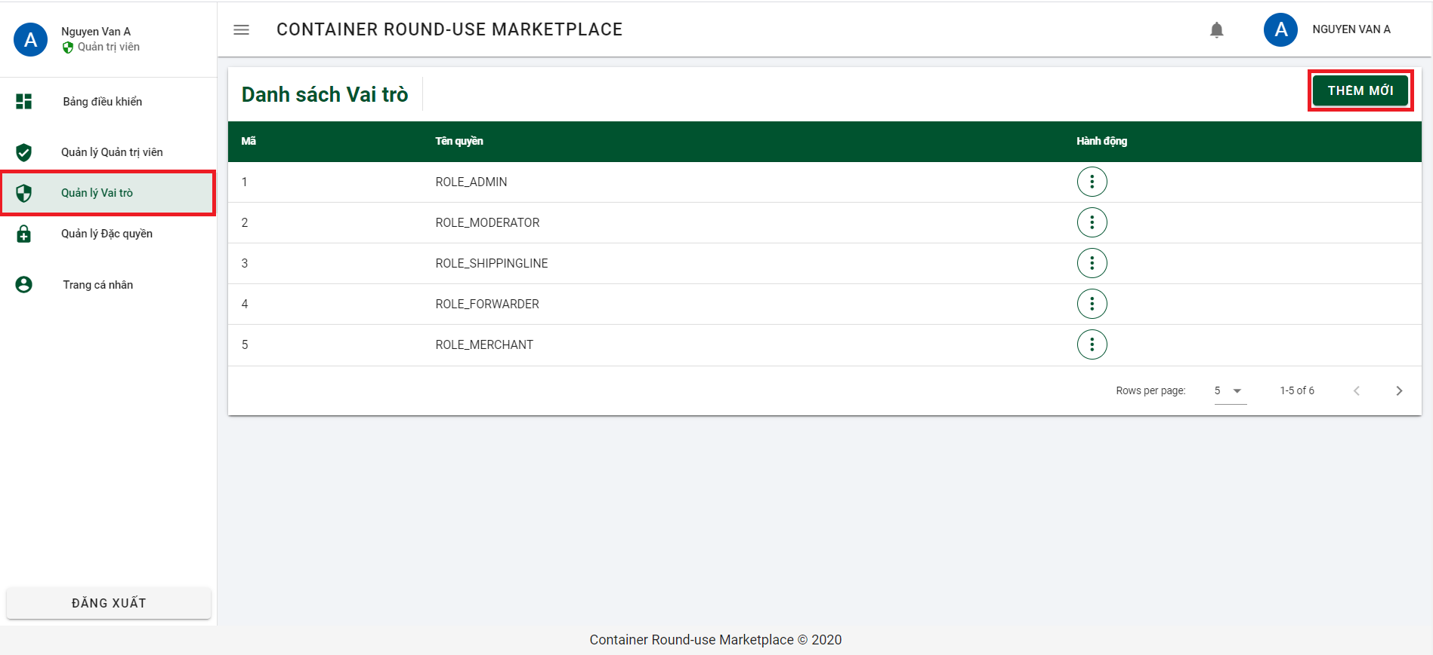

Step 2: Input all requirement information, choose permission for role and click button “THÊM MỚI” to add new role.

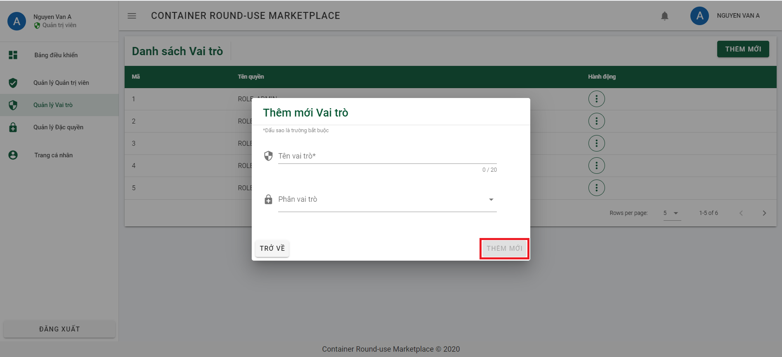

6.2.4.3 Add new Permission

Step 1: Click on “Quản lý Đặc quyền” from sidebar and click on button “THÊM MỚI” to open dialog add new permission.

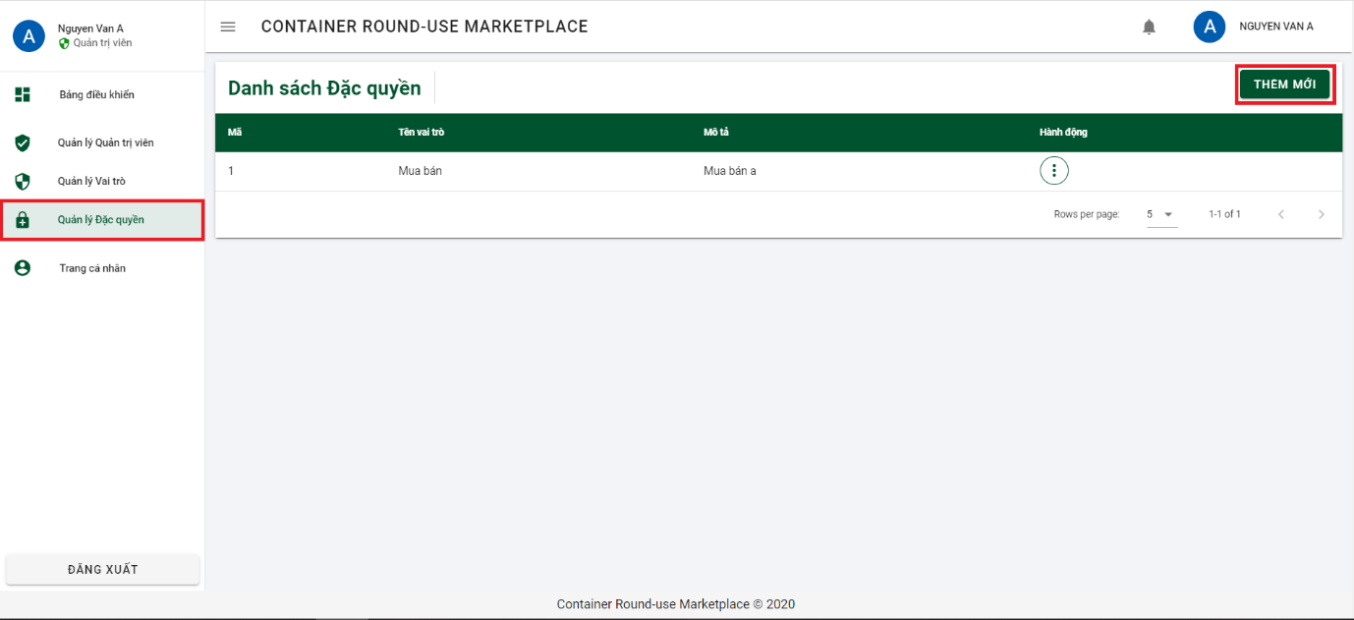

Step 2: Input all requirement information, click button “THÊM MỚI” to add new permission.

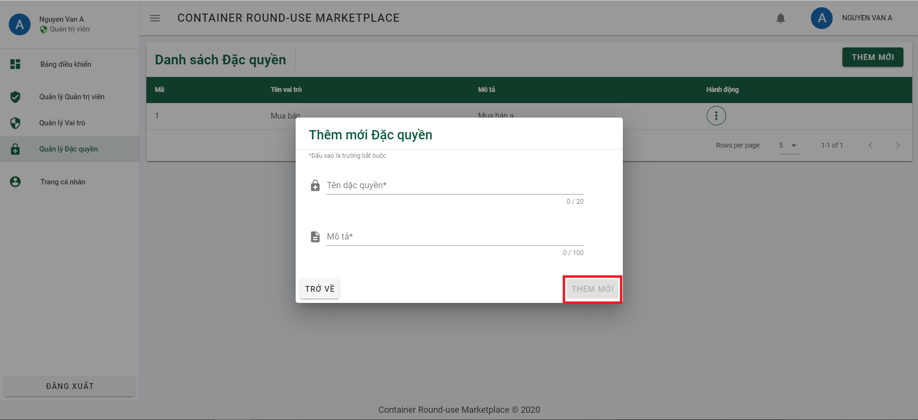

### 6.2.5 Moderator function

6.2.5.1 Approve the registration form

Step 1: Click on “Quản lý Đơn đăng ký” from side bar. And then click on 3 dots of registration form you want to approve.

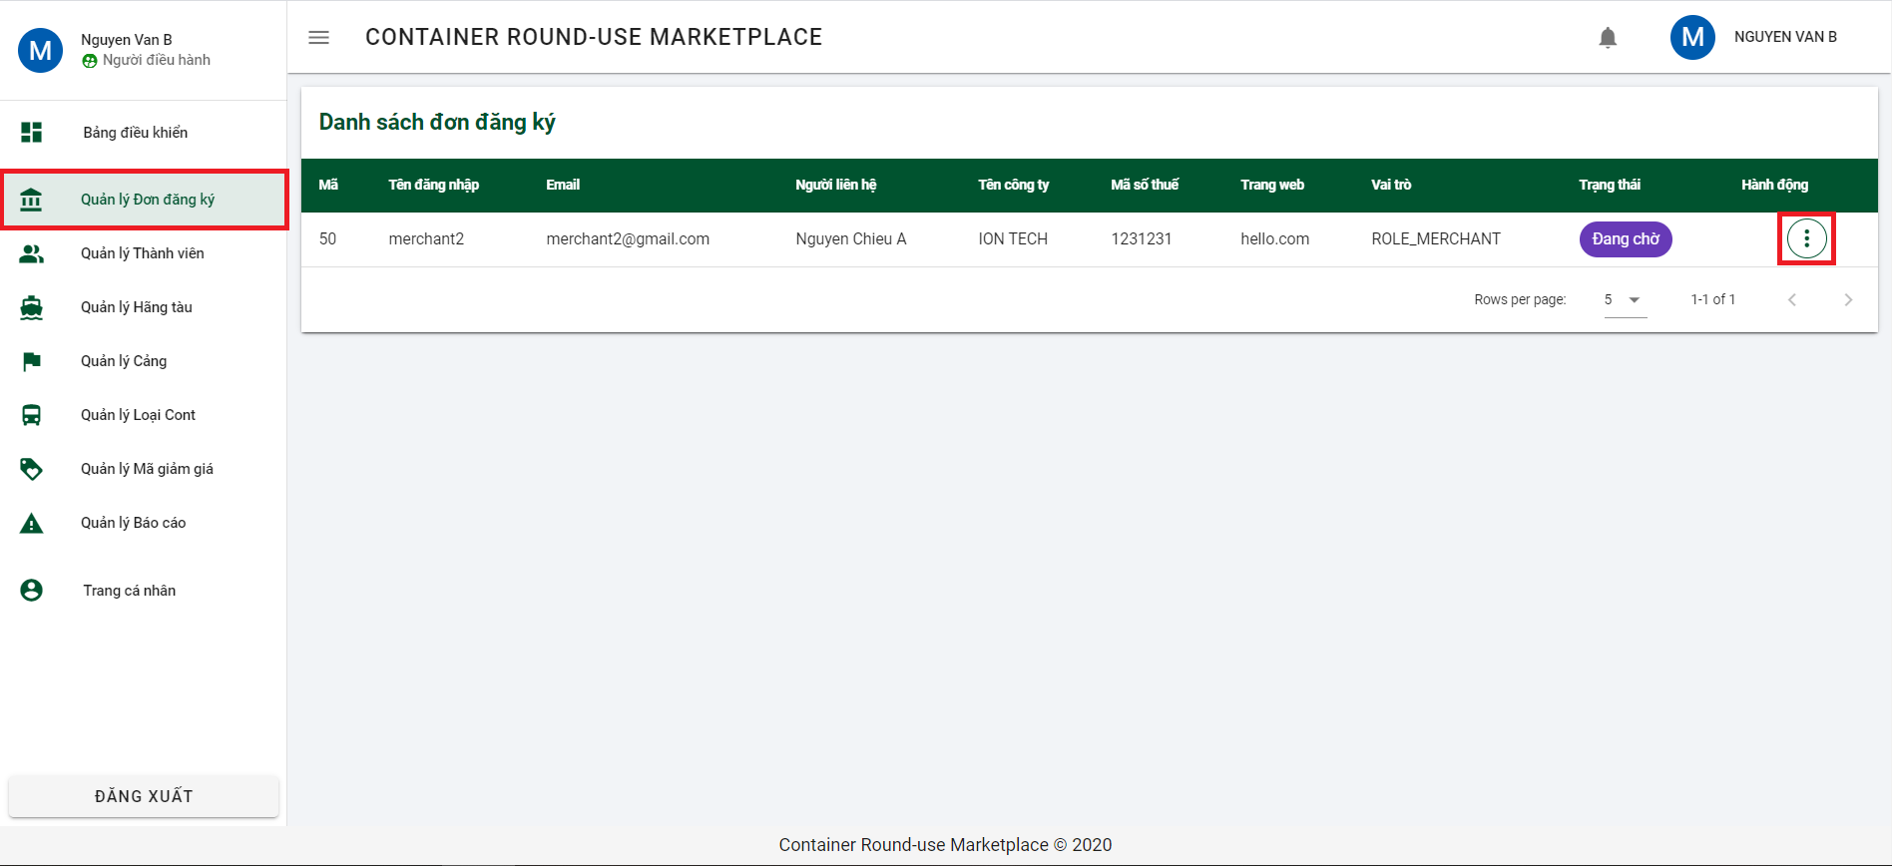

Step 2: Click “Xem chi tiết” to see detail and click “Đồng ý đơn” to open dialog to approve it.

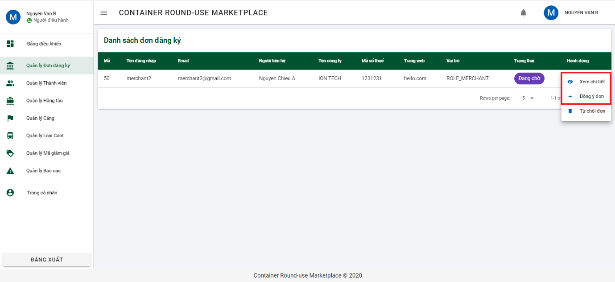

Step 3: Click on button “ĐỒNG Ý” to approve form.

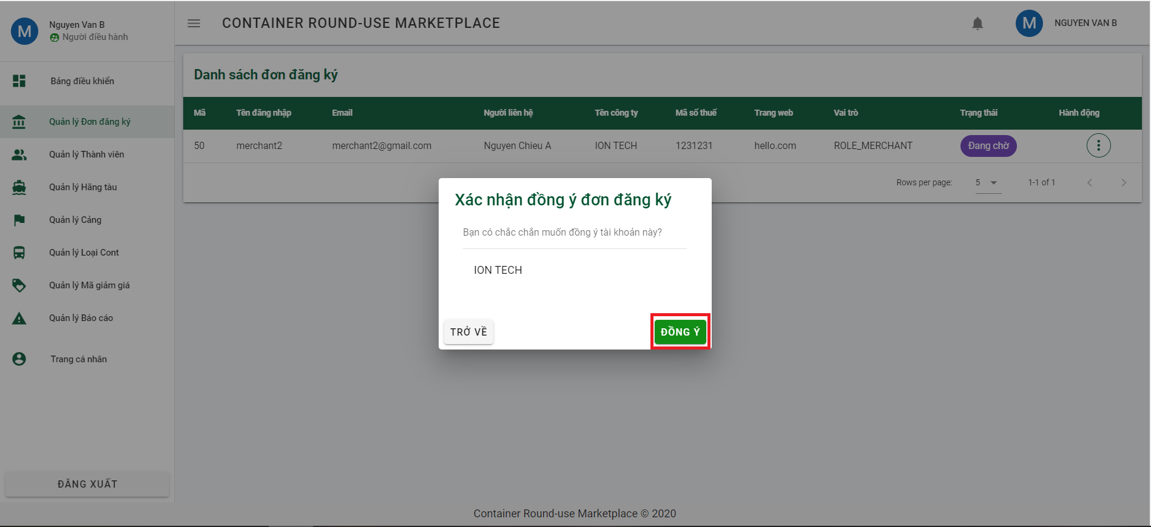

6.2.5.2 Lock user

Step 1: Click on “Quản lý Thành viên” from side bar. And then click on 3 dots of user you want to lock.

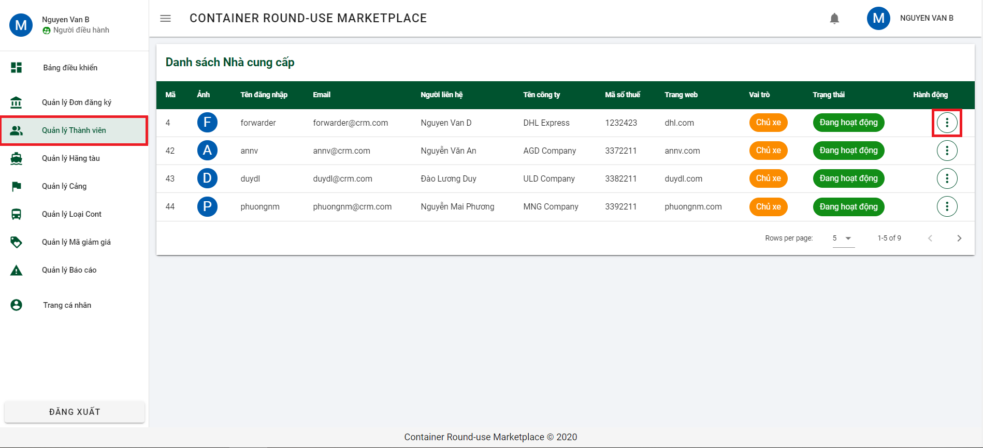

Step 2: Click “Xem chi tiết” to see detail and click “Khóa tài khoản” to open dialog to lock it.

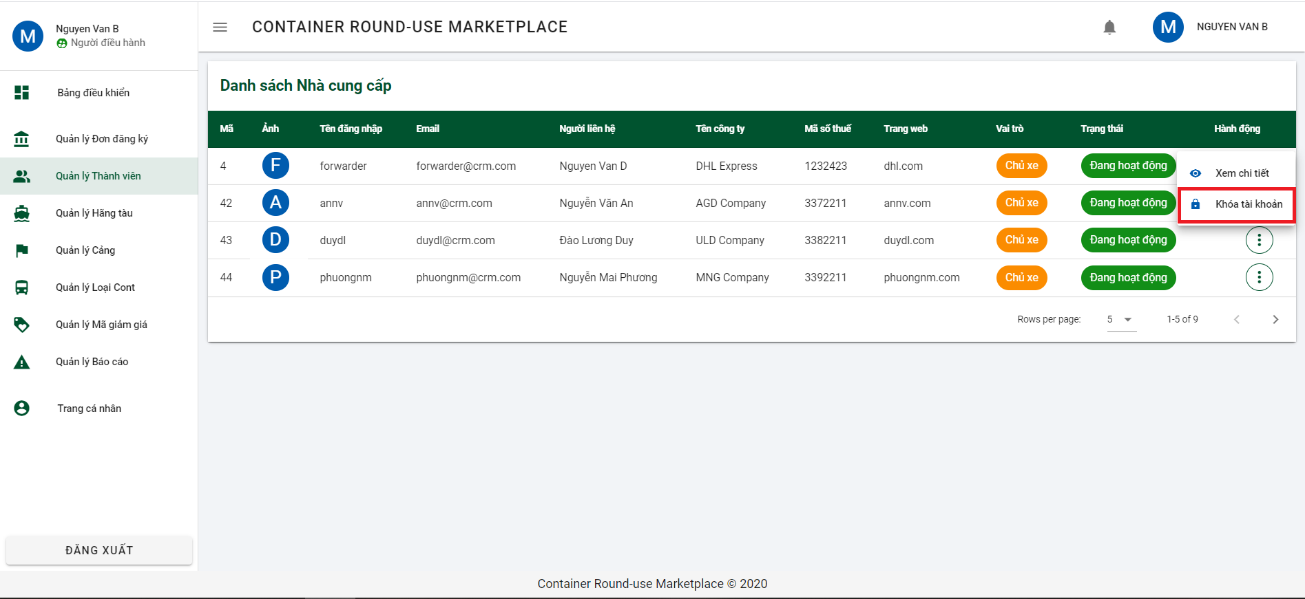

Step 3: Click on button “KHÓA TÀI KHOẢN” to lock user.

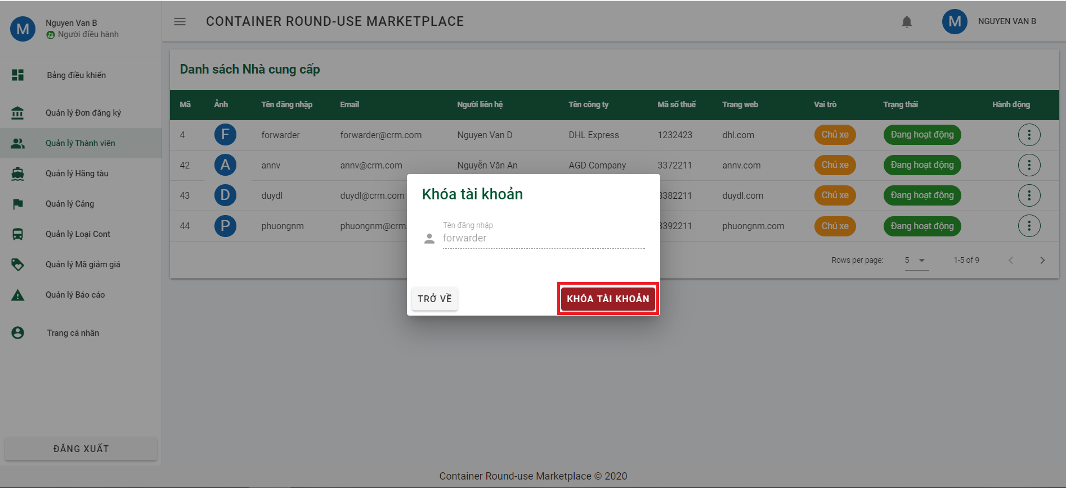

6.2.5.3 Declare shipping line

Step 1: Click on “Quản lý hãng tàu” from side bar to navigate to list of shipping line page. And then click on button “THÊM MỚI” to open dialog declare shipping line.

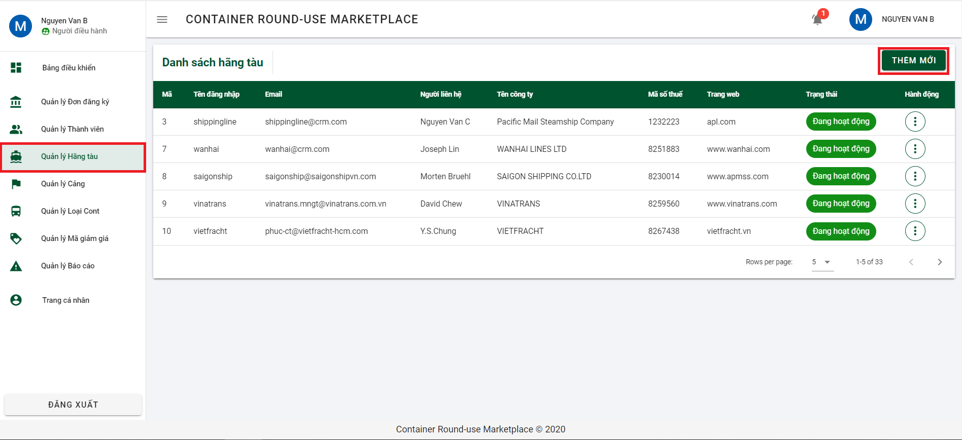

Step 2: Enter all require information and click on button “TIẾP TỤC” to go to next section.

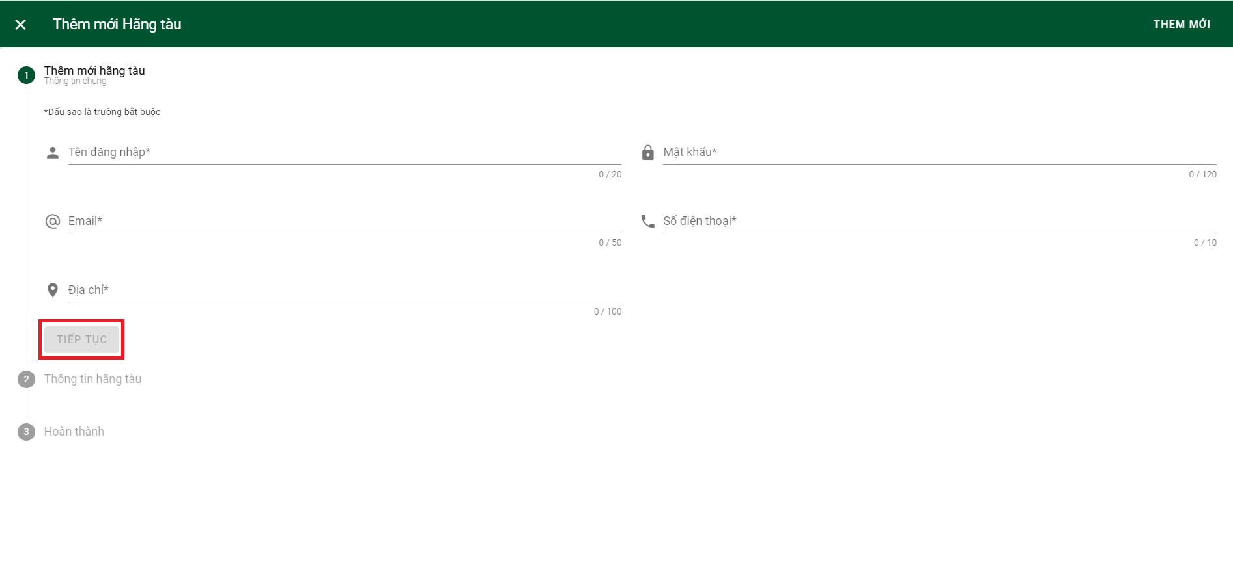

Step 3: Continue to fill in the required information in part 2 and click button “TIẾP TỤC” to go to last step.

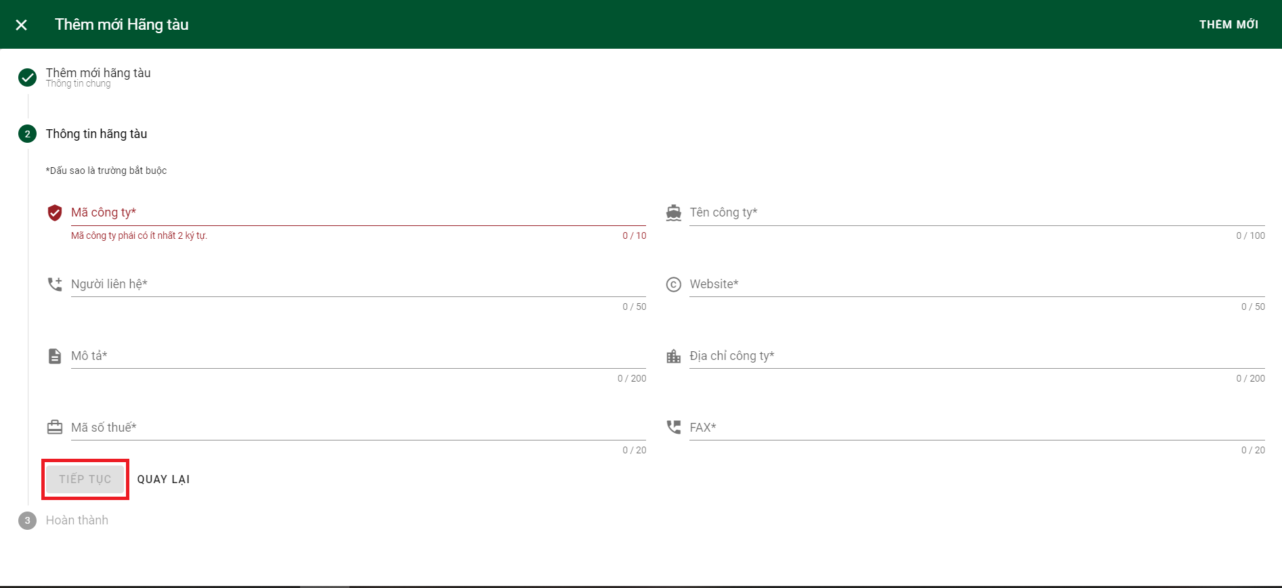

Step 4: Merchant checks the checkbox to confirm all the inputted information is real and clicks button “HOÀN TẤT” to complete declare shipping line.

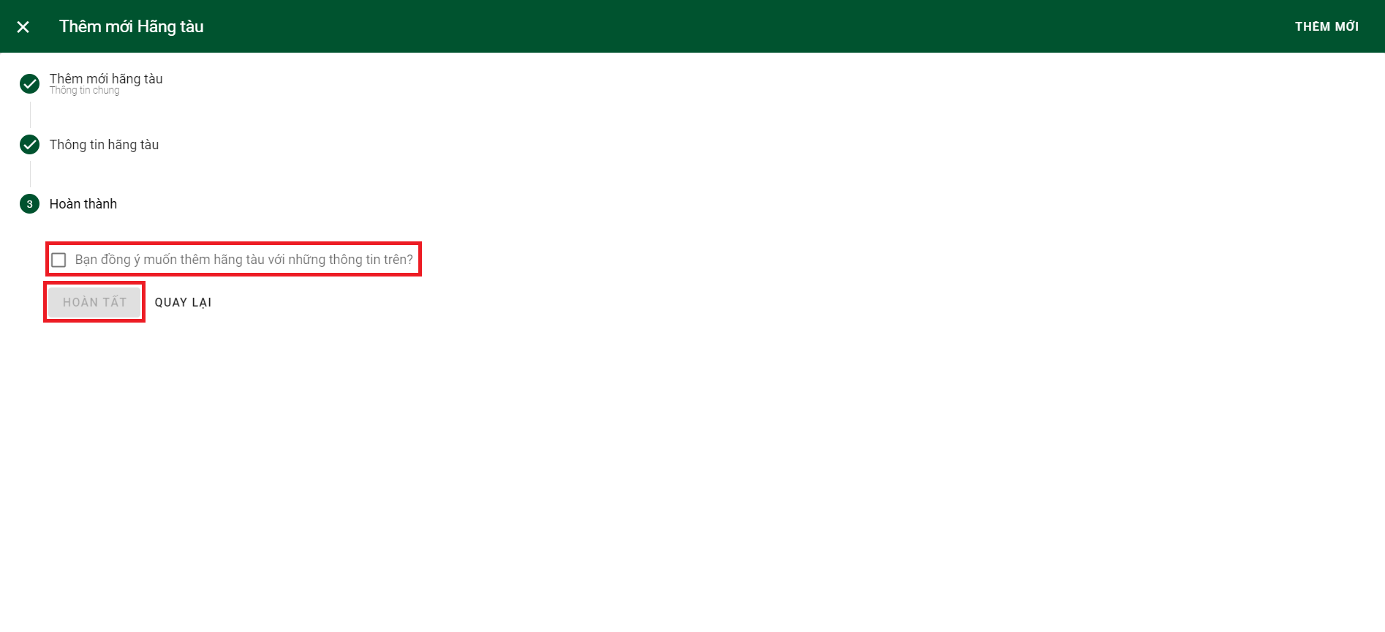

6.2.5.4 Declare port

Step 1: Click on “Quản lý Cảng” from side bar and click on button “THÊM MỚI” to open dialog declare port.

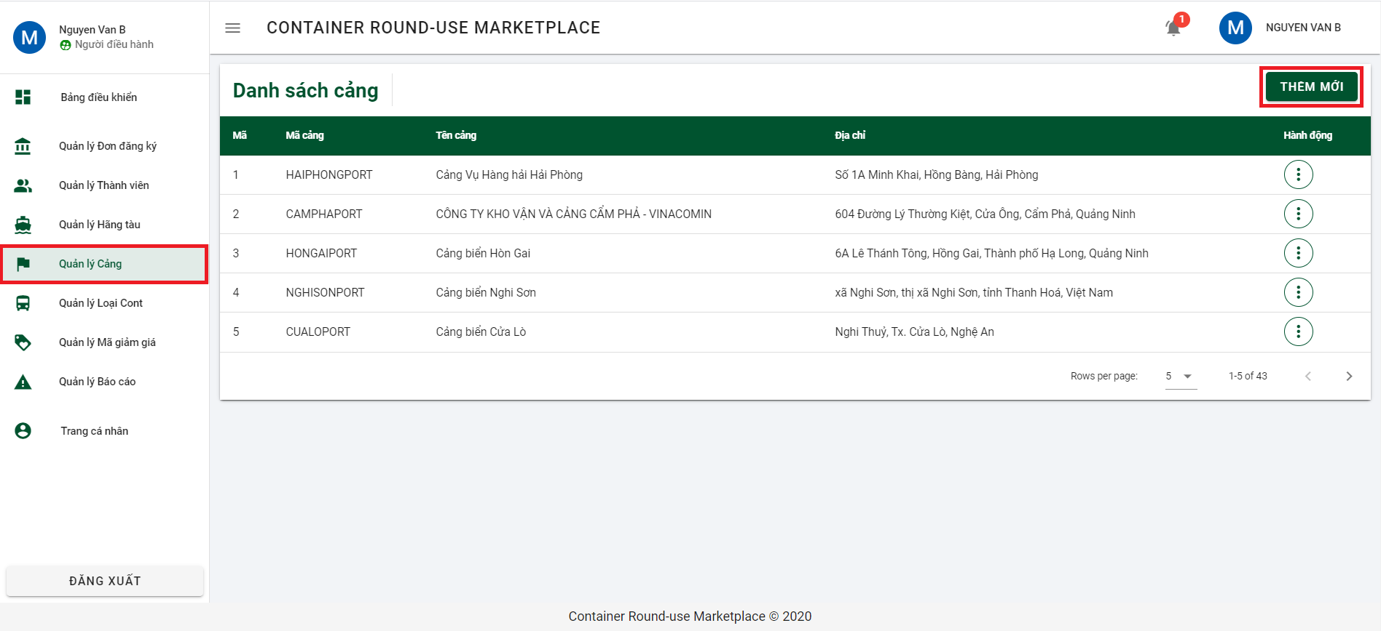

Step 2: Input all required information and click on button “THÊM MỚI” to declare port.

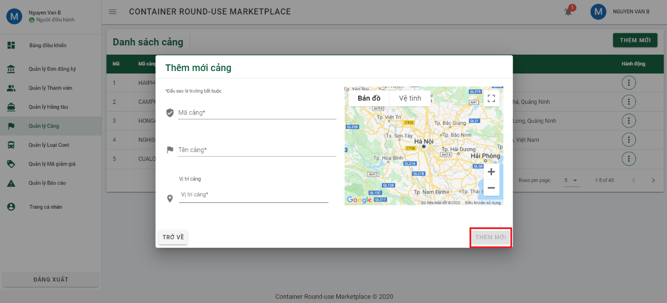

6.2.5.5 Declare container type

Step 1: Click on “Quản lý Loại Cont” from side bar and click on button “THÊM MỚI” to open dialog declare container type.

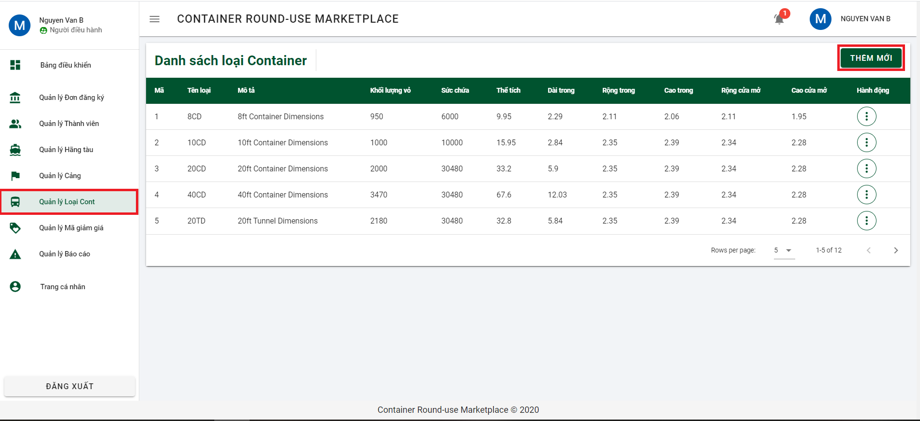

Step 2: Input all required information and click on button “THÊM MỚI” to declare container type.

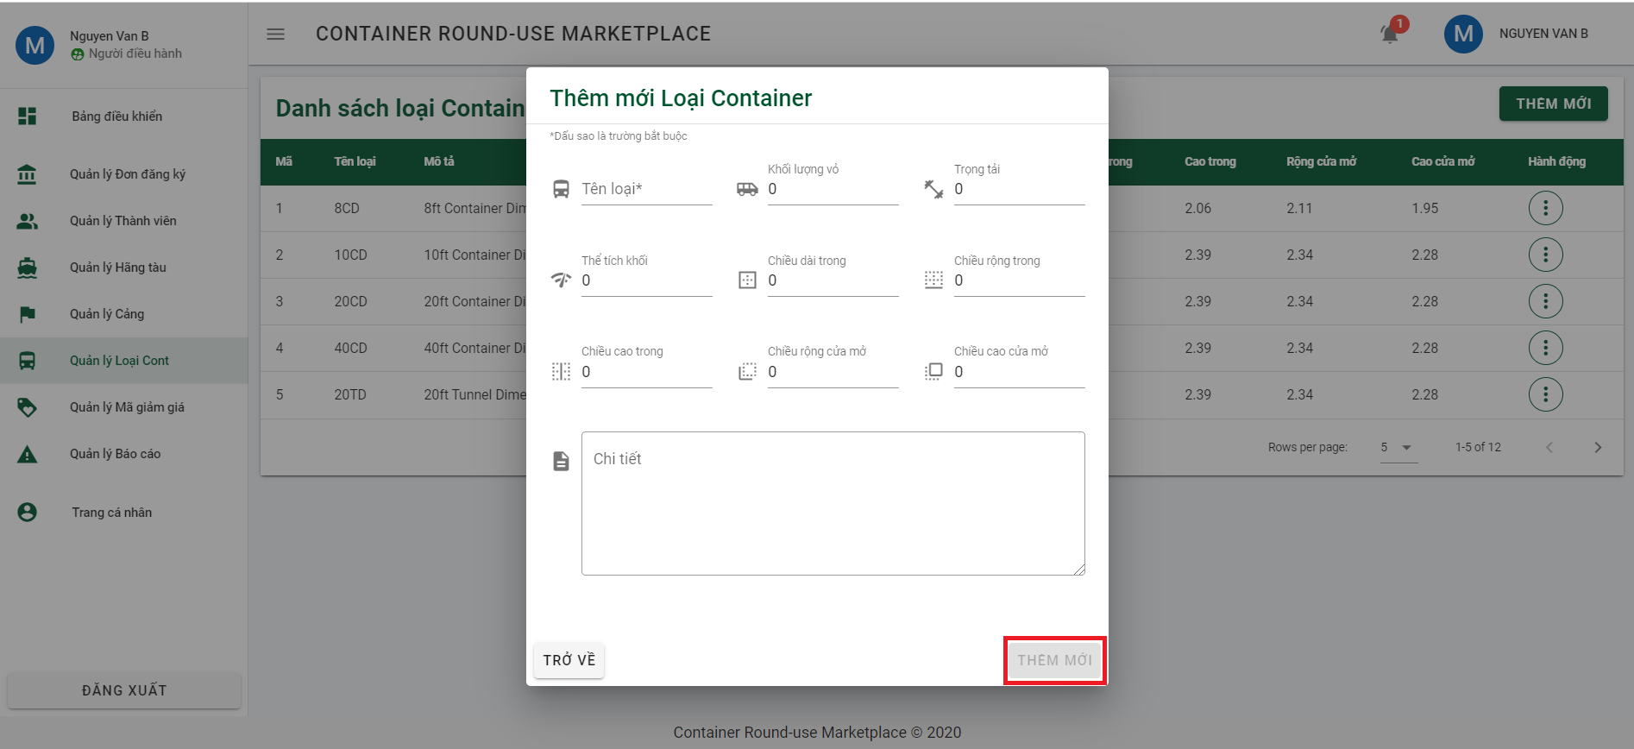

6.2.5.6 Create discount code

Step 1: Click on “Quản lý Mã giảm giá” from side bar and click on button “THÊM MỚI” to open dialog create discount code.

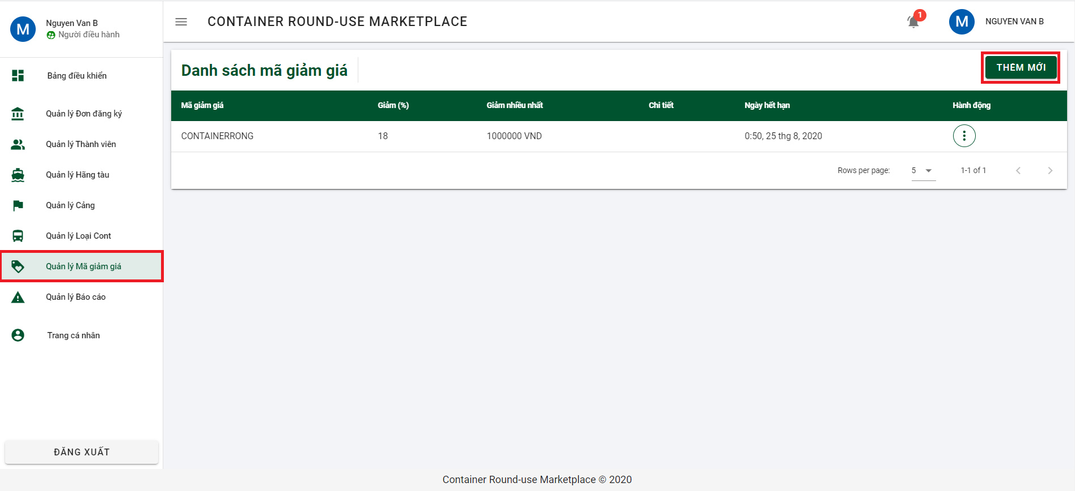

Step 2: Input all required information and click on button “THÊM MỚI” to create discount code.

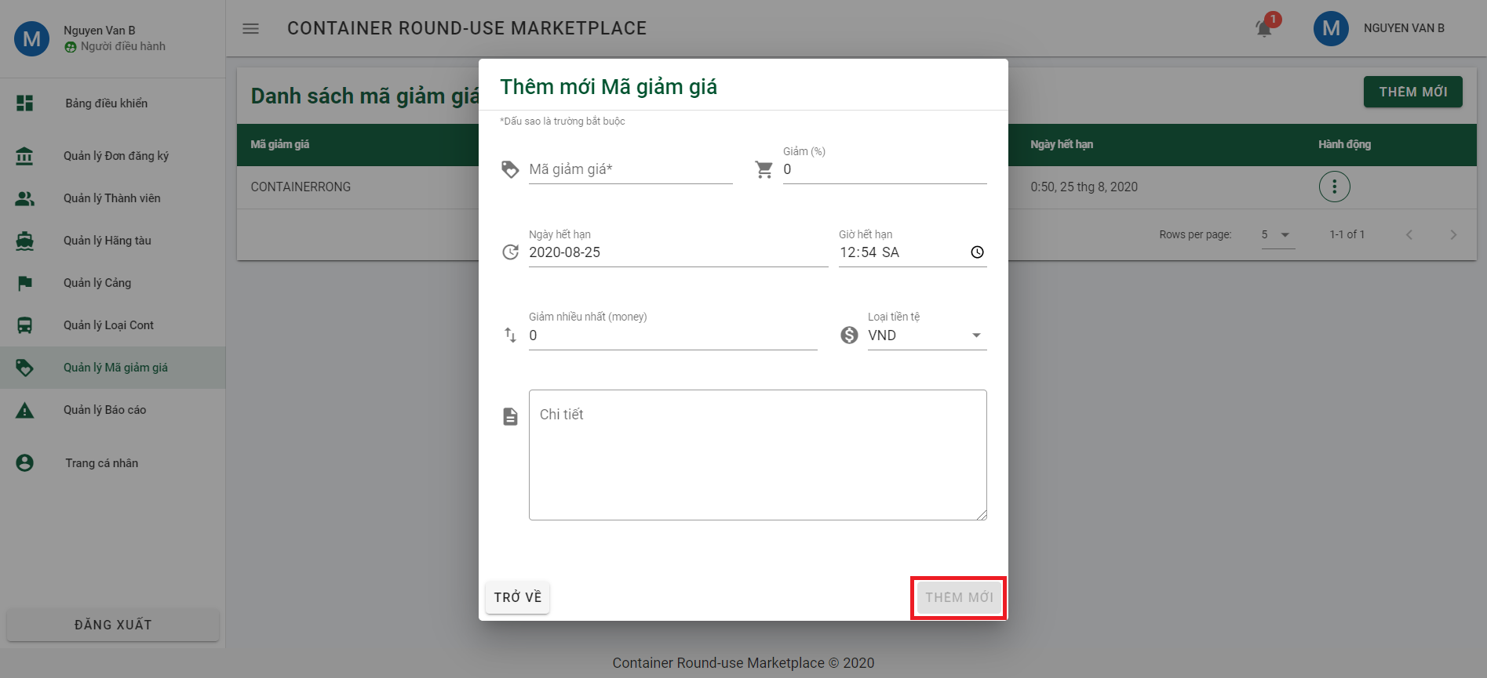

6.2.5.7 Reply report

Step 1: Click on “Quản lý Báo cáo” from side bar and click on 3 dots from report you want to reply.

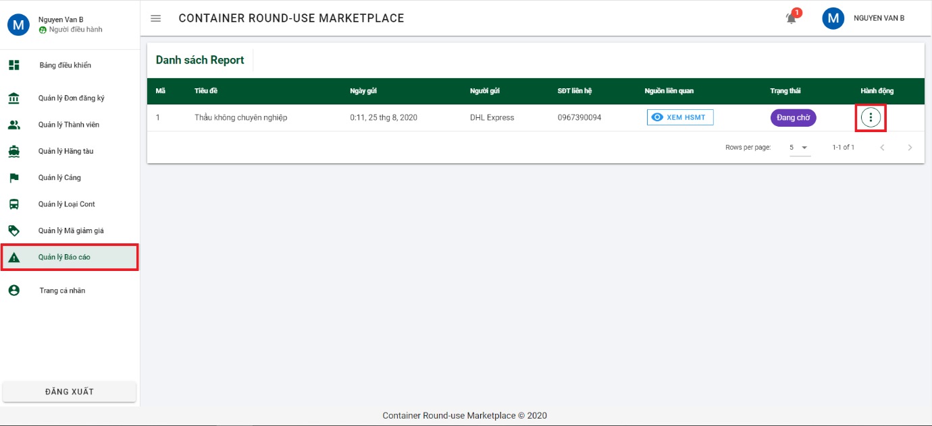

Step 2: Click on “Xem chi tiết” to navigate to report detail page.

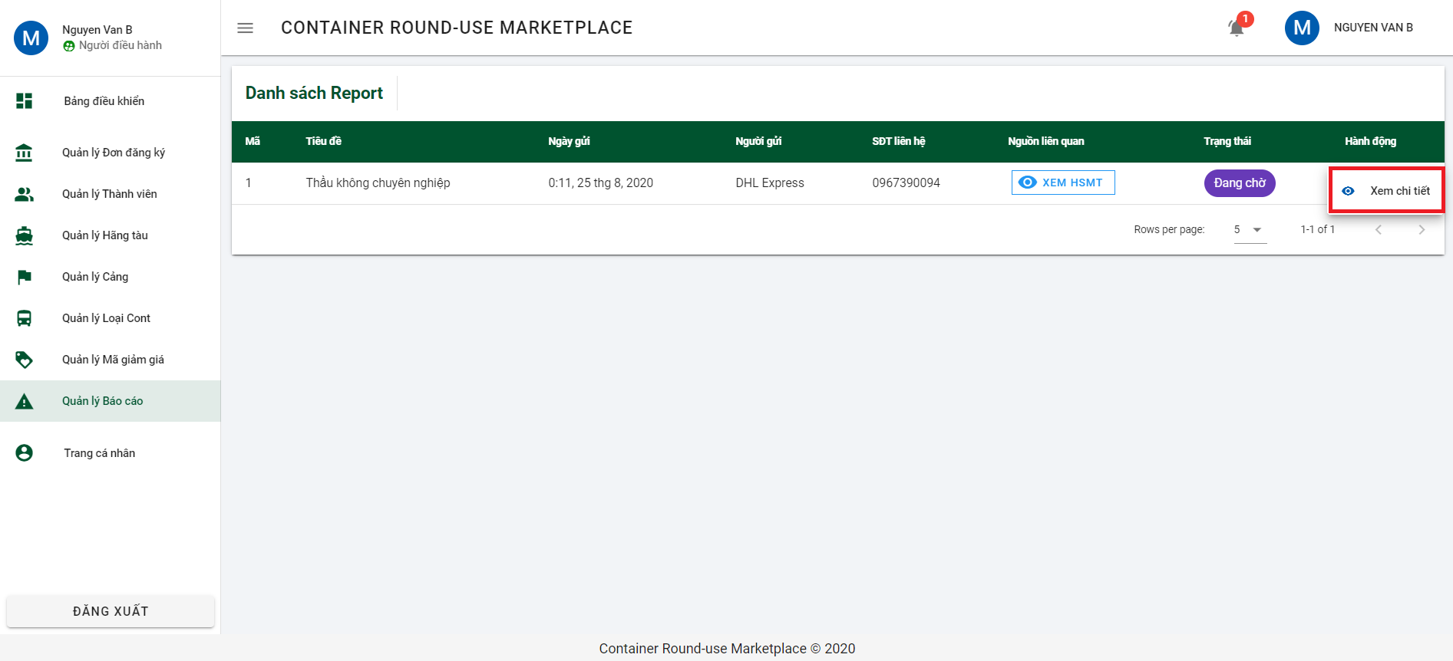

Step 3: Reply report on “Phản hồi tới forwarder” and click enter on keyboard to send it.

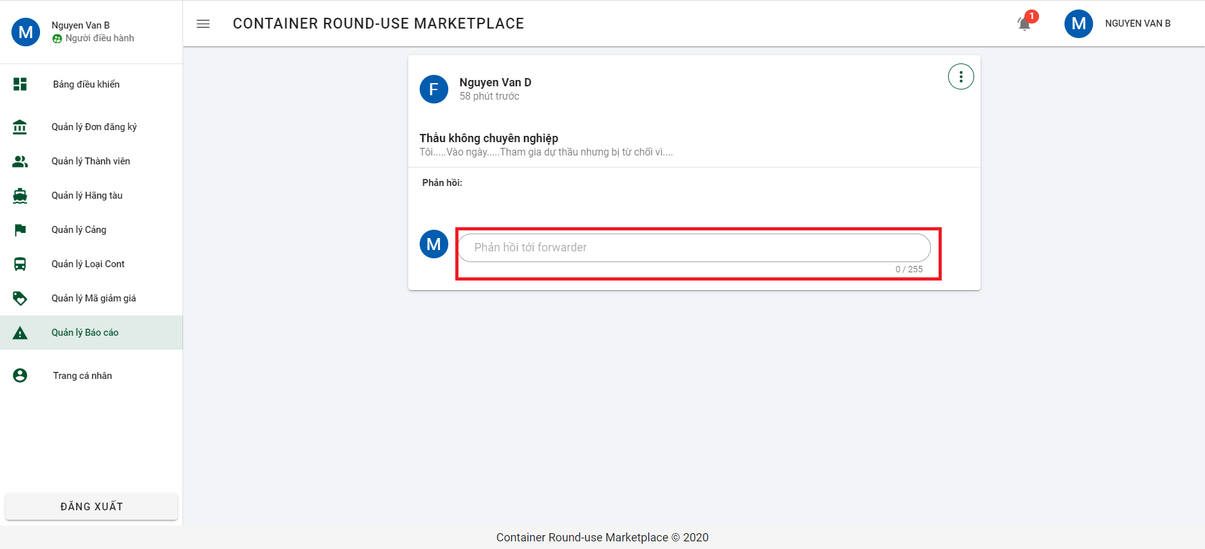

6.2.5.8 Reject report

Step 1: Click on “Quản lý Báo cáo” from side bar and click on 3 dots from report you want to reply



Step 2: Click on “Xem chi tiết” to navigate to report detail page.



Step 3: Click on 3 dots on the right conner of report.

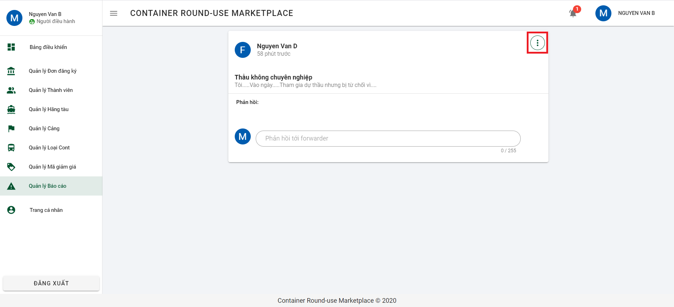

Step 4: Click on “Từ chối” to open dialog confirm reject report.

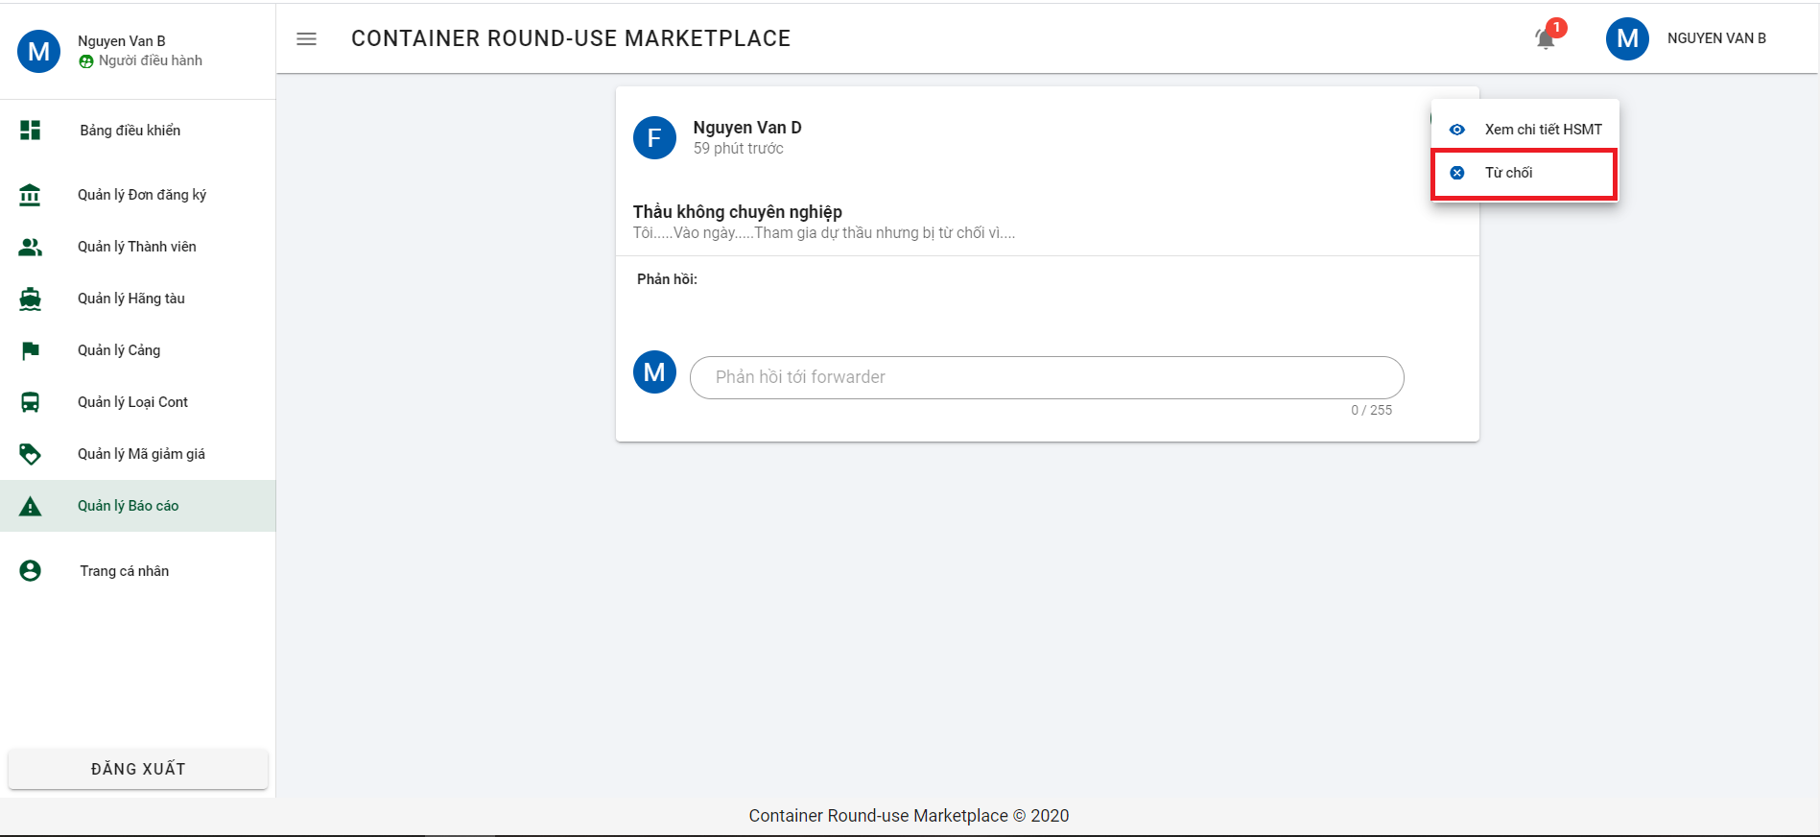

Step 5: Click on button “ĐỒNG Ý” to confirm reject report.

